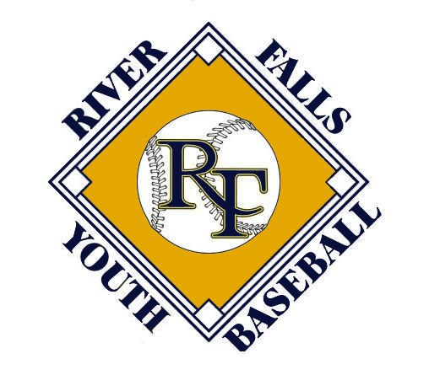 2017 River Falls Youth Baseball Parent Meeting

Steve Rivard- President
Bret Norman- Vice President
Dan Masog- Tournament Director
Nate Schurman- Player/Coach Development
Ryon Pinnow- Treasurer

Monica Weick- Uniforms and Website/Registration
Patti Campbell - Concessions
Jason Belisle - Fields
Melissa Krupa - Umps

Registration
Registration is now open and on our website www.riverfallsyouthbaseball.org
The registration fee is $300 for 2017.

Uniforms
Website Information WWW.CV-SPORTS.COM
Uniforms password baseball
Apparel password wildcats
The deadline to order uniforms is March 11th. Please order by this date in order to receive your uniform by the first game!

Pre-Season Clinic
River Falls High School
Ages 10-11 March 21st and 28th 7-9:00 PM
Ages 12-14 March 23rd and 30th 7-9:00 PM
Mandatory for coaches

Evaluation and Team Placement
March 5th River Falls High School 9 AM-6 PM

10’s - 9:00-10:30
11’s - 10:45-12:15
12’s - 1:00-2:30
13’s - 2:45 - 4:15
14’s - 4:30-6:00

Independent Evaluators will rate players on:
Hitting, Pitching, Fielding, Speed
Will use past year’s coaches evaluation as part of placement process
Purpose of evaluations
- Put players in a position to be successful
- Maximize their opportunity for growth

Announcements of teams - On line
Date: Saturday March 11, by Noon.
Where: RFYBO Website www.riverfallsyouthbaseball.org
The coaches will also contact the players individually after spring break to welcome each player to the team!

Fundraising
6 letters personally written by players to request funds for River Falls Youth Baseball
Pick up your packet at the registration table before leaving
return packet with letters at tryouts next weekend – we will be mailing all letters; no postage is required from you!
Buy out: $20 per letter not filled out/addressed
100 Inning Game
August 12, 2017 – 10 a.m. – 2:30 p.m.
A fun day for players to play baseball!

Concessions
Again we are asking parents to write the board a check for $100 which will be returned if parents work their scheduled shifts.
It is our expectation that the concession stand will be open for all league games at the HS. RFYBO will be scheduling workers for these shifts. It will be the responsibility of the assigned person to find a substitute.
We are looking for (2) candidates to help out with concessions duties this year. As in the past, you will be a member of the board & your child’s registration will be waived. Please see me afterward if interested.

Metro League/Tournaments
Regular Season:
Age/Levels: A-& B-teams for 10s through 14s. Using information from coaches, we attempt to place teams at appropriate levels.
League: Teams play in the Metro Baseball League (www.mbl.bz). 16 game schedule- 8 home games and 8 away games (May- early July); single elimination playoffs mid-July. Weeknights.
Home Game Locations: 10s, 11s, 14s High School; 12s, 13s Glover Park/Freshman Field. 14s will also have the opportunity to play league games at First National Bank of River Falls Field
Opponents: East Metro (Woodbury, Stillwater, Cottage Grove, Mendota Heights, etc.) and Western WI (Hudson, Baldwin, Menomonie, etc) depending on age/level
Practices: Typically at middle School fields in April; scheduled at coach’s discretion thereafter.
Tournaments:

Tournaments are on weekends; 3 to 5 games.

May 13 and14
10AA High School
13AA Glover

May 20 and 21
10A High School
12A Hoffman
14AA High School & First National Bank Field
14AAA High School & First National Bank Field

June 10 and 11
11A High School
12AA Hoffman

June 17 and 18
11AA High School
13AAA Hoffman

RFYBO will be scheduling concessions and field workers for the home tournaments. Like last year, it will be the responsibility of the team’s parents to work these shifts. Typically, these shifts are typically 3 hour blocks and all parents will be responsible to take shifts. please coordinate all shift changes with parents on your team. As mentioned previously, if you work your assigned shifts, your $100 check will be destroyed or returned.

It truly is impossible to have a successful tournament without your help!

Away Tournaments: RFYBO will pay for two away tournaments ($700; May-June) for each team plus the MBT state tournament (mid-July) if first or second in a qualifier tournament.

Coaching Opportunities
Looking for coaching at all levels

Umpires
Great life learning experience, good money $30 - $50 per game depending on the age, good on a resume, and you get paid to work baseball games!
Training: tbd
Contact Melissa at rfumpires@gmail.com

Field Day
Date: TBD
More information will be provided as to start time and meeting location as we get closer to the date

Field of Dreams Information
Open M, Tu, Th, Fri 3-8 (closed Wed), Sat 12-5, Sun (Closed)
Three baseball hitting cages with iron mike pitching machines
fastpitch softball hitting cage
pitching tunnel
two tee areas
hitting & pitching lessons
Phone: 715-781-1456, E-mail: rffieldofdreams@gmail.comWebsite: www.rffieldofdreams.com

Wrap Up – Steve Rivard
Review Grievance Procedure:
- “48 Hour No Contact” rule; Allow emotions to cool before further contact.
- Parent & Coach to schedule meeting time; player must be in attendance!
- If parent does not feel issue has been resolved after coach/parent meeting, contact RFYBO board.
- RFYBO will determine course of action.
Parents: Practice good sportsmanship; emphasize effort; Enjoy watching your son play!

Please contact us at wildcat.baseball@riverfallsyouthbaseball.org with any questions
www.riverfallsyouthbaseball.org

