Patient Name: _____________________________ Date: _______________

1. Is today's problem caused by: □ Auto Accident □ Workman's Compensation

2. Reasons for seeking chiropractic care:________________________________________________________________
___________________________________________________________________________________________________
___________________________________________________________________________________________________
___________________________________________________________________________________________________
Indicate on the drawings below where you have pain/symptoms ____________________________________________
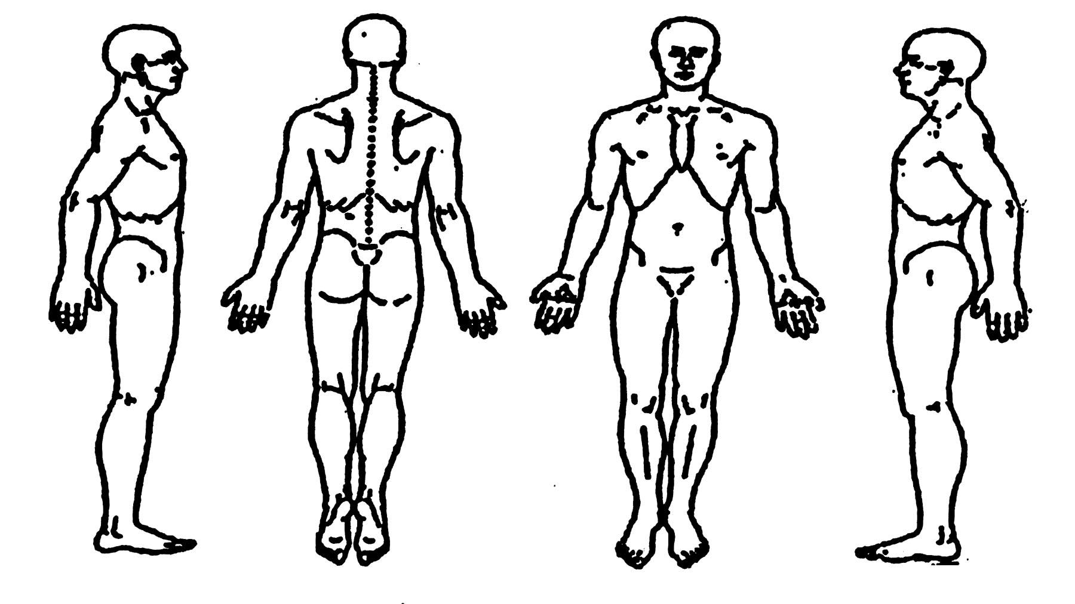
3. How often do you experience your symptoms?
□ Constantly (76-100% of the time) □ Occasionally (26-50% of the time)
□ Frequently (51-75% of the time) □ Intermittently (1-25% of the time)

4. How would you describe the type of pain? (Check all that apply.)
□ Sharp □ Shooting □ Shooting with motion
□ Dull □ Stiff □ Stabbing with motion
□ Diffuse □ Numb □ Electric like with motion
□ Achy □ Tingly □ Other:___________________
□ Burning □ Sharp with motion

5. How are your symptoms changing with time?
□ Getting Worse □ Staying the Same □ Getting Better

6. Using a scale from 0-10 (10 being the worst), how would you rate your problem?
0 1 2 3 4 5 6 7 8 9 10 (Please circle)

7. How much has the problem interfered with your work?
□ Not at all □ A little bit □ Moderately □ Quite a bit □ Extremely

8. How much has the problem interfered with your social activities?
□ Not at all □ A little bit □ Moderately Quite a bit □ Extremely

9. Who else have you seen for your problem?
□ Chiropractor □ Neurologist □ Primary Care Physician
□ ER physician □ Orthopedist □ Other:_____________
□ Massage Therapist □ Physical Therapist □ No one

10. How long have you had this problem? ___________

11. How do you think your problem began?
___________________________________________________________________________________

12. Do you consider this problem to be severe?
□ Yes □ Yes, at times □ No

13. What aggravates your problem?
____________________________________________________________________________________
14. What relieves your problem?
____________________________________________________________________________________

15. What concerns you the most about your problem; what does it prevent you from doing?
____________________________________________________________________________________

16. What is your: Height___________ Weight _____________ Date of Birth ___________

17. How would you rate your overall Health?
□ Excellent □ Very Good □ Good □ Fair □ Poor
18. What type of exercise do you do?
□ Strenuous □ Moderate □ Light □ None

19. Indicate if you have any immediate family members with any of the following:
□ Rheumatoid Arthritis □ Diabetes □ Lupus
□ Heart Problems □ Cancer □ ALS

19. For each of the conditions listed below, place a check in the "past" column if you have had the condition in the past. If you presently have a condition listed below, place a check in the "present" column.
Past Present Past Present Past Present
□ □ Headaches □ □ High Blood Pressure □ □ Diabetes
□ □ Neck Pain □ □ Heart Attack □ □ Excessive Thirst
□ □ Upper Back Pain □ □ Chest Pains □ □ Frequent Urination
□ □ Mid Back Pain □ □ Stroke □ □ Smoking/Tobacco Use
□ □ Low Back Pain □ □ Angina □ □ Drug/Alcohol Dependance
□ □ Shoulder Pain □ □ Kidney Stones □ □ Allergies
□ □ Elbow/Upper Arm Pain □ □ Kidney Disorders □ □ Depression
□ □ Wrist Pain □ □ Bladder Infection □ □ Systemic Lupus
□ □ Hand Pain □ □ Painful Urination □ □ Epilepsy
□ □ Hip Pain □ □ Loss of Bladder Control □ □ Dermatitis/Eczema/Rash
□ □ Upper Leg Pain □ □ Prostate Problems □ □ HIV/AIDS
□ □ Knee Pain □ □ Abnormal Weight Gain/Loss
□ □ Ankle/Foot Pain □ □ Loss of Appetite For Females Only
□ □ Jaw Pain □ □ Abdominal Pain □ □ Birth Control Pills
□ □ Joint Pain/Stiffness □ □ Ulcer □ □ Hormonal Replacement
□ □ Arthritis □ □ Hepatitis □ □ Pregnancy
□ □ Rheumatoid Arthritis □ □ Liver/Gall Bladder Disorder
□ □ Cancer □ □ General Fatigue
□ □ Tumor □ □ Muscular Incoordination
□ □ Asthma □ □ Visual Disturbances
□ □ Chronic Sinusitis □ □ Dizziness
□ □ Other:____________________________

20. List all prescription medications you are currently taking (or submit list):
_______________________________________________________________________________

21. List your allergies to medications:
_______________________________________________________________________________

22. List all of the over-the-counter meds. & vitamins you are currently taking (or submit list):
________________________________________________________________________________

23. List all surgical procedures you have had (or submit list):
________________________________________________________________________________

24. What activities do you do at work?
□ Sit: □ Most of the day □ Half the day □ A little of the day
□ Stand: □ Most of the day □ Half the day □ A little of the day
□ Computer work: □ Most of the day □ Half the day □ A little of the day
□ On the phone: □ Most of the day □ Half of the day □ A little of the day
□ Drives: □ Most of the day □ Half the day □ A little of the day
□ Travel frequently □ Perfom manual labor □ Read a lot

25. What activities do you do outside of work?
_________________________________________________________________________________

26. Have you ever been hospitalized? □ No □ Yes
if yes, why __________________________________________________________________________

27. Have you had significant past trauma? □ No □ Yes

28. Anything else pertinent to your visit today?______________________________________________

I have read the above information and certify it to be true and correct to the best of my knowledge, and hereby authorize this office of Chiropractic to provide me with chiropractic care, in accordance with this state's statutes.

Patient Signature (or Guardian) _____________________________________ Date ______________
Doctors Signature ________________________________________________ Date ______________

