It’s Sumnertime Kids Fit Life Enrichment Tips LLC
2024 Summer camp field trips
EVERY TUESDAY Regal summer movie and Splash Park!
Glenn Dale, Sports and Learning Complex, or Rollingcrest-Chillum.
No Splash Park on June 18th or August 20th.

If paying by cash, please seal envelope with the following written on the outside:
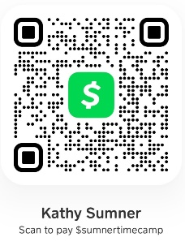
Camper’s Full name, week #, and days attending.

Weekly lunch (pizza-$8) must be paid by cash.

If paying Cash Ap or Zelle, please include child’s
Full name and week #.
Rate: (8:00am-4:00pm) $240 Mon.-Fri. Before Care: (7am-8am)- Additional $25 weekly.
Weekly Rate includes 3-4 weekly field trips. After Care: (4pm-5:30pm)- Additional $25 weekly.
------------------------------------------------------------------------------------------------
Thursday and Friday Trips

- Week 1- 6/18 Kidzden in Bowie (Ultimate Indoor Playground)
​- Week 1- 6/20 LOL Stations (Laugh Out Loud) ​(Laser Tag, Skating, Moon bounces, 360 Tumbler, Bumper Cars, Playground, Carnival Rides) and Fairwood park

- Week 2- 6/27 Adventure Park USA- (Go Karts, Rock Climbing, Laser Tag, Roller Coasters, Mini Golf, Ropes Course, Arcade, Bumper cars, Bowling, Ropes Course)
- Week 3- 7/5 Get Air Trampoline Park

- Week 4- 7/11 Day in Bowie (Skate Zone, Go Karting, and Allen's Pond)
- Week 4- 7/12 Hyper Kidz in Crofton (Ultimate Indoor Playground)

​- Week 5​- 7/18 Rockstars and Rangers- Kidzden in Bowie (Ultimate Indoor Playground)
Champions- Bowling in Crofton, and Allen's Pond Park
- Week 5- 7/19 Pump It Up (Moon Bounce Fun)

- Week 6- 7/25 Rockstars and Champions- Wonderfly Arena-Arbutus
Rangers- Be With Me Children’s Playseum in Columbia
-Week 6- 7/26 Rockstars and Champions- Mayweather Boxing Fitness and Allen's Pond Park
Rangers- Play EC in Capitol Heights and Goodwin Park

- Week 7- 8/1 Urban Air Trampoline and Adventure Park
- Week 8- 8/8 Pirate Adventures on the Chesapeake and Mayweather Boxing Fitness

​- Week 9- 8/15 Rockstars and Champions- Clemyjontri Park McLean, VA and Derrick's Paintbrush
Rangers- Clemyjontri Park in McLean, VA, Old Md Farm, Watkins Nature Center
- Week 9- 8/16 Hyper Kidz in Columbia- (Ultimate Indoor Playground)

- Week 10- 8/20 Scramble Indoor Play in Alexandria, VA
- Week 10- 8/22 ​Urban Air Trampoline Adventure Park

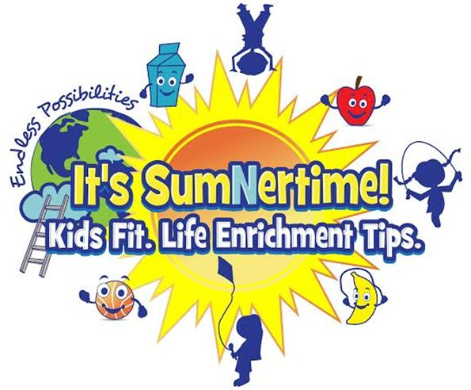
“IT’S SUMNERTIME!”

Name tags: We are on a first-name basis. Respect commands respect. Everyone will receive a nametag on Mondays, or on your first day of camp.

Jewelry: At camp, jewelry should be kept to a minimum, and watches should be waterproof. Primarily, jewelry is unsafe in the camp environment. Earrings should be studs and it is preferred that campers not wear necklaces that could be snapped during play.

Shirts: Every camper will need to purchase a Sumnertime t-shirt ($15.00) to wear on all field trip days.
Shorts: Athletic shorts or loose sweatpants should be worn daily. They should not be torn, cut-off, frayed, too short, or restrict your movement in any way.

Field Trips: We will take 3-4 field trips every week to help your child learn more about the community. Your permission is needed to allow your child to attend the field trip. If your child is not able to attend the field trip, they need to be kept home that day.

Every child will be given a water bottle that must stay at camp. They do not need to bring a water bottle.
Donations: Items that can be donated to the camp are:
Snacks (We are nut free. No peanut butter please)
Popsicles and freeze pops
Clorox wipes and Hand Sanitizer
Case of bottled waters

Our Image

“IT’S SUMNERTIME!”

We are firmly committed to maintaining a safe, secure and wholesome environment for our children. With this in mind, we have established the following Sumnertime Code of Conduct standards. All campers will be expected to adhere to and honor these standards. Please review and discuss the importance of each standard with your child.
- Campers shall treat ALL campers, staff, and volunteers with respect and will value others’ rights and possessions. Any disrespectful, violent or mean behavior, including teasing, taunting, name-calling, or harassment will not be tolerated. Use of obscene language is not tolerated.

- The dress code for all campers must be appropriate for an active program- participants should not wear tight or provocative attire. Modest bathing suits are expected. Preferably two- piece for ages 3-5. Logos depicting violence, inappropriate language or topics, including beer, tobacco, drug or gang references should not be worn. We also discourage wearing any expensive jewelry. All participants are required to wear their Sumnertime t-shirt on field trip days. No body piercing jewelry is allowed.

- Campers shall not possess, consume, or be in the presence of someone using or possessing drugs, alcohol or tobacco (unless prescribed by a physician).

- Participants shall not damage property or equipment (this includes writing graffiti).

- Participants shall not possess or use fire, knives, sharp objects, or anything determined by the Camp Director to resemble a weapon or be considered dangerous.

- If you choose to bring iPods, tablets, kindles, or any other electronic devices to a Sumnertime activity, we will not be held responsible for any loss, damaged, or stolen item. Cellular phones are allowed provided they are turned off during activities and should only be turned on when we have recreational play, free time, or lunch time.

In the event your child fails to meet the above Code of Conduct at any time during summer camp, Sumnertime reserves the right to dismiss a camper and send them home without notice.

Please review this form with your child.
Code of Conduct

