
YOUTH FISHING DERBY
Lyons-Muir Island Fest 2016
8:00 am - 3:00 pm August 6, 2016
Receive Your Free Bait during Registration
8:00 am - 9:00 am - Old Man of the River, 352 Tabor St., Lyons
Derby Time: Once Registered until 3:00 pm

RULES:
- Contact Name & Number for Responsible Adult Required for All
- Age Groups: 0-5yrs, 6-11yrs, 12-16yrs.
- LONGEST SINGLE FISH CAUGHT is how you win
- Prizes for each age group
- To Qualify as Entries, Fish Must Be:
- Legal Size
- Caught By Entrant
- Caught in Maple or Grand Rivers
- CAUGHT DURING DERBY TIME - NO DEAD FISH
- On Time (3:00 pm) for Measurements
- You must follow DNR fishing regulations
- Prizes Awarded to 1st, 2nd, and 3rd Place in each Age Group
- Participation Award - It Pays to Be a Good Sport!
- Measuring of Entries on Island in Hazel Devore Park
- Follow the Signs
* MUST BE IN LINE BY 3:00 PM TO QUALIFY *
Questions: Megan Long, (616) 821-7096
GOOD LUCK, BE CAREFUL
AND MOST OF ALL, FISH ON!!
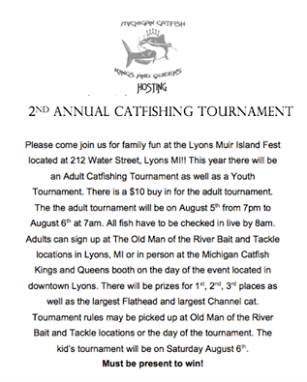

Josh: 616.755.3596

