STOCK DOGS
1 | CALLIE | CATAHOULA
 | 2 YEAR OLD FEMALE | NATE CARTER

Hold up type dog. She is very gritty, hasn’t been struck her own cattle yet but has been there every time. Not a long range dog. Very sweet demeanor and no quit.

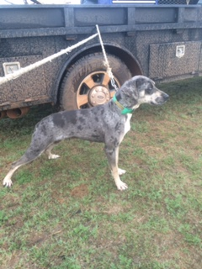

2 | TAZ  16 MONTH OLD FEMALE | 7/8 KELPIE 1/8 BORDER COLLIE
 |  | KORKY HARE

“Taz” is started well on cattle and goats. This is a nice pup that is out of a strong line of working cow dogs. He is a tough dog that will also cover some country.
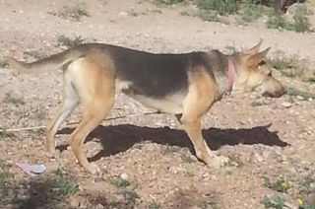

3 | ROCK  2 YEAR OLD MALE | REGISTERED BORDER COLLIE
 |  | BRAD ODER

“Rock” is a two year old dog that I have had since he was 6 months old. He is very fast working dog that bites clean on both ends. “Rock” has done everything on the ranch from loading cattle in a trailer to holding cattle back to me while I rope and doctor cattle outside. He really was a lot of help in the snow that we had this winter. He would also make excellent trailer dog. I used him a lot to hold fresh calves on the cake line. I can’t brag enough on this dog. He knows whistle and voice commands.
