March 11-12, 2018
At: Sleepy Creek Pet Lodge - 1406 Handschke Dr. New London, WI
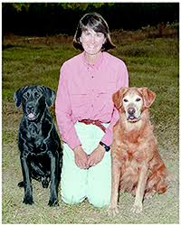

Connie is an internationally recognized dog trainer who offers weekend training seminars across the country and overseas. Her own experience includes 10 obedience trial champions, 2 field champions, 4 amateur field champions and a UDT Maltese and a CDX Shih Tzu. Connie has her own training and boarding facility in Greenville, NC.
Pricing: $225 for 2 day working spot
Audit spots: $75 for 2 days, $60 for 1 day
There are 24 working spots available. All working spots will have individual time on the floor with Connie. There are unlimited auditing spots.
For more information about this clinic please call or email:
920-250-5012 or sleepycreekpetlodge@gmail com

