REGULAR MEETING
SEPTEMBER 19, 2019

A Regular Meeting of the Town Board of the Town of Hampton, County of Washington and the State of New York was held at the Town Hall, 2629 State Route 22A, Hampton, New York on the 19th day of September, 2019.

PRESENT: David K. O’Brien------------Supervisor
Tamme Taran----------------Councilwoman
Donald Sady-----------------Councilman
Andrea Sweeney------------Councilwoman - absent
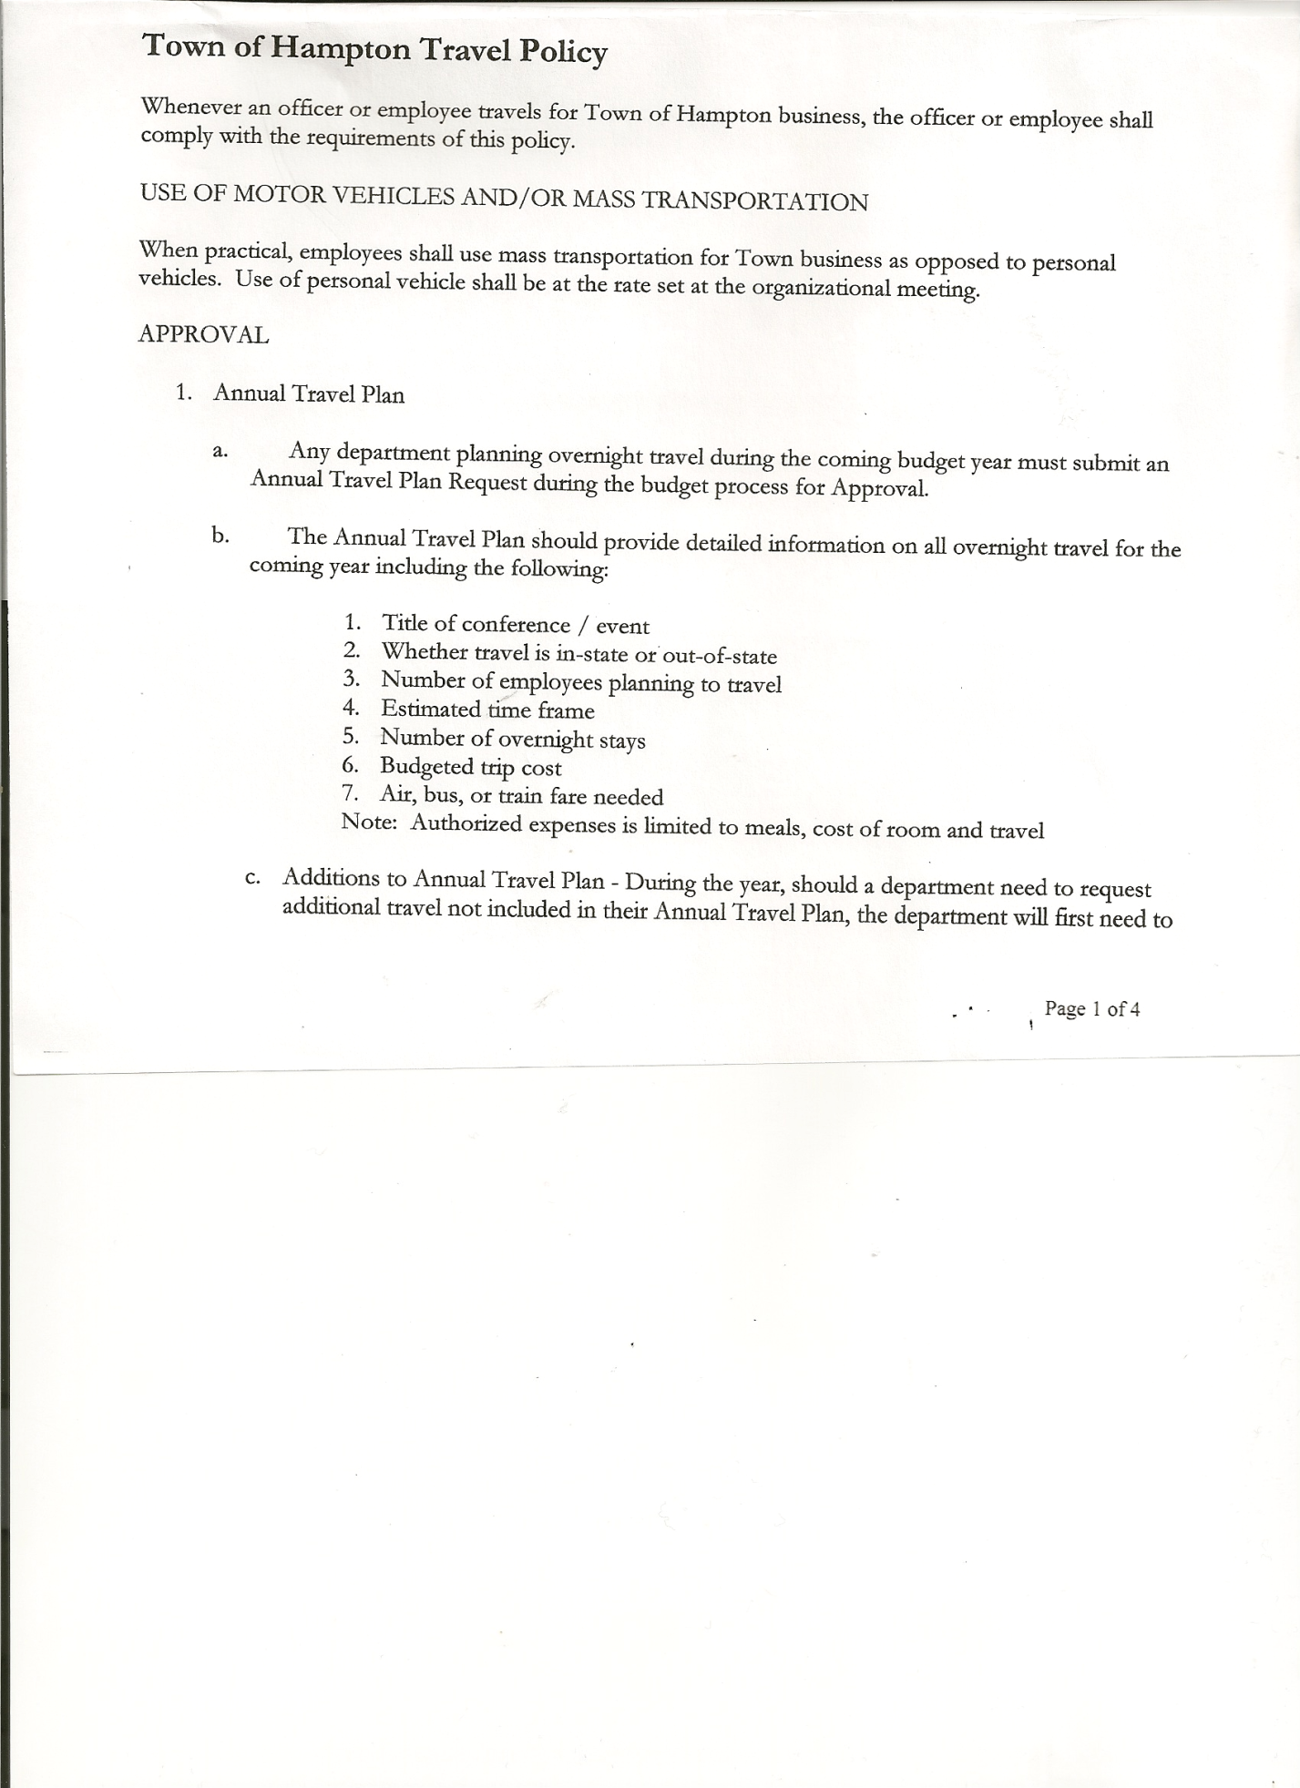
Roger Weeden---------------Councilman
Rebecca Jones---------------Town Clerk
Camilla Shaw----------------Tax Collector/Deputy Town Clerk - absent
Herbert Sady, Jr.-------------Highway Superintendent

Planning Board Member(s): Bonnie Hawley, Chair, and Matthew Pratt

Also present: Ed Longley, Highway Employee, Michael Pietryka, Leonard Reed and Brynna Sady

The Regular Meeting was called to order by Supervisor O’Brien at 7:30pm, followed by the Pledge of Allegiance. Location of Fire Exits were given. Quorum of board members present.

Supervisor O’Brien asked for a moment of silence in memory of John Gildea, Hills Pond Road seasonal resident.

RESOLUTION NO. 82-2019
APPROVAL OF THE MINUTES
On a motion of Councilwoman Taran, seconded by Councilman Sady, the following resolution was ADOPTED: Ayes 4 O’Brien, Sady, Taran, Weeden
Nays 0
Absent 1 Sweeney
RESOLVED, that the Regular Town Board Minutes for August 15th, 2019 are approved.

Larry Carman, Dog Control Officer…no report. Larry has returned as DCO.

Rebecca Jones, Deputy Tax Collector - Zero balance. Submitted a Bank Statement to the Board for review and signatures in Camilla’s absence.

Bonnie Hawley, Chair gave Planning Board Report…
- Continuing to work on Farm Land Ag Protection Plan…they have received maps from NYS Dept. of Ag showing wetlands, soils, etc.
- Planning Board will be meeting twice a month, the 2nd and 4th Wednesdays until further notice.
- Next meeting will be September 25th, 2019 @ 7:00pm at the Town Hall.
October meetings will be the 9th and 23rd, 2019 @7:00pm at the Town Hall

TOWN BOARD MEETING
SEPTEMBER 19, 2019 PAGE 2

Herbert Sady, Jr., Highway Superintendent submitted his report, copy of which, is attached.
Regarding the Tire Changing Tools…
Herb received the following four quotes:
- CarQuest….$985.88
- O’Reilly…..$535.10
- Allied……..$723.96 and
- Tifco……,,,$602.04
Following a discussion the Board asked Herb to wait until next year to make this purchase.

SUPERVISOR’S REPORT/COUNTY UPDATES/COMMUNICATIONS

RESOLUTION NO. 83-2019
APPROVAL OF SUPERVISOR’S MONTHLY REPORT
On a motion of Councilman Sady, seconded by Councilwoman Taran, the following resolution was ADOPTED: Ayes 4 O’Brien, Sady, Taran, Weeden
Nays 0
Absent 1 Sweeney
RESOLVED that, the Supervisor’s Monthly report be accepted as submitted for AUGUST
07/31/19 08/31/19
ACCOUNT BALANCE RECEIPTS DISBURSEMENTS BALANCE
General Fund $ 56,447.15 $ 6,296.53 $ 5,797.71 $ 56,945.97
Highway Fund $103,856.90 $ 4.32 $ 22,314.95 $ 81,546.27
Equipment Reserve $ 29,848.15 $ 1.27 $ 0.00 $ 29,849.42
Fire #1 $ 20,808.00 $ 0.00 $ 0.00 $ 20,808.00
Fire #2 $ 3,878.00 $ 0.00 $ 0.00 $ 3,878.00
Cemetery $ 1,721.13 $ 1.12 $ 0.00 $ 1,722.25
Totals $216,559.33 $ 6,303.24 $ 28,112.66 $194,749.91
All Board Members present signed Supervisor’s Report.

BROADBAND update….
- Slic Network is around surveying poles

Supervisors are working on County Budget
New York State new mandate…..New Discovery Rules that impact the Court

Received letter from Hills Pond/Emerald Lake Association supporting the Town’s effort to reduce the speed limit on Town Roads.

Received letter from Elizabeth Orr, Field Supervisor, Fair Haven Rescue Squad regarding updates to the Fair Haven Rescue Squad. (Copy is attached).

Hampton Fire Department….a 3 year projected Budget was handed out to Town Board members.

The $100,000.00 Grant money for the Highway Truck was received.

The Tentative Budget for 2020 was presented to the Town Board. The Board will have a Special Meeting on October 10th, 2019 and possible one on October 24th, 2019 for Budget Workshops. These meetings will begin at 7:00pm at the Town Hall. The regular Town Board meeting will be held October 17th, 2019.

TOWN BOARD MEETING
SEPTEMBER 19, 2019 PAGE 3

Based on the figures of the Tentative Budget, the following Resolution was introduced

RESOLUTION NO. 84-2019

MOTION BY: Councilman Donald Sady
SECONDED BY: Councilman Roger Weeden

RESOLUTION INTRODUCING PROPOSED LOCAL LAW
TO OVERRIDE THE TAX LEVY LIMIT ESTABLISHED IN GENERAL MUNICIPAL LAW SECTION 3-c

WHEREAS, pursuant to Section 10 of Municipal Home Rule Law, the Town Board of the Town of Hampton (the “Town”) has the authority to adopt local laws; and

WHEREAS, pursuant to General Municipal Law Section 3-c, the Town Board of the Town of Hampton has the authority to adopt a budget that requires a tax levy that is greater than the tax levy limit for the coming fiscal year by adopting a local law by a vote of sixty percent (60%) of the total voting power of the Town Board of the Town to override such limit for such coming fiscal year only; and

WHEREAS, a proposed Local Law has been prepared by the Town Attorney, a copy of which is attached hereto; and

WHEREAS, the Town Board is desirous of proceeding with the review and consideration of this proposed Local Law.

NOW, THEREFORE BE IT RESOLVED that the proposed Local Law is hereby accepted for introduction to the Town Board. A public hearing shall be scheduled for the consideration of the proposed Local Law to be held by the Town Board on October 17, 2019 at 7:15p.m. at the Town Hall located at 2629 State Route 22A, Hampton, New York. Copies of the Local Law shall be available at the Town Clerk’s office for review; and be it further

RESOLVED, that the Town Clerk is directed to post and publish a notice of said public hearing in the Manchester Newspapers (The Granville Sentinel/The Whitehall Times) at least five (5) days before the hearing; and be it further

RESOLVED, that the consideration and proposed adoption of this Local Law is an action under the New York State Environmental Quality Review Act (SEQRA). The Town Board hereby declares that this action is a Type II action pursuant to 6 NYCRR 617.5(20) and (27) and declares that the action does not have a significant impact on the environment and the action is hereby precluded from further environmental review; and be it further

RESOLVED, that this resolution shall take effect immediately.

DATED: September 19, 2019 Supervisor O’Brien AYE
Councilwoman Taran AYE
Councilman Sady AYE
Councilman Weeden AYE
Councilwoman Sweeney ABSENT

TOWN BOARD MEETING
SEPTEMBER 19, 2019 PAGE 4

RESOLUTION NO. 85-2019
PUBLIC HEARING –PROPOSED LOCAL LAW TO OVERIDE TAX CAP
On a motion of Councilman Sady, seconded by Councilwoman Taran, the following resolution was ADOPTED: Ayes 4 O’Brien, Sady, Taran, Weeden
Nays 0
Absent 1 Sweeney
RESOLVED, to set a Public Hearing for October 17th, 2019 at 7:15pm on the proposed Local Law regarding overriding the Tax Cap.

The Town Clerk’s report for August 2019 was submitted to the Board. The Town Clerk had Board Members review and sign bank reconciliation statements for the Town Clerk Account and Special Town Clerk Account dated August 31st, 2019.

RESOLUTION NO. 86-2019

AUDIT OF CLAIMS
On a motion of Councilwoman Taran, seconded by Councilman Sady, the following resolution was ADOPTED: Ayes 4 O’Brien, Sady, Taran, Weeden
Nays 0
Absent 1 Sweeney
RESOLVED that the bills have been reviewed by the Town Board and are authorized for payment in the following amounts.
General Fund No. 125 through No. 131 $ 1,283.47
Highway Fund No. 85 through No. 91 $ 6,769.94
Total both funds $ 8,053.41

On a motion of Councilwoman Taran seconded by Councilman Sady, the meeting adjourned at 8:19pm. All in favor Aye.

Respectfully submitted,

Rebecca S. Jones, RMC
Town Clerk

