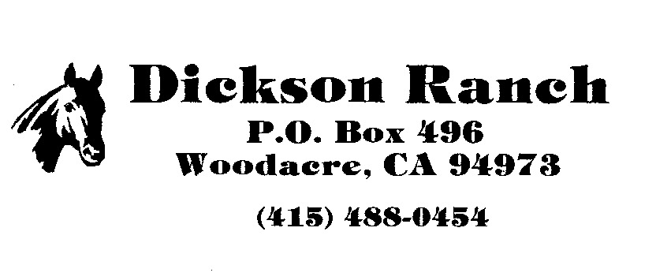
ENGLISH/WESTERN SCHOOLING HORSE SHOW SERIES 2017
DATE: July 15, 2017
JUDGE: Melanie Pervier – San Anselmo, CA
TIME: 8:30 AM - SHARP!!

AWARDS: Various prizes to first; Ribbons through 6th; High Point and Reserve rider in each show in English and Western; Silver Belt Buckle to Series High Point; Cooler to Reserve. SPECIAL THANKS TO MARIN TACK AND FEED FOR THE COOLER! YOU ARE APPRECIATED! Special awards to High Point Series English and Western riders. Many end-of-year awards for Equitation, Trail, Halter, Lead Line and MORE! Also, 11 & Under Division Daily High Points and end-of-year Champion and Reserve. SMALL FRY DIVISION is 9 & Under(#17, 18, 19). Danny’s Jumpers Champion Series Trophy (#4, 5, 6).
**ALL PATTERNS ARE AVAILABLE IN ADVANCE FOR SCHOOLING PURPOSES! JUST ASK**
ENTRY FEES: $15 per class; $1 post entry fee per class; $5 drug fee per horse. Entries close two days before show date. Post Entry charged after closing date.
1. Low Hunters Fences 2’
2. Equitation over Fences Fences 2’
3. Open Hunters Fences 2’3”
4. Jumpers Fences 2’ Table 2 (Touches do NOT count)
5. Jumpers Fences 2’3” Table 2
6. Danny’s Jumpers Fences 2’6” Table 2 Speed Run – No Jump Off
7. Hunter Hack Fences 18”
8. Lead Line English/Western – 6 years and Under (Series High Point and Reserve)
9. Walk Trot Pleasure English - 11 & Under
10. Walk Trot Eq. Pattern English - 11 & Under (Pattern available in advance upon request)
**Classes 9 and 10 have a combined Champion and Reserve for the series**
11. Walk Trot Eq. English – 14 & Under
12. Walk Trot Eq. English – OPEN
13. English Pleasure OPEN
14. English Equitation OPEN
__________________________**Classes # 15-32 start 12:30 PM or AFTER**_________________________________
15. Halter English/Western – 11 & Under Showmanship
16. Nori Demartini Memorial English/Western – OPEN – Halter Showmanship
17. Halter Small Fry English/Western – 9 & Under Showmanship
____________________**Western ONLY Classes – Except Trail (Trail is Open to English riders)________________
18. Walk Jog Equitation Small Fry – 9 & Under
19. Horsemanship Pattern Equitation Small Fry – 9 & Under (Pattern available in advance)
20. Horsemanship Pattern Equitation – 11 & Under (Pattern available in advance)
21. Walk Jog Equitation 11 & Under
22. Horsemanship Pattern Equitation – OPEN (Pattern available in advance)
23. Walk Jog Equitation 13 & Under
24. Walk Jog Equitation 14 & Over
25. Walk Jog Western Pleasure OPEN
26. Walk Jog Gimmick OPEN – Gimmick Pleasure (two hands count as Gimmick)
27. Trail - Walk Jog English/Western - 11 & Under (Pattern available in advance)
28. Trail – Walk Jog OPEN – English/Western (Pattern available in advance)
29. Gimmick Pleasure OPEN (two hands count as Gimmick & lope is at discretion of the Judge)
30. Western Equitation OPEN (lope is at discretion of the Judge)
31. Western Pleasure OPEN (lope is at discretion of the Judge)
**Please note that management has the right to eliminate or add classes if needed**
For more information:
Grace Tolson 1(415) 488-0454; Fax 1(415) 488-4039
Prepare for a long day, our shows can last until dark! Food and Beverages available in FOOD BOOTH
dickson_ranch@yahoo.com

