2017
March
TRUE LIES
The Stuart Rod & Reel Club Newsletter
The Stuart Rod and Reel Club is dedicated to improving local fishing through by increasing angler knowledge, encouraging conservation and maximizing the fun involved in light tackle fishing in the Stuart Florida area. We hold monthly meetings on the second Thursday of each month, year round. Please join us or contact any board member for more information on how you can become a member of the Stuart Rod and Reel Club.
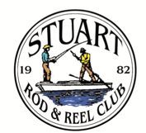

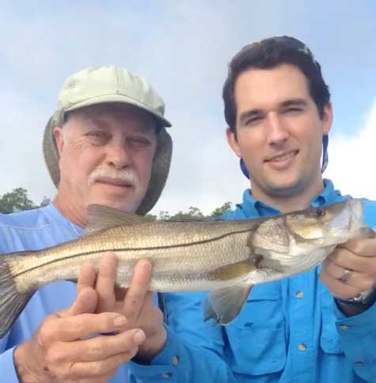
Jim Harter took FWC Regional Director Mason Smith out for a morning fishing trip. Here is a snook that they caught and released using Jim’s magic.
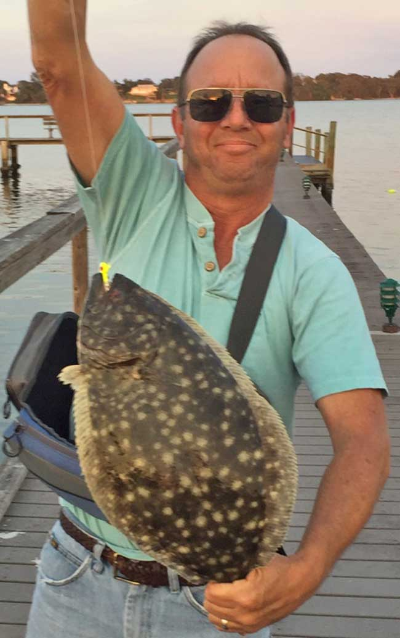
Eric Rosenberg, our new membership director, with a fine 21-inch southern flounder that he caught off the pier at the Conquistador on the St. Lucie River.

SPEAKER FOR MARCH GENERAL MEMBERSHIP MEETING
Jeff Weakley- Executive Editor-Florida Sportsman Magazine-Meeting Date: March 9, 2017.

Jeff Weakly, the Executive Editor of Florida Sportsman Magazine, will our featured speaker for the March meeting. He currently resides on the Treasure Coast and he knows our fishing areas well. Please join us on March 9th at Flanigan’s for this presentation
Read more: http://www.floridasportsman.com/2011/05/16/reference_jeff/#ixzz4ZLLKUzzr

Jeff Weakley, the Executive Editor of Florida Sportsman, has fished nearly every mile of Sunshine State coastline, from Fernandina to the Dry Tortugas, all the way around the Gulf of Mexico to the Alabama state line. And back again. And again.
For that matter, Jeff has scoured every inch of Alabama coast, having spent his teenage years in the port city of Mobile. His passport is inked with stamps from the Bahamas, Costa Rica, Belize and Caribbean islands–and those were just work days. On vacations, he’s hiked hundreds of miles of Blue Ridge trout streams, fished Alaska, Montana, Wyoming, New Mexico and a dozen other states.
He currently resides on the Treasure Coast of Florida, where he chases snook, trout and reds on the Indian River. He runs a 19-foot skiff, a 16-foot canoe, a 9-foot kayak, and a well-worn pair of neoprene wading boots. Jeff has served as a past president of the Coastal Conservation Association Dade County Chapter, and has won numerous writing awards from the Florida Outdoor Writers Association.
Jeff is a founding editor of Shallow Water Angler magazine, an offshoot of Florida Sportsman, where he has been employed since graduating from Stetson University with an English degree in 1995. He has penned hundreds of how-to magazine articles on subjects ranging from fly fishing for snook to trolling for waho
Read more: http://www.floridasportsman.com/2011/05/16/reference_jeff/#ixzz4ZLLKUzzr

Jim Bowdish’s Snook Fishing Report

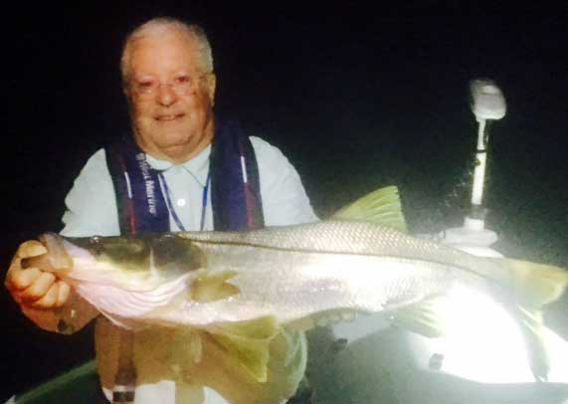
“I hired club member and stalwart fishing guide Jim Cronk to take me fly fishing for snook at night on the full moon of 2/11/17. I caught this 32-inch keeper snook at 7PM on my 9 weight Orvis boron fly rod using a small one-eyed white fly while casting to a lighted bridge fender on the east side of the Evans Crary Bridge. Took about 20 minutes to land after it hit like a freight train. My fly line has four different optional tips, and I was using the black 6-foot lead core tip looped on the floating line to sink the fly while pulling the cast against the commencement of the incoming tide after counting to 10. We kept the fish, and I then opted to fish lighted docks in the St Lucie River and Indian River in the canal going into the end of Sewell's Point and later around Nettles Island. We caught more small snook about 22 inches using an 8 weight fly rod and floating line with a 25 pound fluorocarbon tippet. We landed a total of 8 snook for the night plus some jacks all on flies. When I woke up this morning, I thought I must have been dreaming!
One of Jim Cronk's best tools is his 24-volt Minn Kota GPS trolling motor. It kept us in "anchor" mode while I cast under the bridge or around lighted docks. Jim operates it by remote control from the back of the boat and was able to move us away from the bridge quickly when the monster ate my fly. I am definitely going to replace my old trolling motor with one of these!”----Jim Bowdish, Club Vice President.

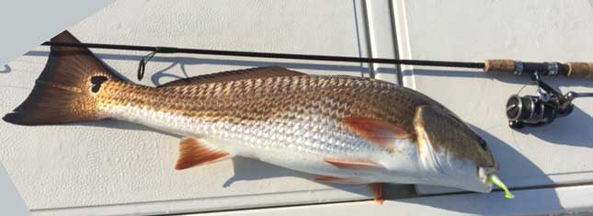
Jim Harter caught and released this pretty 29-inch redfish as it cruised in the South Fork of the St. Lucie.

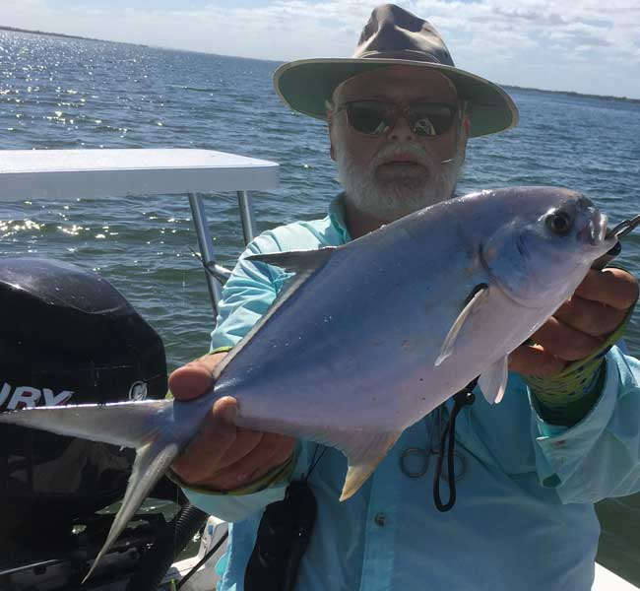
Jim Bohrer caught this beauty fishing in the February Tournament. Jim says, “Nice pompano, but alas, it was not enough to beat Eric Rosenberg in this tournament.”

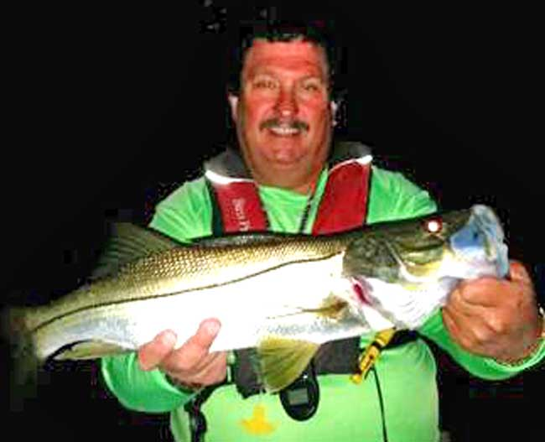
Keith Palant caught this lovely night time snook under the docks. Use a stout leader and patience when seeking out these nocturnal predators.
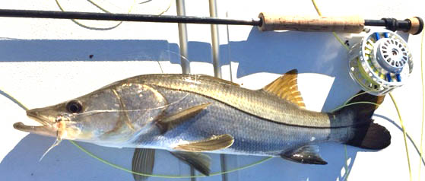
Jim Harter caught and released this pretty daytime snook using a fly rod and what appears to be a Clouser minnow-type streamer fly.

ANGLING CHAIRMAN’S REPORT FOR FEBRUARY TOURNAMENT
Frank Miller, Chairman
“Our February outing was held on the 10th, 11th, and 12th and the targeted species was the wily Pompano which has certainly been elusive the last couple of years during this time period. Our winner this year should have been at the Saturday picnic helping in Ruggieri’s absence but alas he chose to fish instead. I need to give Eric Rosenberg a lot of credit for the work he does around the club so I can't bust his chops any more. Congratulations Eric for winning a beautiful shirt. Eric nailed two nice pompanos before lines-out time and continued to catch more all afternoon in view of the picnic site. Eric also reportedly bagged a number of very nice sheepshead in the inlet.

Major credit goes to Bob Ruggieri, who prepared a fantastic lunch as usual He dropped off the lunch at the park and then left for Clearwater to take his son to a hockey match. Several of us members set out the very tasty ziti pasta and trimmings. You get a gold star, Bob.

A side note, 32 folks signed up for lunch and 24 showed up to eat. Need I say more. If you sign up, show up.

The fish of the month competition for January was won by Gary Mirsky with 30 bluefish and one snapper, so Gary is the proud winner of another FOM cap.”

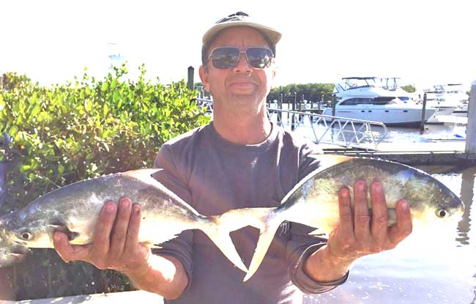
Eric Rosenberg with two of the winning pompano that he caught.
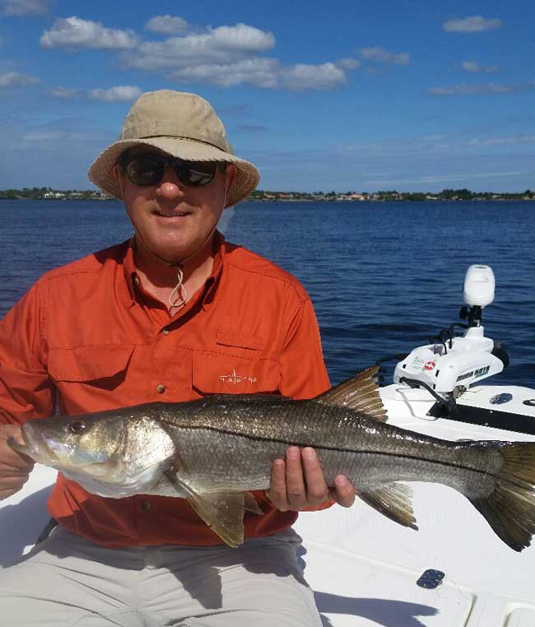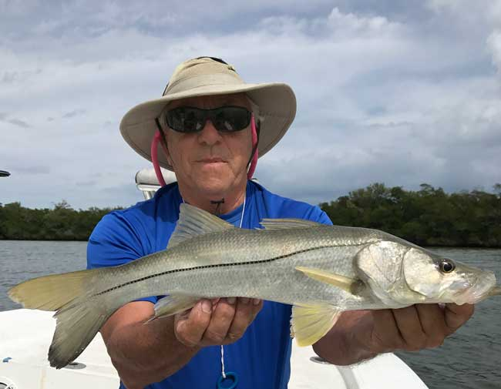
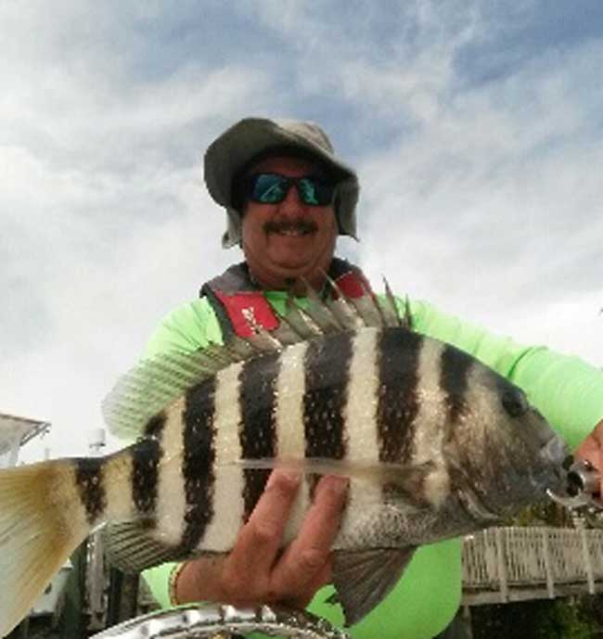
March Luncheon Information:
The March Luncheon will be held on Saturday, March 11th at the Manatee Island Grill in Ft. Pierce. Please note that lunch is included for you (and your family member(s) if you have a family membership). Alcoholic beverages and any other guests are your monetary responsibility. This is a special one day tournament event with rules listed on page 10 below. Thank you for your cooperation. Please make reservations at the March meeting if you intend to attend.
This restaurant has NO dock on the inlet, but has a large parking lot suitable for trailered boats.
ThisT
Men out enjoying their fishing day:

Top Left: Glenn Kellis fishing with Keith Palant caught this snook on a fly. He was sight fishing for this 28 ¼” fish.

Top Right: Jerry Hoge with a bright colored snook caught in the Indian River with Jim Bohrer.

Left: Keith Palant with a big sheepshead.

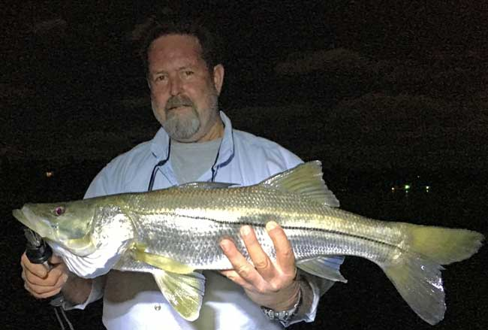
A beautiful night time snook for Phil Norman of Outboards Only.
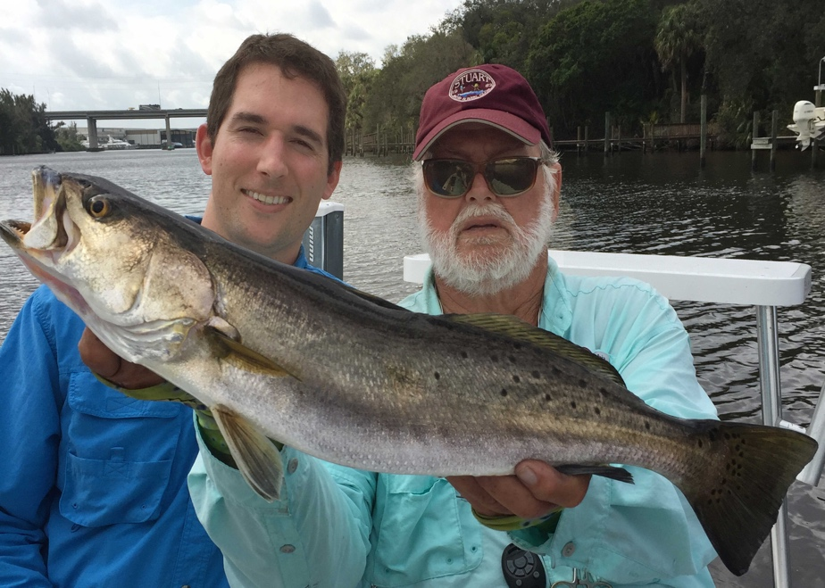
Jim Bohrer took FWC Regional Director Mason Smith out to show Mason some of the large sea trout that inhabit our area

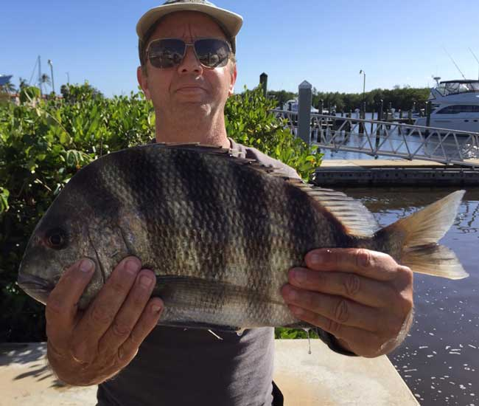
Eric Rosenberg with a full-sized sheepshead. Although a difficult fish to clean, one this big makes it worthwhile. Sheepshead primarily eat crustaceans, so they are great eating when they are this size.

 |  |  | Club Officers
President | Jim Bohrer |  | halieutics@gmail.com | 301-648-2052
Vice President | Jim Bowdish |  | jlsb@crarybuchanan.com | 772-475-5068
Treasurer | Pete Noll |  | mpnoll@aol.com | 772-223-2136
Secretary and Newsletter Editor | Fred Bartlett |  | fredbart@aol.com | 913-909-9326
 |  |  | Board of Governors
Director |  | Roy Buckley | rlbuckley007@aol.com | 772-871-7008
House Committee |  | Jerry Hoge | jhoge@hogeengineering.com | 772-485-7267
Angling Committee |  | Frank Miller | frmiami2@gmail.com | 305-469-4654
Membership Comm. |  | Eric Rosenberg | erosen1031@aol.com | 772-210-5563
Meeting Speakers |  | Jim Bohrer | halieutics@gmail.com | 301-648-2052
Raffle Chairman |  | Jim Harter | pjharter@comcast.net | 772-223-0648
Conservation Coordinator |  | Jim Harter | pjharter@comcast.net | 772-223-0648
Events Coordinator |  | Bob Ruggeri | bob.ruggeri@yahoo.com | 772-285-4264
E-mail all newsletter copy and photos to Jim Bohrer at halieutics@gmail.com or to Fred Bartlett at fredbart@aol.com. Closing date for photos and copy is the 25th of the month preceding publication.

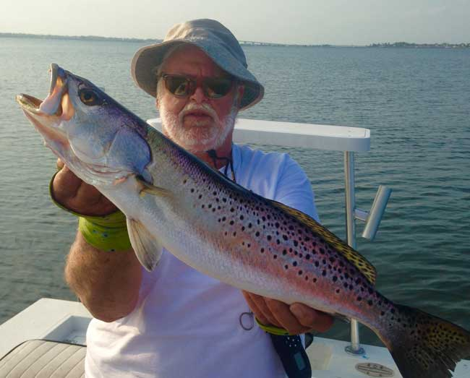
Big Trout Time: Jim Bohrer caught this magnificent sea trout near Joe’s Point. The coloration almost resembles a freshwater trout, perhaps a brown and rainbow mix.
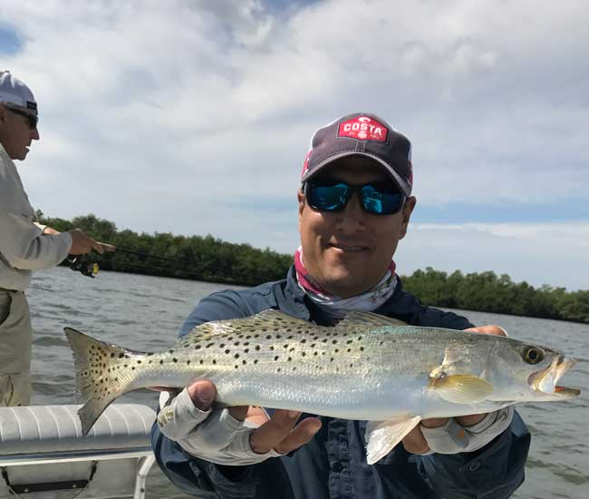
Father and Son Day: Juan Guachino Jr holding a fine trout while his dad, Juan Sr. fishes behind him.
All Stuart Rod and Reel Club Outings are based purely on the Honor System. All scheduled Club Outings will be “Daylight Outings”. You can fish any of the dates listed above. Event will begin at the first safe light in the morning with lines out of the water by 1PM. Scores must be turned into the Angling Director or other board member by email, phone or verbally by 2 PM local time on the day after the event.  Natural Bait (alive or dead) is allowed except for March, May and July. Bait restriction is in effect for September.  Guests and spouses are invited to attend the food services on Saturday at Sandsprit Park. For food at restaurants, guest and spouses will be charged for their meal and beverage costs. | Family members under the age of 18 must be accompanied by a parent or legal guardian to participate in an outing. While guests are always welcome to join members during our outings, you must be a paid member of the Stuart Rod and Reel Club to be eligible to win an outing. Outing scores shall be published in the Club’s Newsletter following the Outing. Outings cancelled due to weather shall be rescheduled for the following weekend. Outing result disputes shall be settled by the Angling Director.  OUTING SCHEDULES AND RULES MAY CHANGE DURING THE YEAR.  FISHING BOUNDARIES  Boundaries will extend from the south shore of the Jupiter Inlet to the North Vero Beach Bridge.

Date | Outing/Event | Details | Host/Food Service | Rules
March  11th only | Round Island | DOA LURE EVENT High Point Wins  Trout=1pt. Snook =2pts. Redfish=3pts.  Max. 3 per species Snook must be 24'' min. | Manatee Island Bar & Grill, Fort Pierce.  1:00 PM, March 11th. | Must use D.O.A. brand lures only.
April  14, 15, 16 | New Member/Old Member | Any Species: Old Member fishes with any with New Member | Sandsprit Park 1:00 PM Stuart, April 15th. | New Member/Old Member
May  12, 13, 14 | Top Water Lures Only | Most Points Total - Snook =2pts.  Trout =1pts. and Redfish 3pts.  Max. 3 per species. | Sandsprit Park 1:00 PM Stuart, May 13th. | Total Points. No bait or jigs allowed.
June 9, 10, 11 | Most Species Caught-Must be legal size fish | Any species of fish caught. | Sandsprit Park 1:00 PM  June 10th | TBA
July  14,15,16 | Local Tarpon Outing | Most Tarpon: 3 Points for angler touching the leader, 1 point for a jumped fish. One point per jumped fish only. No natural bait allowed. | Shrimper’s Restaurant, Port Salerno 1:00PM, July 15th. | Three points for caught fish, one point for each jumped fish.
August  11, 12, 13 | Local Trout and Redfish Outing | Largest Trout & Redfish, total inch length | Sandsprit Park 1:00 PM Stuart, August 12th. | Longest total trout and redfish combined.
September  15, 16, 17 | Longest Snook | Longest Snook –Bait Restriction: Any snook caught on bait is worth ½ a fish caught on an artificial lure. 24” snook minimum length | Sandsprit Park 1:00  PM Stuart, Sept 16th. | Longest snook, minimum 24”
October  13, 14, 15 | Pine Island | Total Length in Inches: 1 Trout, 1 Redfish, 1 Snook (24” minimum on snook) | Pine Island Away  No Local Luncheon | Longest total length
November  10,11,12 | Local Redfish | Longest Overall Redfish | Sandsprit Park 1:00 PM, Nov 11th. | Longest total length
December 9 | Christmas Party | No Outing | Dolphin Bar & Fish House Jensen Beach | No Outing.

2017 TOURNAMENT OUTING SCHEDULE
Support our Advertising Sponsors
We are very fortunate to have many local businesses that advertise on our web site and provide additional sponsorship support to the Club. These businesses provide a wide range of products and services for the entire community. Whether you are looking for lodging, restaurants, fishing supplies, boat repair and restoration, guide services, legal services, or roof repair our sponsors deserve your consideration. You can learn more about these businesses by visiting our website at www.stuartrodandreel.com. Click on the advertiser’s tab and you will find a brief description of our sponsors with contact information and links to their websites. Make our advertising sponsors your priority when shopping. Please let them know that you learned about them through the Stuart Rod and Reel Club and that you appreciate their support.

Bait & Tackle  - Crowder Rods  - D.O.A. Lures  - Fish Heads of Stuart  - Snook Nook  - Treasure Coast Rod and Reel  - White's Tackle  - T & A Jigs, Inc. | Area Lodging  - Marriott - Hutchison Island Resort
Area Dining  - Big Apple Pizza  - Crawdaddy’s  - Dixie Grill  - Manatee Island Bar & Grill  - Manero’s Restaurant  - Polka European Deli  - Rancho Chico  - Shrimper’s | Guide & Charter Services  - Cajun Fishing Adventures Louisiana  - Catch 22 Charters Florida  - The Fish Intimidator Louisiana
Marine Products & Services  - C&H Trailer  - Manatee Marina  - Marine Customs Unlimited  - Marine Parts Outlet  - Master Repair  - Metco Marine Electronics  - Outboards Only  - Sailfish Marina  - Stuart Propeller  - Treasure Coast Battery & Alternator | General Business  - Capps Roofing  - Inn of the Dog  - Plaza 95 Marathon, Dairy Queen and Highway Café  Professional  - Crary Buchanan Attorneys

MEMBER’S INFORMATION
MONTHLY MEMBERSHIP MEETINGS WITH SPEAKERS: The monthly membership meeting is the second Thursday of the month. Our home port is The Quality Inn/Flanigan’s Bar & Grill located at 950 SE Federal Hwy. (US 1) Stuart, FL. We have the privilege of listening to many fishing industry and conservation leaders in the Southeastern Florida region. These experts include tackle manufacturers, tournament winning Captains and guides, television and print journalists, and academic researchers. We have a guest speaker from this pool at each monthly meeting. Speakers will address topics of interests such as how to fish for the upcoming outing’s targeted species and our diverse estuary system. This is a great way to gain additional local knowledge of this fishery. Dinner begins at 6PM with Meeting at 7 PM.

MONTHLY OUTINGS: The Club sponsors a fishing outing each month. All outings are based on an Honor System. You don’t have to keep your catch or take a picture of it either. Outings are scheduled for the weekend following the general membership meeting. Outings are usually three day events where anglers select to fish Friday, Saturday or Sunday. Most outings are scheduled from first safe light till 1PM. The targeted fish and scoring change from month to month with interesting twists such as more points for one species than another. The intent is to have fun! The winner of each monthly outing receives a Club logo embroidered fishing shirt. As part of the outing we have several lunches at restaurants along with club and family cook-outs. Additionally, the Board is encouraging members to partake of the lunch regardless of the day fished. These are no-cost events. With two away outings and the remainder based at Sandsprit Park, there is opportunity to participate without travelling around the state. Frank Miller as the Angling Committee Chairman will also consider your ideas about other outings in other parts of the state. This year’s outing schedule was developed to increase participation, emphasizing the fun of fishing. You are able to view the schedule in every edition of True Lies.

NEWSLETTER: We publish a newsletter, True Lies, each month. It is circulated by e-mail. We are constantly looking for your fishing reports, pictures, recipes, and any other Club related information for inclusion. Submitting information is easy. You can send an e-mail to Jim Bohrer (halieutics@gmail.com).

WEB SITE: The Club’s web site (www.stuartrodandreel.com) is a wealth of information. You can find the latest weather and tides, fishing tips and information on our advertisers/sponsors.

RAFFLE: An activity at our membership meetings that generates a great amount of interest is the “Raffle”. Tickets are $1 each or 6 for $5. Raffle prizes vary monthly but usually include a fishing rod, reel or combination. Other prizes have been tackle bags, boxes, pliers, lures and boating accessories. Your purchase of raffle tickets gives you a good chance of winning and helps support the activities of your club.

MEMBER DISCOUNTS: Your Club membership can help you to save some money. White’s Tackle offers a 10% store discount on all purchases. Be sure to mention that you are a current member of the Stuart Rod and Reel Club and that you appreciate the support that they give the club.

2017 Annual Dues
Dues for 2017 are now past due. Fully paid memberships begin the first day of January, and end on the thirty first day of December of each calendar year. An individual membership is one adult 18 years of age or older. Family memberships consist of the member, their spouse or significant other and their children under the age of 18.

Individual membership for a full year is $80
(January thru December)

Family membership for a full year is $95
(January thru December)

Send your checks payable to:
Stuart Rod and Reel Club, Inc.
c/o Pete Noll, Treasurer
1888 S. W. Mooring Dr.
Palm City, FL 34990
Membership entitles a single person (or family as applicable) to participate in all outings and to enjoy a meal at every local outing. Members also receive an included meal (with soft drinks) at Shrimper’s and Manatee Island Grill on the appropriate dates. We hold monthly meetings with interesting speakers and share information on where and when to fish in our area.

2017 SRRC Fish
of the Month Contests
The Fish of the Month Contest will run from the day after the monthly membership meeting and end at 12 Noon the day of the following meeting. All fish need to be legal size except for Snook that must be 18 inch minimum. Natural bait (live or dead), artificial lures and flies are allowed. The member catching the most fish will be the monthly winner. The monthly winner will receive a monogrammed club hat.
Date | Species
Jan 13 thru  Feb 09 | Snapper, Bluefish
Feb. 10 thru Mar. 09 | Most Pompano
Mar. 10 thru April 13 | Most Snook
April 14 thru May 21 | Largest Trout
May 12 thru June 18 | Most Snook
June 19 thru July 13 | Most Redfish
July 14 thru Aug 10 | Most Trout
Aug. 11 thru Sept 14 | Most Tarpon Caught and Released
Sept. 15 thru Oct 12 | Largest Snapper
Oct. 13 thru Nov 9 | Largest Redfish
Nov 10 thru Dec 13 | Most Black Drum

The Winner of the Year Overall will be the person catching the most total species during the calendar year. The overall prize is a $50 gift certificate to White’s Tackle in Stuart.

