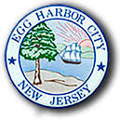
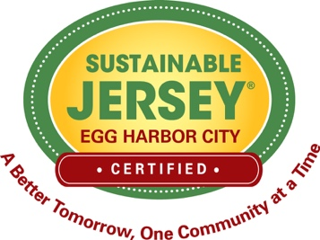

EHC Street Tree Maintenance Pledge

I , owner of the property located at

pledge to properly maintain for two (2) years the street tree(s) planted in the right-of-way in front of my property. I agree to attend a mandatory Tree Maintenance program to be held at Egg Harbor City Hall (time & date TBA).

Required maintenance includes:
- Providing the tree with 20 gallons of water per week from March to December or according to specifications provided by the city
- Mulching around the tree (donuts not volcanoes)
- Pruning (cut above the branch collar, no topping) only if necessary.

FYI: All property owners in the city are required by the City Code to maintain existing and future street trees, which includes: removing them if they are dead, diseased or present a danger to surrounding environs; raking leaves to the curb for pick up by Public Works during the fall leaf collection (see EggHarborCity.org); or placing leaves in proper recycling containers or bags for the ACUA’s regular yard waste collection schedule (see ACUA.com).

NAME DATE

SIGNATURE

Tree planting project funded by a grant from the NJ Urban & Community Forestry Program

