**Author Visit**

**Information Packet**

**Fleur Bradley**

Thank you for considering me for an author visit! School visits are one of the best parts of my job, and I want to make sure you feel confident my visit will be of value to your school and the kids.

I put this packet together to give you information about my presentations, my books, and answer frequently asked questions. Please let me know if you have questions that I haven’t covered! This packet is just intended to be a guide to make sure that the school visit goes smoothly and meets (hopefully exceeds!) your expectations.

**ABOUT ME**

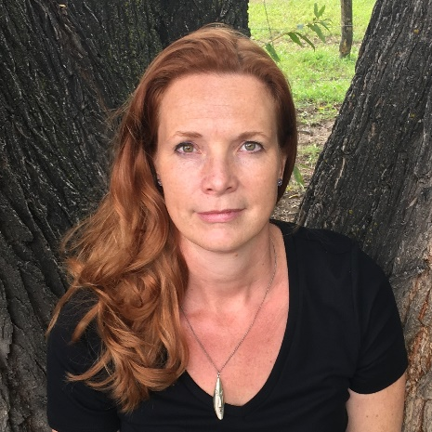I’m Fleur Bradley, the author of more than a dozen books for kids, including award-winning *Daybreak on Raven Island* and *Midnight at the Barclay Hotel*. I’m originally from the Netherlands, and now live in a small cottage in the foothills of the Colorado Rockies.

**I’m is passionate about two things: mysteries, and getting kids to read**—and I believe the two go hand in hand. Who doesn’t love a good mystery to solve? I write all my books with the hope to get (and keep!) kids excited about reading, with great response from kids, parents, teachers and librarians.

**ABOUT THE PRESENTATIONS**

My goal, first and foremost, is that kids (and teachers, of course) come away inspired, whether it’s to write a story, revise something they’ve written that they feel could be better, or try their hand at something else that’s challenging. I’m a big believer that with hard work, a positive attitude, and a willingness to learn and take feedback, you can do anything you set your mind to.

I try to make my presentations fun and interactive, and share my mistakes and successes in an inspring way that speaks to young minds.

**SUMMARY OF SCHOOL PRESENTATIONS:**

**From Idea to Printed Book**

Length: 45 min.

How does an author write a book, and how long does it all take? This virtual presentation covers the whole writing process in a nutshell, from idea to that finished novel you can buy in the store. Includes writer's tips and Q&A.

​**How To Plot a Mystery**  
Length: 45 min.

Ever wonder how an author plots a mystery, how to pick the crime, the suspects, and how to plant the clues...? This virtual presentation covers how to plot a mystery, from ideas and theme to rough outline. Includes time for Q&A.

**Let’s Plot a Novel Together!**

Length: 45 min.

Ever wonder where an author gets their ideas, and how they come up with a good story outline? Together, the class and author will brainstorm ideas and put them in a novel outline format. This is a highly interactive presentation that is best done in front of a classroom (not a large gym-sized assembly group)—the kids will be very involved in creating an outline for a novel.

Note: Requires a large dry erase board and dry erase marker, or a chalkboard.

**FREQUENTLY ASKED QUESTIONS**

**Q. Do you charge for your visits? Aren’t book sales enough?**

A. Yes, I do charge. A school visits means I’m taking the day outside my office, which means I’m not writing. Unfortunately for most authors, book sales aren’t enough to compensate for that lost work time.

I love doing school visits, so I try my best to charge a reasonable fee. Meeting teachers, librarians and students is so inspiring!

**Q. Our school has never had an author visit before. How do I convince my administration that it’s worth the time and money?**

A. Author visits are immensely valuable to kids. To start, students can see that there’s a real human being who wrote that story! Kids are often curious about how long it takes to write a book, where ideas come from, and sometimes silly questions like an author’s favorite food.

From an educational perspective, it can be encouraging for students to learn more about the revision process. I share stories about how long it took me to get the story right, and what I do when I feel like I’m getting stuck.

For budding young writers, it can be really encouraging to see that even a published author deals with the same struggles they do. For all kids, it’s great to see that excellent writing only exists through repeated revision. It’s okay to make mistakes—you can always edit a story to make it better.

**Q. How do I prepare for your visit?**

A. If at all possible, have the kids read my books. Better yet, read my book(s) with the class! Kids get more out of the school visit if they’ve read my books.

If not, at least prepare kids by having them think of questions ahead of time. After my presentations, I try to have ample time for Q&A—the kids enjoy that part a lot.

**Q. Can the kids get your books signed?**

A. Absolutely! If I have enough time, I can even personalize them. There is a book order form with this author visit packet for you to hand out (you can add pricing, etc. yourself). If you have an existing relationship (perhaps with a teacher discount) with a book store, then you can simply arrange the purchase yourself. Otherwise, online retailers carry my books as well as the publisher directly, at a school discount if requested.

**Testimonials:**

"Fleur's presentation was well-prepared, thorough, and perfectly structured and she took the time to answer all participants' questions. She was **engaging, approachable, and informative.** If it wasn't already evident from her top-notch novels, Fleur is passionate about children's literature, has impeccable craft, and knows her stuff!" **-Justin Colón, owner of The Kidlit Hive**

​"Our patrons were so pleased with the virtual writing workshop Fleur taught for Arapahoe Libraries. It was interactive, engaging, and dug into the elements of writing mysteries so that participants left with tools for writing their own."  
-**Kara Seal, Senior Events Specialist, Teens and Tweens, Arapahoe Libraries, CO**  
  
“I would highly recommend Fleur Bradley for a school visit. Her presentations can be tailored to your specific needs and tie in nicely to the grade level audience. (..) A great experience for students and staff.”  
**-Mr. Mavel, EL Coordinator and Lead Mentor, Banning Lewis Ranch Academy**

“Loved the ideas and discussions during the Reaching the Reluctant Reader session!” --**Upper-elementary librarian attending the Fay B. Kaigler Children’s Book Festival**

“Amazing! This was a great talk on a topic that you usually don't hear from an author. Very unique and approachable and inspiring. Thanks for the boost!"  
**-Librarian attending virtual Kids Lit Chat, Mid Atlantic Library Alliance (MALiA)**

**CONTACT INFORMATION**

**Fleur Bradley**

Website: www.ftbradley.com

Email: [fleurbradley25@gmail.com](mailto:fleurbradley25@gmail.com)

For author visit arrangements and book orders:

**Andrea Cruise**

Penguin Author Appearance Coordinator, Penguin Young Readers Group

Email: [PYRAuthorVisits@prh.com](mailto:PYRAuthorVisits@prh.com)