Review of Gaussian modelling at short range and comparison with more complex modelling
This project, funded by the Atmospheric Dispersion Modelling Liaison Committee (ADMLC) and in partnership with CERC, makes use of the advanced computational fluid dynamics (CFD) and wind tunnel capabilities within MAGIC to assess the performance of Gaussian plume models at short time and length scales. Gaussian plume models were initially developed 40 years ago for application to nuclear power facilities and accidental releases, and have since been developed for use in regulation of stack releases, odour releases and urban air quality analysis. These models are popular with regulators and designers as they give good estimates for long term averages and are very quick to run. However, these models are not designed for problems over length scales of meters, or for problems such as puff or instantaneous releases, where short time scales are relevant. CERC’s Atmospheric Dispersion Model System 5 (ADMS5) is an advanced Gaussian plume model. ADMS5 possesses features such as a building model and fluctuations model. Comparisons were made between the ADMS5 building model and Fluidity CFD simulations validated against wind tunnel experiments undertaken the University of Surrey.
The ADMS5 building model simplifies buildings with roofs or at oblique angles to the prevailing wind direction into a single, normal facing building with an equivalent frontal area. The flow features around a normal facing building are well understood and therefore the model can then make assumptions on the nature of the dispersion of releases from the rooftop or from upwind locations. Over the short length scales considered in this project, building orientation and the shape of roofs may have a significant effect on plume dispersion. Figure 1a shows a snapshot of a Fluidity simulation of the instantaneous dispersion of a plume past a cube building, normal facing to a turbulent flow. Figure 1b shows an equivalent simulation for a building set at a 45 degree angle to the approaching wind direction, with a pitched roof. The effect of the different building geometry on the downwind dispersion is clear, with a much increased dispersion for the pitched roof case.
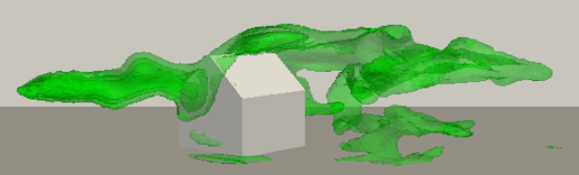
(b)
(a)
Turbulent flow
Figure 1: Instantaneous plume (green) dispersion past (a) a normal facing cube and (b) 45 degree building with pitched roof.
This increased turbulence due to the pitched roof leads to increased mixing downwind of the building, and increases the entrainment of the plume down into the building wake. This can be seen from Figure 2 which shows the plume 95% percentile concentrations at a distance of H/2 downwind of the building face, where H is the height of the normal facing building. Much lower concentrations are seen at the plume centreline for the pitched roof case due to the increased mixing, while higher concentrations are seen lower down in the building wake for this case compared to those for the normal facing building.
Comparisons such as these serve to inform our understanding of microscale dispersion and to evaluate the limitations of simpler models used day-to-day by regulators at such short time and length scales.

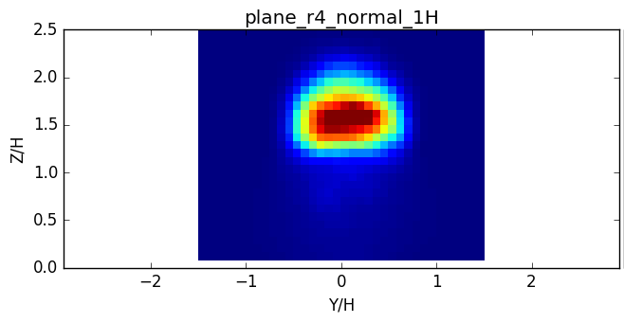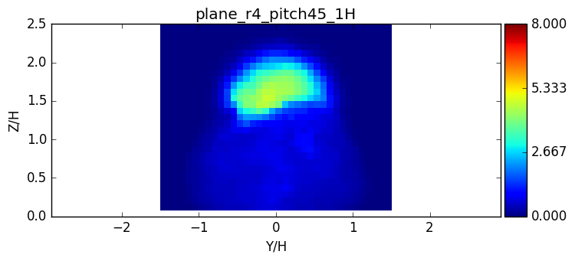
(a)
(b)
Figure 2: Cross-section of plume 95% percentile at half a building height downwind of the building for (a) the normal facing building and (b) the pitched roof at 45 degrees.

