CAFe Tax Prep Express Info Sheet:
Basic Information
Taxpayer’s (Last Name, First Name, Middle Initial):
_____________________________________________________________________________
Date of Birth: __________________________________________________________
Confirm SS#: ___________________________________________________________
Job Title: ______________________________________________________________
# W2s - _______ # 1099s - _______
Did you receive a State Stimulus Rebate in Nov 2023 (approx $200 per person) ☐ - Yes ☐ - No
For 2022 TAx Returns Only- DId you receive a State Stimulus Tax Rebate in Oct/Nov 2022 ☐ - Yes ☐ - No
For 2020 through 2021 Tax Returns only Stimulus #1 amount: ___________ Stimulus #2 Amount: __________
Advance Child Tax Credit amount: ______________
Other Income/Social Security:
____________________________________________________________________________
(for digital text communication & remote signature)
Cellphone #: _________________________ Best time to contact: ______________
Email Address: ________________________________________________________
Cellphone carrier: _____________________

Spouse Name (Last Name, First Name, Middle Initial):
_____________________________________________________________________________
Date of Birth: __________________________________________________________
Confirm SS#: ___________________________________________________________
Job Title: ______________________________________________________________
# W2s - _______ # 1099s - _______
Did you receive a State Stimulus Rebate in Nov 2023 (approx $200 per person) ☐ - Yes ☐ - No
For 2022 TAx Returns Only- DId you receive a State Stimulus Tax Rebate in Oct/Nov 2022 ☐ - Yes ☐ - No
For 2020 through 2021 Tax Returns only Stimulus #1 amount: ___________ Stimulus #2 Amount: __________
Advance Child Tax Credit amount: ______________
Other Income/Social Security:
____________________________________________________________________________
(for digital text communication & remote signature)
Cellphone #: _________________________ Best time to contact: __________
Email Address: ____________________________________________________
Cellphone carrier: _____________________
(If applicable, electronic filing is included in your service fee and includes IRS/State refund mailed or Direct Deposit)

Other notes and comments I have for my Tax Professional:

Address Change: (this typically requires filing for 8822 if you have not filed a tax return. This helps prevent delays in receiving notices sent from the taxing authorities to an old mailing address.
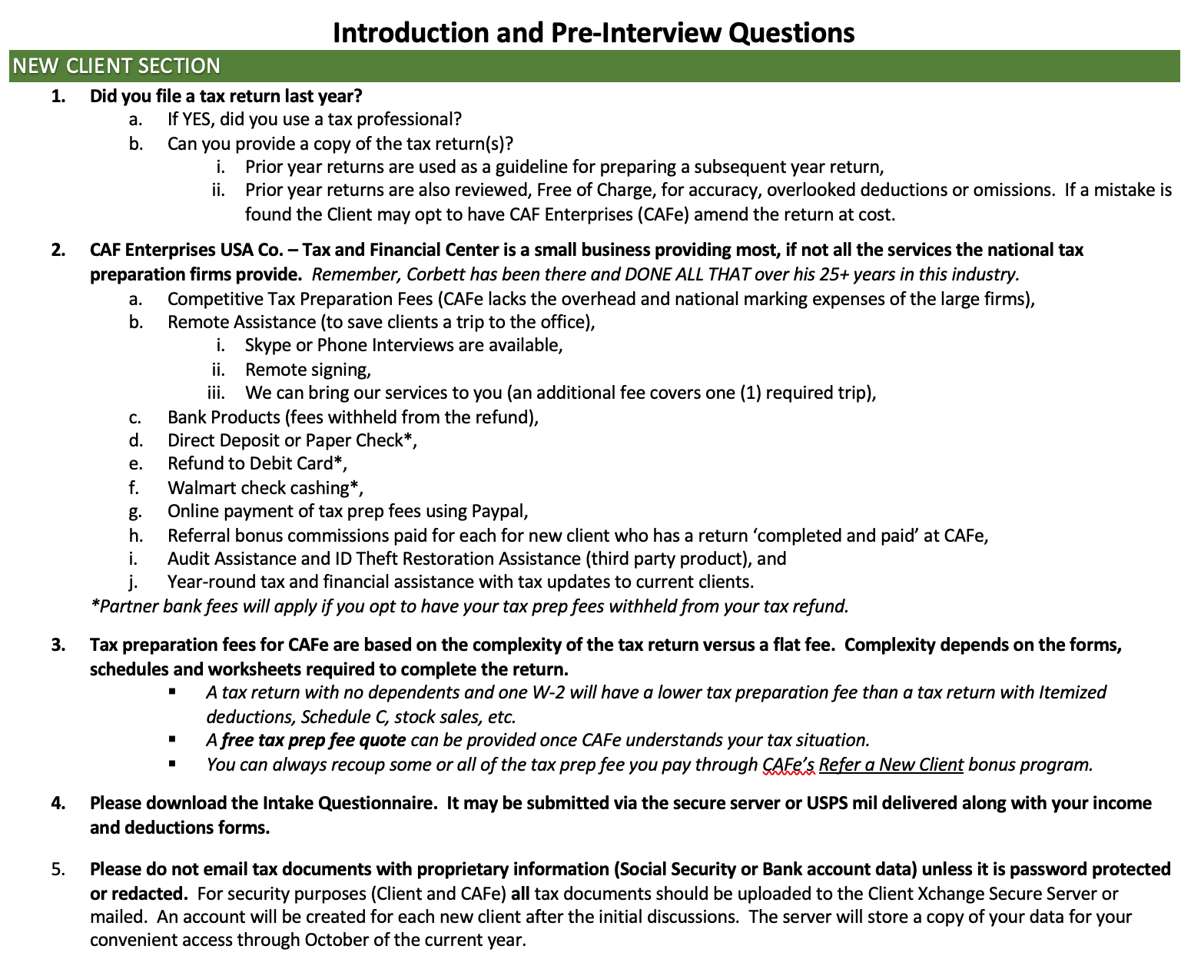

CURRENT CLIENT SECTION (these questions are for thought only… Any updates can be submitted using the tax software questionnaire sent to your email or the Optional Response Form/Links)
- Did you receive any off-season correspondence or income statements relating to the prior year’s tax return? ☐Yes ☐NO
  - If YES, did provide that data to CAFe within 15 days of receipt? ☐Yes ☐NO
- Did your photo ID expire? ☐Yes ☐NO If so, please provide an updated form of ID for the auditable client file.
- Did you refer a friend last year? ☐Yes ☐NO Please confirm that you received your Bonus via mail. ☐Yes ☐NO ☐n/a
- Did you lose or not maintain health insurance coverage all year? ☐Yes ☐NO
Note: The 2018 return is the last year where the government penalty will apply, however, I will still need information regarding your coverage & adv pymnts..
- Did you purchase/sell a home? ☐Yes ☐NO Maintain all info. that may adjust your basis should you sell the house in the future.
- Did your bank account information change from last year? ☐Yes ☐NO (Please provide updated information below)
- Did you have a side or short-term job (Gig) last year or have Bitcoin transactions? ☐Yes ☐NO _________________
Notes:

QUICK LINKS SECTION (ALL CLIENTS) – Most links below point to the CAFe website (nebula). You may receive a warning when accessing.
- CAF ENTERPRISES USA WEBSITE (CAFe Links Page) (this page contains most forms and documents you will need)
- Current Letter of Engagement (*REQUIRED)++
- CAFe Privacy Policy
- Optional Response Form (use to upload confidential responses to the secure tax software file upload)

++ Document is a Form with fields. Form must be saved locally and then reopened to be completed and stored. Not saving file first will cause data entered to be lost.

OTHER UPDATES AND RE/VERIFICATIONS

Annual Direct Deposit Confirmation
For security purposes, clients must confirm direct deposit information annually.
Clients which do not provide updated Direct Deposit information will have their refund(s) processed as a Paper Check.

verifications for dependents and Head of Household filing status

- ALL DEPENDENT INFORMATION MUST BE VERIFIED ANNUALLY FOR ANY OF THE FOLLOWING TAX CREDITS OR FILING STATUSES:
•Earned Income Credit (EIC)
•American Opportunity Credit (AOC)
•Child Tax Credit (CTC)
•Additional Child Tax Credit (ACTC)
•Credit for Other Dependents (ODC)
•Head of Household (HOH)

- Please submit backup annually for each dependent.
- Please confirm the number of days each dependent listed on your return was living at the taxpayer’s primary residence during the previous year.

- Your primary residence must be in the USA for 6 to 12 months.
Confirm the Following (as applicable)

☐ | All dependents included on my tax return are legally allowed to be claimed by me.
☐ | I am the parent or legal guardian.
☐ | I have valid school, medical, and household expense records that I maintain annually for tax purposes. (see RECORDS section below)
☐ | I have or can obtain copies of social security cards and birth certificates for each dependent claimed.

Who is a qualifying child? (Your child meets all the following tests):
(1.) Age (under 19 at end of the year or under 24, if fulltime student) (2.) Relationship (blood relative, adopted or placed by agency) (3.) Residency (in household for over 6month during the year) (4.) Joint Return (cannot file jointly with another person unless “no tax liability”).

RECORDS
Residency of a Qualifying Child
•School records or statement. •Landlord or a property management statement. •Health care provider statement. •Medical records. •Childcare provider records. •Placement agency statement. •Social service records or statement. •Place of worship statement. •Indian tribal official statement.
Disability of Qualifying Child
•Medical doctor’s statement. •Other health care provider’s statement. •Social services agency or program statement.
Schedule C
•Business license. •Forms 1099. •Records of gross receipts. •Summary of income. •Records of expenses. •Summary of expenses. •Bank statements to show income and expenses.

Who qualifies as a dependent?
The IRS rules for qualifying dependents covers may situations - from housekeepers to emancipated offspring. The basic rules below; however, will cover almost everyone.
There are two types of dependents, each subject to different rules:
- A qualifying child
- A qualifying relative
For both types of dependents, you will need to answer the following questions to determine if you can claim them.
- Are they a citizen or resident? The person must be a U.S. citizen, a U.S. national, U.S. resident, or a resident of Canada or Mexico. Many people wonder if they can claim a foreign-exchange student who temporarily lives with them. The answer is maybe, but only if they meet this requirement.
- Are you the only person claiming them as a dependent? You cannot claim someone who takes a personal exemption for himself or claims another dependent on his own tax form.
- Are they filing a joint return? You cannot claim someone who is married and files a joint tax return. Say you support your married teenaged son: If he files a joint return with his spouse, you cannot claim him as a dependent.

Qualifying child
In addition to the qualifications above, to claim an exemption for your child, you must be able to answer "yes" to all the following questions.
- Are they related to you? The child can be your son, daughter, stepchild, eligible foster child, brother, sister, half-brother, half-sister, stepbrother, stepsister, adopted child or an offspring of any of them.
- Do they meet the age requirement? Your child must be under age 19 or, if a full-time student, under age 24. There is no age limit if your child is permanently and totally disabled.
- Do they live with you? Your child must live with you for more than half the year, but several exceptions apply.
- Do you financially support them? Your child may have a job, but that job cannot provide more than half of his/her support.
- Are you the only person claiming them? This requirement commonly applies to children of divorced parents. Here you must use the “tie breaker rules,” which are found in IRS Publication 501. These rules establish income, parentage and residency requirements for claiming a child.

Qualifying relative
Many people provide support to their aging parents. But just because you mail your elderly parent a check occasionally does not mean you can claim him/her as a dependent. Here is a checklist for determining whether your mom (or other relative) qualifies.
- Do they live with you? Your relative must live at your residence all year or be on the list of “relatives who do not live with you” in Publication 501. About 30 types of relatives are on this list.
- Do they make less than $4,200 in 2019, $4,300 in 2020? Your relative cannot have a gross income of more than the stated amounts and be claimed by you as a dependent.
- Do you financially support them? You must provide more than half of your relative’s total support each year.
- Are you the only person claiming them? This means you cannot claim the same person twice, once as a qualifying relative and again as a qualifying child. It also means you cannot claim a relative—say a cousin—if someone else, such as his parents, also claim him.

Credits, Payments and Misc. that can be easily misreported and have substantial tax consequences.
Incorrect information and amounts for the following tax items can be quickly determined by the IRS. The IRS or other tax authority will automatically make the necessary correction and adjust the taxpayer’s refund/balance due at the time of processing. Please ensure you provide accurate information to avoid delays or unexpected adjustments to your tax return.
- Estimated Tax Payments
- Please confirm what estimated payments have been submitted for Federal and to the Federal government and any State estimated payments. State Estimates also affect the itemized deductions (Sch A) if itemizing. Keep copies of your check(s) or a personal tracker that shows the amount and the date each estimate was paid.
- The IRS will automatically correct the figure and reduce the anticipated refund or send via regular mail, a notice of additional taxes owed.
- Prior Year Denied Earned Income Tax Credit
  - If the IRS denied or reduced your EITC for any year after 1996 for any reason other than a math or clerical error, you must qualify to claim the credit in subsequent years. You must then attach a completed Form 8862, Information to Claim Certain Credits After Disallowance to your next tax return. The IRS will not process the next year’s EITC credit if Form 8862 has not been completed and submitted.
- First Time Home Buyers Credit and Repayment
- The one-time credit taken on the 2008 return for first time home buyers (repayable over 15 years).
- If you sell the home the repayment must be reconciled in the year of sale. Any extra payments (over $500 annually) that was paid toward the repayment should be tracked or verified through the IRS portal.

