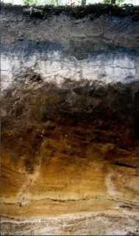
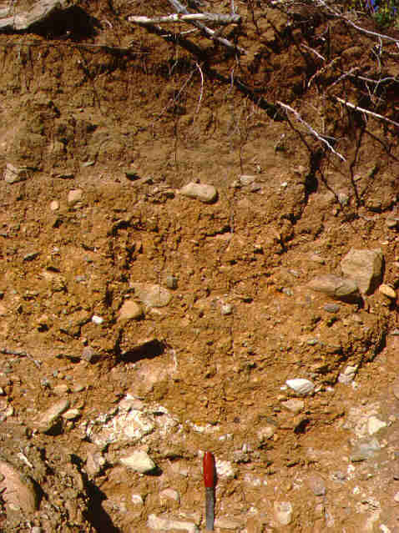
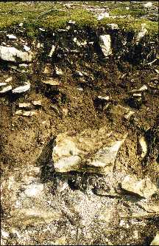
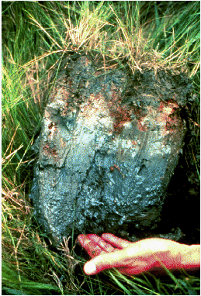
A
B
C
D
SOIL PROFILES
Name the soils
GLEY PODSOL BROWN EARTH RENDZINA (put the correct label with each soil profile)
Explain the circumstances under which each soil forms
What processes are important to each soil

