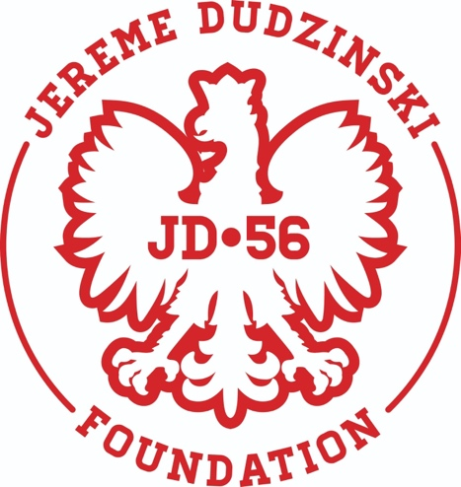
JEREME DUDZINSKI FOUNDATION ANNUAL GOLF OUTING
MAY 18, 2024
BUTLER’s GOLF COURSE in ELIZABETH, PA
Registration starts at 7:30am
Shotgun Start at 9:00am
18 Holes/Cart, 4-person scramble, lunch at the turn, buffet dinner, Promotional item(s), Contests/Prizes

DAY OF GOLF PACKAGES:
$100 per golfer (before April 30th)
$115 per golfer (May1st to May 10th)
Golf Package 1—$550.00
- (2) Large(24x36) Tee Signs and Foursome
Golf Package 2—$500.00
- (2) Small(18x24) Tee Signs and Foursome
Golf Package 3—$420.00
- Foursome and Mulligans (before April 30th)
Advertisement Package—18x24 Tee Signs
- (1) – Tee Sign -- $100
- (2) – Tee Signs -- $150

Online Registration: WWW.JEREMEDUDZINSKIFOUNDATION.COM

Or by mail: Terri Shutterly
113 Pearl Street
Belle Vernon PA 15012

Email: admin@jeremedudzinskifoundation.com

