Student Name:
Date:
Did I earn my free time today? YES or NO

Keep my hands to myself  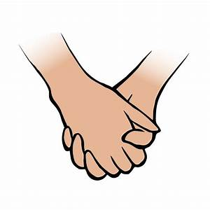 | Stay in my seat and wait for my turn to speak  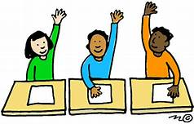

Student Name:
Date:

Student Name:
Date:

