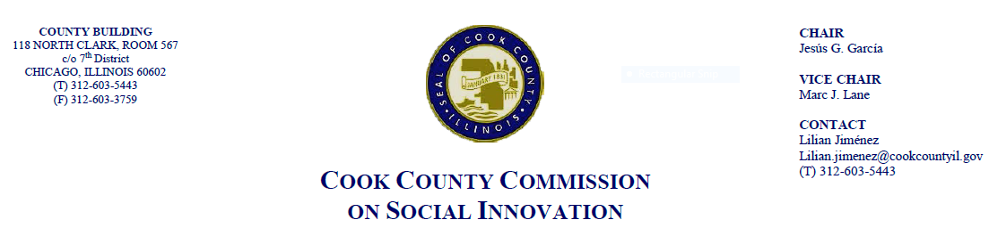October 18th, 2018, 4 P.M.
Cook County Administrative Building
60 W. Washington, 22nd Fl., Conference Room B

MINUTES

- Call to Order

The Cook County Commission on Social Innovation convened via an in-person meeting to discuss committee updates and hear from a guest speaker. The meeting was chaired by Vice Chair-man Lane. The meeting was open to the public and took place from 4:18 p.m. to 5:32 p.m.

Commission Members Present:
- Vice Chair Marc Lane
- Harold Rice
- John Yonan
- Jay Stewart
- Marc Loveless
- Christyn Henson
- Michael Hobbs
- Alma Anaya (proxy for Chairman Garcia)
- Ana Guajardo (over the phone)
- Howard Males (over the phone)

Commission Staff Present:
- Victoria Moreno

Public Speakers:
- Theodore Daffin

- Approval of the Minutes
- Minutes were not approved due to lack of quorum

- Committee Updates

Financial Capital Committee
- Vice Chairman Lane shared that the Worker Cooperative resolution was approved by the Cook County Business and Economic Development Committee and the Board of Commissioners on October 17, 2018.
Social Capital Committee
- Comm. Loveless discussed conversations he has had with the Chicago Film Action Board in how to advance their focus on strengthening local filmmaking.

- Guest Speaker: “Commercial v. Mixed-Use Real Estate Assessment Property Tax Rates”
- Nedra Sims Fears, Executive Director of the Greater Chatham Initiative
- Eiran Feldman, President of the South Side Community Investors Association
  - Presentation on how to support and create businesses on Chicago’s South Side by educating business owners on tax incentives
  - Millennials are not coming back to these communities and this is an opportunity to create proud Black communities where young people can return to
  - There is a higher rate of property owners and businesses in mixed-use buildings
  - There is less demand for stand-alone properties. Knowledgeable investors choose to purchase mixed-use buildings
  - Presenters worked on “Dining on the 5” on 75th St. in Summer 2018 and want to bring more attention to the area by drawing more modern investors and businesses

Post-Presentation Discussion
  - Comm. Loveless talked about his experience living in different parts of the city and how businesses change the environment. Combatting underdevelopment in urban communities depends on the mindset. Development of retail has be carefully based on the needs and practices of shoppers (i.e., online shopping)
  - Comm. Guajardo asked if there would be a community benefits agreement when brining in new business and whether GCI is asking the County for funding. GCI was created by World Business Chicago and the City of Chicago. They want to prioritize the community and bring modern businesses into the area.
  - Comm. Henson commented on her business client who is working on a pop-up business through a new city ordinance. This experience has shown her there is lack of coordination among service-providing agencies and it is challenging to coordinate this work. Younger people are not going to their alderman or community meetings. How do we make sure people who are not large developers have access to resources?
  - Alma Anaya (proxy) stated it is good to work towards improving neighborhoods, but also to think about how to empower current residents and their access to resources. The focus should not only be to provide tax incentives to outside investors but also cultivate the culture and power of the community.

- Adjourn
  - Meeting was adjourned at 5:32 p.m.

