TROUBLESOME THOUGTS

-Since I know that the Patriarchate is the first ecumenical Church; it seems like the Vatican is sort of a succeeded Southern seperative movement in the USA.
Well, thanks God that the Southern did not succeed.
And it’s some kind of a dilemma that I write these sentences while listening to Johnny Cash. May he rest in peace.

-There’s a huge mistake that the USA is doing: Russia invades Crimea, China invades Taiwan. They conquer. The meaning of that is that they invade a place and put their own flag in there. They conquer.
But USA chooses to not do that. USA fights wars too. And does win the wars. But USA doesn’t say “This place is mine from now on. I’m gonna have governors and senators from this new land of ours.” This is a main difference between America and Russia-China.
Guess what? If I’ll be the President of the USA, I will conquer Beijing. I’ll make English the mother language of the people in there. Spanish second and Chinese the third language. Actually the third might be French.
I will be really happy if the flag over the Kremlin will be the American flag.
The lovers of conquering must taste the feeling of being conquered.

-Back in time I remember the people calling the President of USA as the big “nerd”… Now days it seems like the President is the biggest “gangster” of the country. What a scary thing it is if you are hostile towards Americans: an intellectual gangster President.
I don’t wanna give out names, but check out Barack… an author who has written books and also graduated from Harvard as I know. The guy killed osama laden!.. Do we know who pulled the trigger of the gun which killed the bloodiest terrorist of the time? Call me crazy but I suspect it might be Barack himself.
Barack at the barracks… Okay, I admit… maybe wasn’t funny.
But when I look to the pictures of Barack, I can’t stop myself thinking of dialogue like this;
“Sir, we got him.”
“Good job boys, just hold him until I get there. It will take almost 7 hours until I get there.”
“Sir, are you planning to have word with this prick?”
“I am only eager to see what he is gonna say when I shoot him from his balls.”
“Sir, with all respect; he doesn’t have any.”
“Shit! Then I am only gonna shuffle a sword into his ass and twist it.”
“Any other orders other than keeping him alive sir?”
“Yeah… make him believe that he is going to be working for our country. Give him comfort until I get there. Shit! 7 hours of comfort is too much but still, make him believe that he is gonna get a new identification and stuff like that. And when I get there I will show him our ugly face since he enjoys that. Piece of shit likes to be looking at the mirror as I heard.”
“Copy that.”
“Someone teach me how to twist a sword for 540 degrees at one move.”

-Will Smith should admit and declare that he is otistic. The declaration of such truth would give strength to many and many all around.

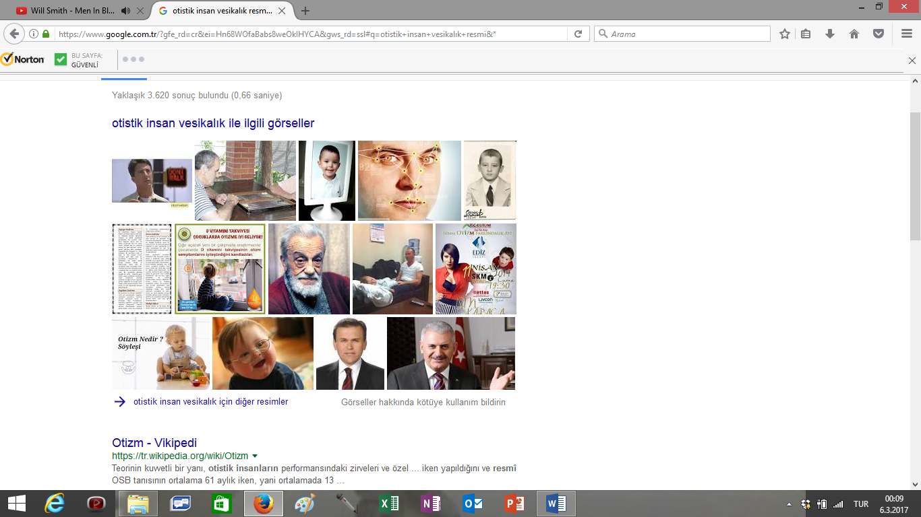

Right down corner is the current Prime Minister of Turkey.
