Sunday | Monday | Tuesday | Wednesday | Thursday | Friday | Saturday
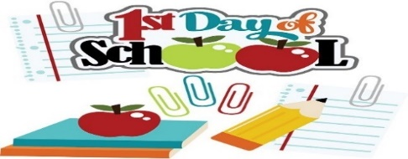 |  | 3 1st Day of School  Cheerios  Granola Bars  Hashbrown Casserole & Veggies | 4  Rice Krispies  Bananas  Ham & Cheese Sandwich & Salad | 5  Oatmeal  Bananas  Baked Chicken with Rice and Salad | 6  Toast  Bananas  Chicken Noodle Soup with Buns | 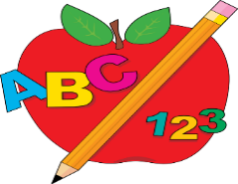
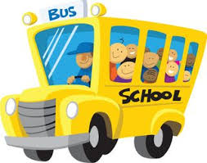 | 9 Cream of Wheat  Muffins  Turkey & Cheese Sandwiches with Carrot Sticks | 10  Shreddies  Apples  Lasagna & Garlic Toast | 11  Toast  Apples  Potato Corn Chowder & Buns | 12  Cream of Wheat  Fruit Cups  Zucchini Pizza Casserole & Buns | 13  PRO-D Day  No School
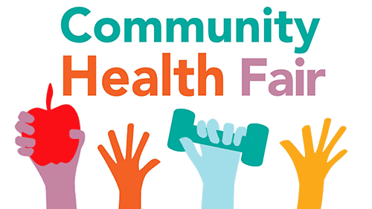 | 16  Toast  Muffins  Burritos & Cucumbers | 17 Picture Day  Rice Krispies  Oranges  Salmon Sandwiches and Caesar Salad | 18 QHS Health Fair  Oatmeal  Oranges  Lunch Provided | 19 Back To School BBQ  Shreddies  Oranges  BBQ Lunch | 21  Cheerios  Oranges  Pasta & Sauce with Garlic Bread | 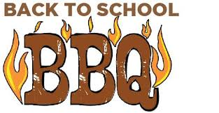
 | 24  Cheerios  Fruit Cups  Chicken Stir-Fry & Rice | 25  Cornmeal  Bananas  Ham & Cheese Sandwich & Salad | 26  Rice Krispies  Bananas  Cheesy Beef Rotini Bake & Salad | 27  Toast  Yogurt  Hamburger Barley Veggie Soup & Buns | 28 Shreddies  Bananas  Meatloaf Muffins with Mashed Potatoes & Veggies
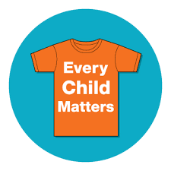 | 30 Orange Shirt Day  Cheerios  Muffins  Pasta & Sauce  With Garlic Toast | 