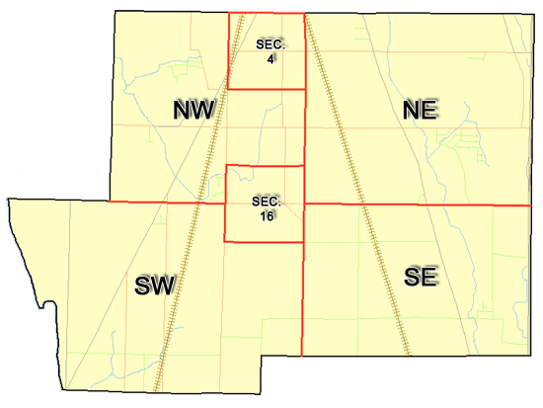 | Pleasant Township  Zoning Commission Minutes  1035 Owens Rd W.  Marion, Ohio 43302
Meeting called by: | Scheduled | Type of meeting: | Regular Monthly
Chairperson: | Mr. Holler | Secretary: | Stephanie Barkley
Timekeeper: |  | Date: July 20th,2023 | Time 7:30 pm
Call to Order by: | Mr. Holler Moment of silence followed by the pledge to the flag.
Roll Call: | Jack Dean, Harry Holler, Tom Leib, Dwight Williams, Joe Thompson, Tyron Canterbury  Stephanie Barkley
Minutes: | Read and approve minutes from previous meeting.  Motion to approve minutes by: Mr. Williams Seconded by Mr. Thompson: All approved
Attendees Address Board: Have sign in sheet on desk by door.
Type in attendees and addresses: see attached.
.
----- Agenda Topics -----
Business
Zoning Reports: | Zoning Inspector goes over reports and provides copy to board.
Unfinished:
New:
Announcements: | Next meeting will be Aug 17th, 2023
Adjournment: | Motion to adjourn by: Mr. Williams and seconded by Mr. Thompson all in favor all approved

Pleasant Township
Zoning Commission Minutes

1035 Owens Rd W.
Marion, Ohio 43302
Business Notes:

 | Discussion:
 | Conclusions:
 | Action items: |  | Minutes signed by: | Date approved:
 | Provide copy of approved minutes to Zoning |  | Chairperson:
 | Inspector. File original in township office. |  | Secretary:
Other Information
Trustees Present: |  | Mr. Creasap and Mr. Schrote
Zoning Inspector: |  | Mr. Baker
Special Guests:

Minutes
The Pleasant Township Zoning Commission met for their regularly scheduled monthly meeting July 20th, 2023 at the Pleasant Township Senior Centre Zoning Commission Board Members were present: Mr. Dean, Mr. Leib, Mr. Thompson, Mr. Williams, and Mr. Holler, and Secretary Miss Barkley and trustee Mr. Creasap, Mr. Schrote and zoning inspector Mr. Baker. Absent Mr. Canterbury.
- Minutes were read from the June 15th,2023 regularly scheduled Zoning Commission meeting. There were no corrections to be made. A motion to approve the minutes was made by Mr. Williams and second by Mr. Thompson motion carried.
- Mr. Tom Baker Pleasant Township Zoning Inspector present the report for June. There were 4 permits. Mr. Baker is continuing sending out violation letters. Nobody from the prosecutor’s office was unable to attend the meeting Mr. Stamolis did answer questions through email. Mr. Creasap had contact with the prosecutor’s office and they advised the township it’s up to the township to handle the issues. The answers that were responded to was discussed in the meeting. Mr. Schrote shared with us that he will be a representative for the solar panels which he will be a judge. He is to answer no questions any questions about this issue needs to go to Mr. Creasap and Mr. Lust. Next meeting, we will discuss on how to handle fines in the township.
4. There being no additional business for discussion Mr. Williams made motion to adjourn, seconded by Mr. Thompson and all Members in attendance agreed and the meeting was adjourned. The next Board Meeting will be held on Aug 17th ,2023 at 7:30 PM.

