Eco Orca’s MARCH 2024 Dinosaurs
SUNDAY |  |  |  | MONDAY | TUESDAY | WEDNESDAY | THURSDAY | FRIDAY | SATURDAY
 |  | 25 |  | 26 | 27 | 28 | 29 | 1 | 2
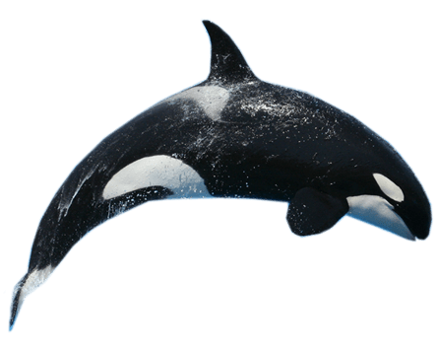 |  |  |  |  |  |  |  | Aylard Farm  Petroglyphs
 | 3 |  |  | 4 | 5 | 6 | 7 | 8 | 9
 |  |  |  | JDF Upper Park | Cole Bay Trails | Rainbow  Park | Devonian Park | Lower Rayal Bay Park | 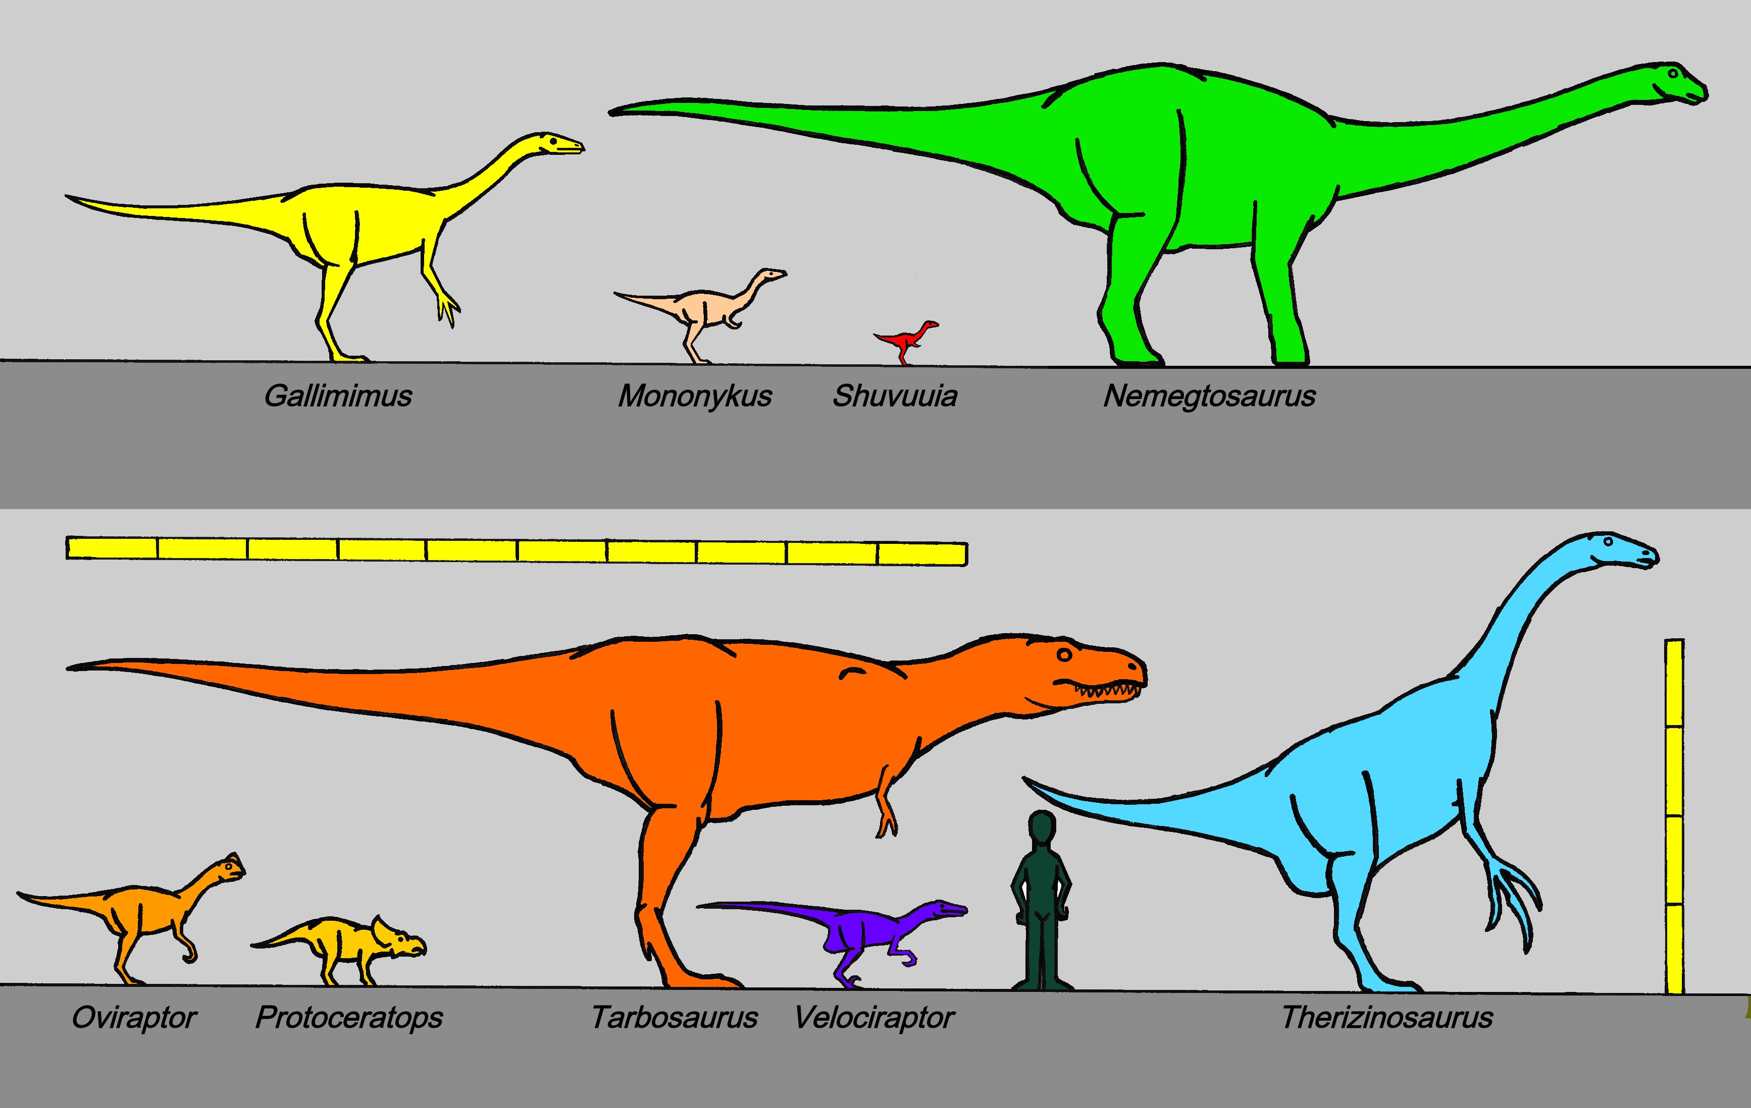  This Photo by Unknown Author is licensed under CC BY-SA
 | 10 |  |  | 11 | 12 | 13 | 14 | 15 | 16
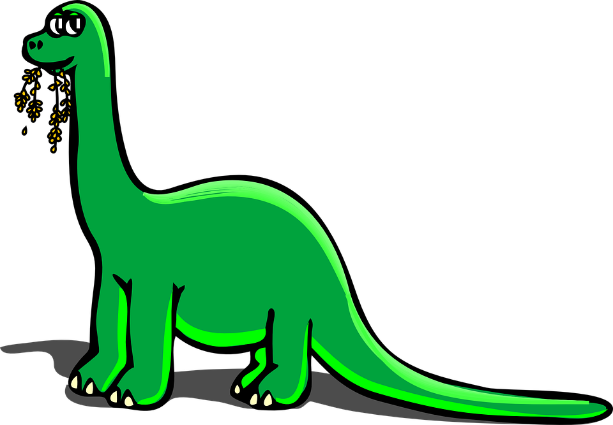 |  |  |  | MT Doug Beach | Cook St  Park | Matheson Lake Trail | Beckwith  Park | Thetis Lake Trails
 | 17 |  |  | 18 | 19 | 20 | 21 | 22 | 23
Spring Break OSC  St. Patrick's Day |  |  |  | Langford Centennial  Park | Movie Day $12 | Gyro  Park | Bowling $8 | JDF Park and Hockey
 | 24 |  |  | 25 | 26 | 27 | 28 | 29 | 30
Spring Break OSC |  |  |  | Beckwith  Park | Seaparc Skating $3 | Cook St  Park | Sooke  Park | Closed  Good Friday
 |  |  | 31 | 1 | 2 | 3 | 4 | 5 | 6
Easter Sunday

