Sunday | Monday | Tuesday | Wednesday | Thursday | Friday | Saturday
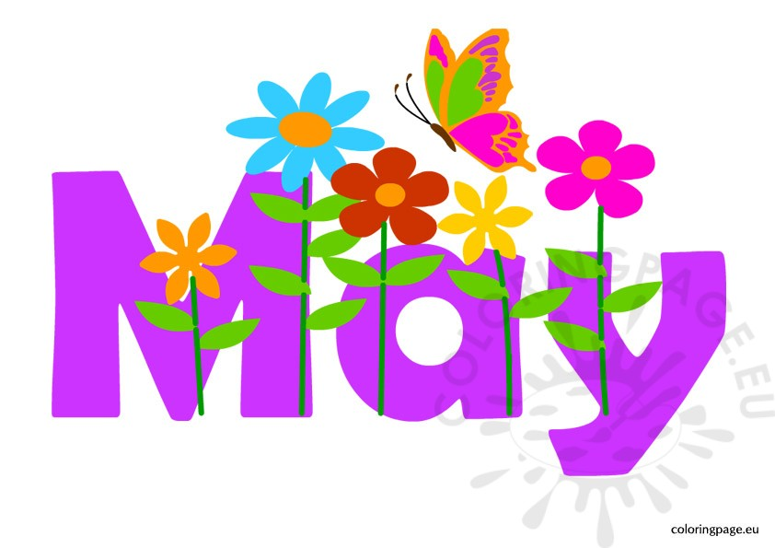 |  |  | 1  Cornmeal  Muffins  Red Lentil & Sausage Stew with Buns | 2  Cheerios  Bananas  Baked Chicken with Greek Salad | 3 Hear & Stroke  Shreddies  Bananas  Roast Beef Sandwiches & Greek Salad | Rodeo Weekend
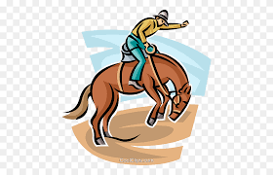 | 6  Rice Krispies  Muffins  Chicken Stir-Fry & Rice | 7 K-5 Traditional Craft  Oatmeal  Oranges  Soup & Buns | 8 Big Little Science  Cheerios  Granola Bars  Turkey & Cheese Sandwiches with Carrots | 9  Shreddies  Oranges  Hashbrown Casserole with Buns | 10 Mother’s Day Lunch  Rice Krispies  Oranges  Breakfast for Lunch | 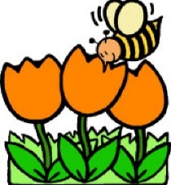
 | 13 Anti-Bullying  Cheerios  Applesauce  Burritos | 14 K-3 Blackwell Dairy  Toast  Granola Bars  Ham & Cheese Sandwiches | 15  Cornmeal  Fruit Cups  Stuffed Pepper Casserole & Buns | 16 YPC & Firehall  Shreddies  Granola Bars  Lunch Provided | 17  Pro-D  No School
 | 20  Victoria Day  No School | 21 QHS K Orientation  Toast  Muffins  Chicken Quesadillas | 22  Rice Krispies  Apples  Chicken Noodle Soup & Buns | 23 Eurika K-1  Oatmeal  Apples  Turkey Sandwiches & Cherry Tomatoes | 24 Rattlin’ Ramble  Assorted Cereal  Apples  Hot Dogs and Fruit | 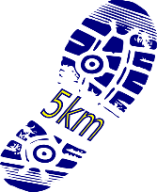
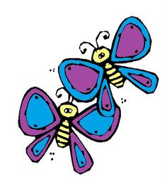 | 27 Eurika 2-7  Cream of Wheat  Fruit Cups  Pasta & Sauce with Garlic Toast | 28 Organ Jack Picnic & Pictographs  Cheerios  Granola Bars  To Be Decided | 29  Oatmeal  Bananas  Hamburger Soup & Buns | 30 Tree Planting  Shreddies  Bananas  Baked Chicken with Rice & Veggies | 31  Rice Krispies  Bananas  Chili & Buns | 