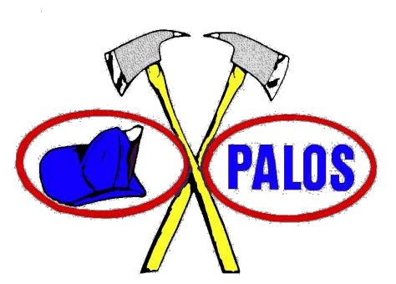
FIRE PROTECTION DISTRICT 8815 WEST 123RD STREET PALOS PARK, ILLINOIS 60464

JAMES GRABEN
Chief

CPR Training

Cardiopulmonary resuscitation (CPR) training is held from 6 P.M to 10 P.M on the second Tuesday of each even numbered month at Fire Station #1, 8815 W. 123rd Street, Palos Park, Illinois 60464. Classes cost $40 for residents and $50 for non-residents, which is payable in advance by check (made out to Palos Fire Protection District) or money order only, and is non- refundable.

Registration closes 1 week prior to the respective class date. Upon completion, you will be certified in CPR through the American Heart Association, and receive your CPR card certification. For large groups and special scheduling contact FF/CPM Kevyn Holdefer at kholdefer@palosfire.org or 708-448-0369.

To register, click on Information- CPR classes- CPR Class Registration at www.palosfire.org. Please be sure to check that you are registering for either the Heart Saver CPR class (general public) or BLS Provider class (Health Care Workers).

Registration

I am a district resident.
Name yes ($40) no ($50)

Address City State/Zip

Phone number e-mail address

Please register me for: BLS Provider on_________ (date) or Heart Saver on (date)

The student understands that CPR training is a physically demanding class where the student must demonstrate the physical ability to perform CPR on certified CPR mannequins. The student will take all necessary precautions regarding equipment owned by the Palos Fire Protection District. The student hereby voluntarily and expressly releases, indemnifies, forever discharges and holds harmless the Palos Fire Protection District and its employees from any and all liability, claims, demands, causes or rights of action whether personal to student or to a third party.

Signature date

Please mail this form to the address above, ATTN CPR with your check or money order in the amount of $25 for In-District residents or $35 or out of District Residents. For Questions or additional information contact FF/CPM Kevyn Holdefer at kholdefer@palosfire.org

BLS Provider CPR Course

This course covers Adult, Child, Infant CPR, AED Training for in-hospital and out-of-hospital situations for healthcare providers and includes video demonstrations that visually enhance the study material. The course also covers bag-valve mask techniques for 1 and 2 rescuers.

Topics Include:

- Introduction
- Legal Considerations / Consent / Deciding to Act
- Adult CPR (For 1 and 2 rescuers)
- Adult and Child Bag-Valve Mask Techniques
- Child CPR (for 1 and 2 rescuers)
- Infant CPR (for 1 and 2 rescuers)
- Infant Bag-Valve Mask Techniques
- Automated External Defibrillator (AED)
- Choking Victims – 1 year and older
- Choking Victims - Infants
- Health Care Provider CPR Quiz

Heart Saver CPR Course

Cardiovascular disease is the single greatest cause of death in the United States. Every year, more than 480,000 adult Americans die due to heart attack or related complications. The victim of an emergency such as a heart attack, cardiac arrest, stroke, or choking may be saved if people at the scene had had the lifesaving skills and techniques training.

- Introduction
- Recognizing Emergencies
- Legal Considerations / Consent / Deciding to Act
- Responding to an Unconscious Adult, Child, or Infant
- Adult CPR (For 1 and 2 rescuers)
- Child CPR (for 1 and 2 rescuers)
- Infant CPR (for 1 and 2 rescuers)
- Automated External Defibrillator (AED)
- Choking Victims – 1 year and older
- Choking Victims - Infants

General Information for Class

We are looking forward to having you in our next class. Please consider the following in preparation for class.

- Please come prepared for class by allowing for 4 hours (maximum) of classroom and training activities
- Bring a pen or pencil to write with
- Bring any food or drink you may need, some light refreshments will be provided.
- This is an informal class setting, so please come prepared to ask questions and participate in hands on training and discussions
- Be prepared to discuss topics involving emergencies and what to expect in emergency situations

Class will be held at Palos Fire Station 1 promptly at 6 p.m, unless otherwise specified by an instructor. Parking can be found on the west side of the station in the parking lot and the entrance to your class will be at the lower level door on the west side of the building, if the door is locked please ring the doorbell and someone will assist you.

