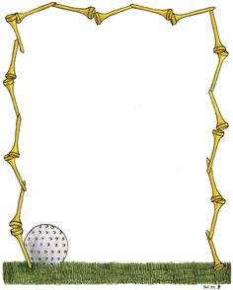

*2018 Doug Bass Invitational*

*Two Man Partnership*

*October 12-14, 2018*

***Cree Meadows***

***Inn of the Mountain Gods***

***The Links at Sierra Blanca***

$400.00 per player

Benefitting

*The Ruidoso Junior Golf Association*

And

*Western New Mexico University*

Friday – Scramble

Saturday – Low Ball

Sunday – *Mixed Six

Scramble 6 holes – Low Ball 6 holes – Alternate Shot 6 holes

* Teams will be flighted first on low player handicap and second based on performance in previous tournaments.
* The entry blank must be completed in full and full payment must be accompanied with completed entry form or your entry will not be accepted.
* Field is limited to first 168 PAID teams!

Please visit our website for updates on the tournament

[www.ruidosojuniorgolf.com](http://www.ruidosojuniorgolf.com)

Cancelation policy:

Before 8/31 – Full Refund

Before 9/30 - $700 Refund

Before 10/5 - $600 Refund

***Anything after October 5th WILL NOT be refunded***

Player 2 Information

Name: _______________________________________________________

Phone #______________________________________________________

Email________________________________________________________

GHIN #_______________________Handicap_______________________

Mailing Address

_____________________________________________________________

_______________________________________________________

Player 1 Information

Name: _______________________________________________________

Phone #______________________________________________________

Email________________________________________________________

GHIN #_______________________Handicap_______________________

Mailing Address

_____________________________________________________________

_______________________________________________________

Must return this completed form with $800 check or money order to:

Ruidoso Junior Golf Association

C/O Melissa Nanz

PO Box 521

Ruidoso NM 88355

575-258-5330