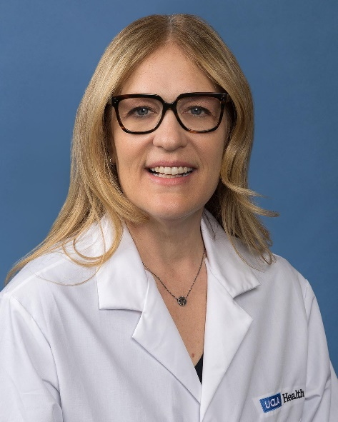

Dana M. Chase, MD, FACOG
Associate Professor
Division of Gynecologic Oncology
Department of Obstetrics & Gynecology
David Geffen School of Medicine at UCLA

Dr. Dana Chase graduated with honors from Brown University in 1996, and earned her medical degree at the University of California, Irvine, in 2003. She completed a residency in obstetrics and gynecology at the University of California, Irvine, in 2007 and subsequently went on to complete her fellowship in gynecologic oncology at the University of California, Irvine, in 2011. In 2011, Dr. Chase joined the Division of Gynecologic Oncology at St. Joseph’s Hospital and Medical Center in Phoenix. She is now a Gynecologic Oncologist at David Geffen School of Medicine at UCLA. Dr. Chase an Associate Professor at the Division of Gynecologic Oncology
Department of Obstetrics & Gynecology David Geffen School of Medicine at UCLA

Dr. Chase’s expertise includes research and collaborative projects with colleagues on scientific questions related to quality of life, symptom management, and supportive care. She is a member of NRG Oncology and a member of the group’s Health Outcomes Research Committee, Patient Centered Outcomes Research Committee, Cancer Prevention and Control, Elderly Committee, and is on the group’s Data Monitoring Committee Panel A.

Dr. Chase is a fellow of the American Congress of Obstetricians and Gynecologists, as well as an active member of the Society of Gynecologic Oncology and American Society of Clinical Oncology. She is a eviewer for Gynecologic Oncology and the American Journal of Obstetrics and Gynecology. Dr. Chase has authored more than 61 peer-reviewed articles along with over 45 abstracts dealing predominantly with the prevention and chemotherapy of gynecologic malignancies and patient quality of life.

