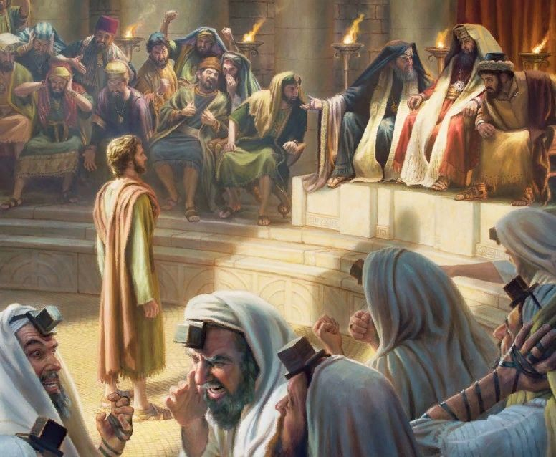

September 25, 2022

16th Sunday after Pentecost

Carson City United Methodist Church

10:30 am

Greeting/Announcements

Call to Worship

L: Christ Jesus, though he was in the form of God, did not count equality with God a thing to be grasped.
P: But emptied himself, taking on the form of a servant, being born in our likeness.
L: And being found in human form he humbled himself and became obedient unto death, even death on a cross.
P: Therefore, God has highly exalted him and bestowed upon him the name which is above all names.
L: So that at the name of Jesus.
P: Every knee shall bow, in Heaven and on earth and under the earth.

*Hymn: Great is Thy Faithfulness UMH 140

Opening Prayer:
Heavenly Father make us instruments of your peace. Where there is doubt help us to sow faith in you. Where there is despair help us to sow the hope found only in you. Where there is pain and hurt help us to bring healing and comfort in your name. Where there is hate, let us sow your love. In Jesus name we ask this AMEN.

Contemporary Song: Who am I (Casting Crowns)

Offering

Doxology UMH 95

Offertory Prayer

Sharing of our Joys and Concerns

Call to Prayer: Turn Your Eyes Upon Jesus UMH 349

Pastoral Prayer

Gospel Reading: MATTHEW 10:19-20

Old Testament: ISAIAH 43:1-3

Epistle Lesson: 1 CORINTHIANS 1:8-9

Children’s Church

Contemporary Song: The God Who Stays (Matthew West)

MESSAGE

*Hymn: God Will Take Care of You UMH 130

Benediction

CCUMC – Announcements & Upcoming Events:

As a courtesy to others please silence or shut off cellphones

==================================================
Town Hall Meeting: Tue, Sep 27th @ 7:00 pm in the Sanctuary. Topic is discussing the disaffiliation from The United Methodist Church as well as our options. Andy Croel will be the speaker.
==================================================
Ad Board/Finance Meeting: Wed, Sep 28th @ 6:30 pm.
==================================================
UWF Soup Luncheon: Fri, Oct 14th from 11:00 am to 1:00 pm.
==================================================
Michigan Conference Mission U: Is held at Gaylord UMC October 17-18. Walthagaye is attending both so if you need a ride, please get in touch with her. The flyer is on the What’s Happening bulletin board with registrations on the shelf under it.
==================================================
CCUMC presents its
13th Annual Trunk-Or-Treat
on Halloween Night – time to be determined
A Safe, Fun Way for Children to Trick-or-Treat

Halloween Candy Donations: There is a box located in the Church Foyer labeled for Halloween candy donations. There is also a sign-up sheet located on the Welcome Desk for those who would like to provide a vehicle and/or decorated during this event.
==================================================
Craft & Vendor Show: CCUMC will be hosting a Craft Show on Sat, Nov 5th, 9:00 am thru 2:00 pm. If you are a Vendor interested in reserving a spot, please contact Dawn Wager @ 989-285-2518.
==================================================

Serving & Supporting Sunday Worship
Audio/Video: Pat Monroe

Joys, Concerns & Prayer Request
For those battling cancers:
Jim Dunlap, Carolyn Nykerk, Dillan Abell,
Amorena Newman-Wojciakowski

For those who need support, guidance or have health concerns: Mindy Dennis, Heather Kile

Weekly Giving
9/4 $1307.97 9/11 $3537.97 9/18 $2609.17

Nursery Schedule
9/18 Molly Fitzpatrick 9/25 Maryann Severson

Lighting of Candles
9/25 & 10/2 Collin & Blake

Passing of Collections Plate
9/25 Collin & Blake 10/2 Colton

Our Church in Ministry This Week

Sun: Women’s Group 6:30-8:00 pm
Mon: P.T. Class 6:30-8:00 pm
Tue & Thu: COA Meal 10 am – 2 pm
Wed: A.R.K. 6:30-8:00 pm

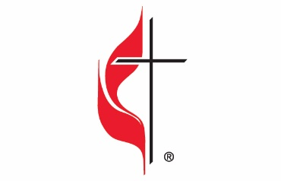

Carson City United Methodist Church
Location: 119 East Elm St., Carson City, MI
Mail: PO Box 298, Carson City, MI 48811
Phone: 989-584-3797 Email: carsoncityumc@gmail.com
Website: carsoncityumc.com
Sunday Worship Service: 10:30 am
Office Hours: Monday-Thursday, 9:00 am-12:00 pm
After hours by appointment
Pastor: Ian McDonald 906-322-5318
Secretary: Bonnie Seaman 989-763-1674

Weekly Sunday Bulletin now available on our website
@ www.carsoncityumc.com

“Dear God, thank You for walking alongside me and placing people in my life who helped to make me who I am today”

