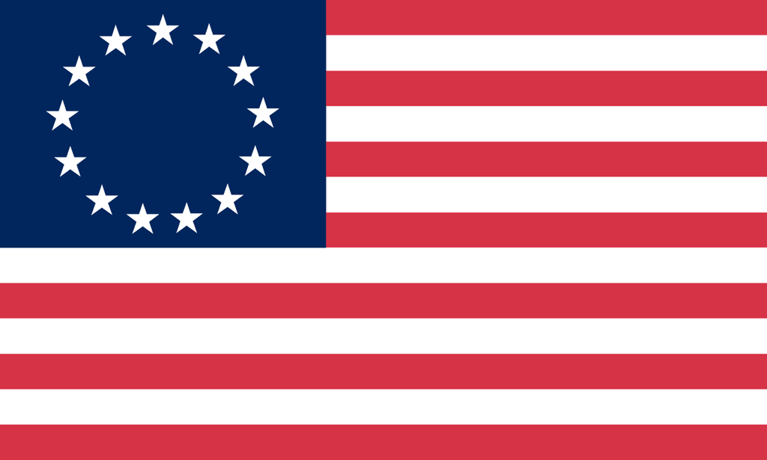U.S. History with Mr. Brown Name _______________________________ Period _____
The Road to revolution Ch6 Book Preview
Directions: Read through Chapter 6 The Road to Revolution in the text book and find the answers to the following questions. (p. 140 - )

1) Put the following events in the correct chronological order:

Battles of Lexington and Concord
Boston Tea Party
Proclamation of 1763
Boston Massacre
Stamp Act

2) British troops that colonists were forced to house because of the quartering act were there to enforce the:

3) Which colonial patriot said, “If this be treason, make the most of it!”?
4) What was the name of the meeting to which all the colonies sent delegates to discuss their reaction to the Stamp Act?

5) What was the most famous secret society that was formed to oppose British policies?

6) How did the Sons of Liberty cause many customs officials to quit their jobs?

7) To enforce the Townshend Acts British soldiers would writs of ______________________ to search colonists’ homes for smuggled goods.

8) How did the colonists protest the Townshend Acts?

9) Who was the lawyer that defended the British troops from the Boston massacre?

10) What company got control of the American Tea trade because of the Tea Act?

11) Boston Tea Party:
How many ships were boarded?

How many chests of tea were destroyed?

12) The intolerable acts were meant to punish Boston for the:

13) What was the name of the meeting at which the colonists voted to ban all trade with Britain until the Intolerable Acts were repealed?

14) Which colonial patriot said, “Give me liberty or give me death” in his speech before the Virginia House of Burgesses?

15) Of Paul Revere, William Dawes, and Samuel Prescott who made it all the way to Concord?

16) What famous writer coined the phrase “Shot heard round the world”?

17) British : _____________________ :: Rebel : Patriot

18) Who ran his house and farm in John Adam’s absence?

19) After Lexington and Concord ______________ thousand troops surrounded General Gage’s British soldiers in Boston.

20) Ethan Allen and his Green Mountain Boys captured ______________________ from Fort _________________.

21) In what battle did colonial Colonel William Prescott yell, “Don’t fire until you see the whites of their eyes!”?

22) Battle of Bunker Hill Casualties: British ___________________

Militia ___________________

23) The Olive Branch Petition was an attempt at _____________________.

24) Benedict Arnold was defeated when he led colonial soldiers in an attack against _________________ in eastern Canada.

25) How long did it take the Continental Army to drag the Cannons captured at Ticonderoga the 225 miles to Boston?

26) What did General Howe and the British Army do when Washington and the Continental Army surrounded them in Boston with the Ticonderoga cannons aimed at Boston?

27) Who wrote Common Sense?

28) What argument did Common Sense make about Mercantilism?

29) Who were the five men on the committee to draft the Declaration of Independence?

30) On what date (day, month, and year) was the Declaration of Independence adopted?

31) The Declaration of Independence is based on the philosophy of ____________________________________.

32) What are unalienable rights?

33) Now that America had declared its independence what did they have to do next?
