Dr. B. A. Ford
102, 49 Richard Way S.W.

Calgary, Alberta T3E 7M8
403-245-3730, fax 403-245-1058

GLAUCOMA SURGERY

PLEASE READ CAREFULLY BEFORE SURGERY

Before Surgery
Medical: -A medical must be done by your family doctor about 1 month or as soon as possible before surgery; medicals are valid for 3 months assuming no health changes.
-Please bring the enclosed medical form to your doctor to complete at your appointment
-If you fail to have your medical done, your surgery will be postponed.
Drops: -Continue your drops as usual until you arrive at surgery.
-Instructions for additional surgery drops are enclosed.

Surgery: _______________________________________
Date: ____________________
Arrival time: ____________________ am/pm (walk in door time)
-Total length of time there is approximately 2 hours, from start to finish. You are not allowed to drive yourself home (taxi is acceptable provided no sedation is given)

Location: Holy Cross Surgical Services
Suite 101, 2210 2nd St SW, Calgary, AB T2S 1S6

Parking: Pay parking available in parking lot, enter in main doors. You cannot drive yourself home from surgery (taxi is acceptable provided no sedation is given)

Post-Operative Appts (at Richard Way Office);
1 Day after surgery: ________________________
2 Days after surgery: _______________________
~1 week after surgery: ______________________

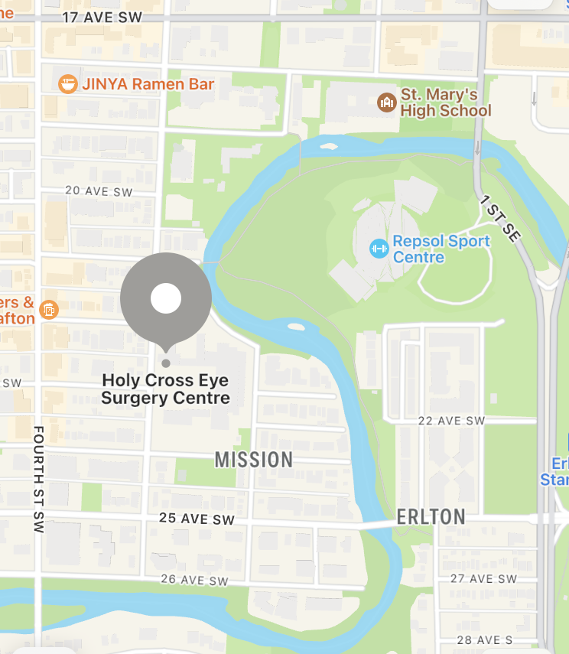

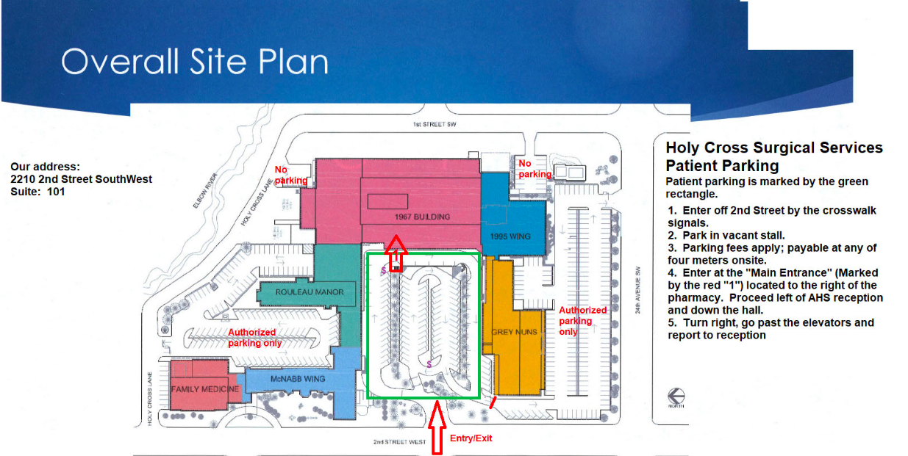

IMPORTANT GLAUCOMA SURGERY INSTRUCTIONS

BEFORE SURGERY
- If you are on Coumadin, please ensure you have your INR checked approximately 5 - 7 business days prior to surgery.
- Do not have any solid food or milk products after midnight before surgery, this includes gum or candy. Do not drink any alcoholic beverages for 24 hrs before surgery.
- You may drink up to 1 cup clear fluids 4 hours before surgery (e.g. tea or coffee with NO dairy/sugar added, apple juice, water, clear broth, jello).
- Your operation may be cancelled due to acute medical conditions (e.g. severe cold). If in doubt, contact your surgeon’s office prior to surgery.
- Take all your medications as normal before surgery with sips of water.
- If you use glaucoma drops in the surgery eye, take them the morning of surgery. After surgery, Dr. Ford will instruct you on the use of your eye drops. A prescription is enclosed with instructions regarding additional drops required for surgery.

THE DAY OF SURGERY
    - It is recommended to have someone accompany you to and from surgery. Please make your own arrangements. Mild sedation is an option at the surgery center provided someone will be with you the entire day of surgery
    - Please bring your Alberta Health Card and Identification
    - Wear loose comfortable clothing. Nothing tight or constricting.
    - Please do not wear jewelry or makeup. If you wear contact lenses, please remove them before surgery.
    - You will check in at Surgical Centres Inc. reception area. There is a waiting room if your driver needs to wait.
    - They will have you sign a consent form and then take you to the back to see the anesthetist. He/she will administer either the anesthetic drops or the local anesthetic, which will freeze the whole side of your face.
    - Once the anesthetic has taken effect, you will walk to the surgical suite where Dr. Ford will do your surgery.
    - You will lie on a surgical bed while covered with a sterile surgical drape. The surgery itself takes about 20-45 minutes and you will be awake for the whole procedure.
    - Dr. Ford will put bandages and a shield over your eye after surgery

AFTER SURGERY
- Leave your eye patch on overnight and the next day until your appointment with Dr. Ford. Do not remove the patch to take any eye drops.
- Go home & rest. Resting quietly the day of surgery is recommended
- You will have a 1 day, 2 day and ~1 week post-surgery follow-up appointment at Dr. Ford’s office. Further appointments will depend on healing but will likely be quite frequent for several weeks
- You may experience numbness of your face, eye and head for up to 6 hours after surgery.
- If you experience discomfort, you may take Tylenol as recommended.
- If you experience severe pain, call the office at 403-245-3730 during daytime hours. After hours, to receive telephone advice, call Calgary Health Link at 811. For an emergency, go to the hospital emergency department (Rockyview Hospital in Calgary).
- You may eat regular meals following surgery.
- Discontinue glaucoma drops/pills for your SURGERY EYE ONLY and use your post-operative drops unless otherwise advised. Continue any drops you take for your non-surgery eye as normal.

POST-OPERATIVE ADVICE FOLLOWING SURGERY
- If you have any questions about your eyes, please call the office.
- Wear eye shield at night for 2 weeks. Tape to face with medical tape or fix the eye shield with elastic (e.g. like a pirate patch).
- Your wound is healing and it will not be firm enough to stand too much pressure for about six weeks.
- Avoid all dirty/dusty environments, stooping, straining, lifting and vigorous activities for at least two weeks. It is impossible to list all the activities you should avoid. Try and sleep propped up for 5 days after surgery.
- Avoid closing the eyes tightly. Never rub or touch the eye. Take care when washing face, avoid getting water or soap in the eye.
- If there is a lot of discharge from the eye upon waking, wipe off the lids with moist cotton, but avoid exerting pressure on the eye, particularly the upper lid. If there is any sticky, colored discharge continuing during day, call the office.
- Wash your hands thoroughly before and after putting in eye drops.
- You may have the feeling of something in the eye due to the incision, but do not close the eye tightly. This feeling may persist for a few weeks, artificial tears may help provide some relief.

PRE-SURGERY MEDICAL FORM

PLEASE RETURN WITHIN 3 WEEKS BEFORE SURGERY
(Form is valid for 3 months provided no changes)

Dear Dr._______________________,

Your patient has been scheduled to have surgery at: Holy Cross Surgical Center

Please provide a complete history and physical examination on this form and fax as soon as possible to: DR. FORD Fax 403-245-1058

Patient’s Name__________________________ Date of Surgery___________________________

Diagnosis: GLAUCOMA Procedure________________________________

HISTORY OF PRESENT ILLNESS

Past Medical Hx - Medication List:

-
-
Recent Steroid use- -
Drug Allergies- -
Previous Surgery- -
Anesthetic Problems- -
Functional Inquiries (Systems Inventory) No Yes
Cardiovascular __ __
Respiratory/Smoking __ __
Heptic __ __
Renal __ __
Nervous System __ __
Endocrine __ __
Musculoskeletal System __ __
Blood or Coagulation Disorders __ __

Pulse__________ BP_____________ Weight____________ Height (approx.)________
Normal Abnormal If Abnormal give details:
EENT ______ _______
Cardiovascular ______ _______
Respiratory ______ _______
Abdominal ______ _______
Nervous System ______ _______
Musculoskeletal ______ _______
Other (Specify) ______ _______

FIT FOR SURGERY? YES____NO____

Date__________________ Dr. Name _____________________ Office Fax # ___________________

