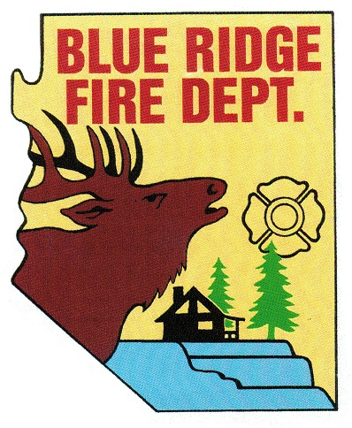
BLUE RIDGE FIRE DISTRICT
5023 Enchanted Lane
Happy Jack, AZ 86024
928-477-2751
www.brfdaz.org

Public Safety Personnel Retirement System
LOCAL BOARD

WORK STUDY SESSION MINUTES

On Friday November 15, 2019 the Public Safety Personnel Retirement System Local Board (PSPRS) held a Work Study Session with Chief Paine, Fire Chief for the Blue Ridge Fire District.

The session was called to order by Chairperson Perelli at 1:04 AM.

Pledge to the flag was said by all present.

Roll Call of PSPRS Local Board members was made and a Quorum met.
Cindy Perelli
Linda Blosser
Tammy Rosenhagen
Brandon Sewell—-present by phone
Ryan MacNeal

Items for discussion:

- Plan for retaining exposure reports?
Per Chief Paine. Print, download and scan in any format the district uses.

- Education, importance and training plan for completion of Exposure Reports?
Per Chief Paine: If the station training coordinator wants to add to the once a month training a section on completing exposure reports it can be done. Also, a form for each employee who has attended the training sign the form and have it placed in his/her personnel file to prove they attended.

- Are Turnouts being cleaned after each structure and wild land fire? Is there a policy?
Per Chief Paine: No need for a cleaning policy. The Turn Outs are being cleaned just fine.

- Does BRFD have job duties defined for each type of employee?
Per Chief Paine: Yes, district requirements for district personnel (job descriptions) can be found on the district website. The more detailed job description (physical requirements) given to the IME for evaluation the better it is for a true and fair claimant evaluation.

- Limited/light duty guideline.
Per Chief Paine: No policy needed. It’s a case by case evaluation of what’s needed to accommodate the injured employee.

Adjournment:

Respectfully submitted November 20, 2019

Linda Blosser ________
Secretary

