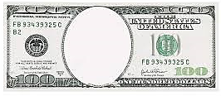
Fair
Labor
Standards
Act
Homestead
Strike
Keating
Owen
Act
Anthracite
Coal
Strike
Pullman Strike
Taft
Hartley
Act

