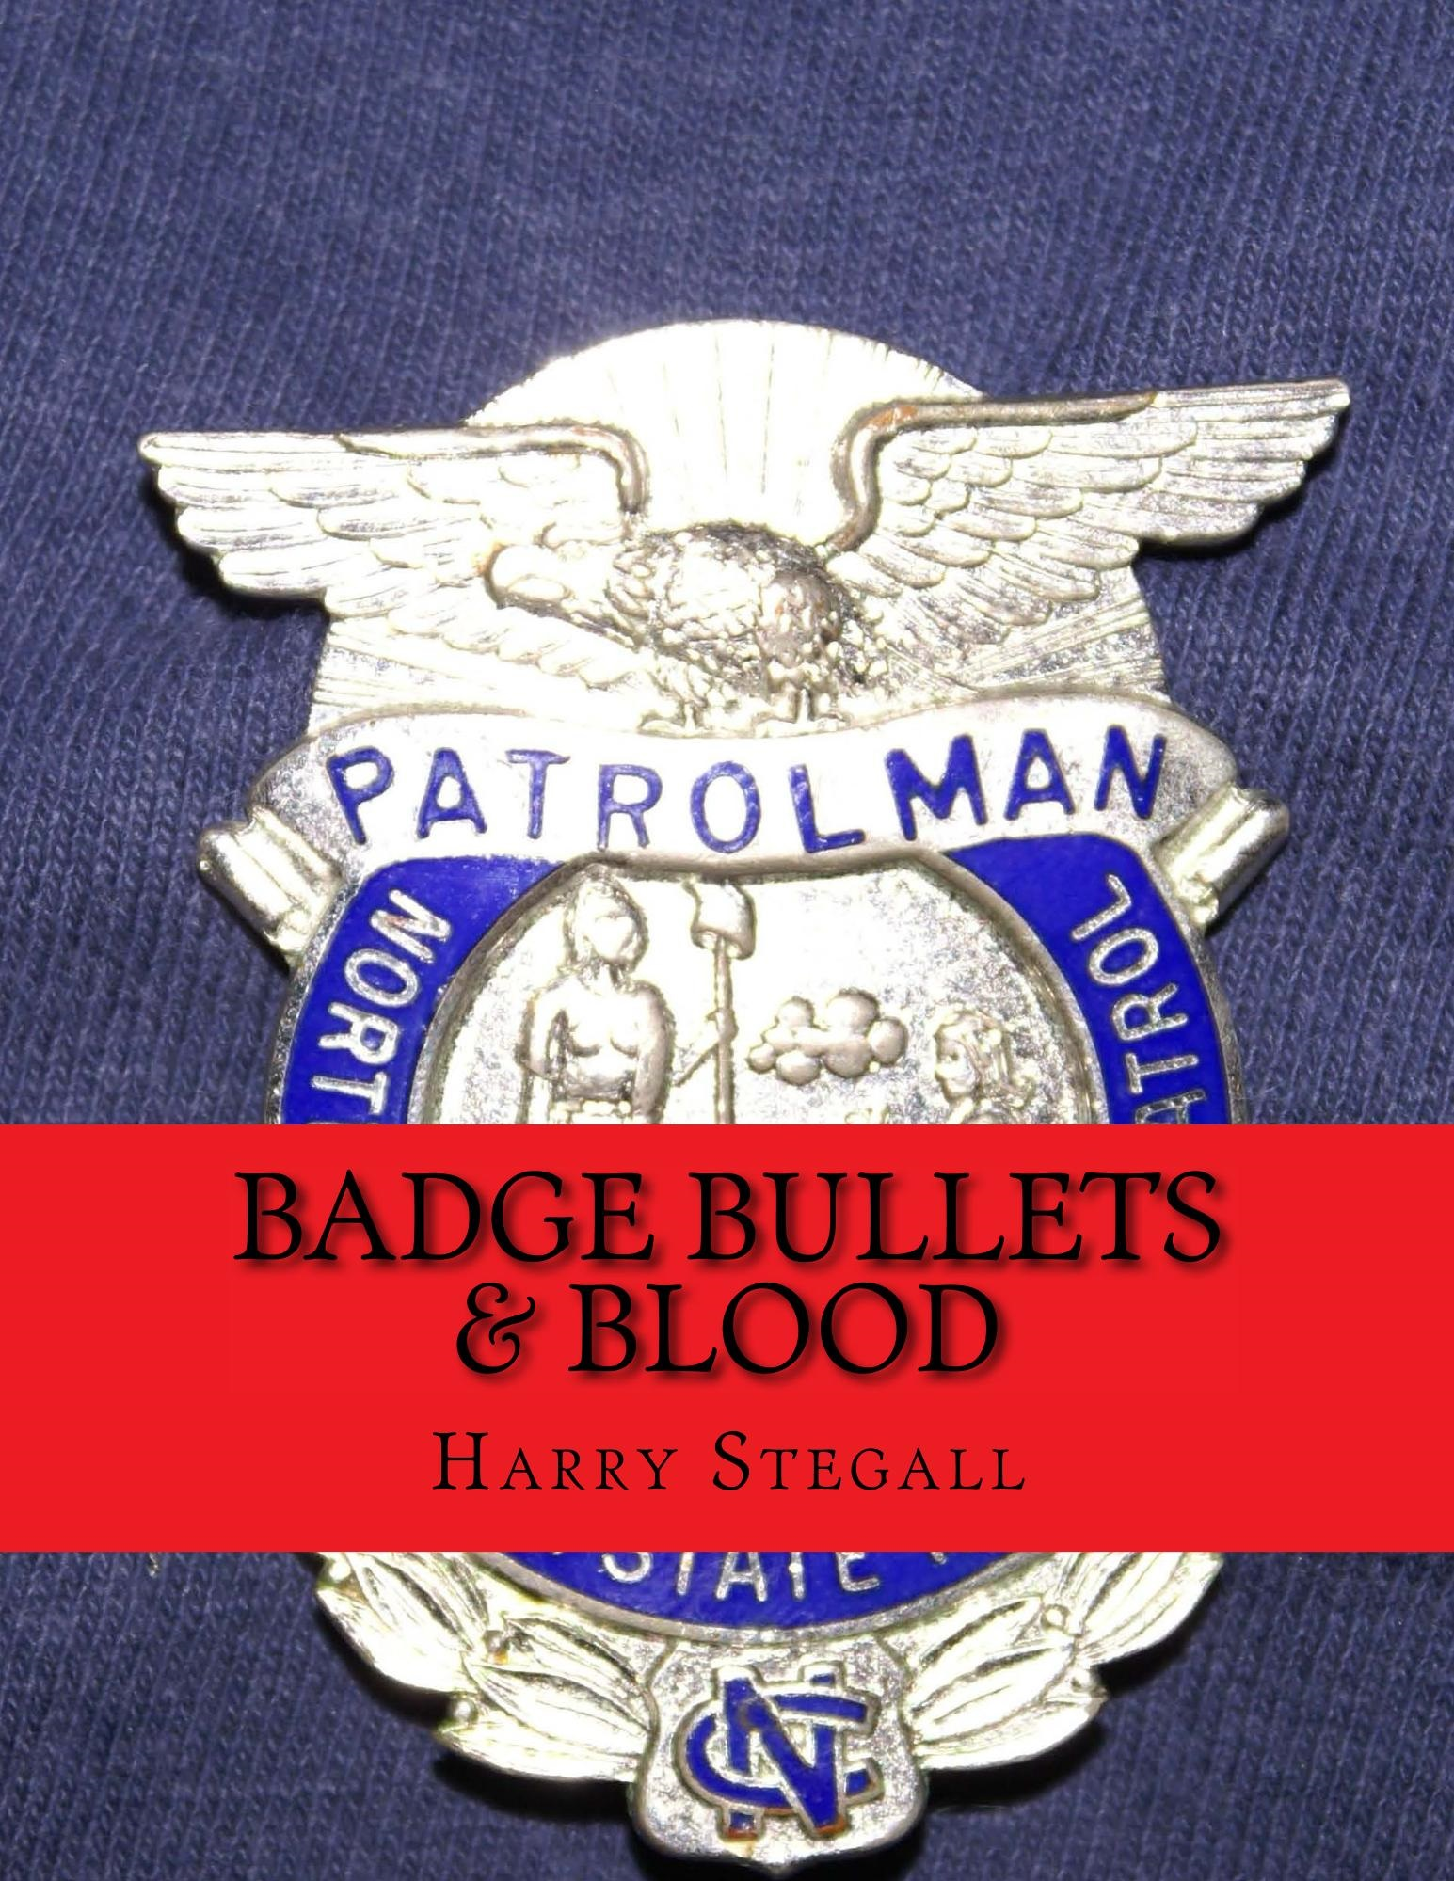

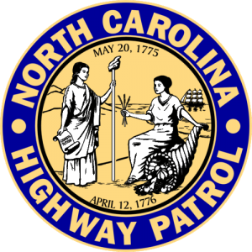

Table of Contents
Chapter 1 My Early Years
Chapter 2 Realizing Choices
Chapter 3 College Years
Chapter 4 Beginning a Career
Chapter 5 Chasing a Dream
Chapter 6 Anticipating January
Chapter 7 A Dream Comes True
Chapter 8 A Short Duty Station
Chapter 9 Troop H District II
Chapter 10 the Longest Day
Chapter 11 the Rescue Begins
Chapter 12 the Manhunt in Full Swing
Chapter 13 Chapel Hill
Chapter 14 the Escape Plan
Chapter 15 Just Wanting To Say Hello
Chapter 16 Escape Plan in Motion
Chapter 17 the Capture
Chapter 18 End of the Escape Plan
Chapter 19 My Recovery Begins
Chapter 20 the Trials
Chapter 21 Back To Work
Chapter 22 Life Moves On

Chapter 23 the Angels Came
Chapter 24 the Critique

Dedication
This is a book is dedicated to every law enforcement officer in the United States killed in the line of duty especially those members of the North Carolina Highway Patrol. A particular tribute is paid to our beloved friends, Trooper R L “Pete” Peterson and Sgt. Ed Lowery.

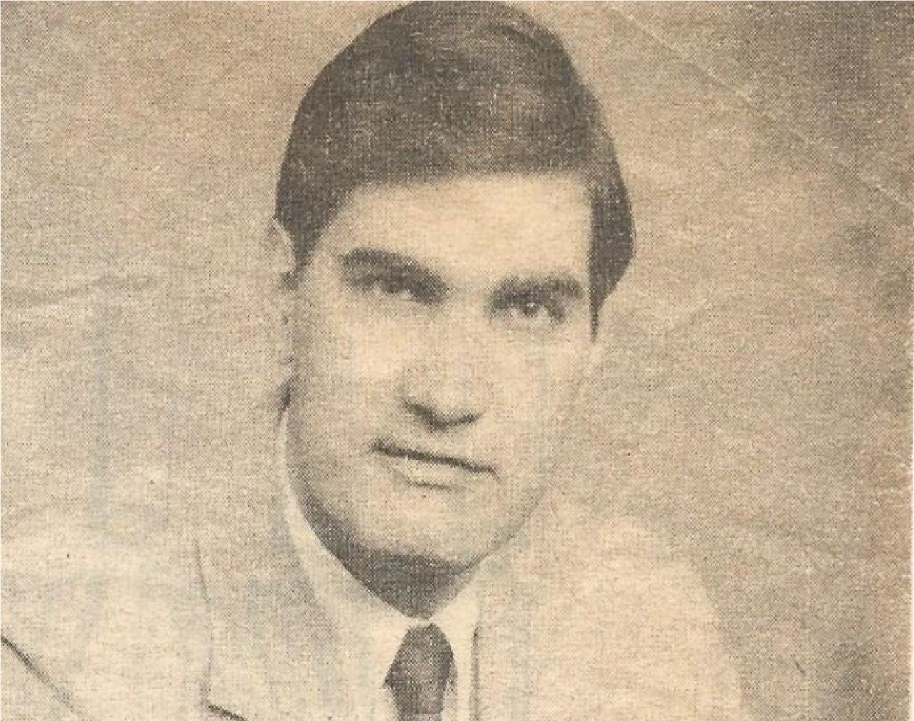

Harry Stegall

About The Author
Raised is a Christian home, Harry was baptized as an infant. At the age of 12 he joined Westminster Presbyterian Church and professed Jesus Christ as his Lord and Savior.
Harry has told his story literally thousands of times and as he learns of an officer’s death he always feels the sting of “survivor’s guilt.” Never knowing God’s plan for him, Harry has been content to feel that part of his mission is to share his story in hopes that it may save just one life.
After many years Harry has concluded that the scariest part of his incident was just moments after the shots were fired. Just a short 10 years after professing his faith in Jesus, he called on God for help. He tells audiences that one thing not issued by any police agency but is necessary every day is their faith and belief in Jesus. His question is “what would have happened that morning if he had not professed his belief in Jesus when he called on God?” He leaves that for you to decide but he knows the answer.

Trooper Stegall
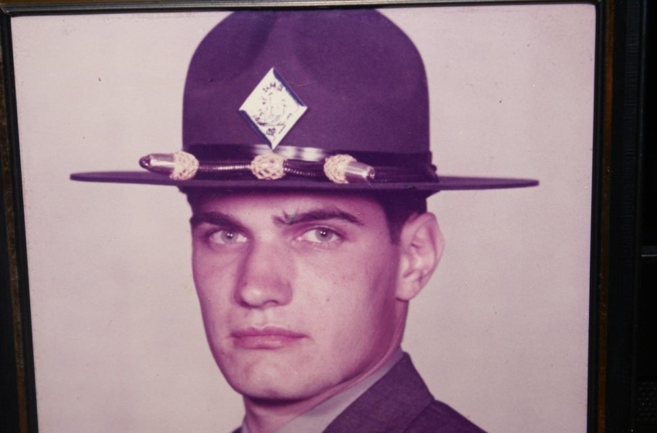
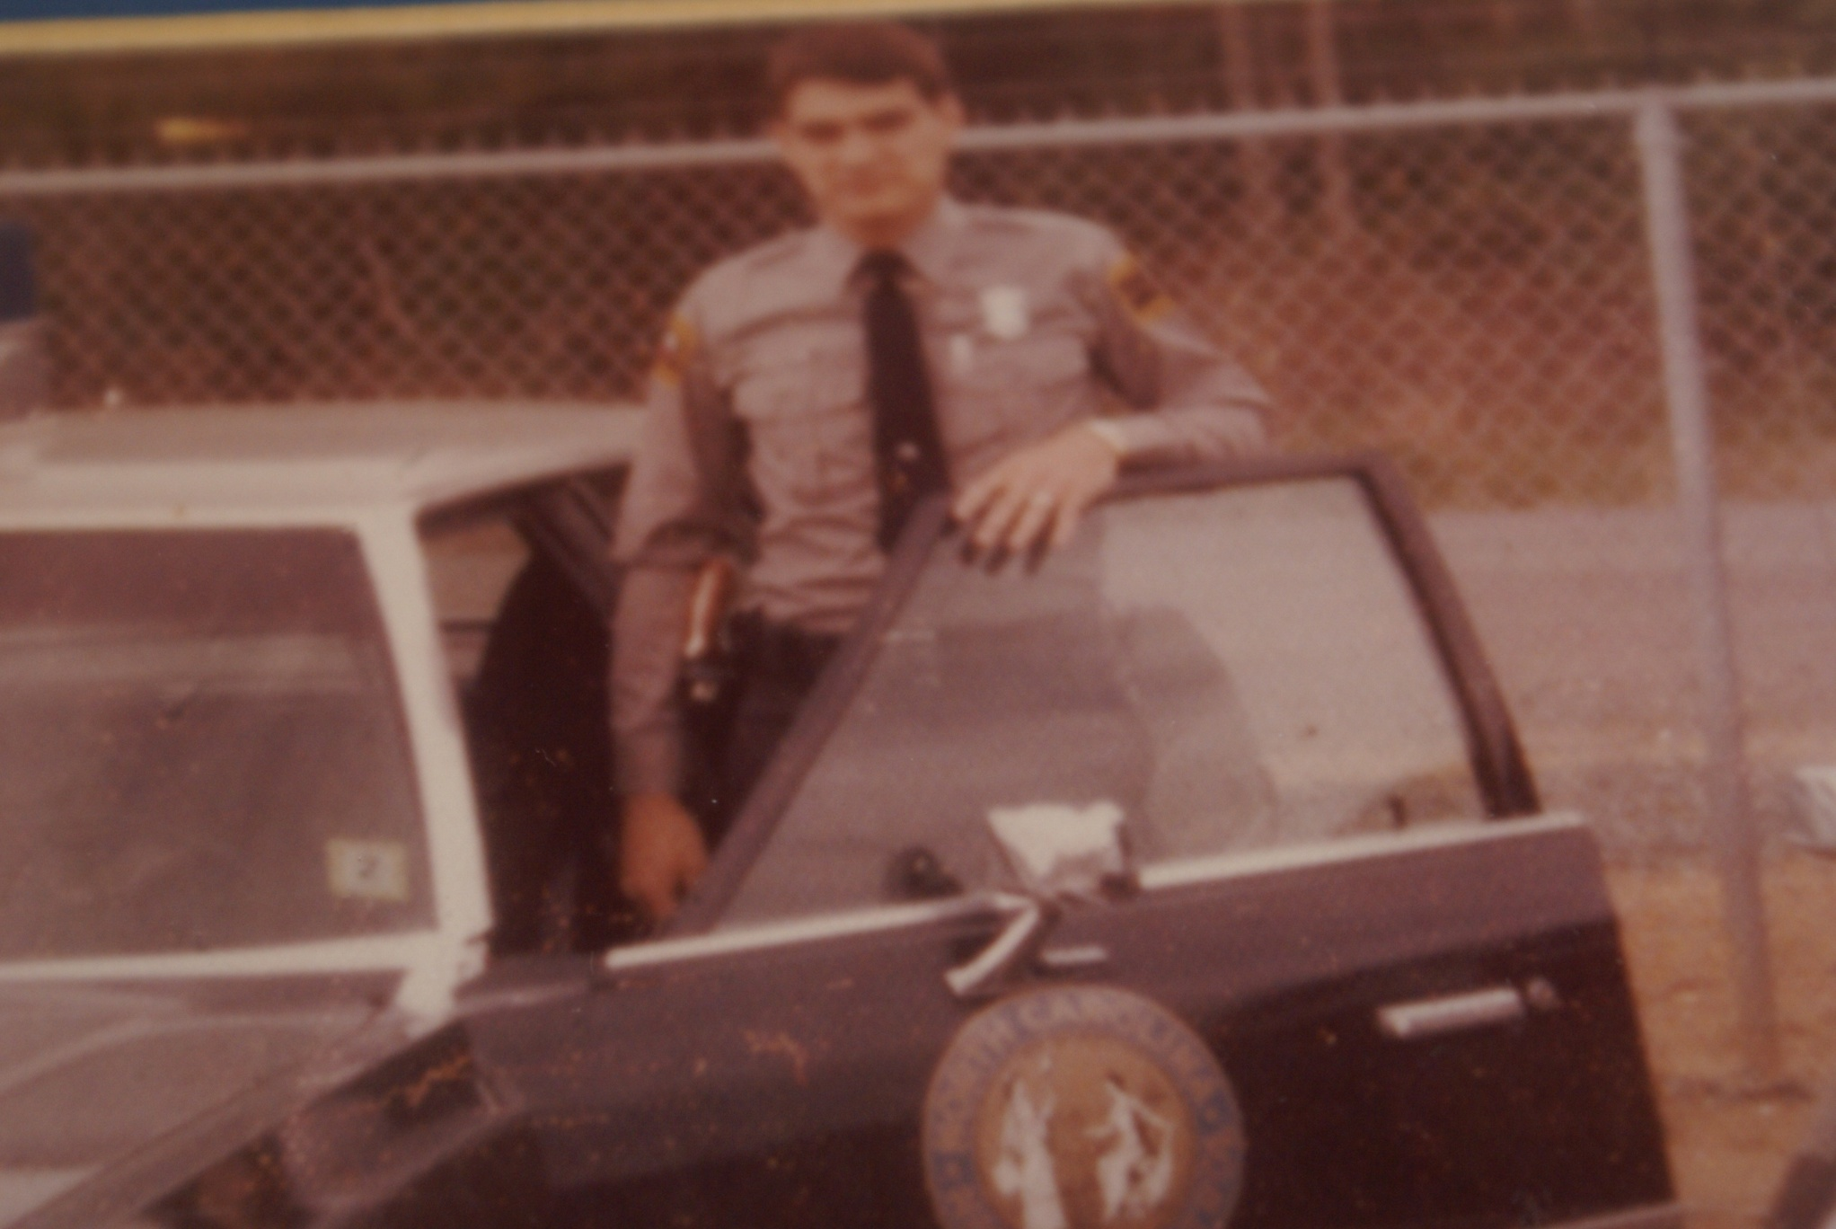

Chapter 1

There was never a time in my entire life as a child growing up that I didn't think about being a police officer. My first memory of my dad was in his police uniform. He joined the Charlotte Police Department in 1948 just after being honorably discharged from the United States Navy. It was often said the reason that he joined the department was so he could ride police motorcycles.

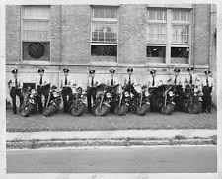

As a child growing up my dad was my hero. I thought everybody's father was a policeman until I was five or six years old and realize that other people's dads had jobs that were not cops. As a small child I always watched and listened to everything my dad said or did to learn as much about police work as I possibly could. My dad was always involved in traffic law enforcement in the Charlotte Police Department so my interests leaned in that direction. At seven or eight years old I could identify any vehicle on the road and know exactly each year model. Traffic law enforcement in Charlotte was high priority because crimes such as murder, robbery, rape and other serious crimes did not occur that often. Most violent crimes were confined to the black neighborhoods.
That was also a period in time where children were very proud of their fathers and what type of career they were involved in. All of my friends knew that my dad was a high profile police officer. His name was in the newspaper regularly.

Everywhere we went people would say “hello Lieut. Stegall“ or “hello Capt. Stegall” or “hello Major Stegall” as he was promoted thru the ranks. I enjoyed that popularity and recognition of my father.

I got my first taste of the death of a police officer in 1962. One morning as my sister and I arose for breakfast, my mother asked us to be very quiet because my father was still asleep. I could tell something was troubling her as she prepared our breakfast. I asked her why daddy was still asleep and she told us that a police officer had been killed the night before. I asked her who it was and she told me it was officer Johnny Annis. My mother was a southern lady so racial slurs really weren't part of her vocabulary. But that morning she said “Johnny was killed by a bunch of men that took his gun away from him.” I'd never heard of a police officer being killed in the line of duty but I remember feeling sad for many days.
The suspect was caught the next day but all I could really do was look at the pictures in the newspaper since the words didn't make much sense to me. This was a topic for adult conversation because most of my friends were aware of the officer's death but couldn't imagine such a thing happening.
My dad was in charge of the police officers and security detail at the Charlotte Coliseum from the day it opened until the day he retired as a major in 1966. Paul Buck was the general manager of the Coliseum and he would not even think of having another police officer in charge of that building. Even as my dad was promoted, it was uncommon for a captain or major to be working off-duty at the Coliseum. Part of it was my dad needed the money. Police officers didn't get paid much back then. My dad was a people person. He was initially recognized in the Police Department for his work with the school safety patrol. When he wasn't riding his motorcycle and working traffic law enforcement, he was working with principals, teachers and elementary students to promote safety on the way to and from school. Everyone walked to neighborhood schools then and there was limited busing. As his administrative duties increased with his promotions, his way to continue interaction with the public was to work off-duty at the Charlotte Coliseum.
There were great fringe benefits for me as my dad's son. I was able to see every event that was ever held in the Coliseum for free. He would take me with him and find me a seat that had not been sold for the show. My favorite event was a hockey game. The Charlotte Checkers were members of the Eastern Hockey League and always provided great entertainment and excitement to the fans young and old. Those hockey fights were the best.
My dad was hardly ever out of uniform because he worked all the time. I remember once when I was with him when we stopped in uptown Charlotte for some reason. I remember exactly that we parked in the 100 block of E. Trade Street in a “no parking zone.” My dad got out of the car and told me that if a police officer comes by tell him not to write me a ticket. He had been gone about 2 min. when the police officer walking the beat happened along and begin to write a parking ticket. We were driving my mom's car so I'm sure it wasn't recognizable to the officer. I did exactly what my dad told me to do. I rolled the window down and said “my daddy said for you to not write him a ticket.” The police officer laughed and finished writing the ticket. He placed it under the windshield wiper. About 5 minutes later my dad returned and found the ticket. He said to me, “I thought I told you to tell the police officer not to write me a ticket?" I told him that I told the officer but he laughed and did it anyway. I was only six years old at the time. The problem was I forgot to tell the policeman who my daddy was. It turned out to be quite a conversational piece. There was a little story in the newspaper with headlines “Police Officer Writes Captain of Traffic Bureau Parking Ticket.”

My dad paid the ticket which was only a dollar in those days and it remained under the glass top on his desk until he retired. After that every policeman made sure to know who Stegall's son was. I knew that I would be in some type of law enforcement when I was older.

Chapter 2
After my father retired from the police department he founded a private security company and named it Safe Incorporated. In order to make ends meet during the start-up of his new company, he accepted a position as the assistant coroner in Mecklenburg County. During this two-year period I saw death in many different forms. Every Sunday after church was over at 12 noon we made the rounds to all of the black funeral homes in Charlotte. In those days someone from the coroner’s office had to officially pronounce an individual dead unless they were under a doctor's care and the doctor was willing to sign the death certificate.
The only people using guns and knives to kill each other during that time were the minorities. Most of the stabbings and shootings resulting in death happened on Saturday night. One Sunday afternoon my dad was required to pronounce an individual dead that had been struck by a train. As we made our way down a dimly lit hallway toward the embalming room one of the workers met us and informed my dad that the victim’s body was as mangled and dismembered as bad as anything he could remember. That scared the crap out of me because I didn’t want to look. My dad walked to the door and knocked on it three times. He said “if you're alive come out and if you don't pronounce you dead.” That was quite a relief to me and I found out later was quite a relief to him as well. In school I would talk about what I had seen on Sunday’s as we made the rounds. Some friends were fascinated and others were grossed out.
I realized that I knew my way around a funeral home but had never been to a funeral. No one in my family had died when I was old enough to attend their funeral. One of my teachers asked the class to write a composition about something out of the ordinary. I wrote about what I had seen in the embalming room the last weekend. Of course she had no idea if my facts were correct so I received an A on my paper. I was glad when my dad’s business flourished so that he could give up this part time job. I did learn that you have to erase unpleasant things from your mind and that has helped me all of my life.
However, what I also learned during these times was that death is a natural and common occurrence. It is either by natural causes or a natural environment and happens regularly. I realized that if I one day pursued a career in law enforcement that I would have to be willing to deal with death on a regular basis.
Three years later my dad’s small private security company was bought out by the William J Burns Detective Agency. The company went on to be known as the Burns International Security Services Inc. with offices all over the world. Part of the buyout agreement was that my dad continued to manage the Charlotte office because of his “home grown” connection with the area.

Shortly after the merger with Burns a retired Army colonel became the Charlotte area assistant manager working for my father. The joke was this was the only organization where a Col. worked for a Major. People still referred to my father as Major Stegall for years to come.

Col. Moosen and his wife Helen had become social friends with our family and I got to know “Colonel” as I called him on a personal basis. As it turned out the Moosen’s had no children. One of the benefits of an Army Colonel is a recommendation and appointment to the United States Military Academy at West Point. During my junior year in high school, Colonel Moosen sat me down and had a long conversation with me about a military career. At that point he said that he would like to offer me his appointment to West Point. I was flattered and shocked at the same time, especially with all of the news about the war in Vietnam. I told Colonel Moosen that I'd like to consider that offer and then he dropped the bombshell. He told me that the only stipulation he had was that I agreed to make a career out of the Army. I jokingly said that might be hard to do since I don't even know who I'm going to go out with this Friday night. We both had a good laugh and I told him that I really appreciated his confidence.
Unfortunately several months later Colonel had a severe stroke while driving home from the office one evening. The stroke left him partially paralyzed and with a severe speech impediment. Colonel’s health continued to deteriorate and within six months he and his wife Helen had moved back to Virginia to be closer to a VA facility that specialized in stroke recovery. At that point the idea of attending West Point was off the table and out of my mind. That uniform thing still stuck out in my thoughts. I liked the idea of being in the Army but not for 20 years.
The private security company that my dad had created, not only offered private investigations and security guard services but an extensive line of residential and commercial burglar alarm systems. My dad was determined to create a work ethic in me so at Christmas time and at the tender age of 14 years old he put me to work with an alarm installation crew. My pay was $20 a week. That wasn't too bad when I went back to school in January with $40 in my pocket. I worked the following Easter break and the entire summer mostly as a gopher. That still wasn't too bad for me to start my 10th grade school year with over $500 in my pockets. It's surprising what you learn from just standing around handing other worker screwdrivers and wire cutters. The unique thing was that I had been there from the very first alarm installations that the company sold. During the next two years while still in high school I was one of two or three people that knew every alarm installation on a continuing basis. By now I'm making minimum wage like the other installers and some of the new people hired were handing me screwdrivers and wire cutters. I was used to making money and I liked it.
During my senior year in high school I was a member of one of the initial Air Force ROTC units in the Charlotte Mecklenburg schools. I had a blast. I became used to wearing a uniform and I liked it. I was the ranking non commissioned officer in the school. I was a member of the Color Guard, Honor Guard and Drill Team. In the spring we all visited Shaw Air Force in Sumter, South Carolina and I was ready to enlist. I knew it was either the military or law enforcement for me.
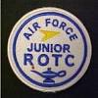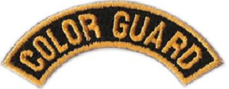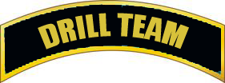

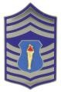 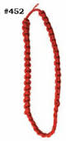Honor Guard Citation Cord

Chapter 3

After graduating from high school I enrolled immediately in college and I'll have to admit it was partially to avoid Vietnam. I'll also have to admit that there were several times during college that I wondered what would've happened if I had taken that appointment to West Point. I remember one day when the Marine recruiters were on campus attempting to enroll men into their officer candidate school. Their proposition sounded very simple. If they enrolled you into their program you had two choices to complete their basic training. The first choice was to attend a two-week summer camp each of the four years you remained enrolled in college. The other option was to complete the eight week training immediately upon graduation from college. Each person completing that training would then be commissioned as a second Lieut. in the United States Marine Corps. I couldn't seem to get away from this desire to wear a uniform.
Vietnam was basically over when these recruiters were on campus. The American public just didn't have the full scope of how the war was actually winding down. I happened to be one of those folks that was not fully aware of what was going on in Southeast Asia so my level of caution was extremely high. The most vivid memories that I had at that time about the war was having heard the numbers of American soldiers killed or missing in action. I felt like I did the right thing by asking different people including the recruiters to explain to me why we were fighting a war in a small Asian country that the majority of American citizens and politicians were against? No one really had a good answer. I still liked the idea of the uniform.
The recruiters were on campus during one visit for three complete days. Each time I had a question either about the Marines or the war I returned to their location out in the courtyard to seek answers. On the second day of their three-day visit a young man in the nearby dormitory displayed an American flag upside down out of his dorm window. One of the recruiters made a comment to several of us in casual conversation that presenting the flag in that way was disrespectful to our country. I approached the window where the flag was being displayed and asked the young man to take it down or display it properly. He told me I would have to make them take it down. That was all I needed to go to his room and make him remove the flag. When I entered his dorm room we began to scuffle. I used an old trick that I'd seen 100 times during a hockey game at the Charlotte Coliseum. When hockey players began to fight they attempt to pull the jersey or the sweater over the head of the opponent. As I struggled with this individual he had no idea what I was trying to do so getting his shirt over his head to where he couldn't see was very easy. At that point I got to the window and out the window he went. We were on the second floor but lucky for him and me both a large shrubbery bush prevented him from falling all the way to the ground. As he fought his way out of the bushes I placed the flag properly in the window and went on about my business.
When I got back downstairs into the courtyard you would have thought that I had raised the flag on Iwo Jima. The Marines thought that was the greatest thing they'd ever seen on a college campus that was in their favor. Most of the time while on campus, the Marines were being called names and not made to feel welcome.
As much as I wanted to I was still uncertain about the military at that point in my college career but I knew that I wanted to be in some sort of regimented disciplined organization so it was a between the military or a law enforcement agency after college.

Chapter 4
As I'm contemplated my career after college the idea of being in the security business was extremely lucrative by comparison to being a police officer. I was away from police work and out in the real world. I realized that my father was making considerably more money compared to his police salary. He never tried to discourage me from law enforcement but at this point in my life he felt that it was important for me to know that there were more lucrative careers available than being a police officer. I decided to enter a management trainee program with Burns International and ended up in Atlanta, Georgia working in a branch office for a little over a year. While the money was good, obviously more than that any starting police officer could make, it still didn't fulfill my innermost desires for the excitement of wearing a uniform and being a police officer. Vietnam was over so the idea of the military had completely vanished.
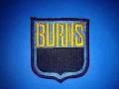
I very quietly began to explore my options to join different police departments to see which one I felt like I was best suited for. While in Georgia I looked over the Atlanta Police Department but it was so big and so vast that I wasn't sure that I would be a good fit. I realized that I didn't have a large number of friends in Atlanta and I would be starting completely from scratch with the law enforcement career there. I was smart enough to know the advantages of knowing many people in an area. Today they call that a network.
I considered the Georgia State Patrol. I was told that I could pick my duty station as a member of the GSP. The year I spent in Atlanta gave me the opportunity to travel around the state on business. The first thing that I noticed was that the Georgia beaches sucked by comparison to the South Carolina beaches. Where would I go on my time off for my vacations if not to a great beach? I was still a kid at heart and I loved the beach.

I also realized that Georgia was a very rural state. Geographically I didn't see the Georgia State Patrol giving me the opportunity to live and work in an exciting location. Atlanta was one big parking lot between 7:00AM and 9:30 AM and again between 4:00PM and 6:30 PM. I knew I didn't want to be stationed Atlanta. Georgia has many nice cities and towns but being stationed somewhere that I didn't know a sole was not appealing.

I thought about the Charlotte Police Department but now that I had grown a little older and wiser, I realized that everybody in the department didn't like my father. As a kid growing up you don't understand the big picture. Police Departments are famous for professional jealousy. We may be riding partners but as soon as one of us gets promoted the relationship changes. My father was fast tracking the Police Department so he moved past some of the people he worked with pretty quickly. In any law enforcement agency the people at the top are always cussed and discussed by the people at the bottom. During my initial evaluation of the Charlotte Police Department I thought that my father's strong ties to the city may work in my benefit. Acting on no specific advice from anyone and no specific negative thoughts from anyone I decided that I needed to make my own way in another department. I did not want to be known as" Jimmy's boy". I wanted to find a department that I could be myself in but not lose my network of friends and father's friends.
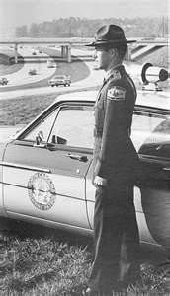
The North Carolina Highway Patrol had always caught my eye. They seemed to have the best equipment, the best uniforms and the best of everything. They were the highest profile law enforcement agency in the Southeast as best I could tell. Even though I was working for Burns and making twice as much money as I would have made on the Highway Patrol, I still submitted my application. Of course I didn't tell anyone at Burns because I didn't want them to fire me.

Chapter 5

After submitting the application I didn't hear anything for over three months from the patrol. I decided to stop by the district office in Charlotte to see if there was a status. First Sgt. Bill Etheridge took my application initially. This time Sgt. Joe Bracey was the acting First Sgt. because Sgt. Etheridge was away in school. Sgt. Bracey called Raleigh to see if there was a status on my application. After several phone calls and inquiries he determined that my application had never been submitted to headquarters in Raleigh. Sgt. Bracey offered another application to me and assured me that if I sat there in the patrol office and filled that application out that he would make sure that it got to Raleigh. I was later lead to believe that First Sgt. Etheridge had tossed my application in the trash. No one seemed to know why but it supposedly happened.

Several months had gone by and I received a phone call from a lady at the training division at the Highway Patrol headquarters informing me that they would be sending me information for an eye test and a physical from my doctor. She also said that as soon as those two documents were returned that I would be scheduled for oral review board in Raleigh. I rushed to get those two medical evaluations filled out and anxiously awaited the call from the oral review board. I knew at that time that my background investigation had already been performed. It had to be satisfactory or the medical of evaluation process would not have been started.
In the early spring I received a letter from the Highway Patrol recruitment officer scheduling my oral boards in Raleigh, 14 days later. I was told to report to patrol headquarters on New Bern Avenue at 8 AM. I was informed that the interviews and testing could last as late as 4 PM that same day. I was so excited I thought those two weeks would never pass. Still no one at Burns knew that I had applied the Highway Patrol. I just couldn't imagine anything keeping me from becoming a member of the North Carolina State Highway Patrol. I had a few tickets and a few scrapes but nothing seemed serious since I made it through the background investigation.
When I arrived on that anticipated morning of my oral review boards there were six other candidates assembled in the training office at patrol headquarters. We were immediately given more paperwork and forms to be filled out requesting all sorts of other information. Lieut. Powell came in and introduced himself as the training and benefits officer. After we completed the paperwork he asked us all to come into another room where we could have a small physical evaluation of our fitness. Lieut. Powell walked over to me and said, "You know that long-hair has got to go?" I said "I know that but in my current job I do have to work some undercover.” I needed to blend in with people out there. I promised Lieut. Powell that cutting my hair was not a problem. He laughed and said “I hope not.” They ask us to do very limited physical activities like 10 push-ups, 5 sit ups, 10 jumping jacks, and 3 chin-ups. Of course being the smart-butt that I was, I kept going on every one of those exercises to show that I was better than 10 push-ups or setups or jumping jacks or chin-ups and that I was strong and ready. Afterward when I had a chance to evaluate the things I had done that day, I realized that I didn't follow orders. I knew at that point that I had exceeded any expectations of their basic physical requirements so far. I just hoped that I didn’t get down-graded for going over the limit.
We were asked to wait in an area together for our individual review boards. Each of the candidates talked freely among ourselves basically asking where were from and how long this application process it taken place. I learned that some of the men there had applied after me and some had applied before me. I guess it really didn't make any difference at this point because we were one step closer to being accepted. The only person I remember from that group was “Clean Sweep” Steve Robinson. That nickname came later because he wrote everything that moved.
We were invited one by one into a large office to meet the board members. The board consisted of Lieut. Powell, two first sergeants, one line Sgt. and one trooper.
During the paperwork process that day we had been asked to write a one-page scenario of why we wanted to be members of the Highway Patrol. We were asked questions about the answers that we gave during the oral review. Obviously our background information was made available to these board members because of the questions they asked. One of the sergeants asked me if I had ever been arrested. I replied that it was a gray area. He told me to explain it. I asked the sergeant if he was referring to the incident in Louisiana. He acknowledged that he was. I told the board that I had been dating a lady whose father was a major in the Baton Rouge, Louisiana Police Department. I had met this young lady along with her family in Myrtle Beach South Carolina about a year earlier at the Southern Police Institute Alumni Association meeting. I explained that this lady and I had visited each other frequently and that she had informed me that an old boyfriend would surface from time to time back in Baton Rouge.

I continued my explanation with as many details as possible. I explained that I had called this woman on a Sunday morning to see if she was coming to Atlanta during the next week. I was unable to contact her directly but I did talk to her sister. Her sister informed me that she had agreed to see her old boyfriend the day before and there was some type of confrontation between the two of them.
After not being able to reach the young lady by telephone I decided to take a quick flight from Atlanta to Baton Rouge to check on her. Her sister picked me up at the airport and drove me to the man's apartment where this confrontation had taken place. I further explained that the incident took place so quickly that I could only remember some of the larger details. I explained that when the man wouldn't come to the door that I kicked the door in, a struggle ensued, things got broken, more things got turned over, and the man escaped.
My lady friend who happened to be at the apartment disappeared in the complex, I supposed to avoid further embarrassment. Her sister insisted that I go to her parents’ house because someone would probably call the police. While we were at the residence of Major Font someone from the Baton Rouge Police Department called him and said that the man that I had confronted at the apartment had filed a disorderly conduct charge against me. Major Font took me to the Baton Rouge Police Department where my fingerprints were recorded and I posted a $20 bond. Later that evening I was back on the flight to Atlanta. At a later date Major Font informed me that the bond had been forfeited and that I did not need to come back to Baton Rouge. The Incident was over. I asked the Sgt. If that was considered an arrest? He assured me that it was considered an arrest. He asked me if I had ever been arrested for anything else. I told him no. He asked me about the speeding ticket that I had received. I explained that I had received a speeding ticket one in North Carolina and one in South Carolina. Both of them were for speeding 10 MPH over the posted limit. The Sgt. seemed to be a little angry as he explained to me that speeding ticket was an arrest. I became concerned at this point that this oral review process was not going as well as I had hoped.

Lieut. Powell asked me what I would do if I accidentally started following my father one night and noticed him weaving in the road like he might be drunk. I thought for a minute and I said “I would turn on my blue light and stop him. I would determine whether or not he was under the influence. If he had not been involved in an accident I would put him in my patrol car and take him home.” I continue to say that I knew that may not be the right thing to do according to policy but I'm trying to be honest here. I also told him “if my dad had been involved in an accident then I would have to enforce the law just like he was any other citizen.” Then Lieut. Powell said “I know your father I don't think you'd ever have to worry about him driving drunk but I just want to see what you would do in a situation like that.”
Now was time for the only trooper in the room to ask his question. He said “I see on your application that you like to hunt?” My response was that I'd hunted before and I think I enjoy being in the woods more than I like to shoot the animals. He asked me what I had hunted. My response was that I had hunted squirrel, rabbits and birds. He asked me what gun I used. It seemed that he was trying to trick me up with a question about what gun I used. I told him that when I squirrel hunted I used a .410 gauge shotgun. When I rabbit hunted I use the same gun. The only time I went bird hunting I used a 12gauge shotgun with bird shot. I think after this he realized that I had hunted a few times and he had nowhere to go with any more questions about hunting.
Lieut. Powell stood up and shook my hand and thanked me for coming for my review board. He said that someone will be in touch with you as soon as we gathered all your paperwork and determine the start dates for a basic school. I shook hands with everyone in the room, thanked them for their time and said that I had hoped that I had answered their questions satisfactorily. The only thing that I had any concern about was the Baton Rouge Louisiana incident. I tried to figure every angle from the questions of the review board and it suddenly occurred to me that they already knew the answers from the background investigation. I wanted to assume that they were trying to determine if I would be honest about what happened. I was told later that that scuffle in Baton Rouge just proved that I was not afraid to go after someone.

One of the fringe benefits that I had always taken advantage of with my father's position in the Police Department was accompanying him and my mother to different police conventions around the country. My dad was a past national president of the Southern Police Institute Alumni Association and the past president of the North Carolina chapter of the SPI. The SPI convention in North Carolina was held in May in Southern Pines. The young lady that I was dating at that time and I went with my parents to the convention, mostly so we could play golf for several days. While at the convention I met a Highway Patrol Sgt. DB Wagstaff and his wife. We had dinner together one night outside at a pool gathering. I mentioned to Sgt. Wagstaff that I had my application in to the patrol and was looking forward to some good news. His wife spoke up and said that when I get up there you better watch out for Peterson. I asked why that was and she said he was the toughest PT instructor they've ever had at that school and he didn't take any crap off anybody. She also told me that when I left there that I be in some kind good shape. He scared the new recruits to death according to her. I never forgot what she said so one of my goals was to continue to work out and be in shape when I went to patrol school rather than just the typical recruit that wasn't prepared for that type of physical training. I ran all summer long, 3 and 4 miles a day, in the heat of the day. I felt like I was in as good a shape as I've ever been in, even after playing sports all through high school and college.

In mid-June I received a letter from Lieut. Powell informing me that I had been approved for employment with the Highway Patrol. The letter informed me that the class of 40 would begin in mid-August and that I was number two on the alternate list. If no one dropped out from the August school then I would be number two on the list for the January school. I was so excited I almost couldn't contain myself. As it turned out no one dropped out from the August school so I prepared myself to be ready for the January school.


Chapter 6
In June I was promoted with Burns International and given my own operating office in Winston-Salem North Carolina. I was one of the few office managers that ran a guard and patrol operation as well as an electronics division. Everything pointed towards a great career with Burns and the lucrative salary. I went ahead and took the promotion and moved to Winston-Salem in August after I was sure I would not be selected as an alternate for the August patrol school.
I knew the office manager in Winston-Salem, Miriam, from dealing with her in the past and I looked forward to working with her. She was very confident and efficient in her office responsibilities. I asked her to locate accommodations for me in a hotel for a week or two until I could find an apartment to move in. When I arrived for work on a Monday morning in late August, Miriam suggested that I stay at the Scottish Inn on Interstate 85. The hotel was located in Kernersville, North Carolina which was about 10 miles from our office. Marion stated that the Hotel was on a quiet interchange and had a great restaurant on the premises. Around 5:30 PM that afternoon I decided that I would try the recommended hotel and see how things went.
When arriving at the hotel I asked the clerk if I could go on the backside of the property where it might be quieter than on the front side. He laughed and said he have one room on the back, all of the other rooms are occupied by highway patrolman working the golf tournament. I said that would be great. I knew I would love to be back there with them. He laughed and handed me the key. As I drove my car around to the back of the hotel there were 20 shining Highway Patrol cars parked in the lot. There happened to be one vacant spot just in front of my room. There I was, literally in the middle of 20 troopers.

As I got out of my car I noticed a trooper standing there wearing his patrol pants, a T-shirt and patrol shoes. He smiled and said “hello friend are you back here with us?” I told him that I was. He asked if I was a police officer. I told him no but it was funny that he asked. I told him that I had been accepted to Highway Patrol school starting in January. He asked me who I worked for and I told him Burns International Security Services in Winston-Salem. I told him that I was the branch manager until I reported to patrol school.
He introduced himself as Pete Humphrey. I introduced myself and then began to remove my clothing from a vehicle. Pete asked me if this was my personal car or company car. I told him that it was my personal car. He said they were in kind of a fix here because no one has an unmarked car. It's kind of hard to get around after they get off with no unmarked car. I offered up my car or told him that I would be glad to take them anywhere they needed to go. Pete then invited me to come into a room and meet some of the fellows. I walked into a hotel room where the door was open. There were five or six men in the room. A couple of them were having a cocktail, several were watching television and some were playing cards. Pete said “fellows I want introduce you to Harry Stegall, he starts patrol school in January.” All of them said, that’s good, mumbled under their breaths how are you that sort of thing nothing exciting. Then Pete said “Harry's got a car we can borrow.” That's when they all jumped up, came over shook my hand, had big smiles on their faces, and asked how long I would be at the hotel. At that point I really didn't care if they liked me personally or for my car. At least I had a shot to meet some of these guys and maybe hang out with them during the week. Being able to hang out with a trooper like Pete Humphrey was incredible. He had been on the patrol since 1947.
All of these troopers were on special assignment at the PGA Tour being played at the Tanglewood Country Club just outside Winston-Salem. Special assignments depending on where they were and who the supervisors were could be a lot of fun or real pain in the butt. As it happened the supervisors were stationed locally so the 20 troopers were pretty much on their own in the evenings. Everyone wanted to get out and go on the first night there. The opinion of the locals was that the hottest spot in town was at the Downtowner Hotel on Cherry Street. It just so happened, that one of the troopers knew someone local and provided him with a car to use for the week. Two cars made it much easier for this crowd to get around. It was about a 10 minite drive from our hotel to the Downtowner Hotel. The lounge at the hotel was called Atelia’s Cave. Since Pete didn't drink, he agreed to be our designated driver. The crowd riding in my car had to be shuttled in two trips over and two trips back. By Wednesday evening the guys made friends with some of the local debutantes and they were able to arrange their own transportation to and from without relying on Pete as a driver. We only had to make 1 trip on Wednesday and Thursday.
I still had my longer hair, but considerably shorter than I wore it at the oral review board. No one could actually tell that I was with these guys in the lounge because their hair was cut short. It was obvious inside the lounge, that's what they were called back then instead of bars, that the short haircuts belonged to military personnel or police officers.
On one of our visits to the “cave” some of the local, less sophisticated gentleman seemed to find fault with this group of short haired men dancing and talking with some of the local girls. I'd never seen what a trained group of troopers could do to an unruly group in just a matter of seconds. Some of those rednecks took a swing at one of the troopers and before you could spit they had knocked two of them to the floor and set them back up in their chairs like they were nodding off. One of the troopers told the bouncer at the door that these guys were asleep. In a couple of minutes those two guys were escorted out by the hotel staff. I thought to myself this is what you call a close knit group. As I came to learn later none of these troopers were in the same duty station and most of them barely knew each other. When it came time to stand shoulder to shoulder it didn’t make any difference. They were all cut from the same cloth.
Unfortunately I had to leave town on Friday to take care of some business in Charlotte. When I returned on Monday I was the only person staying on the backside of that hotel. That was one more quiet and long week. Some of the friends I made that week literally lasted a lifetime. Pete Humphrey was one of those friends. I felt honored that I was one of the few people that could call him by his given name, Felix, and get away with it. Pete and his son Mike Humphrey were the first father-son combination on the Highway Patrol. I worked my tail off all summer long to make sure that I was in the best possible physical shape that I knew how to be. By December I was amazed at just how far I could run and how many push-ups and jumping jacks that I could perform without really being tired. Comparing my current physical condition to playing conditions in college, I felt like that I was as good as I could possibly be. Boy was I wrong.
The management at Burns International was disappointed that I had chosen to leave for law enforcement but they understood. Almost every manager in the company had come from a police background. The regional manager, Les Kitteridge, who was instrumental in creating the manager trainee program, was himself a Boston police officer before coming to Burns. They all wished me well and welcomed me back anytime I wanted to return.

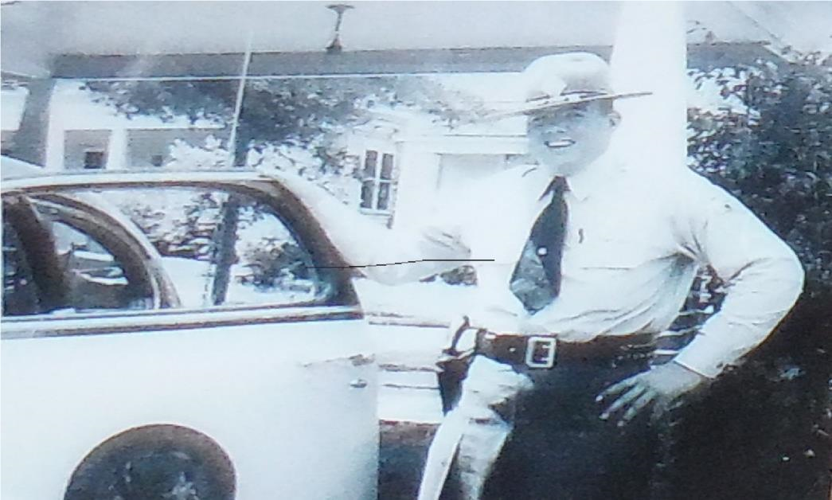
Trp. Pete Humphrey 1947

Chapter 7

The day had finally arrived. I never liked being late so I left Charlotte planning to arrive between 12 PM and 1 PM. I'd been given a map so that I could locate the Institute of Government on the campus of the University of North Carolina at Chapel Hill. It turned out to be a very easy find. I arrived just after noon to a parking lot full of vehicles outside the Institute. I grabbed my paperwork to make sure that my report time was three o'clock. I was right and as it turned out those cars were just parked in the lot because it was available for use over the weekend by anyone.

I'd been a lot of places and done a lot of things and always prided myself on being able to walk in and handle any type of atmosphere that I might find myself in. As I walked up the steps to go into the building where we were to report I was scared to death. I was still quite confident that I wanted to be a Highway Patrolman but I was very unsure of what I might've gotten myself into.
A polished trooper was positioned at a desk in the main office of the Institute. I introduced myself and told him I was there for patrol school. In a very cold callous tone of voice he informed me that my report time was 3 PM and not before. He told me that there were several other men there to report and that I should find them and go somewhere and have a cup coffee or lunch. He said again in a very emphatic voice there's no reason to be here before right at three o'clock. I could barely read his name tag from the distance he kept from me but I was able to determine that he was Trooper Peterson, the guy that Sgt. Wagstaff's wife had warned me about.
I wandered back out of the building and through the parking lot and saw two other men standing and talking to each other. I assumed that the two of them had arrived early for school as well. I approach the two men and introduced myself. They were in fact there earlier than I was. The two men were Wayne Johnson and Johnny Potter. Wayne and Johnny said they were about to go to and find someplace to get some lunch or have a cup coffee. They asked me to join them.
We all piled in Wayne’s American Motors Hornet and set out for lunch. It was a long two hours to kill before being back at three o'clock. Once we started talking and exchanging backgrounds the two hours moved right on by. Wayne and Johnny both had been police officers, Wayne in Hickory, North Carolina and Johnny in Raleigh, North Carolina. They had a tremendous amount of insight to what we were in for during patrol school.
As the three o'clock hour approached we began to meet up with other men that had been turned away to the outside of the building looking at their watches and trying to decide if we should all enter at exactly 3 PM or a few minutes earlier. Suddenly another trooper appeared on the front steps of the building and told us it was time to come into the classroom. As we entered the classroom they instructed us to find the seat that had our names on the desk. Normally when a group of guys go into a room and wait for further instruction there's all types of loud chatter and conversation. Not in this room. Everyone took their seats and you could have heard a pin drop on the floor. Whether we had just learned of the strict regimentation over a cup of coffee two hours before or whether we had been advised all along about the strictness of the school, we were all quiet.
At the front of the classroom there were individual seats lined up side by side facing the class. Just after 3 PM the entourage of the school staff made their entrance. We were called to stand at attention. They were led by the School Commandant Capt. Nutt, Lieut. Fox, Sgt. Wagstaff, Sgt. Johnson, Trooper John Taylor, Trooper Pete Peterson, Trooper Hal McCullum and Trooper Frank Burch. Capt. Nutt remained standing and the other members of the staff were seated. We were told to be seated. Capt. Nutt approached the podium and began his introduction of himself and his welcome to the basic school. Like so many of these old-time troopers, they have a tendency to ramble on about stuff that only matters to them. Capt. Nutt introduced us to Lieut. Fox who had been the commandant of the school and was much more informative about our curriculum and what was going on in the school than Capt. Nutt. Sgt. Wagstaff was introduced and his remarks ran pretty much in line with the other two men that had been introduced before him. Sgt. Johnson introduced himself and explained that his position in the school was to make sure that all of our personal needs whether it be with family members or curriculum were attended to. As it turned out Sgt. Johnson was the guy that came around every morning to make sure that no one needed to go to sick call or that our assignments were up to date. Sgt. Johnson was just a nice guy looking for retirement. Trooper Peterson stood up from his seat, looked across the room, and very calmly said “welcome to Chapel Hill.” He then sat down. So far this Peterson guy was being a real prick. That was not very shocking to most of us who had heard about his tough reputation before we ever arrived. Trooper McCullum introduced himself and told us that he would be assisting in much of the curriculum but that his primary function in the school was our firearms instructor. He also told us that he was in charge of the armory for the Highway Patrol. Trooper John Taylor introduced himself with little fanfare. Last but not least was Trooper Frank Burch. Trooper Burch told us that he was the other half of the physical training team and that he too would be assisting in the curriculum throughout the school. Trooper Burch was probably one of the most unnatural people you'll ever meet. The man could run for hours at a time at a high rate of speed and never get tired. I've never met anybody that can run as long and hard as Frank Burch.
Saturday afternoon and early evening were just more paperwork. I couldn't believe how much paperwork the state of North Carolina required for employment. At approximately 6 PM we got our first taste of the K & W Cafeteria at the Chapel Hill Mall where we would eat two meals a day for 18 weeks. Actually the food was very good. We were allowed to eat all that we wanted. The only problem was that they basically serve the same thing every day.
After our paperwork assignments had been completed that Saturday afternoon and early evening we were allowed to move our personal belongings into the dormitories. We were then escorted over to a fenced and secured parking area where we stored our vehicles each week while we were in school. No one was allowed to use their personal vehicle during the week for any reason. We were issued footlockers for storing certain personal items and explained to exactly what we could and could not have in our dorm rooms. We were divided up into groups so that we can all look closely at the exact way each dorm room was to be presented for inspection every morning. We were also introduced to a can of Johnson's floor wax and a buffer so that we could buff the floors in our rooms to a high gloss as well as the adjoining hallways. Later we were given a demonstration on how to make the chrome and porcelain in the lavatory shine at a high gloss. To make a long story short, white glove inspection including the rails underneath our bed for dust happened every morning. We were allowed free time from 9 PM until lights out at 10 PM. The last thing we heard before lights out was that we would have trial inspection on Sunday morning to see what we had learned and a full inspection on Monday morning to see what we didn't know. There were many short nights and long days ahead.

Sunday morning at 5 AM the lights begin coming home and you could hear the hum of the floor buffer in the hallway. Fallout and formation was at 5:30 AM in the parking lot outside our dorms. My attitude on the inspection was that I had done all I could do and I wouldn't worry about it until they came and tell me what I'd done wrong. In the midst of telling myself that I'm looking over my room to see if there's anything that could possibly be out place and from the doorway shouts this voice “get your butt out in that parking lot. Do you know what time it is?” My reply was “yes Sir” and my butt was on the way out side. It seems that I was about 5 min. late looking over my “I don't care what my room looks like” and missed part of the alignment for formation. We began the process of aligning ourselves in columns of 4 and rows of 10 from the tallest to shortest. We were then instructed for about 1 min. on left face and right face maneuvers. The rest of our drill maneuvers would come very soon. Right now we had a date in the “tin can” that would for- ever make a mark on my physical strength.

As we jogged over to an old gymnasium on campus affectionately referred to as the “tin can”, nothing seemed to be out of the ordinary for physical training. As we entered the gym it all began to change. Our names are being shouted by 20 troopers that were assembled in a large circle inside the facility. As we reported to the trooper that had our paperwork and calling our name, we were ordered to stand at attention. Our instructions were that we would be evaluated on our current physical condition by the number of exercises that we could perform in a given time frame. We were then informed that the time frame would not be announced, and we were to perform as hard as we possibly could until our evaluators told us to stop.
As we began our calisthenics not knowing the time frame of each exercise caused us to assume that the time frame would be short and that we should perform as many of that particular exercise moves as possible. What they did was wear us down and put us in a position to see just how far we could go. The number of moves for each exercise was eventually calculated back into a Raw T score to evaluate us even further physically. Each of us also learned that we were not in as good physical condition as we thought. I kept wondering when this brutality would end. What would this be like if I wasn't the shape I was in? Being pushed that first day was just the beginning of the type mental attitude that I needed to later help save my life.
After this butt whipping that we took in the tin can we all moved outside and lined up in formation. We began to jog around a large physical activity field at a pace that no one could really keep up with. We began to drop out of the formation until there were men scattered all over the field, bent over, puking and staggering along. We made two complete laps as best we could around this field. Troopers Peterson and Burch began screaming at us to fall in, at one particular location on the field. They ordered us to attention. No one passed out but most of us couldn't stand without spreading our feet to maintain our balance. They had accomplished exactly what they set out to do. They intended to show us that regardless of how good we thought we were, we had to get better. For 18 weeks the most precious words after PT were “go to the house". That meant the PT was over for the day.
The night before, all four guys staying in the same suite decided who would go first in order so that we would shower and began to clean the bathroom. We were just trying to set up the system. But all that went out the window when we got back in the dorm. I volunteered to go last in the shower. We were all whining and moaning about what we had just gone through but nobody in our group of four mentioned anything about quitting. Someone in our group asked if every day would be like this and I quickly answered, “What difference does it make? We got through it today will get through it tomorrow". That's when the bellyaching really started. That Sunday morning was the only time in my life that I have ever taken a shower sitting on the floor. My legs were like rubber. The only thing that saved me was that my respiratory system had been built-up from all of the running that I did before school. I could breathe well but the rest of my body felt like it is been run over by train.

The first several weeks of school were hell. I wasn't sure if we were being hazed or trained. The purpose was to weed out the men that really didn't want to be there or were not physically capable of handling the job. These instructors knew from prior experience there were certain levels of standards and endurance involved to perform the duties of a Highway Patrolman as well as to protect themselves in the field. I had promised myself on my trip to Chapel Hill on that Saturday that there was no way that I would ever leave that school unless they put me out or I was in a body bag.
During the first week of school each afternoon we divided up in groups of three and were assigned to a Trooper in a marked patrol car to practice what we had learned each morning about defensive driving. We were told that all eyes on the road would be on that patrol car everywhere we went. The class was to make sure that we were an example to the public as well as to protect ourselves while on patrol. This was really cool. After we had performed the routine car inspection and sat down in the front seat of that patrol car reality was starting to set in. Here I was, buckling the seat belt on 1973 Dodge, with a 440 engine and painted black and silver. As we drove through the streets of Chapel Hill and made our way out to the rural highways in Orange County everything seemed worthwhile. Sunday morning in the tin can wasn't really that bad.
During the fourth week of school our personalities had been discovered by the staff and it was apparent who would succeed physically and who might succeed mentally beyond expectations. I tried to evaluate myself almost every day. My test scores were always 100%. The only thing that I could not do with regularity was to run in formation for long distances. I could do any calisthenics known to man as well as anyone in the class. I could run sprints or run the bleachers. If we started our 5 miles tour of downtown Chapel Hill at a reasonable pace, I did just fine. However if the pace was too fast I had a problem staying in formation. I never got behind the group more than 100 yards on a 5 mile run but those runs seem to last forever. Most of the class fell behind in the fast long distance runs but that was no excuse for me. I later discovered that no matter how fast we ran, the pace would be faster than most could keep up with. Thanks to Trooper Burch. The entire process was to push us harder than we imagined. I was going to need that push very soon.
I suppose it was part of the psychological program to work us as hard physically and mentally as possible and then just at the right time reward us with something that would be rejuvenating both mentally and physically. It was mind over matter so to speak. During the second week of school we were issued to pair of standard patrol shoes. That was a big deal. So far we really hadn't received anything that made us feel like we were part of the organization. Even though we had been sworn in on Sunday afternoon just after our arrival there was nothing tangible to really connect this to the organization.
Everybody had a different way to make their shoes shine. Trooper Peterson told us to hang loose and he would show us how to candle shine our shoes and we could use the same process on the rest of our leather as it was issued. The process was fairly simple. We applied paste kiwi polish to small portions of our shoes. Then over a burning candle we held the shoe so that the polish would melt into a warm paste that could be rubbed with a cotton cloth to a high shine. Each day the shine became a little better and a little better. After two weeks our shoes looked as good as any man on the Highway Patrol. We were starting to blend in. We all were starting to love Trooper Peterson. It was occurring to us that he was trying to prepare us, not hurt us. Trooper Burch went home every day around 5PM. Pete was with us 24 hours a day. Trooper Burch had a family with a daughter on the way.
After more grueling exercises and the beginning of self-defense classes there was no one in the school that wasn't bruised or scraped on several parts of their bodies. You can't teach self- defense looking at a video or going through the slow motion process. The only way you can learn to defend yourself which may be the difference in life or death, is to actually practice the maneuvers in real-time and allow people to use their full strength against your tactics.
We were working on taking a motorist out of their vehicles after we had placed them under arrest and they refused to go. We learned all sorts of arm bar come-alongs, finger twists, neck twists and wrist maneuvers. We practiced these maneuvers in real-time and with resistance from the person pretending to be the uncooperative motorist. Everyone felt pain during these exercises because it taught us how much force to apply to gain control of the unruly person. The instructors knew who they could mess with during the drills and entertain the class. One such session put a man playing the role the trooper outside the car window and me playing the role of the uncooperative motorist. Trooper Peterson quietly told me that if I let the other man take me out of the car he was going to kick my butt. He also told the other student very quietly that if he didn't get me out of the car he was going kick his butt. Now we have two people, both assuming that they're in trouble if they don't perform their roles in this take out satisfactorily.

I had both hands on the steering wheel and the other student hit me on the back of the hand causing me to release the steering wheel. He then used his right hand to strike me in the jaw causing my head to turn hard to the right. At this point he was to open the door and take me out of vehicle. After I let go of the steering wheel I had my hands ready to grab his arm after he hit me in the jaw. As I grabbed his right arm and began to pull him closer to the vehicle making it impossible for him to open the door, he began to reach for me inside the car. His mistake was that he put both arms and his head inside the window to try to gain control of me. The fight was on. I spun around in the seat, put my legs against the door, got my arms underneath his arms and proceeded to pull him inside of the vehicle. He was working just as hard to get me by the neck and get control of me, as I was to make sure that I pulled him inside the vehicle. We were using patrol cars for these exercises and after he and I finished wrestling in the front seat we had broken the radio and electronic siren controls from their mounts on the floorboard of the car. It turned out to be nothing more than to guys rolling around in the front seat of a car try to get position on each other. When they called us off the entire class had gathered around the car to watch a struggle. The other student and I were friends so there was no intent to hurt each other while we were performing this exercise. We were just doing what we were told. It turned out to be a good example of don't put your upper body inside the window of a car when you try to gain control of an uncooperative motorist. It was pointed out that this is where we would use our convoys or black jacks as some people refer to them to gain control of the suspect. Everyone felt beat and banged up but all of that pain went away one evening as the instructors walked through our dorm room during study time and issued each of us two breast badges.

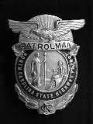

Wow. This felt really official. We were instructed to leave our badges on display in our footlockers as part of our routine daily inspections. Every Friday afternoon when we left to go home one of those badges was in my pocket. That badge served as a reminder to me exactly what I was working for.
Every Sunday night when we returned from our weekend break we had to weigh in. That was our official weight for the week. If you are overweight from the prescribed schedule, your diet was watched strictly and you may have to run extra to make sure that everyone graduated from the school in their prescribed weight class. Finally during the sixth and seventh week of school we all weighed in at the desired weight. The instructors were fairly satisfied that each of us had learned to control our weight and maintaining that control would not be difficult. The big kahuna happened that week. We were issued our patrol hats.

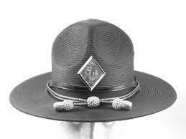

That hat to a Highway Patrolman is as sacred as the hat worn by the Pope. That hat, distinguishes the Highway Patrol from other law enforcement agencies. We were also given our hat tassels which at that time were handmade by a private citizen exclusively for the Highway Patrol. We were given instructions on the exact length of the tassels in the front so that everyone's hat would be exactly the same. Within a week we were issued the hat badges and now we were really something.
As the school rambled on the physical training and the defensive tactics became more and more routine. We had all figured out by then that no one was trying to kick us out of school. Our destiny was in our own hands. We did lose three people during the 18 weeks. One individual complained of neck and back issues and the other two individuals decided that patrol was not for them. Everything was beginning to fall into place.
Accident investigation was incredible. Most people think that when a police officer arrives at a traffic accident that he determines who was at fault, issues a ticket and it's over. This it is truly not the case with the Highway Patrol. Everything that we put down on that DMV 349 could be referred to years later to re-create the accident. We had 40 hours of accident investigation instructions in real time weather. We were outside in bitter cold and even light rain.
Capt. Nutt was the instructor that taught us Policy and Procedure. This could have not been any more boring if we were trying to read the Bible in Chinese. Most of the stuff in the policy didn't mean much to us because we didn't understand it. It meant much more after we were in the field and put ourselves in different situations where these policies might apply. After being bored to tears for two weeks we were given our wake-up call. After dinner one evening we went over to the communications and logistics headquarters and were issued the remainder of our uniforms. We were able to wander around in this room full of uniforms for nearly 2 hours until everyone had selected just the exact jacket, shirt, pants and leather that was perfect for him. The morale boost was obvious the next morning during PT. everyone seemed to have more zing in the steps. We were making some serious progress.
We spend each afternoon for two weeks on the firing range. I was surprised that several of the men in the school had actually never fired a gun. I was licensed as a firearms instructor in the state of Georgia from my previous work at the security company. I had spent hours and hours on a firing range instructing security officers and qualifying them to carry a firearm. I was also license to carry a concealed weapon which in the 70's was almost unheard of. The second day of range instruction I was asked by Trooper McCullum to help some of the students that had never fired a gun before. Eventually everyone qualified as we were supposed to but I can promise you that there were some people in that school that were not proficient with their firearms. It was hard for me to realize that 80 was a passing grade when I never made less than 100. I was quietly reminded that I had been shooting for several years and some of these men were on their second week of training. During those 2 weeks we were introduced to sniper rifles and a Thompson Machine Gun. It looked like something from Bonnie and Clyde.
Four weeks before graduation we were notified of our duty stations. Each of us had been informed and we agreed that we would be stationed anywhere in the state of North Carolina that the Highway Patrol chose to send us. The top five single troopers were selected for the governor's mansion. The instructors try to pass it off as an honor and a privilege to serve the Governor directly, but I didn't just go through this patrol school to be a babysitter for the Governor and his family. By now we had all heard the horror stories that went along with being stationed at the mansion. Even worse some of the troopers were sent to duty stations like Coin Jock and Rich Square. Both of these duty stations were small counties in the northeastern part of North Carolina. Other guys went to Greensboro, Wadesboro, Morganton, Winston-Salem, Salisbury and Asheville. Other than the Governor’s Mansion, no two men from our school were assigned to the same duty station. That meant that 32 counties received new troopers. The normal procedure is that when troopers stationed in some of these godforsaken counties put in for transfers they are normally granted because the rookies have no choice. That four weeks’ notice gave everyone the opportunity to explore a new duty stations and find suitable housing. One trooper eventually quit over his duty station.
We learned high speed and low speed driving maneuvers throughout the 18 week school. Eventually we made it to the driving track where we were able to operate a patrol car just as fast as we could drive it. This driving experience was set up at the Laurinburg – Maxton airport. There were road courses and high-speed straightaway and tracks all over the airport. The first exercise was to drive the patrol car down a long runway at 85 mph. After that run the instructor checked the palms of our hands for sweat to see if this had made us nervous. We then returned to the other end of the runway at 100 mph. The same test was performed on our palms after this run. Then we were allowed to drive the cars at maximum speed back down the runway. After this third run the instructor commented that I didn't seem to be bothered by these high-speed runs.
I grew up driving fast cars so like being on the firing range and flying up and down this runway wasn't my first rodeo. I was a little surprised when we arrived at the airport that the Highway Patrol had sent three wrecker trucks, a tire truck and a gas truck. This wasn’t their first rodeo either. Many tires were changed that afternoon and several of the patrol cars went back to the garage on wreckers. This training was very valuable. There were many members of our school that had never had the opportunity to drive a fast car or to make any of the maneuvers that we were learning on the high-speed course. My advantage was only that I wasn't afraid to drive a car at a high rate of speed. The maneuvers that we learned on that track provided a foundation for each of us to expand on as we were in our training periods at our duty station.
I can honestly say at that point that the means had justified the end. We were about to graduate from patrol school. We have one final piece of equipment to be issued, our patrol cars. On the afternoon before the morning of our graduation we were driven over to the main Highway Patrol garage in Raleigh. As we approached the area there were 37 slightly used, black and silver, 1974 Plymouth Grand Fury's waiting on us. We already knew our call numbers so all we had to do was find the vehicle with our numbers on it. The keys were in the car and the trunk was filled with all types of equipment that we would need to perform our duties.
Nothing seemed to matter. We had received every piece of equipment that any other trooper had in the state. We had accomplished our goal to become members of the Highway Patrol. We drove those vehicles back to Chapel Hill from Raleigh in a straight line one behind the other. 37 patrol cars make quite a long and impressive line. During the entire 15 mile trip you could see blue lights flashing off and on and hear sirens blasting in short intervals.
That evening we were finally able to say goodbye to the K and W cafeteria. The 18 weeks of roast beef, mashed potatoes and green beans were finally coming to an end. We had a graduation banquet at the Governors Inn in the Research Park Area that night that many of the ranking officers of the Highway Patrol attended. We were on display to the organization.
This, the only night during the entire 18 week period that seemed to last forever. Breakfast was no different. Finally was time to say goodbye to the Golden Corral restaurant where we had eaten breakfast every morning. It did occur to me that morning that I would miss the three other men that I ate breakfast with each day. I also wondered how long it would be before we began to run into each other since our duty stations were scattered all over the state.
The graduation ceremony began at 10 AM on April 18, 1975. The auditorium at the Institute of Government was filled with family and friends along with Highway Patrol and State Government Officials. I had no idea that there would be some members of my patrol school that I would never see again. Also I had no idea that death was lurking just around the corner.

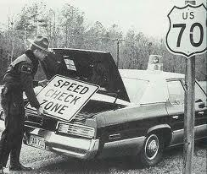

We Gave Them Fair Warning

Chapter 8

Graduation day was fun. It was hard to believe that we had been there for 18 weeks and now it was time to actually go in the field and do some work. The work that I had been assigned to had not been even mentioned during the entire school. There was no special training or curriculum to teach you how to deal with the governor's family while being stationed at the Executive Mansion. I don't believe that any of the five troopers from our school were happy to be heading to that duty station. The procedure was that after each school was completed the five troopers on temporary assignment rotated out at five troopers from the school just completed rotated in. That worked out well when the state was running one school after another. We were informed that due to some legal issues with the Highway Patrol’s hiring process that there was not another school scheduled for at least one year. I couldn't imagine being a babysitter for year.
Just as I had predicted one of my primary responsibilities was to chauffeur the governor's eight-year old daughter to and from school, dance class and any other of her personal activities. Only occasionally when several of the troopers stationed at the mansion were on other assignments were we allowed to escort dignitaries and government officials. The highlight of my short stay at the mansion was the opportunity to escort Sen. Bob Dole from Kansas from a meeting in downtown Raleigh to the Raleigh Durham Airport. Sen. Dole took the time to write the governor a thank you letter for the courtesy provided to him by the mansion security staff.
I hated to do it but I wanted out of the mansion and couldn't imagine being in there for one year. I knew my dad had some contacts in Raleigh so I asked him to make a couple of calls and see what he could do. Two days later I was transferred to Troop H district 2 which included the town of Laurinburg in Scotland County. Heck, I would've gone to the Mojave Desert on a black and silver camel with blue humps just to get out of the mansion.

Chapter 9

On Friday June 20th 1975 I reported to the Troop H headquarters in Monroe North Carolina to meet the Troop Cmdr. Capt. H B McKee. As always I arrived early and was kept waiting until the district First Sgt. and my training officer Trooper Craig Howell arrived. At that point Capt. McKee invited us all into his office where we were formally introduced. The captain advised me that Trooper Howell would be my training officer and that I would be under the direct supervision of the district First Sgt. I was also advised that my call numbers would be H – 238. After 15 or 20 min. of idle conversation Capt. McKee excused Trooper Howell and me to travel back to Laurinburg to begin my training.
Scotland and Robeson counties were considered two of the roughest duty stations in the state. Both counties were over 70% minorities, being Lumbee Indians or blacks. That old story about alcohol not mixing with the Indians is true. The Lumbee Indians are some of the craftiest workers around. By day the majority of them are law-abiding citizens. When night falls, things begin to change. Never having worked another duty station I didn't realize that having to forcefully arrest people on a regular basis was the norm. There were no circumstances that could deter my positive attitude about being stationed in Scotland County rather than the Executive Mansion.

The drive from Monroe back to Laurinburg took nearly 2 hours because I didn't dare drive over the posted speed limit. This was the beginning of the “feeling out period” for Craig and me to get to know each other. We stopped along the way to have lunch and we arrived back in Laurinburg around 1 PM. We drove to the Scotland County Sheriff's office and parked my patrol car and began to use Craig’s patrol car. His car had a VASCAR unit inside which allowed us to work traffic looking for speeders. For an hour or so we rode around the county so that Craig could make me familiar with the main roads in the area.
Scotland County had several main US Highways passing through, US 401, US 501 and US 74. As we toured the county we may our way back to US 74 W. to a VASCAR position to begin observing traffic. For the next three hours Craig operated the VASCAR and I wrote the tickets. At the end of the day I had written six traffic citations for speeding that were basically uneventful. We worked our way back to the Sheriff's office and arrived there at approximately 5:50 PM. Craig told me that unless we were on call or had an important reason to stay out that we could drive home and check out at our scheduled time. He also told me that by the time I got to the Holiday Inn and checked off that it would be close enough to 6 PM to call it a day.
The trunk and the backseat of my patrol car were loaded with extra uniforms and equipment along with my personal wardrobe so I could have clothes when I was off duty. The only problem was that my personal car was still in Charlotte and I had no way to get around after work. After I unloaded my patrol car and got situated in my hotel room, I went down to the restaurant and had dinner. As I was walking back to my room I noticed a patrol car pulling into the parking area next to where my car was parked. I didn't recognize the trooper in the car but as I approached I realized that it was one of the line sergeants stationed in the area. The Sgt. got out of his car and introduced himself as Sgt. J R Blalock. I introduced myself and he asked me if I had gotten situated with my hotel room? I told him that everything was fine and I look forward to working in Scotland County. Sgt. Blalock asked me if I wanted to ride with him for a while that evening. I jumped at the chance. I asked him to give me a couple minutes while I put my uniform on and I would be ready to go. This ride a long was another attempt for a supervisor to get to know me since I would be working in his area.
Sgt. Blalock and I seem to get along well as we traveled around the county showing me certain areas that I would be in much sooner than later. Around 8:30 PM Sgt. Blalock said that we needed to head over to the district office in Hamlet were he needed to take care of some business. As we were traveling west on US 74 entering the city limits of Hamlet, a vehicle pulled out in front of us approximately 100 yards ahead, spinning his wheels and fishtailing in the roadway. The vehicle was far enough ahead that the driver couldn't tell who we were. Sgt. Blalock took off after the vehicle and as we approached activated the blue light. The driver of the vehicle made a hard right turn onto a side street and once again spun his tires and fishtailed in the highway. The driver made the next right turn and did the exact same thing he had done in the two previous turns trying to elude us. We only traveled a couple of hundred yards on this side street when the road ended. Sgt. Blalock pulled his car alongside the vehicle we were pursuing and said to me, “grab him before he can pull off.” I jumped out of patrol car and went right through the window after the driver. I use that training maneuver from patrol school where I forcefully turned his head to the right and began to exit the driver out of the vehicle by the neck. At the same time the driver was trying to put the vehicle in reverse and drive off. I finally got control of him and was able to reach inside the vehicle and pulled the gear shift lever into Park. I had him about halfway out the window when it occurred to me that if I could open the door he would fall out of the car. He was so off balance that when I opened the door, still holding him around the neck with my right hand, he fell to the ground. He was still resisting and refused to place his hands behind his back. As I banged his head on the ground twice, he decided to cooperate. I got him up off the ground and began putting in the backseat of patrol car. He wanted to fight a little bit more by kicking at me and refusing to put his right leg inside the car. After the car door slammed on his leg twice he decided to cooperate again.
By now Sgt. Blalock had notified the Hamlet PD that we had a vehicle stopped and asked for assistance. Sgt. Blalock suggested that we give this drunk driver to Hamlet because we did need to get tied up in the booking process at this point in the evening. That decision was fine with me. We had a little action, got a drunk off the road and got better acquainted. The next day I heard Sgt. Blalock tell one of the troopers in the county that they didn't have to worry about me because I flew all over that guy without even getting the car stopped. Anytime a trooper goes to a new duty station everyone wants to know whether or not they can count on him when a situation gets ugly.
On Sunday afternoon 2 days after arriving in Laurinburg, at approximately 5 PM, six Scotland County troopers in six different cars including myself, when flying over to Robeson County near Maxton to back up a trooper in pursuit headed from Lumberton toward Maxton. This is my first opportunity to take off to help somebody, driving as hard as we could but as safely as we could. We all got separated by traffic. Suddenly I saw a teenager waving at me sitting on a dirt bike. I stopped and the young man informed me that there was a trooper chasing a yellow car and they both had wrecked down the dirt road. I asked him to take me where they were and he agreed. We traveled down the dirt road with huge holes causing my car to bottom out on several occasions. I had already burnt my breaks up flying around Maxton and they were grinding as I applied them. We traveled approximately 1 mile along this dirt road and sure enough there was a patrol car and a 1966 yellow Ford sedan with all four doors open and no one around. I turned my car off the listen for what I could hear. I had failed to get the road number that we had followed off of US 74 to my present location. I got on my radio and called Craig telling him that I had found the patrol car and the yellow car that he was chasing. I tried to describe area where I had turned off. I told Craig that I was headed to the woods to see if I could find the trooper and or the guys he was chasing. I got my shotgun out of the trunk of a car and headed down a path near where we were all parked. As I started down the path Trooper Clyde Fields was bringing one of the suspects out of the woods. He told me that the others in the car had gotten away but this was the driver and the one he wanted. I went back to my patrol car and let everyone know that the suspect was in custody and that I was headed back to Laurinburg.
Since I was on the same shift at Craig was working, my scheduled days off with the next two days, Monday and Tuesday. When I arrived back at the Scotland County Sheriff's office to finish my weekly paperwork I commented to Trooper Howell, “This place seems to be like Dodge City.” Craig said, “Welcome to Laurinburg.”

One thing that did come to my mind when I was transferred to Scotland County was that Trooper Larry Walton had been killed in December, 1972 in Robeson County only a few miles down US 501 from the Scotland County line. We had seen the pictures of Trooper Walton after his death in patrol school but as I always said, “this won't happen to me.” For some reason when I patrolled US 501 I occasionally thought about Larry. We all knew that the man that killed him was given the death penalty which was a comfort.

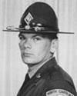
Trp. Walton
Killed in Robeson County

During the time that I was researching which law enforcement agency that I wanted to apply to, I vividly remember the deaths of Sgt. Arledge and Trooper Canipe on October 5, 1974 by a man being administered a breathalyzer in the Asheville, North Carolina jail. These pictures like the ones of Trooper Walton were very vicious. There had been other troopers to die in the line of duty in 1972 through 1974 but not at the hands of an assailant. These brave troopers died as a result of automobile crashes and helicopter crashes. These deaths affect the members of the patrol just as sadly and heartfelt as any death but without someone to blame.

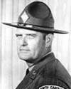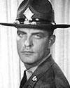

Sgt. Arledge Trp. Canipe
Killed in Buncombe County

I was working the morning that Trooper Tom Davis was killed in Martin County on September 2, 1975 around mid-morning. Trooper Davis has stopped the vehicle that he did not realize was occupied by three suspects that had just robbed a bank. The suspects were captured fairly quickly and our assignment since we were so far away was to continue routine patrol but be on the lookout for a vehicle provided from the description of an eyewitness.

I was working 12 days later on September 14, 1975 when Trooper Hugh Griffin was shot and killed in Pender County. Once again the suspects were identified and captured fairly quickly so a full-scale manhunt with troopers from around the state never materialized.

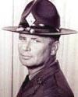
Trp. Griffin
Killed in Pender County

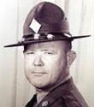
Trp. Davis
Killed in Martin County

One evening I had just returned to duty from a short dinner break around 6:30 PM. I happen to be on patrol near Laurinburg, heading east on US 74. I heard E-Town acknowledge Sgt. Blalock and Trooper Stephens check back on shortly after I did from their dinner break. In approximately 5 minutes I heard conversation from the Highway Patrol dispatcher back to Trooper John Flynn who was stationed in Robeson County. Trooper Flynn advised that he had been shot on I-95 near Magnolia. The dispatcher was attempting to communicate with Trooper Flynn about his condition and the suspects involved. Just in front of me Sgt. Blalock and Trooper Stephens pulled onto US 74. Now we were all three heading eastbound. Sgt. Blalock was communicating with the dispatcher and beginning to work to establish a perimeter near the Scotland County and the Robeson County line. By now we were all three traveling well over 100 miles an hour heading east on US 74.
When we had to slow down in the town of Maxton, Sgt. Blalock told me to turn left and head over to NC Highway 211 and set up a checking station. Trooper Flynn continued to communicate with the dispatchers relaying information about the suspect and the vehicle he was driving. I drove like wild man toward Highway 211. I was forcing drivers headed in my direction off the road so I can pass as well as forcing drivers traveling in my opposite direction to run off the road and get out of my way.
As I arrived at NC 211 my classmate from patrol school Trooper John Potter, who was stationed in Robeson County, met me in the intersection. For the next seven hours we stopped every vehicle traveling through that intersection in any direction. At approximately 2 AM we were relieved at that checking station by troopers that had been called in from other surrounding counties. We were sent home and told to check on the next morning by 9 AM for assignment.
What we learned the next morning was that the assailant had parked the Monte Carlo he was driving when he shot Trooper Flynn about one fourth of a mile from our checking station on Highway 211. When the owner of the house where the suspect ditched his car went out to go to work the next morning, he found that his vehicle of been stolen. After calling the police and reporting his vehicle stolen and a strange car behind his house it was determined that that vehicle belonged to Trooper Flynn's assailant. We had reason to believe that the suspect saw our checking station, stole a vehicle and then proceeded on. We worked 12 hour shifts for the next four days searching for this individual. On the fifth day we were notified that he was stopped in Knoxville Tennessee for traffic violation and arrested for shooting Trooper Flynn. The expression” you don't know what you don't know” is exactly what I was experiencing. I had been on the Highway Patrol long enough to realize that we were in a period of time where assaults on troopers was outrageously high. No one could predict or imagine what would happen in those 30 days that would make this period one of the bloodiest in history of the Highway Patrol.
Most people didn't realize in those days that the Highway Patrol did not operate on a 24-hour per day basis. It varied by the size and the traffic activity from county to county. Scotland County was considered a small to medium-size duty station. Our normal workday was from 9 AM Sunday through Thursday until 12 midnight. On Friday and Saturday are normal workday was from 9 AM until 2 AM the following morning. Each trooper took turns at late calls and early calls. I had specifically asked the Sgt. if I could work my scheduled shift on October 17, 1975 from 7 AM until 4 PM instead of the traditional 9 AM until 6 PM Shift. My request was approved simply as a test to see what type of activity might occur for enforcement during those earlier hours.
October is beginning of the cool down season in southeastern North Carolina. After a hot and muggy summer which was customary in that region any drop in temperature is a welcome relief. October is also the time when the patrol changes uniforms from a lightweight summer material to a heavier winter material. This included going from a straw hat to the traditional felt hat.

One of the things that I enjoyed about the Highway Patrol was the camaraderie between the men. We were always together. Everyone knew that we had all been through the same training and this job wasn't handed to us, we had to earn it. When something good happens, we all cheered for each other. When something bad happens, we all come running. We all stood together, shoulder to shoulder in life and death. We were still mourning the deaths of Trooper Davis and Trooper Griffin some 30 days before. No one could imagine what was next.

Chapter 10
As I walked outside that Friday morning, October 17, 1975, I noticed that the clouds were thick and I could smell the moisture in the air. I was glad to see the seasons starting to change. A little cool weather sure made our uniform easier to wear. We wore long sleeves and ties all year. Just like every morning that I went out, I cranked that big 440 Plymouth and loved to hear it rumble. As I made my way out of the apartment complex parking lot I called E- Town and checked 10– 41 for the day. E-Town is the abbreviation for Elizabethtown which was the Highway Patrol radio station we worked. 10-41 meant that I was in service and ready to take calls.

As I pulled onto S. Main Street I noticed that McDonald's was open and the hunger bug hit me right then. There weren’t any drive- thru windows in those days so I quickly went inside, ordered in an Egg McMuffin and a small coke. Little did I know that this could've been my last meal? The Egg McMuffin was horrible. Two bites and in the bag went. I have never eaten one since.
I made my way down South Main Street toward the US 74 bypass and then headed east. I planned in my mind that there was a spot in the eastbound lane that would be good for clocking vehicles traveling westbound from a stationary position. I was also able to clock vehicles traveling eastbound after they had passed my location. I was parked near a magnolia tree which prevented eastbound traffic from detecting the location until they had already passed. The traffic on US 74 was very light. Never working at that particular hour in the morning, I had nothing to compare the traffic to. I also noticed that the patrol radio was very quiet. I had only heard two or three cars in any of the surrounding counties check on that morning. About 7:35 AM a vehicle passed my position traveling 67 mph in the 55 mph zone.
As soon as the vehicle passed my location the driver noticed my patrol car and began to slowdown. I pulled onto the eastbound lanes of US 74 and proceeded after the vehicle that I just clocked. By the time I got to the vehicle the driver had slowed down and pulled to the side of the road. My normal routine was to visually check for current registration on the rear the vehicle, check to see how many occupants were in the vehicle and then approach. I had noticed as a vehicle passed my stationary position that it was driven by a woman. During my brief pursuit and during the actual stop I could not detect anyone else in the vehicle except the driver. When I approached the driver side of the vehicle the lady already had her driver’s license and her registration card in her hand. I briefly introduce myself and asked her if she realized how fast he was traveling. Her reply was that she didn't know her speed. I informed her that I had clocked her at 67 mph in the 55 mph zone. I then informed her that I would be issuing her citation and asked her to remain in her car until I returned. This was just a simple speeding ticket about to be issued to a local woman with no unusual circumstances.
The Highway Patrol had a great deal of latitude in issuing citations for speeding. For example a citation for 65 mph carried less of the fine than a citation for 66 mph. A citation for 71 mph or 15 mph over in a 55 mph zone demanded an automatic court appearance by the driver. Often times to save the driver a few dollars for a fine the citations were reduced to a 65 mph charge. Charges of 71 – 75 mph were often reduced to a 70 mph charge. The attitude of the driver played the most significant part in any type of reduction whether it was to reduce the fine or avoid a mandatory court appearance. In this particular case the lady that I had stopped for 67 mph in a 55 mph zone was very pleasant and on her way to work.

While in my patrol car I ran a 10 – 27 on her driver’s license and determined that she had no other moving violations. It was my judgment at that point to issue her a citation for speeding 65 mph in a 55 mph zone. I finished writing the ticket and approached her vehicle explaining the charges and her schedule appearance in the District Court of Scotland County in Laurinburg North Carolina. I also explained to her that I had reduced the charges to save her $10 on her fine. I pointed out the information on the reverse side of the citation showing her that she could pay the ticket off without going to court if that was her desire. I asked her if she had any questions and her reply was no. I replied to her with my typical response to everyone that I had issued a citation was, “Try to be careful.” I then returned to my patrol car and finished the information required by me on the citation to prepare for court.
I then proceeded to cross the median and traveled back west to the same stationary position that I had been working before I issued the earlier citation. I subconsciously noted to myself that the traffic was still light at this time of the morning. I remember looking at my watch and noticing that it was about 7:50 AM.
I repositioned myself in the same location as before and begin to observe the traffic both east and westbound on US 74. I thought to myself that it was unusual that I had not heard any other troopers check on any of the surrounding counties. I assumed that I was the only car working until 9 AM. What I didn't know was that there was another Scotland County car working an early call previously dispatched before I checked only 7 AM. That car in fact was Trooper Mike Stephens, H – 236.
At approximately 8:15 AM. I observed a faded red or dull orange small compact station wagon vehicle approaching me from the east traveling west. Immediately the radar signaled and locked in a speed of 64 mph. I observed the vehicle continuing to travel toward me and at the same time reset the radar. There was an unwritten Highway Patrol policy that motorist were allowed a 10 mph variance in 55 mph zones. After resetting the radar my visual conclusion was that the vehicle had not slowed down. Normally when a driver sees a marked patrol vehicle they begin to slow down so rapidly it's obvious. During my observation of the vehicle continuing to travel at the same rate of speed, the radar locked in at 65 mph. Realizing, there could have been dozens of reasons why the driver didn't slow down did not trigger any unusual curiosity at that point.

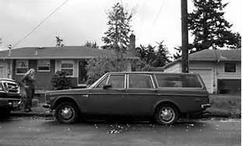

Jones’s Vehicle

When the driver of the vehicle passed my exact location he looked across the median and it became clear that he recognized my patrol car. I assume that conclusion because he began to slow down. I checked the traffic in both directions and made my exit from a stationary position and crossed the median to head westbound in pursuit. After crossing the median I realized that the vehicle had slowed down so the only pursuit was for me to catch up with his current location. As I pulled in behind him on US 74 westbound we were beginning to approach the US 401 business exit. Like many other exits on a controlled access highway the off and on ramps are confusing to a motorist that is not familiar with the area. He glanced into the rear-view mirror as a motorist would to see if I was following him personally. I'm positive after we made eye contact and he saw the blue light flashing and that he realized that I was following him and not some other vehicle. This short portion of the roadway had an emergency lane that would have been sufficient for both of us to pull safely off the highway. His vehicle had slowed down to approximately 20 mph and he continued to ramble forward. He looked in his rear-view mirror and saw me motion for him to pull over. I sounded my siren at this point just to make sure that I complied with the law. North Carolina required at that time that an audible signal be available to alert the motorist stop. Maybe this was why he didn’t pull over.

There was still nothing happening at this point to draw any suspicious conclusions on my part. I had seen so many drivers, scared to death when the light came on that this was nothing unusual. We called this “Black and Silver Fever.” The only obvious choice for him to pull over was now to take the down ramp off of US 74 heading toward US 401 business or Main Street. The driver took the off ramp and proceeded about 50 yards before stopping on the left shoulder of the ramp.
I had already determined from following the vehicle for well over one quarter of a mile that the driver was the lone occupant of the vehicle. I had also determined that he is registration or license tag as you may know it, was valid and from Georgia. I also recognized that the registration was issued in Dekalb County which was one of the five counties that made up the greater Atlanta area.
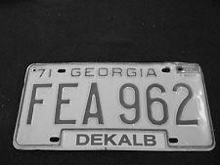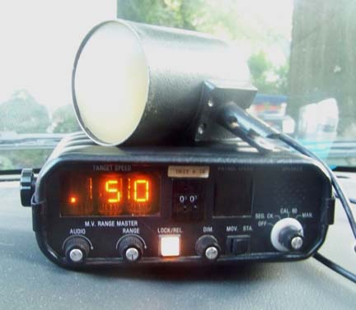
One of the tricks that I had been taught early on was to check and see how the license tag was attached to the vehicle. Often time’s stolen vehicles along with stolen license tags are attached with only one screw or bolt. Another sign of the stolen vehicle might be that the front license tag is placed on the rear of the vehicle and covered with bugs. Another sign is that two different types of bolts or wire to secure license tag may be used. I’d done this so many times that these checks were subconsciously done during my initial vehicle approach to the traffic stop. None of these signs were apparent so nothing alerted me to this being a stolen vehicle.
I positioned my patrol car in a normal location just back far enough that I could see the license plate along with the entire vehicle in case something was moving around inside. As I made my initial approach I kept my eyes on the driver but once again checking for hidden occupants in the vehicle or anything suspicious. I noticed a greenish colored tarp or cover in the rear compartment of the vehicle. There were some clothes in the rear seat area but so far nothing looked out of place.

After looking at hundreds of traffic stops you just automatically glance for weapons or drugs or anything out of the ordinary that might be a problem. I asked the driver for his license. My particular routine was to ask for a driver’s license only on the initial conversation with a motorist. Many troopers asked for license and registration. I felt like giving the driver the opportunity to lean over and conceal a portion of the middle of the car along with putting his hand out of sight in the glove compartment was risky. My thoughts were that if I address him and find out who he is first, would allow me to worry about whether or not the vehicle he's driving a stolen or properly registered at a later time.
The driver reached into his right front pocket and produced a Sucrets Lozenge box. He opened the box and inside was his driver's license. I thought that most unusual that I'd never seen that type storage container for a driver’s license before. As he removed the license I noticed there was a small amount of change in the box as well is some sort of a medallion or a button.
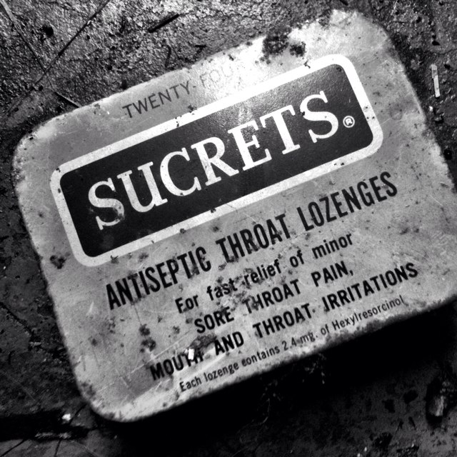

I very carefully looked at his driver's license to make sure that his physical traits match the picture on the license. Gregory Hudson Jones was his name. After making a positive identification of the driver based on his driver’s license I informed Mr. Jones that it would be necessary for him to follow me to the magistrate's office to post bond since he was an out-of-state motorist. At that time only a few states had begun to recognize each other’s traffic citations and agree to impose penalties on the drivers if they did not return to the state issuing the citation and satisfactorily complete and abide by any penalties imposed by the issuing state.
Jones simply nodded his head in agreement with my informing him he would need to follow me to post a bond. At this time I could still see his hands in his lap and he was not making any nervous jesters or movements that would cause me to believe that this was anything other than a simple traffic citation.
The mind and the conscience play huge tricks on an individual on the run. I'm sure that when Jones first noticed me along US 74, he had to believe there was a great chance that I knew who he was. I'm sure sitting in the front seat of his automobile he realized that at some point by following me to a magistrate's office his identity would be discovered. There I was, standing beside his vehicle and the only thing separating him from his continued freedom at this point was me. In his mind shooting one more person to maintain his freedom was not a big decision. After all he had shot three other people and killed a man in Wilmington North Carolina, so what was one more.

As I turned to step away from his vehicle I heard his voice say “hey”. I stepped back to his vehicle in the same position I had previously taken during my earlier information exchange with him. When I stepped back beside his vehicle he raised a .380 automatic pistol and with both arms extended and elbows locked he began to fire into the left side of my chest in the area of my heart.

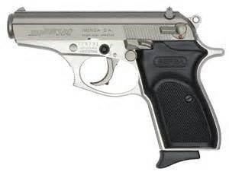
Typical .380 Semi-Automatic Pistol
As the first bullet slammed into my chest and lodged on top of my heart. My body went into full shock. Everything appeared in slow motion. Jones fired the first four rounds at me as fast as he could pull the trigger. I could actually see the bullet casings ejecting from the right side of the weapon onto the dashboard of the vehicle Jones was driving. That’s how I knew it was a semi-automatic weapon. The second bullet went thru my chest into my left lung and out my left side. The third bullet went into my upper chest and out my back. The fourth bullet went in my left chest, traveled thru my upper body and lodged under my right shoulder. As my body began to turn counterclockwise and move away from the gunfire I began to bend forward at the waist and provide a clear target with the right side of my head and neck for the fifth bullet to slam into my body just under my right ear. This was the most devastating blow so far. My head felt like it'd been hit with a baseball bat. I was still standing after 5 shots.

My counterclockwise turn continued but I was able to reposition my feet so I would not lose my balance and fall down. I did stagger backwards but I was able to keep my balance by placing my left hand on the rear quarter panel of Jones vehicle to prevent me from falling. During the twisting and turning it occurred to me that I should draw my weapon and fire back at the assailant. My mind told my body to act but my right arm was numb and would not react. By now I'm spitting blood and I'm too confused to think about using my left hand to draw my weapon and return fire.
After balancing myself at the rear of Jones vehicle I felt my legs beginning to weaken. They didn't seem to want to hold me up any longer. I squatted down thinking I may regain my composure but I fell backward onto my left side. As I looked back towards the driver's door of the vehicle I noticed that Jones had gotten out and gone into the grassy area beside the vehicle to retrieve his driver’s license. Subconsciously when I began to turn away from the first three or four bullets I had tossed his driver’s license which I was holding in my left-hand out into the grass.
I'm lying on my left side hoping that Jones would get back in his vehicle and leave but instead in a crouched down position using his vehicle for cover from a passing motorist he lunged towards me with the weapon in his right hand and fired two more shots into my body. The first shot struck me in the front side of my right hip and the second shot struck me in my right arm tearing through the shoulder patch that was on my uniform.
He stood over me, pointing the gun at me and squeezing the trigger. He was out of bullets but I could still hear the trigger click as he was pulling. There's no doubt in my mind if there were more bullets in the gun he would have continued to shoot me.
I could now hear vehicles approaching the down ramp and I was hoping this activity would scare him off. Jones took his right foot and stepped between my legs placing his left foot next to the outside of my right leg. He was reaching for my weapon and there wasn't anything I could do about it. He was about to get his hands on a Smith & Wesson model 19 .357 Magnum loaded with 158 grain steel jacket hollow points.

Just one shot with my weapon would've finished the job. Jones pointed the weapon at me and I could hear of vehicle passing right by our position on the side of the road. We were both hidden on the left side of our vehicles so that approaching traffic really couldn't see what was going on. Jones didn't have time to take a survey to determine whether or not he had been seen so not taking any chances he raced back to his vehicle, quickly got inside and drove off with my gun.

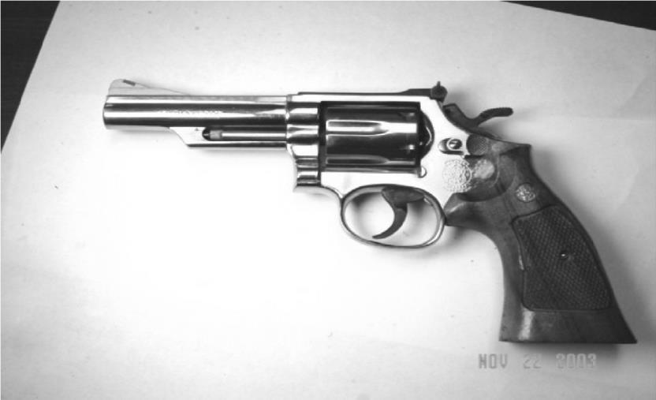

Smith & Wesson Model 19 .357 Magnum

This is the exact a moment that the strangest thing in my life occurred. As I'm lying on the side of the road, still positioned on my left side so I could spit out the blood, I had a complete flashback of my entire life ending with me in a casket with my parents and sister looking down on me. The details of my funeral were incredible. The service was held at the Second Presbyterian Church in Concord, North Carolina with a Highway Patrol honor guard standing at each end of my casket. I was wearing my full dress uniform including white gloves and my patrol hat was positioned just below my hands. This was the church that my grandparents attended and that my mother grew up in. My casket was placed in the exact spot where I had sung a solo in church at the age of six years old. The church was packed with friends, troopers and law-enforcement officers from jurisdictions all over the southeast. Rev. Crawford White proceeded over the funeral allowing testimonies and eulogies from different friends, family members and coworkers. I could see every hockey game at the Charlotte Coliseum, all of my high school days, college parties, and so many more lifelong details that were so vivid. The lifelong flashback seemed to go fast but the funeral seemed to dwell on. I could hear the official Highway Patrol radio broadcast, Attention all cars, funeral arrangements for Trooper Harry E Stegall, H-238 Laurinburg. Visitation will be held Monday evening, October 20, 1975 from 7PM until 9PM at McEwen Funeral Home, 600 East Morehead St. Charlotte, North Carolina. Funeral services will be held Tuesday October 21, 1975 at 1:00PM at the Second Presbyterian Church, Franklin Avenue, Concord, North Carolina. Interment will follow at Sharon Memorial Park at the corner of Sharon Amity Rd and Monroe Rd. Charlotte, North Carolina.

I seemed to snap out of this flashback just as quickly as it had happened. I then said something to the effect “Lord I need some help here, I'm not ready to go yet, there's still a lot of things I want to do and I'll try to be a better person”. I felt that had no other alternative but to try to help myself at this point and I am sure God sent me help.

All of a sudden at the very moment that I asked God for help, from nowhere, a passing motorist stopped, jumped out of his vehicle and came to my rescue. As he approached me on the side of the road he realized how bad my condition was and decided he needed to go for immediate help. He told me that he would be right back with help. I begged him to get into my patrol car and use my radio to call for help. He resisted at first but I kept telling him that help was right there in the front seat. He finally agreed and got into my patrol car. As he got in I hollered to him to make sure that the radio was on channel 1 before he tried to transmit. I told him to key the microphone and say “there’s a trooper shot behind the Chevrolet place on the 74 by-pass in Laurinburg.” I heard him say something to that affect. I didn't hear response from the radio station so I hollered to him as best I could to say it again. He basically repeated the same transmission and again with no response.

I'm sure the man was panicked and as shocked as I was about being in that position with a police officer, needing help. The man, later identified as Rudy Bartholomew ran back to his vehicle and took off to get help. Rudy traveled to the end of the down ramp, crossed Main Street and entered the Plaza Texaco service station. He told one of the workers at the gas station to call an ambulance because there was a trooper shot right up there on the hill. God had sent me the first angel of the day.
Suddenly, I felt all alone again and realized that while help may be on the way it was up to me to try to make something happen while I was still alive. I knew that someone needed to know the man's name that shot me. I tried to get up but I couldn't. I rolled from my left side onto my back and began to push myself with my feet back towards my patrol car. I would feel my mouth began to collect blood and I would have to stop and spit it out so that I wouldn't choke. Even though one of the bullets had struck me in the right hip, I was still able to pull my legs all the way up, dig my heels in and push my body approximately 1 foot at a time. I stayed focused on trying to get back to my car and was worrying about scaring my belt and not being able to wear it when I returned to duty. I was in a positive frame of mind. I was in the survival mode. That pushing I took in patrol school was paying off.
Looking back on the incident I was surprised that no one else stopped to help me. However, I have to believe that by the time a passing motorist saw me on the side of the road, stopping their vehicle could put them in a dangerous position from some other motorist coming off the down ramp and not being able to stop.
I had pushed far enough along on my back that I was beside the left front wheel of my patrol car. I knew I only had a couple more feet to go until I got to the door. Several more pushes and I realized that my car door was open. Thank God for that because there would've been any way I could have pulled myself up and opened the door. I was now able to reach out with my left hand and pull as I pushed with both feet to push me and pull me closer and closer to my goal which was to get to my patrol radio. Pushing myself past the open door of my patrol car allowed me to take my left hand and pull myself into a sitting position by the armrest on the door. From that sitting position I rolled to my right placing my shoulder and upper body against the car for support. That radio was only a few feet away and I had to get to. I was listening to see if I can hear any radio traffic about me being shot. The radio seemed dead. I could see blood squirting from my chest. I was still focused on making a radio call.
I thought about all those mornings on those long runs around Chapel Hill that I didn't think I could go a step further. I thought about how I reached down and found a little more energy to finish that run. I specifically told myself that I was a Highway Patrolman and no one could take that from me. Get to that radio, get to that radio, I thought over and over.
My left lung had completely collapsed at this point and my breathing was very shallow and far apart. Resting against the side of the car I thought I may get my second wind and crawl up in the front seat and call for help. It occurred to me that there might not be a second wind and that I better give it all I had and get up there and call right then. With the steadfast determination and the help of the good Lord, I took my left hand and with the steering wheel pulled myself up onto my knees with my upper body resting partially on the front seat and partially on the floorboard of the patrol car. Again with my left hand I reached for the cord on the radio that held the handset. As I began to pull the cord I realize that the handset had fallen off the seat and was in the passenger side floorboard. I had to reposition my hand several times to get to the microphone. I keyed the mic and before I had time to say anything I realized that the radio was on channel 4. The patrol did not use this radio station in our part of the state. That's why when Rudy Bartholomew tried to call for help there was no response.
I felt my body getting very weak as if I wanted to go to sleep. I wondered if this was how death feels as it comes upon you. My overwhelming thought was to get a radio transmission out so this man will get caught. I knew if I failed to let someone know his name it may take months to figure out who he was. I felt angry for a moment, angry that I had let this happen. So angry that I was going to get that radio no matter what. I reached the channel selector with my left hand and switched back to channel 1. I thought to myself that this might be my last call so do it right. Calm down, do it right.

I said in a very calm voice, “H – 238 E-Town I've been shot on the bypass behind the Chevrolet place in Laurinburg last name Jones.” I remained calm and transmitted the exact same message again. I heard the dispatcher then say “all car stand-by. H-238 has 10-33 traffic.” At that point I knew my message had been received. All radio transmissions were on tape so I was confident that my complete message would be heard. I felt weaker and weaker but I knew I had done all that I could do. I knew that I was truly in the hands of God as I slipped away. I was later told by one of the sergeants in the area that he heard my transmission and said that I was so calm that he had to listen to it again to be sure what I was saying. He said I certainly didn't sound like a man has been shot and was calling for help. For all intent and purposes I was gone, unconscious and unable to breathe. In that struggle for life I held on long enough for help to arrive. Or should I say “God kept me hanging on.”

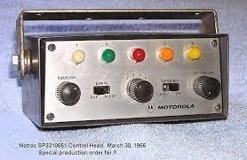
Exact Radio in my Patrol car

Chapter 11

Unknowing to me Rudy Bartholomew had done exactly what he pledged to do and that was to summons help. There was no 911 in those days but the emergency medical services were making great strides in how to help patients stay alive in route to a trauma center or hospital. The Scotland County ambulance service was located less than ½ mile from where the shooting took place. In the mid-70s the ambulance services were making the shift between the Cadillac hearse type vehicles to the big box ambulances like being used today. The biggest improvement in patient care during the transport was that the men and women who had earlier been referred to as attendants were being trained and referred to as EMTs.
Not much had gone right that morning or at least in my eyes, but my luck changed when the ambulance arrived. We were only 1.5 miles from the hospital but the emergency care that I received along the way saved my life. The director of the Scotland County ambulance service was on board that morning and answered my call. Ted Williams, the director whom I affectionately referred to as “Stump” was a trained EMT. I did not invent the name Stump as everyone called him but I sure enjoyed using it to agitate him. Obviously he was not tall in stature.

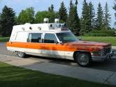
Ambo to Hospital

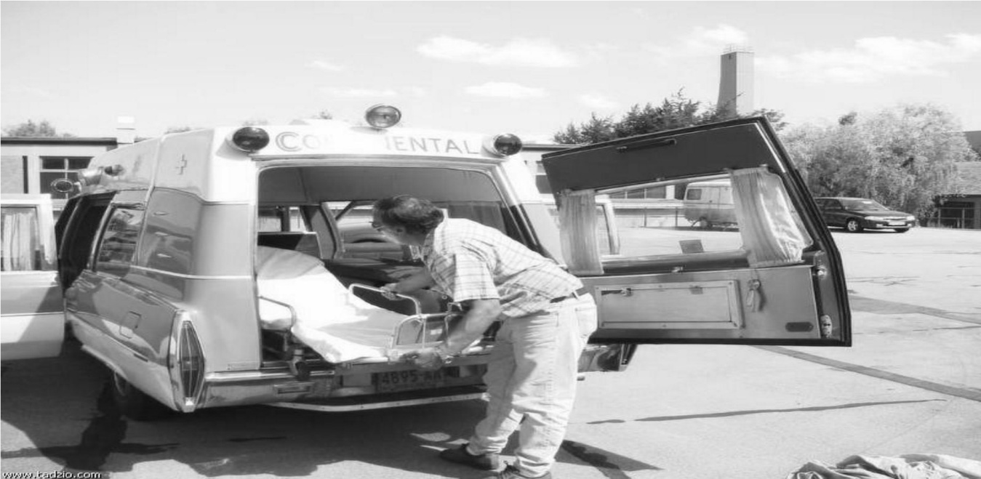

When I regained consciousness in the ambulance on the way to the hospital I was so disoriented I didn't know where I was. My first thoughts were that I was in a hearse because the siren was not blaring. Then as I turned my head to the right and I saw Stump. He immediately became my new best friend. I looked around and realized that I was in an ambulance and I reasoned to myself that the siren wasn't on because we were near the hospital. Ted had placed an oxygen mask on my face which had helped my breathing and allowed me to wake up. I tried to move my right arm but it was still numb. With my left hand I removed the oxygen mask from my face so that I could ask Ted how bad was I hurt. Like all good medical personnel he gave me the standard answer “everything is going to be okay”. Well I knew that was a lie because I had counted the bullets and my right arm would not move. I reached over and got Ted by the shirt with my left hand, pulled his face close to mine and said, “This is no time to lie to me, how bad am I?” Ted replied very quickly and in an almost hysterical manner “you're pretty damn bad, you're pretty damn bad, lay still.” That's all I was looking for at that time was an honest answer. I soon realized that Ted Williams was the second angel God sent me that day. Trained in EMT, he saved my life before we arrived at the hospital.
As soon as we arrived at the emergency entrance to the hospital I heard Ted Williams give some information to one of the nurses that was about to take over my care. He gave her blood pressure reading, a pulse reading and something else I was unable to determine. He also informed her that I had swallowed my tongue but on their arrival to the scene they were able to use a tongue suppressor and place my tongue back into the normal position.
I was rolled into the emergency room at the Scotland Memorial Hospital to a team of doctors and nurses which seem to go to work immediately as if they knew what they were doing. While some of them worked feverishly to control my bleeding, one nurse began to cut my uniform off me. Little by little I watched that uniform disappear from my body. The effects of taking that uniform off were almost as dramatic as being shot. I just couldn't imagine what might be next in my life if I survived.
I felt like a cowboy wanting to die with his boots on. I wanted to die with my uniform on. The shoes came off with my socks. I was freezing cold. I heard every squeeze of the scissors as they went up both pant legs to remove my pants. The scissors went up my shirt beside the front buttons and up from both cuffs to the shoulders. They were going to cut my belt off and I asked them not to. I told them how to remove the buckle. My t shirt was covered in blood also. They cut it from my neck to the shirt tail. Everything was pulled from underneath my body. My under shorts were last but not for long. I was naked in more ways than one. No clothes and no uniform. Looking at that uniform as I tried to survive on the side of the road was my reminder of who I was, what I stood for and not to quit.

Making his way into the emergency room and sliding into position next to my right shoulder was Sgt. Blalock. I could tell from the look in his eyes and the expression on his face that he had doubts if I would survive this just like I did. By now my uniform was off. Each time they removed the bloody gauze to check the wounds Sgt. Blalock could see where those bullets had torn into my body. He quickly regained his momentum and asked me what I could tell him about the shooter. I told him that his name was Gregory Hudson Jones from Atlanta Georgia. I also told him that I stopped Jones for speeding and that he was driving an orange or red Opel or Volkswagen station wagon. I was also able to provide the first three letters of the license tag on the vehicle. Blalock said he would be back later that he needed to get that information out as soon as possible. I suppose in a show of goodwill he patted me on my hand and said “will get him and you're going to be okay.” I had always believed that whatever Blalock said was one of the missing books of the Bible. He and Trooper Peterson were my idols.
There were medical procedures being performed right and left. A portable x-ray machine was brought into the room and pictures of my chest were taken. I felt the pinch on my right ankle and then noticed it being raised about 12 inches above the table. The doctors were starting blood transfusions. The nurses asked me several time if I was any pain at first I replied yes. Then I realized that they begin to administer morphine. Eventually most of the pain had subsided or was very much under control.
My training officer Trooper Craig Howell arrived at the emergency room in the middle of all the chaos. He took my hand and I could see the tears in his eyes. Before he could say anything I looked at him and said “go find that man and kill him especially if I don't make.” Craig nodded his head and quickly left the emergency room. Craig had been on the Highway Patrol for a long time and personally knew 4 of the last troopers killed. I guess I looked like number 5.
One of the nurses asked me if there was a family member that I need to call. My dad was the first person that came to mind and probably in the grand scheme of things the most important to inform. I was able to give his office telephone number to the nurse to contact him. The nurse immediately dialed the number and learned that my dad was out of the office but could be reached by his car phone. Car phones in the middle 70's were almost like a gadget from outer space. Not many people had one. The nurse reach my dad by phone and then past the call off to me. He told me that the nurse told him that I'd been shot and that I was in the emergency room at the hospital but she didn't have much more information for him. He asked me what I knew and I filled him in the best I could. I told him that I felt like I was stable but that I wasn't sure exactly how many times I've been shot. He told me that he had to drop someone off at the office that was riding with him and that he would go pick up my mother and they would come to Laurinburg. I told him to go get my mother and then get back to their house. I was sure that someone would be contacting them to make arrangements for a patrol car to bring them to Laurinburg. I told him he probably had a phone call waiting at his office to make the arrangements. He later told me that he was comforted by the fact that I was able to give details and suggest arrangements for him and my mother to get the Laurinburg.
At approximately 9:30 AM that same morning, one of the doctors approached me, still in the emergency room and gave me their plan for my treatment. The doctor said that they would continue to give me blood transfusions and stabilize my condition. He said that they were going to insert a chest tube to remove some of the blood that was in my left lung. The doctor then told me not to be alarmed but that my neck wound and some of my chest wounds needed to be attended to by trauma specialists that were not available in Laurinburg. He said they would make arrangements for me to be transported by helicopter to the UNC Hospital in Chapel Hill, which was a designated gunshot trauma center. The doctor’s tone of voice was almost like he was asking me if it was okay to follow this course of treatment. I thought to myself, what can I do? I have no idea what they can and can't do to me anywhere. I looked at the doctor and said “thank you for what you're doing here, let's get going.”
It became common knowledge quickly in the hospital that I was going be transferred by helicopter. I suppose some people would draw the conclusion that my condition was much worse than it seemed. Now that the doctors had backed off from what they could do, the care seemed to be in the hands of the nurses monitoring my vital signs and paying close attention to my blood transfusions. One particular nurse whom I was very fond of happened to be on duty that morning in the emergency room. In those days nurses wore white dresses but were very short. I had commented on numerous occasions about this particular nurse's good-looking legs. I used to tease her and say that if she would just let me play with her legs I would leave the rest of her alone. That morning as I waited in limbo to see what the next move was with the transport, she rubbed my fore head, wiped much of the blood from my face and tried to be very consoling. She asked me if there was anything she could get from anyone or if there was anything I needed her to do. I told her that I was still not certain if I was going to make it out of this situation and if I had to go I want to be holding on to her thigh when I went. She started to laugh and said “you just won't give up will you?” I just smiled and barely shook my head no. I had been taught to never give up. She said “you win, go for.” Lucky for me the IV was in my right arm and my left arm was available to hold onto her thigh. The funny thing was that people came in the room with my hand up her dress and were either embarrassed or left or just shook their head and laughed.

Bad luck struck again. Someone else came into the emergency room and she was called away to administer treatment to that person. Oh well, I could hold on to that thought. At approximately 9:45 AM Sgt. Blalock returned to the emergency room as one of the doctors was about to give me more information about helicopter flight. The doctor informed me that the 57th Army medavac transport helicopter had left Fort Bragg and would be arriving at the Scotland County high school in approximately 45 min. I would be transported by ambulance to the high school where I would be placed in the helicopter and flown to Raleigh-Durham Airport. At that time I would be placed in an ambulance and transported by ground to the UNC Hospital. The doctor also suggested that I have someone in my family or close friend accompany me all the way to Chapel Hill. Sgt. Blalock was listening to this conversation but I doubt he was ready for what I was about to ask. I told Sgt. Blalock he was the closest thing I had the family anywhere around so he was it for the helicopter ride. He told me he needed to go home, shower and clean up and then he would be right back. Before Blalock left he asked me if I was sure I didn't know who this Jones was when I stopped him? I told her no I did not know who he was but should I have known? Blalock replied that Jones had been on the news for a couple of days in connection with a murder and several shootings in Wilmington. I reminded him that I had been off duty for several days and had traveled to Charlotte.

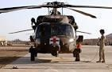

Army Helicopter Ft Bragg, NC

Chapter 12

While I was resting in the emergency room the beginning stages of the manhunt were under way not just in Scotland County but surrounding counties and in South Carolina. The procedure was to determine how far a particular assailant could have traveled from the time of the assault until the time of notification. I was able to give them an exact time early on in the hospital so they calculated that this individual that shot me probably could have not gotten more than 15 miles away based on the traffic condition without being detected. The captain ordered roadblocks in Robeson County east of Maxton on US 74. Also at the Scotland Hoke County line on US 401 North. He also ordered roadblocks on US 501 N. a few miles into Moore County. Roadblocks had already been established on US 74 W. in Hamlet about 15 miles from where the incident occurred. South Carolina troopers received notification and begin setting up roadblocks on 401 S. just across the state line and additional roadblocks were established on 501 S. into Robeson County. At that point the initial perimeter had been established for major roadways.

At approximately 10:15 AM just about two hours after the shooting there was no sign of Gregory Hudson Jones. At this point conferring with Highway Patrol officials Captain McKee ordered roadblocks on another perimeter about 50 miles away from where the shooting occurred. The roadblocks on the first perimeter were continued in case Jones had not escaped area but the second perimeter was established just in case that he had escaped the main area. All that could be done now was to work checking stations and patrol the area in hopes of spotting the suspect or his vehicle.
When I arrived at the hospital at approximately 8: 25 AM I gave the attending physicians and emergency room personnel the exact name of the assailant on the driver’s license Gregory Hudson Jones. I also informed them that he was driving a faded orange or red Volkswagen or Opal station wagon with current Georgia registration plates. I also provided the hospital staff the first three letters of the license plate on the suspect vehicle. My information included a description of Jones and what he was wearing.
As soon as this information was relayed to the Highway Patrol dispatchers it was sent to every computer terminal in the state of North Carolina. At that time the PIN or the police information network was the immediate link between every dispatcher in every law enforcement agency in the state as well as other states. When the information was transmitted the dispatchers and New Hanover County where Wilmington, North Carolina is located, they recognized the name as an individual wanted for murder, kidnapping and assault with a deadly weapon the prior week on Wrightsville Beach. Once they gathered the sketchy information from patrol telecommunications and began to ask questions they verified that the individual that shot me was the same individual that local warrants were about to be issued for the day before in another shooting.
This corresponding information was transferred to the detectives working the case in New Hanover County. They immediately contacted the district attorney's office and asked that they could appear before a Superior Court judge and obtain a warrant for Jones for interstate flight to avoid prosecution in their cases. This would allow the FBI to join in the search and use their resources to notify other law enforcement agencies that Jones is on the run. The judge that they appeared before granted the interstate flight warrant because the assault on me was so close to the South Carolina line that there was a good chance that Jones could have fled across the state line. At that time the district attorney asked the judge to declare Gregory Hudson Jones an outlaw in the state of North Carolina. After listening to all of the information from the violent crime spree in New Hanover County in the preceding days it was determined that Jones more than fit the profile of an outlaw. To make the case even stronger the bullet was removed from Peter Fearing’s head and rushed to the SBI lab in Raleigh. Removing the other bullets from the boys that were shot on Thursday night took a little more time because surgery had to be scheduled. The SBI lab was standing by waiting to match the bullet that was taken from me to the bullet taken from Peter Fearing to confirm one of the most bizarre incidents in the history of the state of North Carolina.
All of the pieces of the puzzle were starting to come together as to who Jones was and the reason that he shot me. Word spread faster than fire about the kidnapping, murder and assault with a deadly weapon on three different people in New Hanover County making everyone involved in this case realize that Jones was a dangerous man. Gregory Hudson Jones was a Vietnam veteran and a former member of the Army's 101 Airborne unit. He was honorably discharged in 1970. He later enrolled at Cape Fear Tech in Wilmington, NC in their Oceanography course. A subsequent search of his home in Wilmington discovered large amounts of Heroin and LSD. He was later described as a major drug dealer.

As soon as I was brought into the Scotland Memorial Hospital information was relayed to the local television and radio stations that a trooper had been shot in Scotland County. This brought a wave of reporters and photographers to the hospital to follow the story and to keep their viewing and listening audiences up to date. The information was sketchy in the beginning so the television and radio broadcasts didn't have much to go on other than color of the car and a basic description of the driver.
At approximately 9:15 AM a bread truck driver, based in Charlotte, was traveling westbound on US 74 approaching Hamlet, North Carolina. At this point the bread truck driver, later identified as Richard Broadway of Charlotte, had not heard the radio notifications about the shooting. About ½ mile from the Hamlet city limits a vehicle traveling eastbound on US 74 was flashing it's headlights to oncoming traffic. Just as soon as the Broadway realized that an oncoming vehicle was flashing his lights he noticed a small compact orange or red vehicle make a quick left turn onto NC 381. As a professional driver he realized that many motorists would avoid checking station for all sorts of different reasons and paid no more attention to the hard left turn. As a Broadway approached Hamlet he noticed six police officers with shotguns stopping and talking to every driver both East and West bound. When Broadway approached the officers his truck was inspected and he was motioned on. After he was released from the checking station Broadway continued on westbound 74 towards Charlotte.

As Broadway continued his journey towards Rockingham, North Carolina he noticed five or six Highway Patrol cars speeding east on US 74 with their lights and sirens on. This tweaked the interest of the bread truck driver so he turned on his AM radio and tuned into a local station in hopes that he might find more about what was going on. Within minutes Broadway heard the broadcast on his AM radio that a trooper had been shot in Laurinburg. The assailant was described as a white male, in his mid-20s with long blonde hair. He was believed to be driving an orange or red Volkswagen or Opal station wagon with Georgia registration. It immediately occurred to the Broadway that that orange or red vehicle that had made that abrupt left turn approaching the checking station at Hamlet matched the description of the suspect vehicle. Being a good citizen Broadway turned around and went back to the checking station in Hamlet and informed the officers of what he had seen just before approaching their location on US 74. Acting on this information troopers were summoned to the area of NC 381 to look for Jones.
As Jones made the left turn on Highway 381 he knew that those flashing headlights meant that the police were ahead. He also realized that he was in the process of being surrounded and that continuing on in that vehicle would surely lead to his capture. As Jones traveled east on Highway 381 he could see a railroad track running parallel with the highway. He realized that railroad track would not be traveled by any vehicles looking for him and that the tracks will provide good cover. Having experience in the Army, Jones found a densely wooded area filled with pine trees. He knew he had to find a place to hide his vehicle where a passing police car or even just a motorist would not be able to see its location. Jones maneuvered his vehicle between rows and rows of pine trees finally into a position where it could not be seen from Highway 381. He covered the vehicle with the green tarp that I had noticed in the rear compartment of his vehicle during a traffic stop. This tarp provided excellent cover from ground and air search. Having only one way to go, Jones made his way down the railroad tracks towards an unknown land but away from the area where he last knew that law enforcement officers were waiting. That unknown land he was headed to was Gibson, North Carolina, approximately 11 miles from where he had hidden his vehicle.

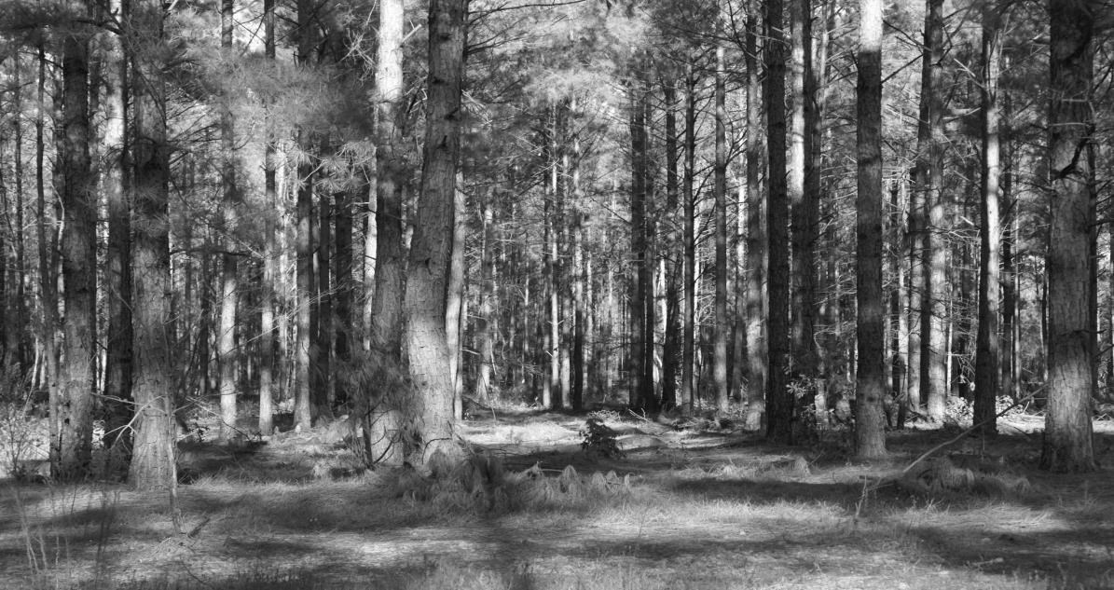

Jones Hid His Car in These Woods

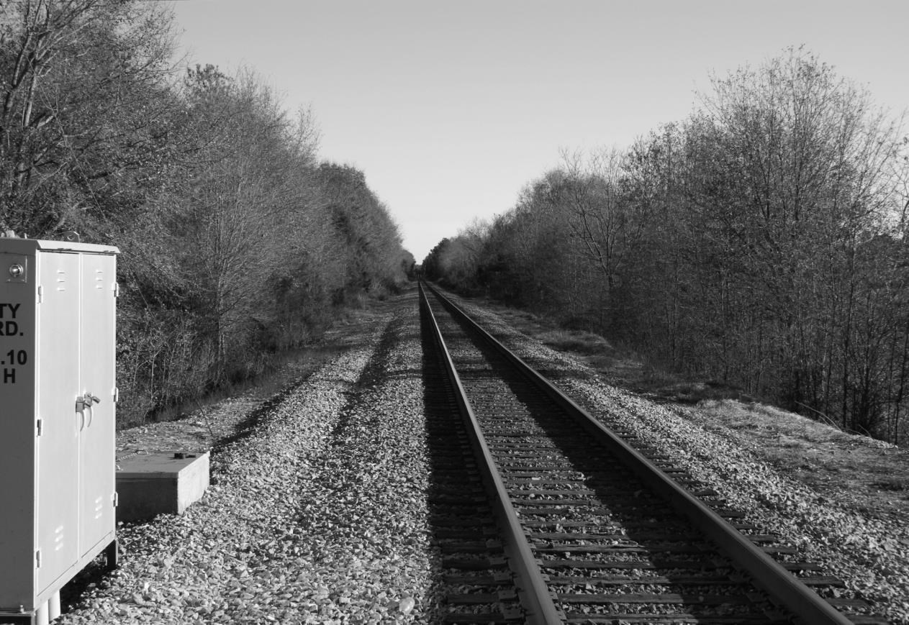

The Railroad Tracks Were His Cover and Escape Route

After lying quietly for what seemed like my second eternity of the day the nurses came in and started to prepare me to move from the stretcher that I was on to another stretcher to be placed into the ambulance. They disconnected me from the main oxygen supply in the hospital and placed with me on a small bottle of oxygen which would eventually make its way to the helicopter. My body was cold. I felt like I was in a refrigerator I asked for more blankets because I had on nothing on underneath the blankets. All you can see was my head sticking out of the big bandage under my right ear. As we made our way to the ambulance there were hospital personnel and other people just standing by many with tears in their eyes and all of them wishing me good luck. After being placed into the ambulance, we made the 5 min. trip over to the Scotland County high school with a police escort. We traveled at the normal rate of speed lights on but no sirens. I could see out the side of the ambulance because again I was transported in one of the old hearse style vehicles that had windows down both sides. I recognize landmarks as we travel toward the high school as well as when we arrived at the school.
I didn't realize at the time but we pulled into the main front lawn of the high school which was wide open. Once we were in position the helicopter landed about 30 yards away. As I was taken from the ambulance I could see that it looked like the school had been dismissed to come outside and watch this event. There was a ring of police officers 100 yards wide around the helicopter an ambulance. I supposed this was protection in case this guy wanted to come back and try to finish me off. I expect that was more dramatic than anything else. I had to be loaded from the stretcher into a basket located by the exit door. I noticed that there was a medic in the back with me along with Sgt. Blalock sitting on the jump seat and two pilots up front. It suddenly occurred to me that I had asked a close friend and coworker to possibly watch me die. I didn't know if I would live or not and he later told me that the only thing he could see were holes in my chest which weren't very encouraging. I needed him there so I would die with a friend. He made a sacrifice to take a chance that I have never forgotten.
While being transferred to the helicopter I was amazed that it looked just like the pictures of the Army helicopters with the big Red Cross on the nose and the side that you saw on the news channels that had flown wounded soldiers out of Vietnam.
There were so many things going on at this particular time that it was impossible for any one person to keep up with everything. Capt. McKee had notified my father earlier in the morning that there would be a patrol car to meet him at his residence and transport him and my mother to Laurinburg. During this exchange of information the Capt. McKee had no idea that I would be transferred to Chapel Hill. My dad had found my mother at her normal Friday morning beauty shop appointment. Her hair had just been washed and set and she was about to go under the dryer. My dad walked in and immediately she knew something was wrong. He told her that I had gotten hurt and to get her pocketbook and let's go. During the ride home he told my mother that I had been shot but that he didn't know the full extent. He also told her that he talked to me and that I seemed in good spirits and seemed to be coherent with everything going on.
When they arrived at their home on Providence Road a patrol car was waiting in the driveway to take them to Laurinburg. Both my parents ran inside, grabbed a few personal items and put them in a small suitcase. They were out the door and gone in less than 10 minutes. My parents were about to receive another shock that they couldn't do anything about until they finally got to my location. When Trooper Yelton, H-541 advised the patrol radio station that he was in route to Laurinburg with my parents, the dispatcher informed Trooper Yelton that I was being airlifted to Chapel Hill. There was nothing anybody could say or do to try to explain the sudden move to a higher level medical facility. All during that normal 3 ½ hour trip that only lasted about 2 ½ hours, the Highway Patrol radio continued to broadcast wanted bulletins for Gregory Hudson Jones in the shooting of Trooper H. E. Stegall. My parents didn't know the procedure but Trooper Yelton knew that if I were to die those bulletins would be immediately changed to Gregory Hudson Jones wanted in connection with the murder of Trooper H.E. Stegall. For Trooper Yelton this made the trip even more difficult knowing that my condition had changed and no answers were available. If I died he would have my parents to deal with.
Like any good trooper in a hurry you tend to get faster and faster. Trooper Yelton was no different. He told me later that he had eased up to consistent speed of over 120 mph on the way to Chapel Hill. At one point he told me that my dad reached over and touched him on the arm and told him that it was OK if he wanted to slow down since it was raining. After running 120 mph 90 seems like you are going slow.

Legislation passed by Congress on 01 July 1974 allowed the 57th Medical Detachment (RA) to become one of the first participants on the Military Assistance to Safety and Traffic program commonly known as the MAST Program. On 12 October 1980, the unit reached a milestone in medical evacuation support when it completed its one-thousandth MAST mission. As of 01 March 1985, the unit had flown more than one-thousand five-hundred MAST missions. In the MAST program, the 57th Medical Detachment (RA) provided on call Air Ambulance service to civilian communities of North Carolina, South Carolina, and Virginia.
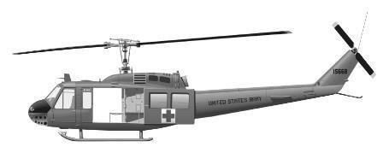

I’d never been in a helicopter before. When I was very close to joining the Marines I expressed my desires to become a helicopter pilot. I just thought they were fascinating machines. Now I'm getting a free ride but under circumstances that no one could wish for. I was being air lifted by the 57th Medical Detachment based at Ft. Bragg, North Carolina. The 57th had a prestigious history serving in Vietnam.
It was loud inside the chopper. I noticed that the medic had on headphones along with Sgt. Blalock. They seem to be communicating between each other using the headphones. This ride seems like my third eternity for the day. I kept my eyes closed and tried to rest. My good thought for the day was holding on to the nurse’s thigh. My body was still freezing cold. Periodically I would open my eyes and look to the left and all I could see was gray skies. I had no idea how high we were or how fast we were traveling. I noticed that the medic looked at the oxygen bottle several times. I couldn't see the gauge on the bottle but that's the only thing he could be looking at. Having no idea how long we had been in the air, I began to feel the helicopter stop moving and feel like it was hovering. As I looked out the window it appeared that the density of the fog was going straight up which meant we were going straight down.

We appeared to be moving very slow so I assumed that we were landing. The medic told me in my ear that we had landed in Raleigh-Durham and were waiting on an ambulance to transport me over to Chapel Hill. At that point I had no reason to question why we didn't fly the helicopter on the Chapel Hill. Not being able to judge time I just lay there in my state of eternity. I noticed the medic pick up my oxygen bottle and the gauge was on the very low side. I thought to myself they better change this bottle I might be out in a few minutes. There was no extra oxygen bottle. The medic reached under the blankets with a stethoscope and listened to my heart and lungs. He said something to the pilot and I felt the helicopter began to lift and then the sensation of flying again. I couldn't imagine what we were doing. I thought were waiting on an ambulance to take me to Chapel Hill. The distance between the Raleigh-Durham airport and North Carolina Memorial Hospital by air is less than 15 miles.
What I didn't know was that one of the most heroic efforts by an Army pilot flying a civilian was taking place at that very moment. It was determined by the medic that I was almost out of oxygen and that I couldn't wait on the ambulance. It seems that the ambulance was late leaving downtown Raleigh. It made more sense to try to fly me on to the hospital in Chapel Hill than wait because of the lack of oxygen.
Communications with the ground did not exist because nothing had been set up to fly directly to the hospital. These pilots were truly, on their own. I had no idea what was going on other than that we were hovering and moving and hovering and moving a little bit at the time turning from side to side. I assumed that they were trying to position themselves to land or to do something other than just travel. As we were in a hovering position the clouds began to break piece by piece and I noticed a crane that looked like it was within 50 feet of the helicopter. I thought to myself, oh no, I survived this far and now I'm going to get killed in a helicopter crash. I felt the helicopter move again and then reposition itself. I then felt the helicopter touch the ground. I was ready to get back on the ground. I realized later that God sent me another angel to fly that helicopter mission.
Here is the story told by the pilot himself, CWO 4 Richard G Seifried:
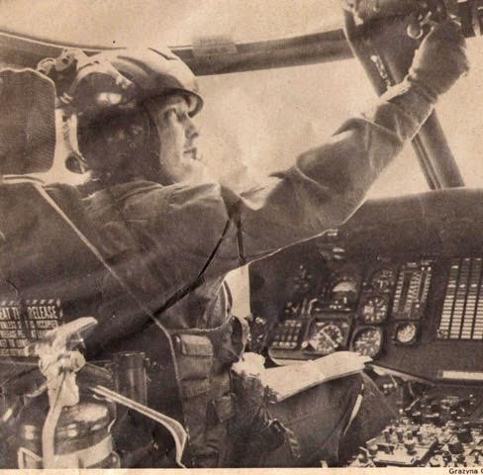
The Flight to save an Officer Down
I was First Up, Pilot-in Command assigned to the 57th Medical Detachment, Fort Bragg, NC when we received a call in the early morning hours of October 17, 1975 in our Ready Room at Simmons Army Airfield, for a MAST (Military Assistance To Safety and Traffic) mission to pick up a women and her premature baby in a small hospital north of Asheville and fly them to CMC in Charlotte, NC. The mission went smooth and after dropping them off, we were on our return flight to Fort Bragg in the clouds IFR (Instrument Flight Rules). When we were in the area over Pinehurst when we heard a call on our Police Band Radio that an officer was down in the Laurinburg, NC area.

The Medical Evacuation Pilot’s Motto is: “Anyone, Anywhere, Anytime” and we always tried to live by our Motto to honor the memory of ones who had fallen. After I reviewed the situation, not doing this mission due to weather or any other reason was not an option! We’re going!

I realized there was not an Airport in the Laurinburg area that I could shoot an instrument approach to and we only had 30 minutes of fuel remaining without going into our emergency fuel load. After several radio calls and planning, I formulated a plan on how to do this mission. I requested an abbreviated GCA (Ground Controlled Approach) approach into Simmons Airfield and to save time requested hot refueling through my Base Operations Center. We never shut down or got out of our aircraft. I filed a flight plan and checked weather over the radio with Base Ops and was reminded that the weather at the airfield and most of North Carolina was below VFR (Visual Flight Rules) flight weather minimums. Within 10 minutes of landing I took off and as I was passing through 50 feet and outside the airfield Control Zone I acknowledged the radio call regarding the weather and changed frequencies. I radioed ATC (Air Traffic Control) requesting flight following and traffic advisories to Laurinburg and was told that due to my altitude they were not able to get radar contact with my aircraft. Using a NC road map I found Laurinburg by following roads and we found our pickup site about 45 minutes later in a field near a school. The field was lined with people, many in uniforms and police cars with lights flashing and I saw the ambulance just as we landed.

At this point all we knew was that we were picking up a NC Highway Patrol Trooper who had been shot, and we were not going to let him die on our watch. As he was being loaded onto our UH-1 Huey another man approached my Crew Chief and informed him he was coming along too. I could tell from the look on his face that despite anything any of us said or did, or the fact that we were not allowed to transport civilians, that man was getting onto my aircraft. So I told my Crew Chief to let him board unless he thought he could kick his ass. He quickly let the man board our aircraft behind the cabin area. (He was Sgt JR Blalock) As our patient was being loaded, someone came to by door and handed me an envelope and told me it was the patient information. On the outside of the large envelope was his name; Trooper Harry Stegall. We got Trooper Stegall and his Sgt. loaded and took off quickly, as my crew closed the doors, heading north.

The weather continued to decay with heavy rain and a few minutes after takeoff I declared an emergency with ATC, and climbed to an IFR (Instrument Flight Rules) altitude requested priority IFR clearance directly to Raleigh-Durham airport. A few minutes after take-off my medic was reviewing Trooper Stegall’s medical information in the envelope and gasped as he said, “This guy has been shot 7 times. We need to get him to Chapel Hill as soon as possible.” At this point I pushed our UH-1 air speed as fast as I could. During the flight to the Raleigh Durham airport I made several radio calls to ensure an ambulance was waiting for us with all the needed medical equipment, and informing UNC Hospital of our time of arrival to ensure a trauma team was on standby. After a fast instrument approach into Raleigh Durham we started looking for our ambulance as soon as we broke out. I landed on a runway, calling Tower and Ground Control to ask about our ambulance. They could not tell me where our ambulance was or give me an ETA. The only thing they could tell me was that they were sure the ambulance delay was due to the severe weather in the area. If we waited much longer fuel would become an issue and we would have had to shut down to refuel at a civilian airport which was time we could not afford. Moments later my Medic told me we were running low on O2 and he did not think Trooper Stegall would live if he was not on a OR table in 30 minutes. With no ambulance, and running low on O2, I decided we had to try and make it to the UNC Hospital to save Trooper Stegall and take off now!

I called the tower and requested Take Off clearance. They warned me about the weather again and asked if I was sure I did not want to wait for the ambulance or try and make it to Duke instead. I thanked them for the warning and advice about trying for Duke but told them we had to try for the UNC Hospital. They gave me take off clearance as I was clearing the runway heading southwest to UNC.

Again using a NC road map, we found Interstates and roads that led us to Chapel Hill but the weather kept us at no more than 100 feet AGL (Above Ground Level). In route we had a bird’s eye view of many of the taller buildings that were higher than our altitude in and around Raleigh Durham. Rain was heavy at times requiring us to fly about the speed of a fast walk not loose visual contact with the ground. We flew past several construction cranes that we were not able to see the top sections. As we got in the Chapel Hill area the weather went zero, zero and were forced to land in a parking lot next to a shopping center. I had my Crew Chief go ask a man (shocked that we had just landed next to his car) if he could give us directions to the UNC Hospital. He told my Crew Chief to follow the road we were on and turn right at the light in 6 blocks. As we took off my Co-pilot and Crew Chief was looking out the windows looking for obstacles in our flight path and helping me navigate around them. I saw a cross appear out of the clouds and realized it was on the top of a church as I flew around it. At one point we saw a red light thinking it was a light on top of a tall building, suddenly realized it was the traffic light at the intersection where we needed to turn right to UNC. After a few minutes I spotted the Bell Tower on the UNC Campus and knew exactly where we were and setup for approach to the parking lot behind the Emergency Room.

After we landed, I unplugged and helped unload Trooper Stegall and all the medical equipment. I followed the trauma team and Trooper Stegall into the ER entrance. Once inside I handed Dr. Herb Proctor (Chief of Trauma Department) all the paperwork and information we were given in Laurinburg and I returned to my aircraft. We took off and returned to Simmons Army Airfield.

This mission was a pivotal moment in my life, learning the true meaning of “Risk vs. Reward”, and what could be done if you set your mind to it and refuse to give up! This lesson served me well over the next 20 years as a UH-60 Blackhawk, Instructor Pilot flying many other rescue and special operation missions in peace time and in war.

It was not my actions that taught me this…it was Trooper Harry Stegall’s.

More than forty years later on February 13, 2016 we found each other and talked for the first time on the phone. It was one of the most wonderful phone calls I have had in my life. Of the hundreds of missions that I have flown over the years he was the only patient that I had ever talked with. I think talking to Harry that day was a validation that all of the bad that I have seen, all of the deployments, all of the deaths, all of the hardships that I put my family through during my 23 year Army career, maybe it was worth it. Thanks Harry!

This is Trooper Stegall’s story; I was just a small part of it!!!!!!

Richard G. Seifried, CW4, AVN, US Army (Retired)
Warm Regards,

Chapter 13

Obviously someone on the ground figured out that we were coming by air because the second we touched down the doors flew open and the basket I was in was quickly moved outside the helicopter onto a waiting transport vehicle. I had been so thirsty in the hospital and on the flight but was not allowed water. I opened my mouth and felt the steady rain slip down my throat. After all I've been through in the last through four hours I didn't feel like a glass of water would kill me.
Waiting for me was a legend in the making, Dr. Herb Proctor. Dr. Herbert J. Proctor was the principal leader in the development of biomedical services at NCMH. He was the founder of the Department's Trauma Service, was instrumental in developing aero medical services throughout North Carolina, and specifically at UNC. Gaining first-hand experience with the lifesaving capabilities of air transportation for critically injured persons as a military surgeon in Vietnam, he initiated a relationship with the Army at Fort Bragg, NC, that in 1972 resulted in the first aero medical program in North Carolina, known as the “MAST” (Military Assistance of Safety and Traffic) Program. I later learned that the pilot flying my mission was assigned by the Army to assist Dr. Proctor as he introduced the MAST program around the state. They flew together to many small hospitals to introduce the program that would lead to my successful treatment. I was in the best of hands with these two men.

As a trauma surgeon at UNC-CH, Dr. Proctor served as aero medical Commander for NCMH, dispatching military helicopters across the state for missions bringing neonatal and trauma patients to Chapel Hill. When the MAST Program closed in 1985, each hospital proceeded to develop its own program for aero medical services, remaining loosely affiliated. The Carolina Air Care Program began at UNC Hospitals in 1986, saving innumerable lives. Dr. Proctor’s vision and energy had founded Carolina Air Care's formation and catalyzed its success.

In 1996, the UNC Hospital's Board of Trustees named the aero medical facility on the roof of the new Neurosciences Hospital "The Herbert J. Proctor MD Memorial Aero medical Facility," recognizing Dr. Proctor's contribution to trauma transportation and care in North Carolina.
Dr. Proctor, a popular member of the faculty and former Secretary-Treasurer of the Nathan A. Womack Surgical Society, died in 1990. The Proctor Award was created in his honor to provide recognition and support of surgical resident research.

Dr. Herb Proctor
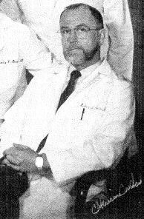

Everything seemed to be in place. I made it to the trauma center, roadblocks had been set in numerous locations and troopers were called in from all over of the state to search for the vehicle. I was notified that my parents were about 15 minutes away from hospital. What was happening in the outside world was almost incomprehensible.
What I was learning piece by piece was that an undercover police officer in New Hanover County was in a bar on Wrightsville Beach sometime around October 1, 1975. This undercover officer heard Gregory Hudson Jones whom he had no idea who he was, agree to kill another man named Peter Fearing for $50. Now, who in their right mind would believe that there was a hit on somebody for $50 over a drug deal? Nobody!

On October 11, 1975 Jones went down own Wrightsville Beach looking for Peter Fearing. The Beach is a good place for kids to hang out smoke dope because the wind blew the smell away. As Jones approached the group that he believed Peter Fearing was a part of, he recognized several of the young men in the group. They also recognize Jones and didn't think it out of the ordinary for him to hang around with them since he always had some grass with him. Jones didn't realize that one of the other young men in the group was named Butch Herring. Since they all called each other by their last names, Jones was confused about which man was Butch Herring and which man was Peter Fearing. After partaking in a marijuana joint shared by everyone on the beach in that group, Jones decided that it was time for him to act on the reason he was searching for Peter Fearing. Actually Jones was convinced that Butch Herring was Peter Fearing and set his sights on him. Jones moved himself into position so that he would have an easy shot on his target. Jones pulled out the same semi-automatic pistol that he would use during the rest of his crime spree but was grabbed by one of the young man in the group trying to prevent Jones from shooting his target. A brief struggle ensued and Jones got off one shot that hit Butch Herring in the groin. This mistake proved to be life changing for Butch Herring. The shot severed Herring's testicles from his body. Everyone scattered in all directions. Not knowing the extent of his injuries, Butch Herring ran up the beach and into a bar about 200 yards from the shooting. Herring collapsed to the floor but the patrons of the bar realized he was bleeding terribly and call the police and an ambulance. When the police were finally able to question Butch Herring he told them that Gregory Jones was the shooter but knew nothing more about Jones. In order to protect his friends who were all involved in drugs, Herring continued to tell police that this was just a random act of violence. The police didn't particularly believe Herring but was nothing more to go on there was little they could do.

Jones made his escape off the beach and back to his car. The only way on and off Wrightsville Beach is to use the causeway or swim across the channel. One of the young men that was in the group on the beach was walking across the causeway when Jones spotted him as he was about to drive away. Jones pulled up beside the young man named Ronald Elkins, pointed his gun at him and ordered him to get inside his vehicle. Elkins being scared that he also might be shot took a seat in Jones's vehicle. Jones had reason to believe that his target was still alive and at gunpoint ordered Elkins to tell him where Peter Fearing lived so he could go finish the job. Elkins finally put a piece of the puzzle together and realized that Jones had shot the wrong person. Elkins convinced Jones that he had actually shot Butch Herring and that Peter Fearing was the tall slender blond headed guy that was in the group on the beach. Jones demanded that Elkins show him where Fearing lived. At gunpoint Jones drove Elkins to the address that he provide and pointed out the Fearing residents. Jones then told Elkins that if he told anyone that he was looking for Peter Fearing that he would return and kill him as well.

In the next several days everything returned to normal. It's unimaginable that Elkins didn't tell Peter Fearing that Jones had shot the wrong person and that his life may be in danger. It's also unimaginable that Elkins would continue to hang out with Peter Fearing knowing that Jones was looking for him. I can only surmise that in the world of an 18-year-old that spends his life smoking dope and listening to loud music wouldn't think at all about a guy like Jones returning to finish the job.

5337 Fielding Dr. House Where Jones Killed Fearing

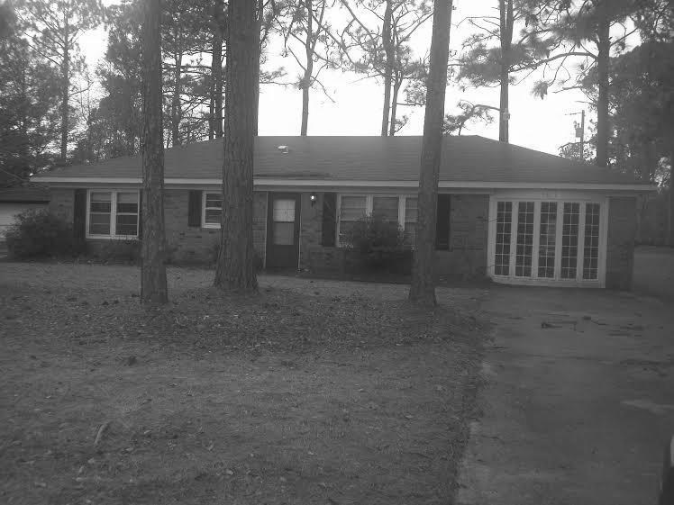
On Thursday, October 16 several of the guys who hung out and around this little group gathered over at Peter Fearing house to do what they do best. Smoke dope and listen to music. As the sun set that evening Jones returned to the neighborhood and began to watch Peter Fearing's house. It didn't seem to bother him that there were other guys in the house along with Fearing. As Jones approached the house after darkness set in he could hear the loud music coming from one particular front corner of the structure. Jones slipped around to the back of the house and found an unlocked window with a screen that could be easily removed. With all the music Jones could have taken a baseball bat and knocked the whole window out and no one would've known.

After removing the screen, opening the window and slipping into the back bedroom Jones made his way down a hallway that ran almost the entire length of the house. He checked each room to be sure no one was asleep or could attack him from the rear. Jones checked to make sure that his weapon was in the firing position and that he had an extra clip ready to go to his pocket. The particular type of weapon he was using held six rounds in the clip and one in the chamber. As Jones made his way to the entrance of the room where the music was coming from he noticed three young men hanging around. Elkins had his back to Jones and was adjusting a stereo.

Jones first two shots struck Elkins squarely between the shoulder blades in the middle of his back. Elkins slammed forward into the music equipment and everything went silent. The shock of the sudden attack briefly paralyzed the other 2 men in the room. Jones quickly shot Bryan Jones (no relationship) in the thigh. He had 4 bullets in this clip. His target Peter Fearing had been stretched out on the couch. As quickly as the shots were fired, Fearing realized what was happening and he rolled onto the floor seeking cover. Jones then began to fire at Fearing as he moved around the couch continuing to seek cover. Jones had emptied his weapon, striking Fearing twice. Very calmly he ejected the clip, replaced it with a full clip, breached the weapon and began firing again at Peter Fearing. After several more shots at Fearing, he began to barely move on the floor. Jones approached the back of Fearing's body and fired a bullet into his head that completed his mission. Jones gathered his spent clip and headed for his vehicle parked just down the street. In all the confusion Bryan Jones was able to escape to the next-door neighbor's house and ask the resident to call the police.

At this point there was no reason to connect the Wrightsville Beach shooting of Butch Herring to the Peter Fearing killing. The only person that knew the connection was Elkins. Elkins was probably one of the luckiest people on earth. He been run over by Greyhound bus, struck by lightning and shot twice between the shoulders and was alive to talk about. As the evening progressed and investigators were able to talk to Elkins, the pieces of the puzzle with Gregory Hudson Jones began to come together.

What they knew so far was that Jones shot three people, kidnapped one person, killed one person and broke into the Fearing residents. The strangest piece of the puzzle continued to be missing because there was no clear motive as to why Jones would go on this type crime spree without good reason. When all of the area law enforcement agencies were alerted about Jones, the Wilmington Police detectives said Jones was eluding them on a breaking and entering warrant they were trying to serve from a week earlier. After obtaining a search for Jones residence, large amounts of LSD and other drugs were seized. It was looking like Jones was more than a casual drug user.

I felt worn out in the emergency room at Chapel Hill while this story about Jones and his escapades in New Hanover County were told to me. I'm trying to listen to what the doctors and nurses are telling me about my condition with one ear and the other ear glued to this information coming out of New Hanover County. I was told that the patrol felt that Jones had not escaped the initial parameter and more troopers were being brought in at that very moment to continue the search.

I had answered every question about my previous health conditions to help the doctors establish if there were any drugs or treatments that I might not respond well to. After performing several x-rays, one of the doctors went out and asked my parents if I had been shot before? Both my parents were floored. They had no idea that I'd ever been shot before, because I had not. What was baffling the doctors was that one of the bullets that entered my left chest traveled through my body and was lodged underneath the back part of my right shoulder. The bullet, not causing any damages across my chest, is what led the doctors believe that I've been shot previously. I heard one of the technicians say that they were about to declare that this was medically impossible for this bullet to cross my body and do no damage. That was the least of my worries.

There were no MRI’s in those days. The closest thing to a full body scan was a dye test. A special type of dye is injected into your bloodstream is in different locations of your body. During the x-ray the dye will show up not only in the blood vessels but outside the vessels if there are ruptures and tears. The test took approximately one hour which again was another period of time my life that I'd never get back. The only good thing about the test was that it did warm my body up.

I was being pumped full of antibiotics because of any potential infection from the gunshot wounds. One of x-rays had revealed that a bullet was lodged directly on top of my heart causing an indentation in the heart wall. What they couldn't tell from the x ray was if the bullet had cauterized that section of the heart. What the doctors had hoped would be a simple bullet removal had the potential to rip open my heart and cause all kinds of problems.

My right arm was still numb. No one would even address that at this point because to them it really wasn't life-threatening. To me it was very life threatening. Not being able to use my right arm would have been the end of the Highway Patrol for me. The doctors promised me that they would call in a neuro specialist to have an initial look at my arm within 24 hours. There wasn’t much I can do about it except pray and hope it got better. I listen to those doctors off and on for several hours and the number one thing they were concerned about was adding trauma to my body from unnecessary surgery. I had three bullets in my body and all I could think of was Doc Adams on Gunsmoke saying “those bullets gotta come out.”

With x-ray showing that there was a bullet lodged deep underneath my shoulder and another bullet lodged deep in my jaw I could only imagine how much surgery this could take to remove these bullets. After several hours doctors came in and told me that the bullet under my right shoulder may be causing the numbness in my right arm and hand. They told me that they had made the decision that my body wasn't strong enough to go under and exploratory surgery to try to weave around and find that bullet. As for the bullet in my face they felt the same way. They suggested that I consult an ear nose and throat specialist along with a plastic surgeon since the bullet removal would be obvious without plastic surgery. They also told me that part of their job was to recommend where I go next for treatment best suited for my situation.

Momentarily another doctor entered the room and they introduced me to him as a surgeon that would be removing the bullet on top of my heart. I asked him when this surgery was going take place and he informed me that I would be in the operating room within 30 min. I could only think that these doctors were the best of the best or they wouldn't be at this gunshot trauma center. I could only trust their judgment to leave those two bullets in but I did understand that these two surgeries could be as dramatic as the gunshot wounds. I was informed that everything was just it is been earlier in the day with no sightings of Jones anywhere in the area. All I could do was sit back and wait.

While I was waiting on surgery about 4 PM that afternoon Jones had made his way down the railroad track into the outskirts of Gibson. When you're on the run all you can do is look for something familiar or something that you know how it works. As Jones continued along the railroad tracks he noticed a school. He assumed that it being Friday afternoon after everyone left that no one would be back until Monday. This would give them safe haven until he could initiate his plan to escape from the area. Just across the street from the school was at church. People were subject to come and go from churches at all hours of the day and night. The church just wouldn't be a good option for Jones to hide.

About 5 PM the last vehicle left the school grounds and Jones begin to take a closer look at the layout of the school while it was still light outside. Having no flashlight he needed to make his plans early. As Jones walked around school he found a door going into one of the rear areas that wouldn't pose a problem for him to forcefully enter. Jones waited off in the distance until night came so that he could see a vehicle by the headlights pulling onto the school grounds that might pose a threat to him.

The first thing Jones did after entering the school was to find the cafeteria. There he found milk and leftover food that had been served in the previous days. The food was still good so he was able to find nourishment after his long hike down the railroad tracks. During that long walk Jones developed a scheme that he thought would help him escape the area.

Just after 4 PM I was taken to what looked to me to be a prep area for surgery. Everyone coming in and out of the room was dressed in hospital scrubs and wearing masks and gloves. Within a few minutes the doctor came in and introduced himself as the anesthesiologist that would be handling my surgery. He asked me several routine questions about what I was allergic to and if I had ever had general anesthesia before. I told the doctor that I'd never had an operation of any kind so this would be my first. He said “we’ll take good care of you”. One of the nurses told me to start counting backwards from 100. I don't even remember saying 99. I was out like a light.

The removal of the bullet on my heart went as planned. The X-rays immediately after the removal showed no damage to the heart walls. My wounds were cleaned and packed with an antibiotic material. My chest tube was performing properly but the doctors wanted me to stay on oxygen until they were certain that my chest was back at full capacity. The bullet removed from my heart was rushed by a waiting SBI agent to their lab in Raleigh for positive confirmation that the bullet that had shot me came from the same gun that killed Peter Fearing the day before in Wilmington. Within two hours the SBI ballistics lab had confirmed that the same gun was used in both shootings.

At approximately 6 PM my eyes opened and I couldn't remember anything except a nurse telling me to begin to count backwards from 100. A nurse standing only a few feet away noticed that my eyes were open and moved closer to speak to me. She said “welcome back, everything went great, how do you feel?” She began to rub my forehead in a very gentle and soothing manner. I told her that I felt very sleepy and drained. She mentioned that I needed to stay in the recovery room for at least another 30 minutes if I was trying to wake up. I asked her if I could sleep for a while because I was still so tired. She smiled and told me that I could sleep as long as I wanted to and that she would be right there with me. I closed my eyes and didn't wake up again until after 7 PM.

The same nurse was right there continuing to take my vital signs and monitoring equipment that I was attached to. I asked her what's next. She laughed and told me that she'd never seen that many people in a hallway waiting on someone to come out of surgery. She said that she had gone out earlier and told everyone that I was resting comfortably and it asked to sleep a little longer. She was able to determine that some of the people outside were family members, some were civilian friends but there were probably 20 Highway Patrolman out there. I asked where I would be taken next and she told me that they had a private room waiting for me in a critical care section especially for gunshot wounds. I told the nurse that I was ready anytime she was and thanked her for being so kind.

I actually started to feel guilty that all of those people were standing outside worried about my condition and I had not gone out to show them that I was okay. After all I was a Highway Patrolman and indestructible or at least that’s the face I'm supposed to wear. I was already thinking about long term recovery and if I would be able to go back to work.

As we made our way out of the recovery area heading towards my hospital room I was amazed at the number of people that were waiting for me. It looked like one half of the patrol headquarters personnel were there along with friends that I never expected to see that day. Of course my mom and dad were there, along with several of their very close friends to offer support to them as a waiting game continued. I was waiting on information about my condition, waiting for Jones to get caught and waiting for some reason that all of this had happened.

Chapter 14

Jones made his way to the principal's office that Friday evening and found a telephone. He tried to implement his plan to escape by calling a friend just outside of Atlanta, Georgia. When Jones found his friend by phone he told him that he needed him to come and pick him up in a small town in North Carolina because he was in trouble. He told his friend that he was located in Gibson, North Carolina and that he was at a school across the street from a church and down the street from the cemetery. Jones told his friend to find a vehicle and head that way first thing Saturday morning. The plan went so far that Jones had some way roughly calculated the time that it would take his friend to drive from Atlanta to Gibson. Jones told his friend that if he left Atlanta between 7 AM and 8 AM and drove the speed limit that he should arrive in Gibson at approximately 2 PM on Saturday afternoon. His friend continued to press Jones for what type trouble he was in. Jones finally told him that he shot someone in Wilmington and shot a Highway Patrolman in North Carolina trying to escape. His friend told Jones he would try to locate a car and they will work out the plans later that evening. He never called Jones back. Jones called his mother knowing that she would come for him.
Almost immediately after the friend hung up talking to Jones, the friend called the Georgia State Patrol in his area. He began to ask the dispatcher at GSP questions about a trooper being shot in North Carolina and if there were any suspects. The dispatcher became suspicious and transferred Jones's friend over to a supervisor. At this point Jones friend laid out the plan that Jones had in mind to pick him up and help him escape. What his friend couldn't remember was the name of the town where Jones told him he was hiding. The only thing that he could remember was that he was at a school, across the street from the church and a nearby cemetery. The friend refused to give any more information because he said he was scared of Jones. Without caller ID which had not been dreamed of yet or a wiretap, finding that friend would be impossible.
The Georgia State Patrol supervisor contacted the North Carolina Highway Patrol and informed them of the similarity of the information they had received from the police information network and the information they had received from Jones's friend. The North Carolina Highway Patrol made immediate contact with the Georgia State Bureau of Investigation. They both agreed that a stakeout on Jones mother's house also just outside of Atlanta might produce results to help capture Jones. All of this information was relayed to the command center in Laurinburg as just another missing piece to the puzzle. The FBI was able to secure a wiretap on Mrs. Jones residence. They determined that she was coming to North Carolina but her exact location was questionable.

Chapter 15
Once I was situated in my hospital bed people began to file through. Everyone just wanted to say hello and offer their best wishes for a speedy recovery. I'm still flat on my back and can barely move so I was not able to be my normal cordial self. The first Trooper in the room was Col. E W Jones. He was actually an old friend of my fathers, so he had a double interest in my well-being. He assured me that everything was being done to capture this individual and that they would not rest until they found him. I thanked him for coming. The floodgates opened. People were in and out, just touching my foot or my hand telling me they were thinking about me and they would see me soon. Around 8:30 PM I was surprised to see two of my long-time personal friends from Charlotte. They were Rudy and Sue Harrelson. They had heard about the shooting and decided to come to Chapel Hill when they both got off work that evening. Sue was an RN and had graduated from UNC – Chapel Hill with a nursing degree. She also worked there in the hospital and was familiar with the surroundings as well as many of the staff members. Sue asked me if she could sit as my private duty nurse until the next morning. Of course I agreed.

As the crowd began to thin out and Rudy (not the Rudy that stopped to help me) could get to me alone, he whispered in my ear and asked me if there was anything that I needed to tell him that I couldn't tell anybody else? As I smiled at his question he said, “Was there a jealous husband or boyfriend or anything like that?” I had to laugh even though it hurt but I assured him it was not a jealous husband.

I was scared at that point, the doctors couldn’t tell me much, my arm was numb, and I could hardly breathe. My thoughts were on my recovery if there was to be one. I was worried about going back to work. God sent the fourth angel at that moment. There was not a person on this earth that could have comforted me other than who was about to walk into my hospital room.

Suddenly in the doorway a man appeared that no one in the room recognized except me. He had a very stern look on his face. Everyone stood still as he walked to my bedside, reach down and touch my arm and said “You are going to be ok. If you don’t mind, I brought a book and I'm going to sit here beside you and read all night.” There was a calmness that came over my entire body. I was speechless. My eyes began to tear up in a huge lump appeared in my throat. The only thing that I could do in response was to just shake my head in a positive manner. Of course after that he introduced himself to everyone in the room and they all recognize his name from hearing me talk about him so often while I was in patrol school.

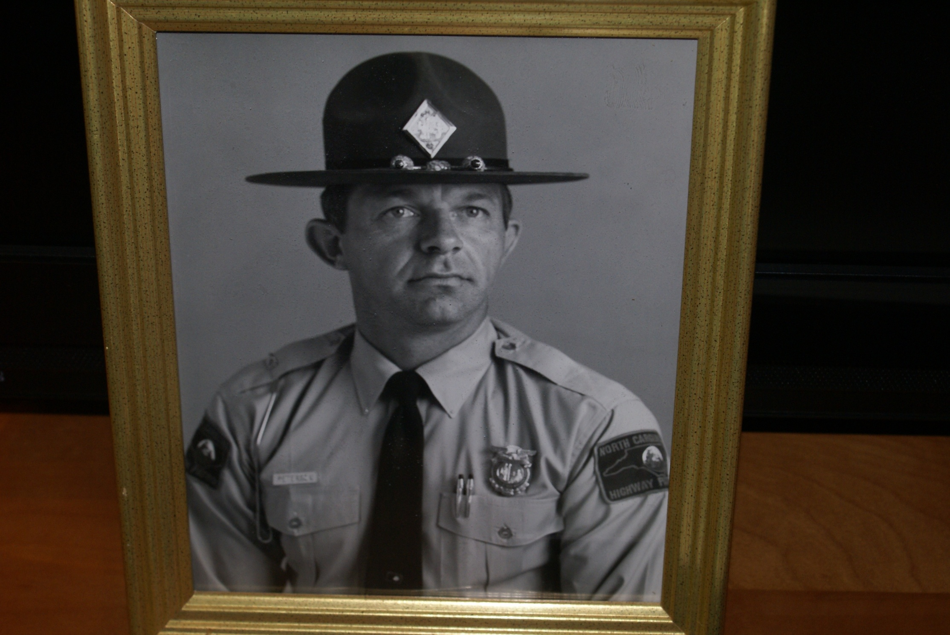

R L “Pete” Peterson
This was R L “Pete” Peterson, who seemed to be the most respected man on the Highway Patrol, there with me in the flesh. Pete had been our inspiration during the entire patrol school and was now there for me again. I woke up many times during that first night in the hospital, seeing trusted beloved friends Sue and Rudy on one side of the bed and one of the two Troopers that I admired most in the world on the other side of my bed. That was the site that I'll never ever forget. Pete was killed in the line of duty on May 31, 1979. No other troopers were killed in the line of duty from the date of my shooting until Pete was killed. That is still a terrible feeling knowing that I was so close to death and he was there with me and would be the next trooper killed. A piece of my heart broke the day Pete died and it will never be repaired.

The rest of the night was wake me up and then put me back to sleep, wake me up again and then put me back to sleep again. I was able to sneak in several packs of crackers and some Coca Cola off and on during the night. Having not eaten again since that sorry Egg McMuffin at 7 AM, those crackers and Coca-Cola tasted like a charcoal steak and a good cold beer.

Chapter 16

Sure enough, the police were right. Jones's parents (Jones step father) left their house at approximately 7:30 AM on Saturday, October 18. They loaded to small suitcases into the trunk of their car. To the investigators it did seem like a coincidence that they were going out of town while her son was on the run. While Mrs. Jones drove north on I- 85 she was followed by several agents with the Georgia Bureau of Investigation. The Georgia agents had been in touch with agents from the South Carolina Law Enforcement Division which were on standby to pick up their surveillance if Mrs. Jones crossed into South Carolina. After stopping for gas and continuing to drive north on I- 85 the Georgia agents advise the South Carolina agents through each other’s dispatch system to assume their surveillance positions and be ready to take over in just a few minutes.

Mrs. Jones crossed right into South Carolina and from vehicle descriptions and registration information the SCLED agents were now in charge of the surveillance. The distance from the Georgia and South Carolina state line to the South Carolina and North Carolina state line is approximately 100 miles. The agents predicted Mrs. Jones would be in North Carolina within 1 ½ hours. After the surveillance continued northward from Spartanburg South Carolina the North Carolina SBI agents were advised to assume there surveillance positions and be ready to take over within the hour.

As Mrs. Jones crossed into North Carolina the SBI agents picked up the surveillance and began to notify Highway Patrol officers that it appeared that the Jones were heading to help their son. This was the first time that a statewide radio communication was available to contact everyone involved to be ready to act accordingly to bring an end to this manhunt.

Early on Saturday morning October 18, the Highway Patrol command staff was not willing to take anything for granted. Not knowing for sure that Mrs. Jones was headed to her son, the patrol began to assemble and assault team to search specific locations where they thought Jones may be hiding.

From the information gathered by the Georgia State Patrol earlier the previous evening, troopers began to search maps of Scotland and surrounding counties for a location where a church, school and cemetery were in the same close proximity. Since the friend couldn't remember the name of the town that Jones was hiding was cause for the troopers to consider that Jones had made it into a surrounding county. However, their first duty was to flush out the locations that were mapped in Scotland County. The assault team had the use of a helicopter to remain overhead as 10 selected troopers saturated the given area in an attempt to flush Jones out. After making their presence known in the particular area they notified school officials to open the buildings for complete search.

The first location was in the northern part of Scotland County. The location failed to turn up any evidence that Jones was hiding or had been hiding in that location. At approximately 1 PM Mrs. Jones was traveling through Richmond County only about 15 min. away from Scotland County. The assault team had cleared their location also at approximately 1:30 PM and headed to the next location which was in Gibson, North Carolina, still in Scotland County but only a few hundred yards from the South Carolina state line.

Three Troopers, Mike Humphrey, Tim Thomas and Sgt. Minchew had been assigned to the Gibson area to alternate between roving patrols and roadblocks. At approximately 1 PM the troopers decided to set up there roadblock or checking station on Highway 381 at the Gibson town limit. What these three troopers did not know was that Jones was hiding less than ½ mile from their location. Neither Jones nor the troopers could see each other from their positions.

Being on the run and having to wait, makes time seeming that it will never pass. Jones projected rendezvous with his mother was at approximately 2 PM. Having no way to contact her he moved outside to make sure that if she arrived early he would be able to flag her down. After all his arrival time was a guess.

Jones had no idea of the logistics of the small town of Gibson, North Carolina. The people that lived in and around Gibson were mostly black. This was a farming community. If Jones had realized how easily he could be recognized as being “the only white man around” he would have probably planned his meeting with his mother during the nighttime hours so he wouldn't be detected. Jones had taken up a position beside the school in a hedgerow that adjoined a bean field. Jones had actually been in that field earlier trying to gain a vantage point to see his getaway vehicle. Unfortunately for him the beans were just not high enough for him to lay undetected in the field. That's when he decided to move over to the hedgerow between the bean field and the school.

There were several small children riding their bicycles and playing in the area near the school. The story of the shooting had been on all of the radios and television stations. By now nearly everyone in Scotland County knew that there was a man hunt underway for a white male with long blonde hair. The children riding bicycles and playing in the nearby area spotted Jones in the bean field just after 1:30 PM. The children went and told a man sitting on his front porch, passing the time of day, that there was “a white man in the bean field.” From his front porch position the elderly gentleman could see the patrol cars over on Highway 381 at their checking station. The man instructed the children to ride their bicycles over to the troopers and tell them what they had seen.

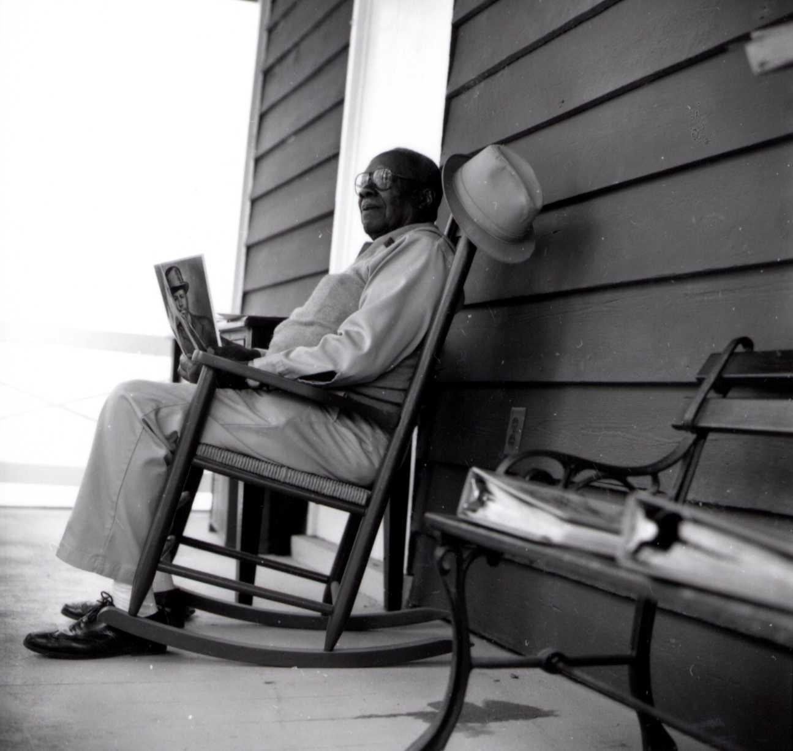

Old Gentleman Told the Children to Notify the Police

Chapter 17

After receiving the information from the children the three troopers jumped in their patrol cars and sped over to the school. Jones had nowhere to run without being detected so he hid down low in the hedgerow. The trooper's notified the command post of a possible sighting of Jones because they felt that what the children had seen was real. A quick search of the outside perimeter of the school revealed a door that had been broken into. The troopers entered and searched the school and it appeared that someone had been inside the building. Things didn't seem to be in place and food items were left out as if they had been eaten and partially discarded. After being sure that there was no one in the school, the troopers met outside to determine their next search grid in the area.

When they arrived back outside they noticed that a Marlboro County, South Carolina, Sheriff Deputy was pulling into the parking lot to offer assistance. As he got out of his police car he was carrying a machine gun. He told troopers that he heard them call the command post from his location on the South Carolina state line.

Approximately 25 yards away the troopers heard something scrambling on the ground and suddenly Jones stood up and said, “Can I give up?” Knowing the Jones was armed with my weapon and possibly the weapon he used in the other shootings the troopers immediately took up positions and ordered Jones to the ground. With Jones holding his hands high in the air and settling on his knees for officers began to spread out and approached Jones with caution. They ordered him to the ground, spread eagle and hands behind his back. The officers were creeping up step by-step to make sure that Jones was not hiding a weapon so that he could roll over and fire at them. Four gun barrels were pointed at Jones just waiting for him to make one false move.

As the officers approached they noticed what they immediately thought was my weapon just out of Jones' reach. Suddenly the three troopers dropped down on Jones's body to secure him and handcuffs were placed on his wrists behind his back. Two of the troopers picked Jones up by his arms and took him over to one of the highway patrol cars where he began the rest of his life in custody.

Trooper Humphrey was ordered to secure the crime scene which would in a matter of minutes produced a massive search throughout the school and the surrounding area for the weapon Jones had used in the other shootings. This immediate area also focused on the search for the automobile Jones was driving and any other evidence that might be crucial in a court case. Unfortunately the vehicle and the gun were not found at the scene of the capture.

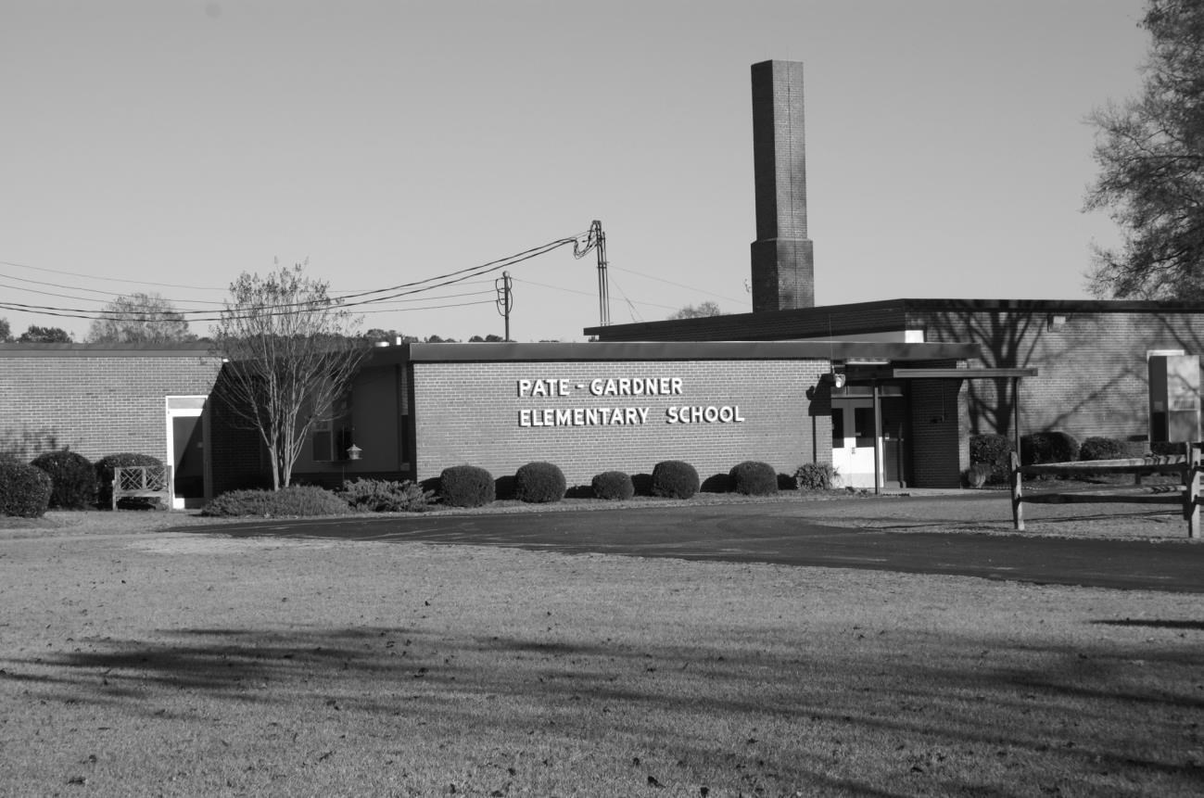

Jones Captured Just Outside the School

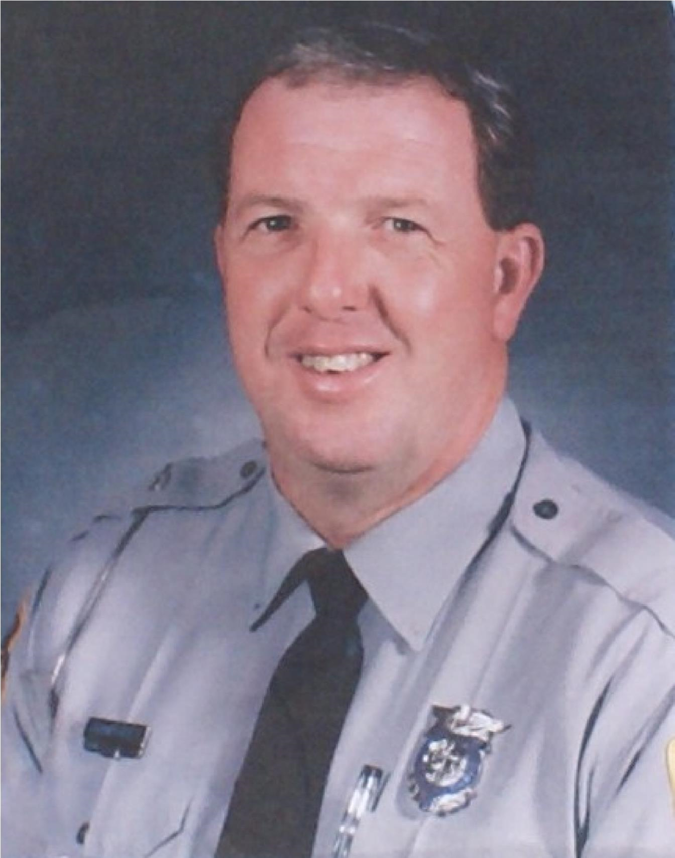

Trp. Mike Humphrey Helped Capture Jones

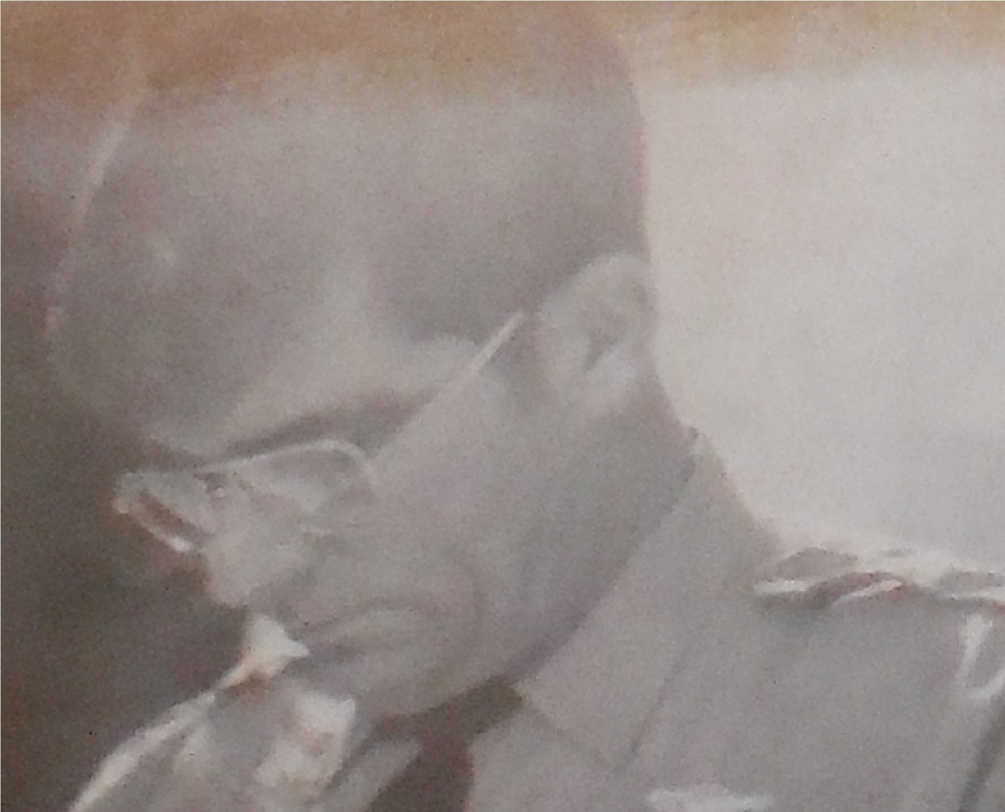

Trp. Tim Thomas Helped Capture Jones

Chapter 18

SBI agents and Highway Patrolmen continued to follow Mrs. Jones as she made her way through Richmond County heading toward Scotland County. When the troopers in Gibson radioed the command center that they had the suspect in custody in Gibson, Troopers Ed Lowery and Ron Airy, both stationed in Richmond County made a traffic stop on the Jones's. Being very coy, Trooper Lowery asked Mrs. Jones where she was headed. She seemed irritated because she was stopped but said that she and her husband were on vacation. Trooper Lowery had the pleasure of breaking it off in her. He told her that she was telling a lie and that she was headed to pick up her son which had just been captured only moments ago in Gibson, North Carolina. Not knowing if they may charge Mrs. Jones with aiding and abetting the escape of the fugitive Trooper Lowery took her into custody for questioning. He allowed her husband to drive the vehicle while he escorted Mrs. Jones in his patrol car. Ed Lowery was a smart trooper. He tried to prod Mrs. Jones on their 20 minute ride to Laurinburg about her attempt to help her son escape. Not much information was obtained because Mrs. Jones seemed to be in a fog after learning that her son had been captured. Trooper Ed Lowery was in my basic patrol school. He was a good man, a good father and a good husband. He was also one of the best troopers the state had ever had. On September 23, 1997 Trooper Lowery was killed on a traffic stop on I-95 by two men that had just robbed a savings-and-loan in South Carolina. Killed along with Trooper Lowery was a Cumberland County Sheriff’s Deputy, David Hathcock.

Sgt. Ed Lowery

Killed Cumberland County
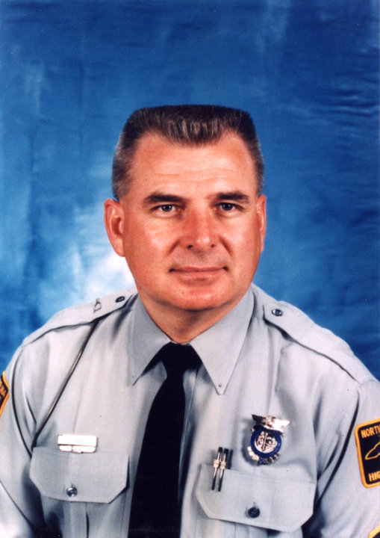

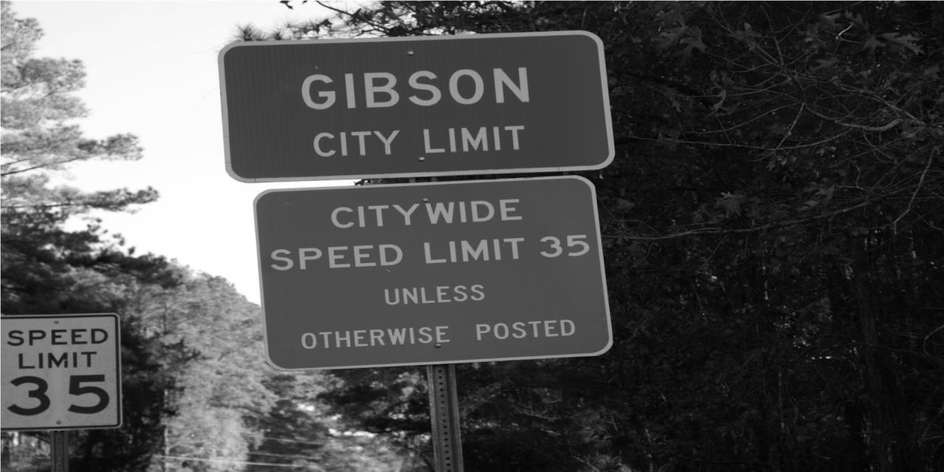

The Town Where Jones Was Captured

Jones in Custody with Trooper Joe Stanley

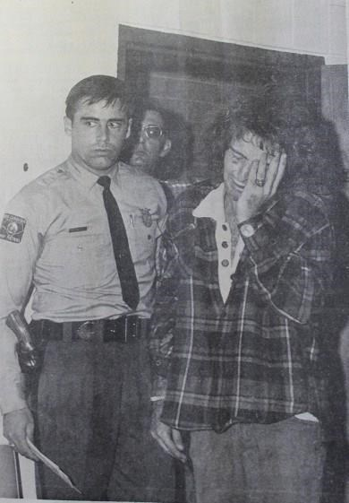

Jones Being Shown Personal Belongings When Captured

Laurinburg Police Chief N W Quick

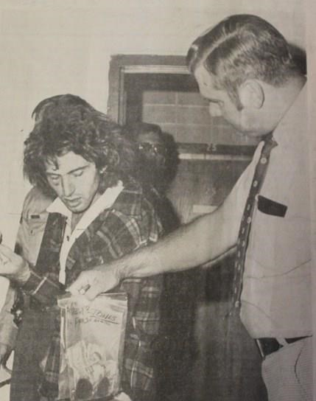

After Jones was captured on Saturday afternoon he was interviewed extensively by several different organizations including the Highway Patrol, the State Bureau of Investigation, the Federal Bureau of Investigation and the Scotland County Sheriff's office. Some of the clues to the investigators right after being shot turned out to be accurate and would eliminate any doubt in anyone's mind at preliminary hearing or at a trial that Jones was the assailant. One of the key pieces of evidence that seemed so ridiculous was that I told investigators that Jones retrieved his driver’s license from a small metal Sucrets can that he had in his pocket. When Jones was captured, the small metal can and his driver’s license were in his pocket. Of course my weapon in his position provided more evidence that Jones was the assailant.
Investigators drilled Jones for hours at a time about where he hid or tossed the .380 semi-automatic that he used to kill Peter Fearing and later shoot me with. Jones was actually driven around the county on several occasions to see if he could recognize an area where he discarded the gun. Unfortunately the Sandhill’s of North Carolina look very similar as you travel about.

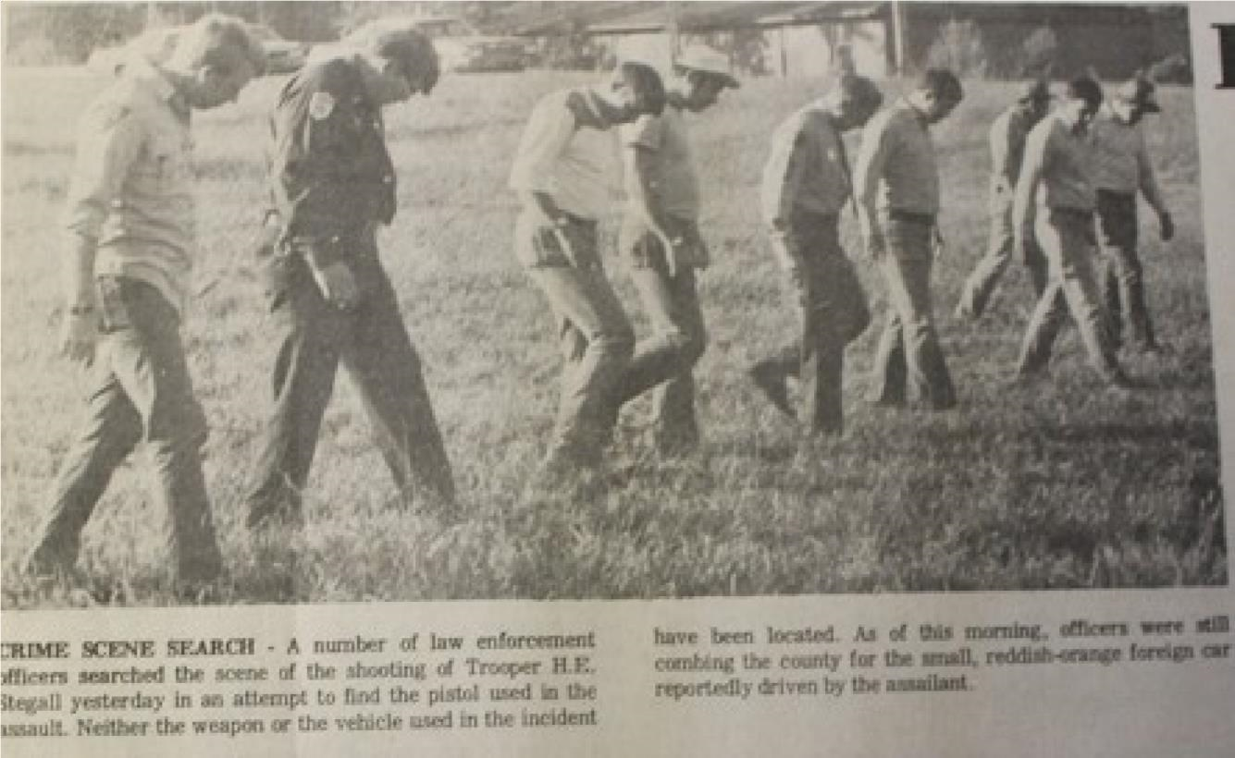

Crime Scene Search for Gun
Photos Provided By the Laurinburg Exchange

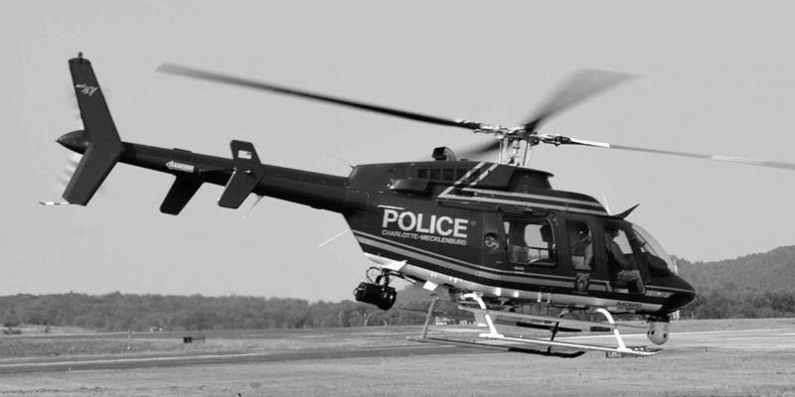

Charlotte Police Helicopter Assisted In Searches
Helicopter searches were conducted throughout the county for several days. Troopers were called in to assist in the search that officials believed had covered every square inch of Scotland County. The state decided to offer a reward for information that would locate the suspect vehicle. As days went by the award grew reaching $5000. Then suddenly a landowner found the vehicle parked on his property and very well hidden. Sgt. Blalock told me that he had personally been in the helicopter that flew that area at treetop level on two occasions and the vehicle could not be seen.

After recovering the vehicle there were sufficient clues that Jones had operated that car and based on the information that I was able to provide, it became clear that this was the vehicle that Jones was driving when he shot me. Not having a clue where the gun he used to shoot me might be the search was called off.

The Vehicle Found and Impounded
Photos Provided By the Laurinburg Exchange

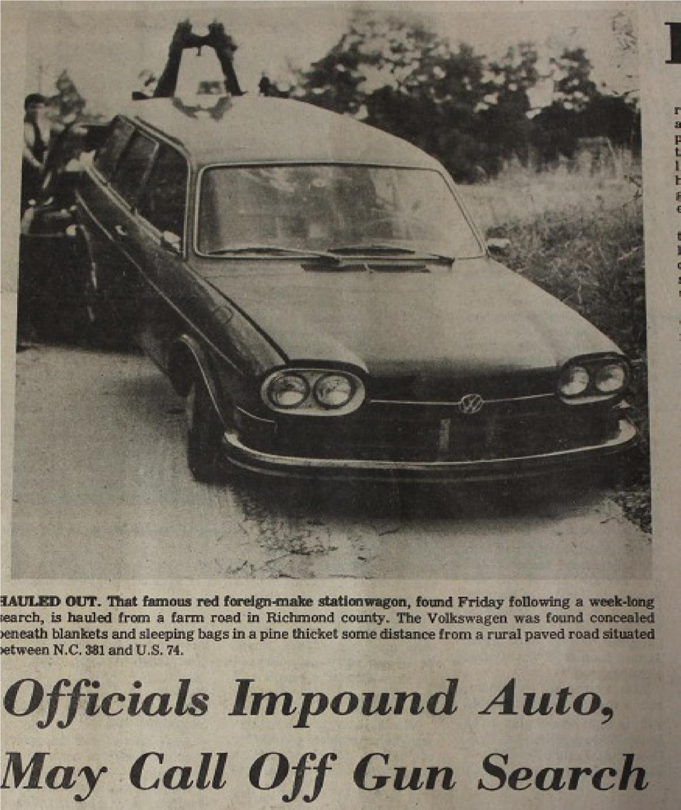

Vehicle Inventory at the Scotland County Sheriff's Office
Photos Provided By the Laurinburg Exchange

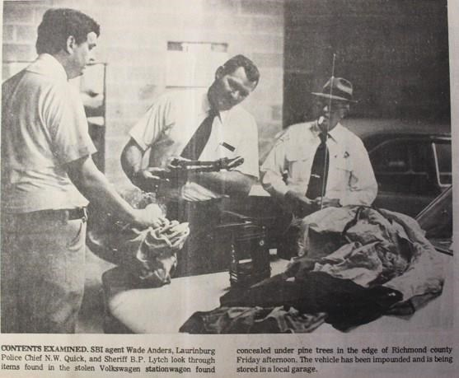

Chapter 19

There was a sense of jubilation in the hospital room from my friends and troopers that were visiting on Saturday afternoon. Knowing that Jones had been captured was like a shot of adrenaline to my spirits that allowed all of my emotions to be concentrated on recovery. I didn't realize how stressed I was while Jones was on the run. The doctors even told me that on Monday they would remove the chest tube from my left lung because it seemed to be operating at near full capacity. I was still full of pain killing drugs but I felt the stress of wondering how and when Jones would be captured. What a relief.
I was actually given my first solid meal on Saturday evening which I had to learn to eat left-handed. The swelling in my jaw from the bullet lodged in the left side of my face prohibited me from taking a normal bite of food. The doctors told me that they would work on stretching my jaw muscles and keeping the scar tissue from forming in hopes that I would be able to open my mouth normally.
Sunday morning began exactly the same way Saturday morning had begun. I was awakened at the crack of dawn but given a real breakfast. I was able to move more freely on Sunday morning than the day before but the areas affected by the gunshots were still very sore. Naturally I told everybody that I felt great and that I was ready to go home. The majority of the medical attention that I received on Sunday was to simply keep the wounds clean, preventing infection and forcing each of the wounds to be kept open so that they would heal from the inside outward.
Just after I finished lunch on Sunday my dad came in the room and said that I had a couple of special visitors downstairs in the lobby. He said one of them was named Lisa and had told everyone she was a friend of mine from Laurinburg. Lisa looked good enough to raise suspicions of just exactly what type of friend that she was. I was told that the other guest in the lobby was Kathy Kempf, my longtime on-again off-again girlfriend. Kathy seemed to have the upper hand because she let everyone know that she was wearing my horseshoe ring.
The horseshoe ring was sort of my trademark. My dad given it to me a number of years before and it was just the kind of ring that people noticed. It also made an obvious mark upside someone's head if I had to use force during an arrest. For that very reason the back of the ring had broken and I had asked Kathy to drop it by the jeweler in Charlotte that had worked on the ring before. Kathy and I had been out on a date on Wednesday night October 15 just two days before I was shot. That's when I gave her the ring to drop off at the jeweler.
My entire philosophy on life had suddenly changed within the last 48 hours. That philosophy would remain with me throughout my entire life causing me to do some things that I probably would not have otherwise done. My dad asked me how was going to handle these two girls in the lobby. For the first time I used the philosophy, “I've just been shot seven times and left for dead. I don't think these two women can cause any more confusion than that.” My dad laughed and said which one do you want up here first or do you want both at the same time? I laughed and said no send Lisa first.
Both of the women acted like the ladies that they were. I knew it was a little awkward for Lisa, but in the end she kissed me on the cheek and I told her I would see her when I got back to Laurinburg. As for Kathy, I'd loved to her since she was 14 years old and had a mouthful of braces. We had dated off and on for five or more years but I was just too immature to realize what a good wife she would make. Kathy was by my side for the next three months of my recovery attending to my every need. She was a good Catholic girl. I think she convinced her mother that taking birth control pills was good for her complexion. 10 days after I was shot I proved to her that everything worked.
My chest tube came out on Monday and it hurt more than going in. I saw the tube after it was removed and I know there were at least 10 feet of tubing inside my lung. The tube goes in and winds all around inside the lung. The small holes all along the tube extract the fluid. That same morning we went down stairs in the hospital for a nerve conduction study. This was the first time that anyone had begun to check what was actually wrong with my right arm. I was scared to death that the news was going to come back that I had some permanent damage and not have full use of my right arm. Needles with electrodes and wires attached to a machine were placed all up and down both of my arms. My left arm provided the normal activity and my right arm provided information for damages. It wasn't as painful as I had anticipated but I knew I didn't want to have one of these tests performed every day. The technician gathered the information from the print outs and told me very quietly that he thought the doctor would have some good news for me. I couldn't decide what good news meant. Was I going to just be able to blow my nose and feed myself or was I going to be able to squeeze the trigger on that .357 Magnum?
Several hours later the doctor did provide me with some great news. He said that my nerves had been damaged and severed causing the numbness and the inability for me to use my right arm. He felt like the numbness would go away in time and that I would regain the strength in my right hand to function close to normal What he couldn't tell was how fast those nerve endings were going to re-grow and regain their normal positions. I tried to pin the doctor down to a time frame but he wouldn't commit. He did reschedule me for another test in 60 days to see how the recovery was progressing.
On Tuesday morning after breakfast the main doctor in charge of my well-being, Dr. Herb Proctor came into the room and informed me that I was going back to the surgical area to receive stitches in my wounds. He also informed me that they had made a long-term decision to leave the bullet in my face and in my back and monitor how they affected my daily life. He assured me that the old adage from Gunsmoke was not true in today's world. If the bullets aren't bothering anything leave them alone.
Dr. Proctor said on a final note if you feel like it tomorrow were going to discharge you to home. I was ready to go. That hospital bed was very uncomfortable and coupled with the fact that I was already sore made sleeping terrible. True to his word at 11 AM on Wednesday, October 22, 1975 I put on my civilian clothes and walked out of the hospital. I tried to get the Highway Patrol let me wear my uniform but they said no. I was determined to walk out. I was a state trooper and we walk out, I told myself. That old never give up feeling was still in charge.

Chapter 20

On December 15, 1975 Gregory Hudson Jones was transported back to Scotland County from central prison in Raleigh for a preliminary hearing to determine if there was sufficient evidence for his case to be sent and scheduled for trial in Scotland County. I attended that hearing and was able to come face to face with him in a hallway leading to the court room. I asked him if he remembered me. He wouldn’t respond or even look at me. Jones had already been arraigned in Laurinburg on Tuesday, October 21, 1975. Jones was charged with assault with a deadly weapon with the intent to kill inflicting serious bodily injury. Probable cause was found and Jones was bound over to Superior Court but no trial date was scheduled.
On Wednesday October 22, 1975 Jones was arraigned in Wilmington and charged with first-degree murder, kidnapping, and assault with a deadly weapon and several other felony charges. The court found that there was sufficient evidence and Jones was scheduled for trial in April of 1976.
At the trial in New Hanover County in April, 1976, Jones was convicted on every count including the first-degree murder of Peter Fearing. After the lawyers got a hold of the story no one knew the real truth. Ronald Elkins was in jail awaiting trial for another crime so he wasn't reliable on the surface. In the end, Jones was sentenced to die in the states gas chamber for the Peter Fearing murder. Several years later during the appeal process the state of North Carolina overturned the use of the death penalty and Jones was remanded to prison for the remainder of his natural life. He was also found guilty and sentenced individually for the other crimes that he committed during that spree in October of 1975.
In a move that to this day no one can explain, the district attorney for Scotland County, Joe Freeman Britt refused to put Jones on trial for shooting me. His excuse was that Jones had already been given the death penalty so adding 25 more years to a death sentence just didn't make sense. He was also charged in Scotland County with breaking into the school and stealing my weapon. That didn’t sit good with me.
In 1979 when North Carolina abolished the death penalty I asked District Attorney Joe Freeman Britt through several sources to please try Gregory Hudson Jones for shooting me. It's my personal opinion that Joe Freeman Britt has a huge ego and would never reverse a decision that might call his judgment into question.

Chapter 21

On January 6, 1976, less than three months after being shot seven times and left for dead I returned to work as a member of the North Carolina State Highway Patrol. I made many mistakes along the way and I had no idea how wrong they were at the time. Afraid that a psychiatrist may take me off the job and force me to retire I never asked for help. Of course the State never offered any help either. They weren’t prepared to handle anything like my incident. I had nightmares regularly reliving the shooting. It’s hard to get the picture out of your mind of a man standing over you pulling the trigger of an empty gun and wondering if there might be one bullet left. It took years for those nightmares to subside.

Do you remember what I said about” you don't know what you don't know?” I just assumed that all of these feelings were normal. In retrospect the Highway Patrol should have never put me back to work without psychological evaluation to see if I could still handle the job. The state of North Carolina had a huge liability with me if I had hurt someone while on duty and the cause was directly responsible for my instability. I was told by someone in patrol headquarters, off the record, that no one really knew what to do with me. Troopers being shot or injured like I was normally die and that procedure is clear. The insurance policy pays off, there's a nice funeral and the family gets a flag.

Everywhere I went there was a reminder of what had happened. Almost everyone in the county was aware of the fact that I'd been shot. Most, if not all of they wanted to wish me good luck and success. A few didn't and they made it clear. At first it seemed to be a form of flattery. But very soon I began to view the conversations as a bit aggravating because I wanted to move on. Reliving that incident every day is certainly no way to heal. But what did I know?
I even drove the same patrol car that I was driving the morning I got shot after I went back to work. I could still see stains in the carpet where the blood had been wiped away while cleaning up the vehicle. I knew that I was carrying two bullets. I had a load of baggage. Never give up I kept saying.

My apartment complex literally backed up to the shooting scene. Every morning when I got up and looked out my bedroom window, I could see the exact location where I had been shot. My bedroom window was less than 50 yards from the crime scene.
The worst thing that was happening to me was that I was not giving anyone the benefit of the doubt during a traffic stop. I remembered so vividly how I saw Jones's hands in plain sight and within a split second those hands produced a weapon that shot me full holes. I had a fixation about wanting to see everybody's hands when I was having violator contact. If I had someone stopped and we were on the side of the road talking I couldn't do anything until I was sure his hands were free. I found myself constantly asking people to remove their hands from the pockets. Most of the time the ones that didn't show me their hands, found themselves slapped upside the head, down the ground and handcuffed. I don’t mean during simple traffic stops but I do mean with people that were uncooperative.
Being in those surroundings had definitely changed my personality. I was often rude and didn't even realize it. As much as I loved those troopers in Scotland County and some of my close friends there, it was a horrible mistake to go back into that environment. But again the patrol had no idea of what to do with me. I was in the mode to prove how strong I was and able to do the job. The patrol could have done numerous things with me but didn’t. I have never faulted anyone for anything including the dispatcher that failed to read the PIN message he had received about Jones several hours before I checked on that morning. I had the worst First Sgt ever. He could see all of my faults falling into place but he chose to look the other way. He was not looking away to protect me but to let me hang myself. I accept full responsibility for everything I ever did. It would have been a great time for the 5th angle to come along and bail me out.

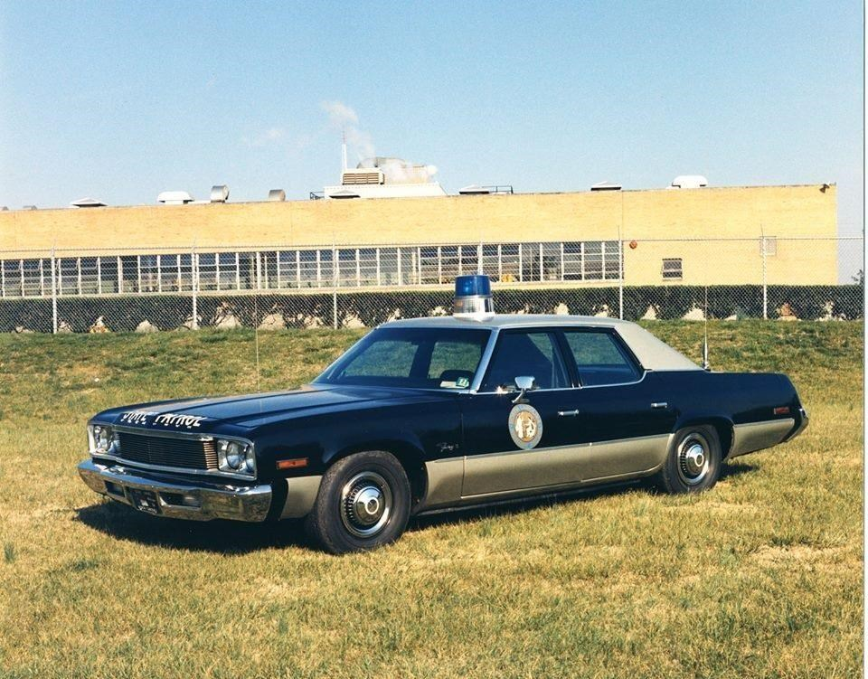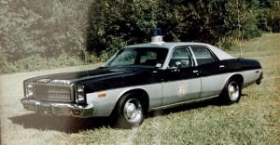

Chapter 22

Eventually I took my workers compensation settlement and moved on. Even after moving back to Charlotte it seemed like everyone knew my story. I needed a break. I needed to move somewhere that no one knew who I was and I did not have to bring all of that heartache and misery to life unless I wanted to. I moved to the North Myrtle Beach, South Carolina area for approximately one year. During that time I had the opportunity to reflect back and learn to separate all of the positive things that I had learned so far in my life and disassociate myself with the negative things that caused me grief. The one person that I hurt and am so regretful for was my girlfriend Kathy Kempf. She would've stood by me walking through the fires of hell. I wasn't smart enough to separate my feelings for her with my feeling that I needed to escape my past until I could sort it out.
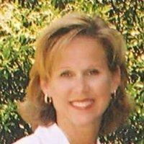
Kathy Kempf

During the next several years she and I both meet different people and went different ways. I hardly ever look back and say “what if “about anything. I have said “what if,” about Kathy. I learned quickly to turn everything negative into something positive. Today I'm living back in the North Myrtle Beach area where I'm as happy as I've ever been. Telling the story has now allowed me to help other officers realize how easy and quickly danger and death appears. I tell my audiences that I can speak for every police officer that ever died in the line of duty. None of them went to work that shift knowing it would be their last day on earth.

After living through this or listening to the story, how could you not believe in Jesus Christ and God in heaven?



Chapter 23

Some people believe in Angels. I certainly do. They appear in our lives in many different ways. Some are more obvious than others. Sometimes just lending a helping hand makes someone an Angel. There were 4 specific times on that October day that Angels appeared and at the most appropriate time.

The first Angel was the man that stopped to help. He stopped at the exact moment I asked God for help. I mean exactly when I asked. He tried to use my patrol radio but insisted on going for help. He actually sped up the reaction time of the Ambulance service by several precious minutes. No one else was available to do what he did at that exact time. He was heaven sent.

The second Angel was the director of the Scotland County Ambulance Service. He was on board the ambulance that morning and trained in EMT. That is a standard today but not in 1975. He saved my life at that point with his acquired skills in emergency medicine. He was the only trained EMT at that time in Scotland County. He was heaven sent.

The third Angel was the helicopter pilot that decided to fly tree top level into Chapel Hill that morning. Any other pilot not knowing the layout of the city might not have taken the risk to fly me to the hospital. If he had not known where to fly I would have run out of oxygen waiting for the ambulance to take me from the Raleigh-Durham airport. He was heaven sent. What are the odds of this brave pilot flying my mission? He risked his life and his career by breaking regulations concerning visibility and civilian transport.

The fourth Angel was sent to me when I was scared and really confused. After surgery that afternoon I was concerned about being able to recover to go back to work. The patrol was my life.
The thought of losing my job to injury was devastating. No one could give me any answers. Doctors as good as they seemed, were closed mouth. My family was in shock. God sent the only man on earth that could actually comfort me. I had no idea he was coming. I had no idea I could be comforted. When Pete Peterson touched my arm and said “everything is going to be ok,” I knew it would. He didn’t have to come to my side. Heaven knew how confused I was and sent him to comfort me. Pete was exactly right, everything is alright with me. We sure miss him.

I do believe in Angels in many different forms. These four men did something at the right time that day that no one else could do. I am forever grateful for Angels.

Chapter 24
The Critique
The very first thing that comes to mind is “did I do anything wrong?” According to policy the answer is no. Would I do anything different? The overwhelming answer is Yes, Yes, Yes. Let’s start from the beginning.
When I first noticed Jones I saw that he was traveling slightly over the speed limit of 55 MPH. The radar locked on 64 MPH. I always gave 10 MPH to anyone and this was no different. I reset the radar and it immediately locked on 65. I do not believe Jones saw me until well after he was first observed by me.
Here could be the first clue that was not taught in 1975 but I recommend this tactic very strongly today. I noticed Jones turn his head 90 degrees to the left and look hard at me. I honestly can’t remember if he turned his body past the 90 degrees but that is a dead giveaway when anyone in the car turns past a normal look and glance. Maybe that could have been the first suspicious move to alert my curiosity. Pay attention to body language people.
Jones reduced his speed as I approached his vehicle as if he didn’t think I was following him specifically. I sounded the siren and my blue light was activated. He knew I was following him because he saw me pull off from my stationary position and there were no other vehicles around.
Jones didn’t stop immediately. This could have been my second clue that something was not right. I gave him the benefit of the doubt and clearly should have not done so. Jones continued at 35 MPH over the bridge and then pulled off to the right onto an exit ramp.
The exit ramp was wide enough for Jones to have pulled over the right shoulder as any motorist would do. Instead he pulled to the left shoulder. I look back and see this as a huge clue that something was wrong. This is 20-20 hindsight. I equate this to a driver after seeing the traffic stop is under way drives behind a building to hide from any on-lookers.
We have to take in consideration that Jones knew he was wanted for murder and I did not. There is no way he would have known that except by my demeanor. He didn’t notice me on my radio or anything that would have alerted him to my knowing who he was at that time.
Jones pulled to the left side of the ramp and now anything that goes on at his door or the left side is blocked by our vehicles from passing motorist. Again, he knows his situation and I did not. Should I have executed a felony stop with these clues? Nothing was cast in stone. It was still my judgment call on how I approached but with no reason to feel suspicious, I followed the normal approach.
Remember that I had visually checked his license registration plate and noticed that it was valid and didn’t see any signs of the plate being on the wrong car.
Ok let’s take a break here and remember that I am critiquing this to show you how easily things can accumulate and lead to disaster.
I had no reason to believe anything is wrong with this stop but Jones was clever and waited for me to make the first move. I approached the vehicle and no flags went up. I asked him for his driver’s license and he produced one. As usual I never took my eyes off Jones or anyone else that I had stopped standing beside the vehicle. If he had made a move for a gun I would have noticed his actions. He was clever waiting for his chance without my knowing his plans.
After I explained the he would have to follow me to a magistrate and post a bond because he was from out of state, he realized that his time was running out. He also knew that I didn’t know who he was. I stepped away from the vehicle and took my eyes off him. This gave him his chance to produce his weapon. Here is a thought to remember and work by, every person you encounter, man or woman, young or old might try to kill you.
In retrospect I suggest backing away several steps or moving parallel with the vehicle eliminating the surprise that was waiting for me when I turned back toward Jones. Jones actually signaled as if he was asking me to return to his window. He said “hey” in a tone of voice that indicated to me that he had questions or concerns to address. If I had conducted business from the rear of his door over his left shoulder he would have had to seriously reposition himself to begin shooting me.
I suggest that once you have begun your decent to your vehicle that your concern and re-approach heighten to its original status if you re-approach. I see officers turn their backs and walk off from drivers about 90% of the time. This is a dangerous tactic. If I had walked away watching Jones he would have had to adjust his plan to attack me and the outcome could and probably would have been different.
Jones knew he had to stop me because he felt certain that I would have learned his identity. That old guilty conscience comes into play often and you will not know when. I always ran the vehicle information as well as driver’s license information while en route to the magistrate’s office. He was right, I would have learned his identity.
I have to step on some toes here because we are critiquing this shooting with the idea that it might save your life. The computer in your car today is only as good as the input. I say that again, the computer in your car is only as good as the input. Just because there are no warrants or warnings listed, doesn’t mean that the driver or occupant isn’t wanted or dangerous. We had no on-board computers in 1975 but we have a dispatcher. There was a PIN message available to the dispatcher that he failed to broadcast. If I had run a 10-27 or 10-28 when I got back to my car Jones would have been captured. If the dispatcher had read the message to cars checking 10-41, I would have recognized Jones as he passed by when I clocked him speeding. You know the old BOLO thing.
We can take that broadcast one step further. Trooper Mike Humphrey was working the same stretch of US 74 that I was on but in the next county. Trooper Humphrey issued several citations that morning but didn’t notice Jones and had no reason to be suspicious of any vehicle on US 74 wanted for Murder. Speculation is that if the broadcast was presented Trooper Humphrey may have spotted Jones before I stopped him. The lesson here is that you can’t rely on computers 100% of the time.
Jones had to make his move so when I re-faced his vehicle he began firing at me. I suspect that if I had moved to my patrol car Jones would have exited his vehicle firing. He noticed that I tossed his driver’s license into the grass and knew he had to retrieve them or leave a clue as to who the assailant might be. Jones wanted to make sure I was dead so he fired 2 more shots into me while I lay on the ground. He also wanted a larger weapon so he stole my .357magnum.
Why did I not fire back? My right arm was numb. I was trying to regain my composure and believe me I knew what was going on but it took a few seconds. I was in enough control to toss Jones’s drivers license. That’s why I repeat never take your eyes off the subject. I believe if I had seen the gun being produced I would have tried to draw and fire. I was well trained in firearms before I joined the patrol and I actually practiced those situations. But you can’t draw and fire if you do not see it coming and you are shot 5 times in 3 seconds.
Jones drove away and I remembered the first 3 letters of his license plate and his name. It was my job to make sure someone received that information to catch this man. I have given you a blow by blow of this shooting. It shows how easy a traffic stop can escalate. It shows that you don’t know what you don’t know. It is my hope that this story will resonate with each of you and provide beneficial to your safety.

Winston Churchill said “Never, Never, Ever Give Up!”

In Memory of These Great Men That Gave Their Life
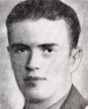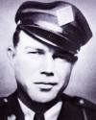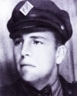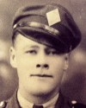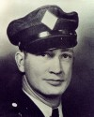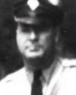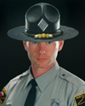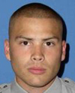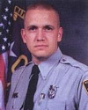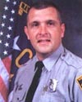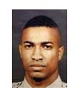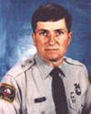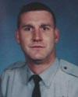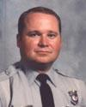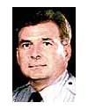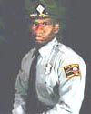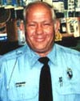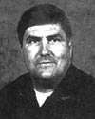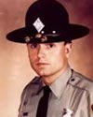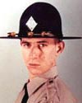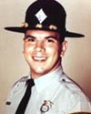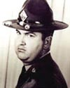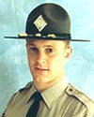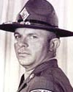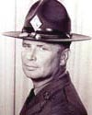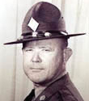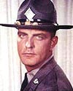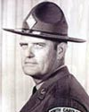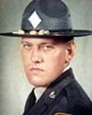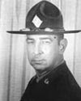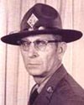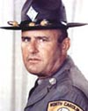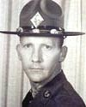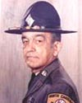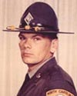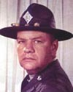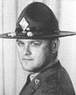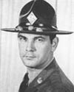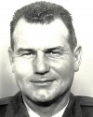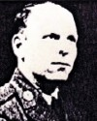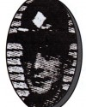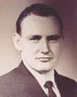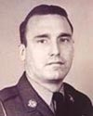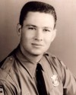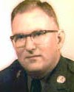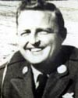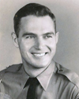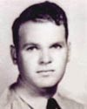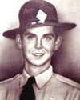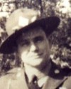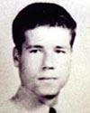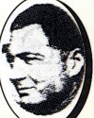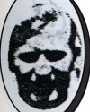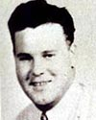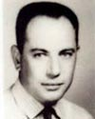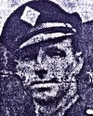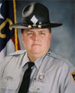

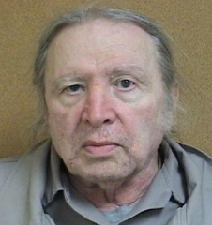

Gregory Hudson Jones

Incarceration Status: | ACTIVE | Total Incarceration Term: | 110 YEARS
Conviction Date: | 08/22/1977 | Projected Release Date: | 07/29/2072
Primary Crime: | MURDER FIRST DEGREE (PRINCIPAL) | Primary Crime Type: | FELON
Special Characteristics: | REGULAR | Current Status: | FELON
Admission Date: | 06/15/1978 | Admitting Location:
Control Status: | REGULAR POPULATION | Next Control Review: | UNKNOWN
Custody Classification: | MEDIUM | Next Custody Review: | 07/01/2016
Number Of Infractions: | 116 View Infractions | Last Infraction Date: | 11/16/2015
Current Location: | MOUNTAIN VIEW CI | Previous Location: | CALEDONIA CI
Last Movement : | RECEIVED FROM CALEDONIA CI | Last Movement Date: | 11/18/2014
INITIAL | 75015634 | MURDER FIRST DEGREE (PRINCIPAL) | 10/16/1975 | FELON | FELONS (PREFAIR)

Sentence Number: | BA-002 | Commitment Type: | INMATE
Conviction Date: | 08/22/1977 | County Of Conviction: | NEW HANOVER
Service Status: | ACTIVE | Sentence Begin Date: | 08/22/1977
Sentence Status: | ACTIVE | Actual Release Date:
Punishment Type: | PRE-FAIR | Projected Release Date: | 08/02/2057
Sentence Type 1: | DEPT OF CORR DIV OF PRISONS
Sentence Type 2: | LIFE SENTENCE
Minimum Term: | SL 80 | Maximum Term: | SL 80
Commitment | Docket# | Offense (Qualifier) | Offense Date | Type | Sentencing  Penalty  Class Code
CONCURRENT TO SENTENCE NUMBER BA-001 | 75015635 | BURGLARY 1ST DEGREE (PRINCIPAL) | 10/16/1975 | FELON | FELONS (PREFAIR)

Sentence Number: | BA-003 | Commitment Type: | INMATE
Conviction Date: | 08/22/1977 | County Of Conviction: | NEW HANOVER
Service Status: | FUTURE | Sentence Begin Date: | 08/02/2057
Sentence Status: | ACTIVE | Actual Release Date:
Punishment Type: | PRE-FAIR | Projected Release Date: | 09/28/2065
Sentence Type 1: | DEPT OF CORR DIV OF PRISONS
Minimum Term: |  | Maximum Term: | 20 YEARS
Commitment | Docket# | Offense (Qualifier) | Offense Date | Type | Sentencing  Penalty  Class Code
CONSECUTIV TO SENTENCE NUMBER BA-002 | 75015633 | KIDNAPPING 2ND DEGREE (PRINCIPAL) | 10/16/1975 | FELON | FELONS (PREFAIR)

