DATES CLOSED  JAN. 2 NEW YEARS  JAN. 20 STAFF INSERVICE  APRIL 21 STAFF INSERVICE  MAY 29 MEMORIAL DAY  JUNE 30 STAFF INSERVICE  JULY 4 INDEPENDENCE DAY  SEPT. 4 LABOR DAY  OCT. 20 STAFF INSERVICE  NOV. 23 & 24 THANKSGIVING DAY  DEC. 25 CHRISTMAS  JAN. 1 NEW YEARS DAY  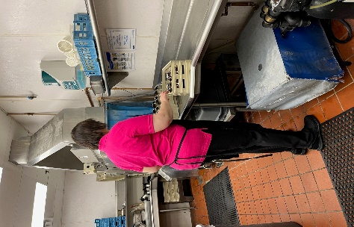  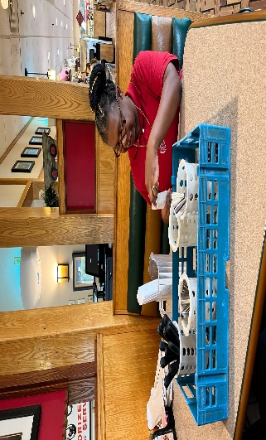  “OPPORTUNITIES” |  | CLW CALENDER 2023  January S M T W T F S 1 2 3 4 5 6 7 8 9 10 11 12 13 14 15 16 17 18 19 20 21 22 23 24 25 26 27 28 29 30 31 May S M T W T F S 1 2 3 4 5 6 7 8 9 10 11 12 13 14 15 16 17 18 19 20 21 22 23 24 25 26 27 28 29 30 31 September S M T W T F S 1 2 3 4 5 6 7 8 9 10 11 12 13 14 15 16 17 18 19 20 21 22 23 24 25 26 27 28 29 30  February S M T W T F S 1 2 3 4 5 6 7 8 9 10 11 12 13 14 15 16 17 18 19 20 21 22 23 24 25 26 27 28 June S M T W T F S 1 2 3 4 5 6 7 8 9 10 11 12 13 14 15 16 17 18 19 20 21 22 23 24 25 26 27 28 29 30 October S M T W T F S 1 2 3 4 5 6 7 8 9 10 11 12 13 14 15 16 17 18 19 20 21 22 23 24 25 26 27 28 29 30 31  March S M T W T F S 1 2 3 4 5 6 7 8 9 10 11 12 13 14 15 16 17 18 19 20 21 22 23 24 25 26 27 28 29 30 31 July S M T W T F S 1 2 3 4 5 6 7 8 9 10 11 12 13 14 15 16 17 18 19 20 21 22 23 24 25 26 27 28 29 30 31 November S M T W T F S 1 2 3 4 5 6 7 8 9 10 11 12 13 14 15 16 17 18 19 20 21 22 23 24 25 26 27 28 29 30  April S M T W T F S 1 2 3 4 5 6 7 8 9 10 11 12 13 14 15 16 17 18 19 20 21 22 23 24 25 26 27 28 29 30 August S M T W T F S 1 2 3 4 5 6 7 8 9 10 11 12 13 14 15 16 17 18 19 20 21 22 23 24 25 26 27 28 29 30 31 December S M T W T F S 1 2 3 4 5 6 7 8 9 10 11 12 13 14 15 16 17 18 19 20 21 22 23 24 25 26 27 28 29 30 31 JAN 1  146 NORTH WASHINGTON STREET  NEW PARIS, OHIO 45347  ADMINISTRATOR  DEDE WRIGHT-DELONEY  (765) 977-5229  DWRIGHT-DELONEY@THECLW.COM

