- 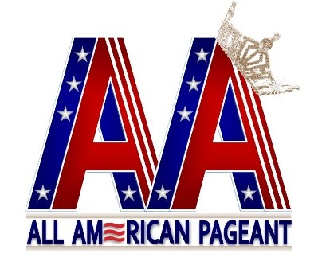
All American Pageant/Mrs. All American Pageant
Official Application 2022
(Please print)
Name: _____________________________________________________________ Address: ___________________________________________________________
City: _________________________State: ________ Zip Code: _______________ Home Telephone __________________ Mobile Telephone. __________________ Email: _____________________________________________________________
What is the best way to reach you: (Check all that apply)
Facebook ________ Texts _______ Phone ________ Mail ______
Age: _______________ D.O.B. ________________ Birthplace: ______________ State you wish to represent ____________________________________________ Division you are competing in: _________________________________________ T-shirt Size ________________________ Shoe Size ________________________
What makes you a good candidate for this pageant? _________________________ __________________________________________________________________ Recent Honors/Awards: ______________________________________________ __________________________________________________________________ __________________________________________________________________
FOR RETURNING DELEGATES ONLY:
I would like to use my current sash. Y or N
I would like to order a new crown ($50 fee). Y or N

ALL APPLICANTS:
The FREE optional competition I want to compete in is:
_____Talent _____Photogenic _____Community Service
I would like to compete in other optional competitions (please list): Y or N ____________________________________________________________
Please include a $150 (non-refundable) application fee – per state title you are applying for – along with an application for each title. Please send a recent 5x7 photo of yourself (headshot preferred) along with your application.
____________ (Initial and Date)
- I am enclosing a money order with my application. _________ (initial)
- I am sending fees via PayPal _________ (initial)
They can be sent through PayPal to allamericanpageants852@gmail.com. Military Y or N First Responder Y or N
(EMT/EMS/Nurse/Police/Firefighter)
By signing this application, I am certifying that all information is true and correct to the best of my knowledge.
__________________________________ Signature ___________________ Date

All American Pageant/Mrs. All American Pageant
If I am competing in both pageants, why do I need to pay two application fees?
Each pageant is independent from one another.
All American Pageant Divisions
All American Teen 13-17
All American Miss 18-26*
All American Ms. 27-39*
All American Woman 40-49*
All American Lady 50-Over*
All American Classic 25-Over (Size 16 up)* *Married, Widowed, or Divorced
Mrs. All American Pageant Divisions
Mrs. All American 21-40*
Mrs. All American Woman 40-49*
Mrs. All American Lady 50-Over*
All American Classic Mrs. 25-Over (Size 16 up)* *Married or Widowed
Int’l All American Pageant
All American International Any Age, Foreign Heritage or Military Abroad Service
ALL Delegates-Age determined as of September 1, 2022.
Divisions with less than three contestants may be combined with another division.
Selection of State Delegates: Delegates can choose to represent any state or region based on residency, birthplace, work, or any special tie to the state. All states are awarded At-Large on a first come, first serve basis.
National Competition Judging Criteria:
Delegates are judged individually, never as a whole. Scoring areas and weight:
➢ Interview 50% ➢ Runway/Fashion Wear 25% ➢ Evening Gown 25%
National Entry Fee:
The pageant entry fee is $695.00 for nationals

Qualifying delegates may compete in both pageants. The second pageant entry will be an additional $300.00 The Teen division is $295.00 for the national entry fee. International division is $100. Veteran’s division is $100.00.
All entry fees and installments are due on or before July 1, 2022. All entries received after July 2, 2022, are due in full upon approval of application.
The state sash is included in the registration fee. A state crown is optional and can be purchased for an additional $50 fee. No application will be reviewed or accepted, until the application fee is received.
All American and Mrs. All American Pageants
c/o Patricia Sullivan
249 East Taylor Avenue
Wildwood, New Jersey 08260

Please direct any email correspondence to the pageant office email at allamericandirector@gmail.com.
Completed application due by September 1, 2022

