OCC Lab 11 Biotech I: Restriction Enzymes and DNA
OCC Lab 12 Biotech II: Separation of DNA Fragments by Gel
Electrophoresis
Background info:
DNA splicing, the cutting and linking of DNA molecules, is one of the basic tools of modern biotechnology. The concept behind DNA splicing is to remove a functional DNA fragment — let’s say a gene — from one organism and to combine it with the DNA of another organism in order to study how the gene works. The desired result of gene splicing is for the recipient organism to carry out the genetic instructions provided by its newly acquired gene. For example, certain plants can be given the genes for resistance to pests or disease, and in a few cases to date, functional genes have been given to people with nonfunctional genes, such as those who have a genetic disease like cystic fibrosis.
The DNA restriction analysis that you are about to perform is fundamental to a variety of genetic engineering techniques, including gene splicing, DNA sequencing, gene localization, forensic DNA matching, or DNA fingerprinting. You’ll be simulating the real-world application of gene splicing. The DNA we’ll be using will simulate a chromosome that has been cut into many fragments. Of the fragments that are produced, one particular fragment may represent a specific gene. This imaginary gene can code for any number of traits, but before it can be given to a recipient organism, you must first identify the gene by its size using agarose gel electrophoresis.
In this two-part lab, you will…
Part I:
“Cut” Lambda DNA into a series of fragments using restriction enzymes.
Part II:
Separate and sort these fragments according to their size via gel electrophoresis and then determine the size of each DNA fragment.
Restriction Enzymes:
The ability to cut and paste, or cleave and ligate, a functional piece of DNA predictably and precisely is what enables biotechnologists to recombine DNA molecules. This is termed recombinant DNA technology. The first step in DNA splicing is to locate a specific gene of interest on a chromosome. A restriction enzyme is then used to cut out the targeted gene from the rest of the chromosome. This same enzyme is also used to cut the DNA of the recipient into which the fragment will be inserted. Restriction enzymes are proteins that cut DNA at specific sites. Restriction enzymes, also known as restriction endonucleases, recognize specific sequences of DNA base pairs and cut, or chemically separate, DNA at that specific arrangement of base pairs. They were first identified in and isolated from bacteria. These prokaryotes use restriction enzymes as a natural defense mechanism to cut up the invading DNA of bacteriophages — viruses that infect bacteria. Any foreign DNA encountering a restriction enzyme will be digested, or cut into many fragments, and rendered ineffective. In this way, these enzymes in bacteria could be considered life’s first biological immune system. There are thousands of restriction enzymes, and each is named after the bacterium from which it is isolated. For example:
EcoRI = The first restriction enzyme isolated from Escherichia coli/Ecoli bacteria.
HindIII = The third restriction enzyme isolated from Haemophilus influenzae bacteria PstI = The first restriction enzyme isolated from Providencia stuartii bacteria 4
Each restriction enzyme recognizes a specific nucleotide sequence in the DNA, called a restriction site, and cuts the DNA molecule at only that specific sequence. Many restriction enzymes leave a short length of unpaired bases, called a “sticky” end, at the DNA site where they cut, whereas other restriction enzymes make a cut across both strands creating double-stranded DNA fragments with “blunt” ends. In general, restriction sites are palindromic, meaning the sequence of bases reads the same forwards as it does backwards on the opposite DNA strand or more precisely the 3’ to 5’ sequence the enzyme recognizes is the same as the 5’ to 3’ sequence it recognizes.
For example, here is a list of enzymes and the sites where they cut:
EcoRI G A-A-T-T-C
C-T-T-A-A G
HindIII A A-G-C-T-T
T-T-C-G-A A
PstI C-T-G-C-A G
G A-C-G-T-C
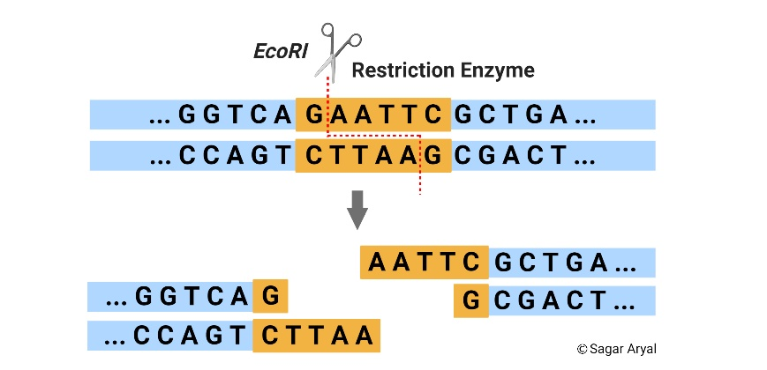
Lambda Phage DNA:
Lambda DNA is the genomic DNA of a bacterial virus, or bacteriophage (phage), which attacks bacteria by inserting its nucleic acid into the host bacterial cell. Lambda is a phage that replicates rapidly inside host cells until the cells burst and release more phages to carry out the same infection process in other bacterial host cells. Bacteriophage lambda is harmless to man and other eukaryotic organisms, and therefore makes an excellent source of DNA for experimental study.
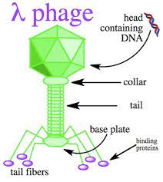
In this investigation, you’ll observe the effects of three restriction enzymes on lambda DNA. Since the lambda genome is approximately 48,000 base pairs, each restriction enzyme will cut the DNA several times and generate restriction fragments of different sizes.
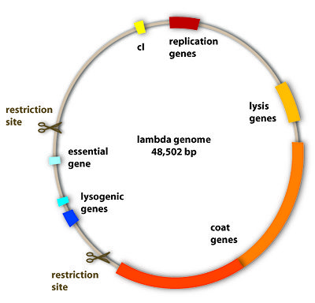
In this activity, three separate samples of lambda DNA will be cut using three different restriction enzymes, and one sample will remain undigested. Each sample produces DNA fragments whose sizes can be estimated when run on an agarose gel using electrophoresis.
Electrophoretic Analysis of Restriction Fragments:
A restriction enzyme acts like molecular scissors, making cuts at the specific sequence of base pairs that it recognizes. The three-dimensional structure or shape of a restriction enzyme allows it to fit perfectly in the groove formed by the two strands of a DNA molecule. When attached to the DNA, the enzyme slides along the double helix until it recognizes a specific sequence of base pairs which signals the enzyme to stop sliding. The enzyme then chemically separates, or cuts, the DNA molecule at that site — called a restriction site. If a specific restriction site occurs in more than one location on a DNA molecule, a restriction enzyme will make a cut at each of those sites, resulting in multiple fragments of DNA. Therefore, if a given piece of linear DNA is cut with a restriction enzyme whose specific recognition sequence is found at five different locations on the DNA molecule, the result will be six fragments of different lengths. The length of each fragment will depend upon the location of restriction sites on the DNA molecule. DNA that has been cut with restriction enzymes can be separated using a process known as agarose gel electrophoresis. The term electrophoresis means to carry with electricity. Agarose gel electrophoresis separates DNA fragments by size. DNA fragments are loaded into an agarose gel slab, which is placed into a chamber filled with a conductive buffer solution. A direct current is passed between wire electrodes at each end of the chamber. Since DNA fragments are negatively charged, they will be drawn toward the positive pole (anode) when placed in an electric field. The matrix of the agarose gel acts as a molecular sieve through which smaller DNA fragments can move more easily than larger ones. Agarose has a texture similar to gelatin. Imagine the gel as a strainer with tiny pores that allow small particles to move through it very quickly. The larger the size of the particles, however, the slower they are strained through the gel. After a period of exposure to the electrical current, the DNA fragments will sort themselves out by size. Fragments that are the same size will tend to move together through the gel and form bands. Therefore, the rate at which a DNA fragment migrates through the gel is inversely proportional to its size in base pairs. Over a period of time, smaller DNA fragments will travel farther than larger ones. Fragments of the same size stay together and migrate in single bands of DNA. These bands will be seen in the gel after the DNA is stained. An analogous situation is one where all the desks and chairs in the classroom have been randomly pushed together. An individual student can wind his/her way through the maze quickly and with little difficulty, whereas a string of four students would require more time and have difficulty working their way through the maze.
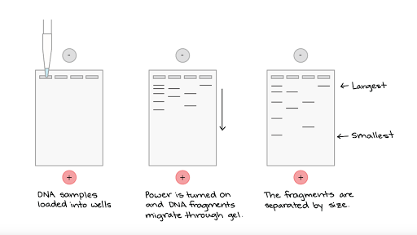
Making DNA Visible:
DNA is colorless so DNA fragments in the gel cannot be seen during electrophoresis. A loading dye containing two blue dyes is added to the DNA solution. The loading dye does not stain the DNA itself but makes it easier to load the gels and monitor the progress of the DNA electrophoresis. The dye fronts migrate toward the positive end of the gel, just like the DNA fragments. The “faster” dye comigrates with DNA fragments of approximately 500 bp, while the “slower” dye comigrates with DNA fragments approximately 5 kb in size. Staining the DNA pinpoints its location on the gel.
After the gel run is completed, the gel is immersed in Fast Blast DNA stain. These stain molecules attach to the DNA trapped in the agarose gel making the bands visible and allowing you to compare the DNA restriction patterns of the different samples of DNA.
Analysis of DNA Fragments:
A set of fragments of known sizes is called a molecular weight ruler/standards/marker or ladder. The positions of separated fragments of a marker can be used to determine the size of fragments of unknown DNA. Each fragment of a marker has a known number of base pairs. Knowing the base-pair size of each fragment of a marker allows you to estimate the bp size of unknown fragments that are seen at the same location on a gel.
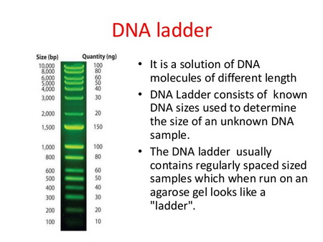
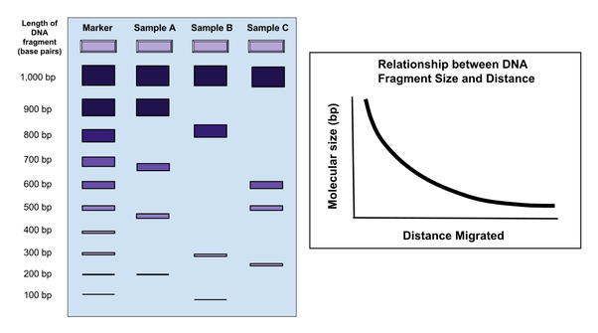
In this lab, Lambda DNA that was pre-digested with HindIII was used as your DNA marker/standard in lane 1. HindIII produces six fragments when it digests Lambda DNA (5 cuts). Each will move through the gel a different distance. The size of each fragment is already known, measured in number of base pairs. They are:
Band fragment size measured in bp distance (mm) from bottom of gel
1 23,130
2 9,416
3 6,557
4 4,361
5 2,322
6 2,027
Using a ruler, measure the distance (in mm) that each of these known marker
fragments bands traveled. This distance is measured from the bottom of the well to the bottom of each DNA band. Record your numbers in a chart.
Estimate the length of unknown fragments:
Now measure the distance travelled by the fragments of the other digested DNA samples and record those in your chart. Estimate the sizes, in base pairs (bp), of each of your unknown restriction fragments by comparing the distance that the unknown bands of PstI and EcoRI digested Lambda DNA that travelled alongside those of those of the HindIII digested Lambda bands/marker bands.
Plot the length of known fragments:
A more accurate way of estimating unknown DNA band sizes is to first construct
a standard curve based upon the measurements obtained from the known
HindIII lambda bands. This involves graphing the size of the known fragments from the DNA standards against the distance each DNA band moved through the gel, to generate a standard curve. This is most accurately done using semilog graph paper which I will provide. To plot the unknow sample fragments:
Fragment size (bp) is on the vertical (y) axis.
The horizontal (x) axis is your scale for the distance traveled by the fragments through the gel in millimeters.
Using the fragments from the HindIII lambda digest, plot the distance traveled
in relationship to fragment size for each fragment. Connect as many of the points as you can by drawing a straight line through them. This will provide a standard curve with which you will be able to determine the size of your unknown fragments from the other samples.
Determine the length of unknown fragments:
Line up a ruler vertically from the distance traveled position on the horizontal x-axis for a fragment of an unknown sample to the line that you constructed.
From the point where your ruler intersected your line, place the ruler horizontally
and note where it intersects with the vertical y-axis for fragment size. This will
be your determination of the size for that fragment.
At the end of lab 7, please submit your chart and graph.

