Location
Shiloh, Ohio

Facility Type
Solid Waste Landfill

Client
Allied Waste.
Rumpke Waste

Services Provided
- Permitting/Design
- Construction Inspection/Quality
- Assurance
- Construction Certification
- Reporting
- Project Management
- Soils Pre-qualification

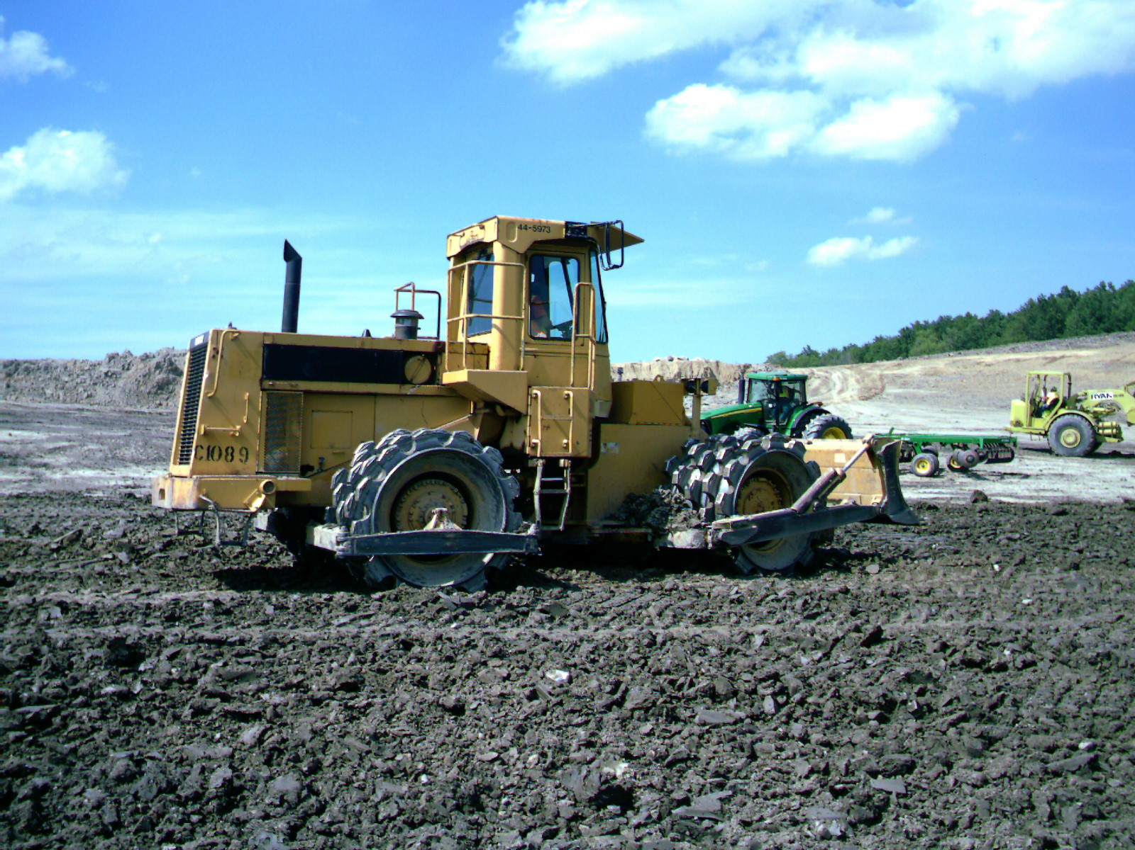

Recompacted Soil Liner Installation

Project Descriptions
NPE has provided soils pre-qualification, construction quality assurance and certification services for the following disposal cell projects:

Cell 8A (2015) – 7 ac disposal cell
- Cell 6 (2014) – 9 ac disposal cell
- Cell 5 (2012) – 10 ac disposal cell
- Cell 4B-N (2008) - 2.8 ac disposal cell and northern sedimentation basin
- Cell 4B-C (2006) - 4.3 ac disposal cell
- Cell 4B-S/Partial 4B-N (2005) - 2.1 ac disposal cell
- Cell 4A (2004) - 9.4 ac disposal cell
- Cell 3C (2003) - 4.0 ac disposal cell

NPE has also provided engineering design services:

- PTI Application (2016-2017) for 90 ac lateral and vertical expansion
- PTI Alteration (2015) for phasing revisions

Typical elements of the constructed cells have included a 3 foot recompacted soil liner, structural fill embankments, sand pocket excavation and replacement with added geologic material, 60 mil HDPE geomembrane, leachate collection and forcemain piping, leachate drainage layer, dual sided geocomposite drainage layer, rain flaps and separation berms.

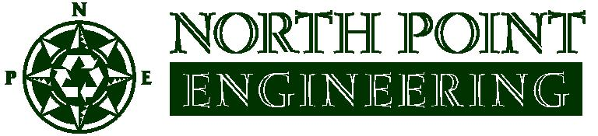
NPE has provided CQA and certification services for numerous phased Landfill Gas Collection and Control System (GCCS) construction projects at the site between 2010 and present.

