11/10/2017 11/13/2017 and 1/20/2018

About 8 months ago I authored several articles concerning the dates 11/13/2017 and 1/20/2018.

It happens that we are currently in the 70th year of the existence of the modern sovereign State of Israel. And it happens that 11/13/2017, in just a few days, is the precise center date of the 70th year of modern Israel's existence.

There is a method of composing literature found throughout the bible known as chiastic structure. Chiastic sentence structure is usually employed to point to a central event in a series of bible verses. The central event is the main theme of the group of bible verses.

Because the nation of Israel has been chosen by YaHuWaH Elohim to be a witness to the world, we can look for a chiastic structure of events at the center date of Israel's 70th year and perhaps see clues that have been placed there by our Creator Elohim.

The center date from 5/14/2017 to 5/14/2018 is 11/13/2017. We look at that particular date for evidence of the workings of our Creator Elohim who used chiastic structure throughout the bible to emphasize certain topics.

To avoid a longer email article, here are some links to the articles that were composed and published in the Spring of 2017:

1. Concerning former President Bill Clinton, President Hassan Rouhani of Iran, and Prince Charles http://www.joybysurprise.com/bill-clinton--hassan-rouhani--prince-charles--and-israel.html

The graphic below illustrates curious conception and birth date chiastic relationships between the men mentioned above and the central date of Israel's 70th year.

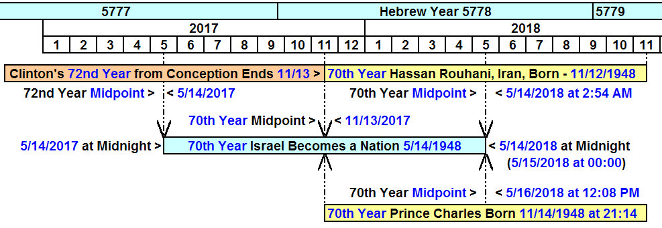

2. The article concerning 11/13/2017 and some other odd or rare events is available on this page: http://www.joybysurprise.com/the-emphasized-events-of-1948-and-11-13-2017.html

The graphic below illustrates some of the events that reach fulfillment on 11/13/2017:

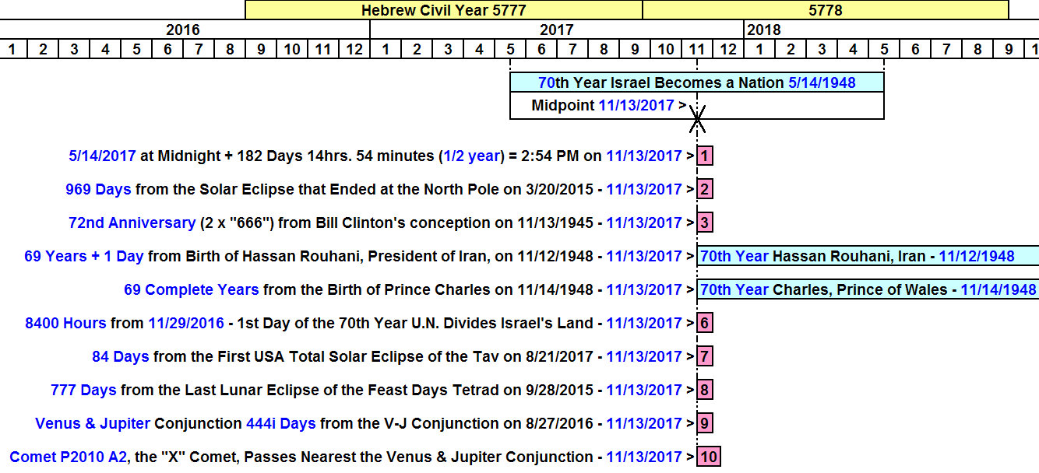

An example of an odd event is number 10 on the graphic above. It happens that just before sunrise in Jerusalem on 11/13/2017 there will be a Venus and Jupiter conjunction. But nearby will be the strange "X" comet, P2010 A2, that astounded astronomers when it was discovered in 2010.

Below is a graphic showing the location and proximity of the strange "X"comet as it flys by the Venus Jupiter conjunction on 11/13/2017 as seen from Jerusalem. The comet could have been anywhere else in the sky, but it just "happens to be near" (it was ordained to be there by our Creator at this particular time as a sign to us) the moderately rare Venus Jupiter conjunction of 11/13/2017.

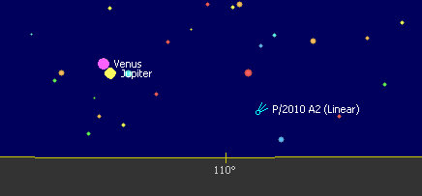

Below is an image of comet P2010 A2:

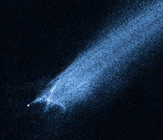

Above: The odd "Flying Hebrew Paleo Tav" comet, a harbinger of the end.

It was mentioned in a previous article that the P2010 A2 Flying Tav comet marked President Barack Obama on 12/10/2016 by appearing to precisely and sharply reverse course on the 7th anniversary of President Obama receiving of the Nobel Peace Prize on 12/10/2009.

The gods of Egypt

I have no desire to study Freemasonry and I usually shy away from reading anything associated with it. I have purchased some books authored by Thomas Horn and others who delve into the subject, but I read little of them. My wife and I continually read through the bible, but read very little of other books.

I'm slowly coming to the conclusion that YaHuWaH Elohim is teaching me the secrets of Freemasonry without reading a book on Freemasonry. I'm also beginning to understand that the gods of Freemasonry (ancient Egyptian gods such as Osiris) will be again be active in the end times. A repeat of the plagues of Egypt 3500 years ago will again occur as the same gods (those of Freemasonry) will be judged at the end of the age and a chosen people will exit the nations.

Hillary is in the 72 Mix

I loaned a book titled "Saboteurs" by Thomas Horn to a neighbor to read a few weeks ago and when the neighbor returned the book he said that the number 72 was mentioned in the book. I thought that was odd because I had been spiritually discerning the numbers 36 and 72 in my experiences for the past several months.

Hillary Clinton is mentioned on pages 146 and 147 in the book "Saboteurs" by Thomas Horn. He mentions, among other things, that she will be 72 years old during the next presidential election in 2020.
I had been investigating the birth and conception dates of recent Presidents, so I decided to look at Hillary Clinton's conception date which was found to be on or around 1/20/1947 by subtracting 280 inclusive days from her date of birth.

Below is a graphic showing the birth dates and calculated conception dates of some presidents and also Hillary Clinton:

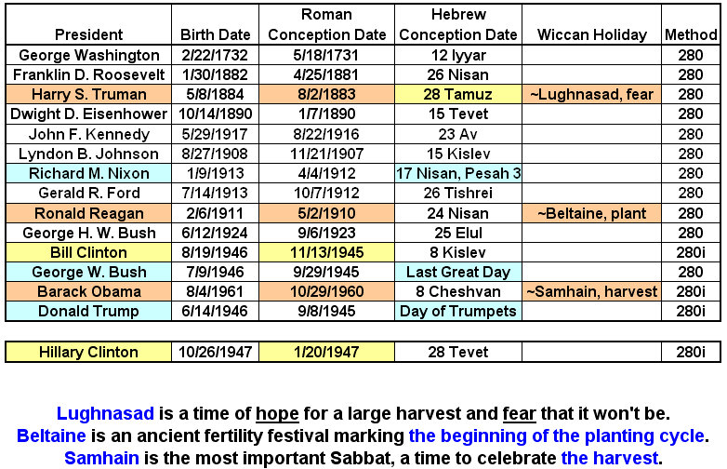

Below is a graphic showing the 72nd year from the conceptions of both Bill and Hillary Clinton, with Bill Clinton's 72nd year from conception ending precisely in the middle of Israel's 70th year on 11/13/2017.

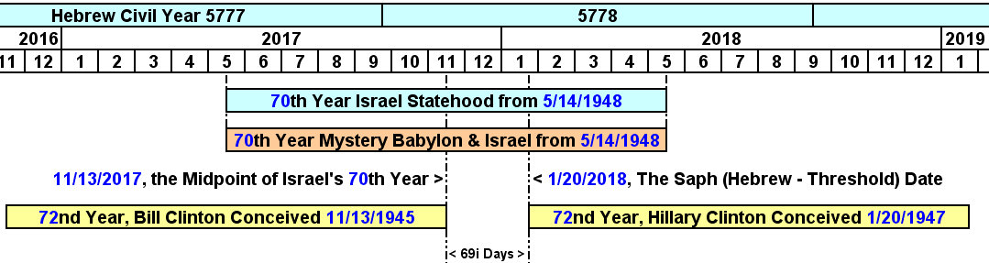

The Threshold and the Beginning of Hillary's 72nd Year of Life

3. The date 1/20/2018 was found to be "Threshold" event date in an article published about 8 months ago and available here: http://www.joybysurprise.com/the-threshold.html

I was surprised to find that Hillary Clinton's conception date fit precisely with the 1/20/2018 "Threshold" event date, with 1/20/2018 being the 1st day of the 72nd year from her calculated conception on 1/20/1947.

Note also that Hillary Clinton was born exactly 434 inclusive days or 62 weeks (62 x 7 days) after Bill Clinton was born.

It appears that we may be seeing the living embodiments of the ancient Egyptian gods of Freemasonry in Bill and Hillary Clinton and other prominent world political figures. All of this began around 1945 - 1947 as Israel was about to become a sovereign nation again after over 2000 years of foreign occupation and dispersal throughout the world.

Daniel 2:41 And whereas thou sawest the feet and toes, part of potters’ clay, and part of iron, the kingdom shall be divided; but there shall be in it of the strength of the iron, forasmuch as thou sawest the iron mixed with miry clay.
42 And as the toes of the feet were part of iron, and part of clay, so the kingdom shall be partly strong, and partly broken.
43 And whereas thou sawest iron mixed with miry clay, they shall mingle themselves with the seed of men: but they shall not cleave one to another, even as iron is not mixed with clay.
44 And in the days of these kings shall the God of heaven set up a kingdom, which shall never be destroyed: and the kingdom shall not be left to other people, but it shall break in pieces and consume all these kingdoms, and it shall stand for ever.
45 Forasmuch as thou sawest that the stone was cut out of the mountain without hands, and that it brake in pieces the iron, the brass, the clay, the silver, and the gold; the great God hath made known to the king what shall come to pass hereafter: and the dream is certain, and the interpretation thereof sure.

The "they" in Daniel 2:43 above refers to beings who are other than human. They are not the "seed of men", but they mix in with the seed of men.

It may be that extra dimensional beings exhibit peculiar timing marks in the lives of their "hosts" as their hosts live "charmed" lives.

The supernatural anointing of YaHuWaH Elohim will enable us to conquer the rogue and rebellious beings who are out to destroy the image of YaHuWaH Elohim from the earth by mingling themselves with the seed of men.

