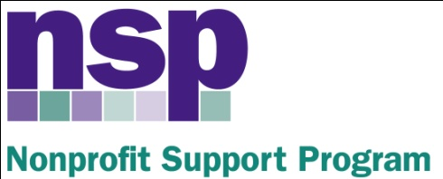

Hartford Foundation for Public Giving
Nonprofit Support Program
Building Evaluation Capacity (BEC) Program
Class of 2017, Session 6

May 11, 2016

AGENDA

PUTTING IT ALL TOGETHER
8:30 – 8:45 | Making Methodological Choices
8:45 – 9:05 | A note about Focus Groups
9:05 – 9:20 | Putting it All Together
9:20 – 9:45 | Level of Effort/Timeline Work Session
9:45 – 10:15 | Evaluation Reporting – Discussion + Add to LOE
10:15 – 10:30 | Budgeting
10:30 – 10:45 | Break
10:45 – 11:45 | Planning for the Conference
11:45 – 12:00 | Evaluative Thinking
HW | Complete your evaluation design and construct your Final Conference Board

Anita Baker
Evaluation Services
www.evaluationservices.co

