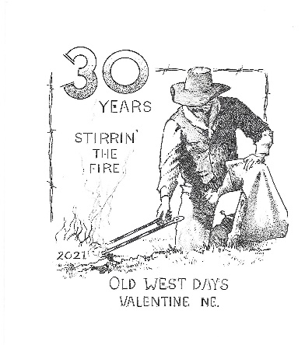
OLD WEST DAYS
WESTERN ART & TRADE SHOW
VALENTINE, NEBRASKA

OCTOBER 8-9th, 2021

VENDOR REGISTRATION

NAME: ___________________________________________________________
Vendor Fee:
__10 x 10 space - $50.00
__10 x 20 space - $100.00
__ + $50 for each add'l 10x10 space
__ + $10 for each additional table

*Fee is for both days and
includes 1 table & 2 chairs

Electricity & wall space is limited. Please let us know if you need either.
“First come – first served!”

LOCATION:
Valentine Rural High School gym: 431 N. Green St.

Set Up: 7 am on Friday
(No early set up, please)

Take Down: Around evening performance on Saturday (approx.. 7:30 pm)

Trade show schedule:
- Friday from 10 am until 7:00 pm
- Saturday from 10 am until 7:00 pm
(Please note: gym stays open until at least 10 pm both nights)

BUSINESS NAME: ________________________________________________

MAILING ADDRESS: ______________________________________________

CITY/STATE/ZIP: __________________________________________________

PHONE: __________________________________________________________

EMAIL & WEBSITE: ________________________________________________

MERCHANDISE TO BE SOLD DURING THE EVENT: Please note: preference
given to Western and Homemade Items. Non-western or MLM vendors must be voted on
by committee for approval. Thank you for your understanding!

___________________________________________________________________

___________________________________________________________________

When returning your application, please attach the following:

1) Description of items to sell.
2) Check made payable to OLD WEST DAYS

*NOTE: Application deadline is
Sept. 10th!
Contact Ann Krueger if unable to get form back in time.
SPACE IS LIMITED!!!

MAIL APPLICATION & PAYMENT TO:

Ann Krueger
Old West Days
413 N Macomb Street
Valentine, NE 69201
Questions? 402-322-1005
email: ann@kvsh.com

I, as renter, agree not to hold Valentine’s Old West Days and/or any of its volunteers responsible for any lost, damaged or stolen articles before, during or after the show days and further agree not to hold them responsible for any accidents should they occur. I, as renter, agree to pay the full amount of the vendor fee that is due before the show for the hold of the space. Absolutely no refunds will be issued for cancellations made after September 15th. Booth may only be canceled by speaking directly with the Trade Show Chair.

Vendor Signature: ______________________________

Date: ________________________________________
Keep this page for your information! Old West Days – Valentine, NE

Booths: The booths are approximately 10’ x 10’. Your registration fee includes one 6 ft. table and two chairs. Additional space, tables and chairs are available for a fee. Please indicate on your returned form what you will need. The trade show is set up in a gymnasium with a tarp floor covering. Booths will be located against three walls, or down the center of the space. Electricity is very limited! Please let us know your preference of a wall or center booth, and whether or not you absolutely need electricity. Preferences will be filled on a “first come, first served” basis depending on when your form and payment are received. Display racks, extension cords, power strips, etc… are to be provided by the vendor. If your booth has high outside walls, please let me know. Pictures are helpful! If you are sharing your space with another vendor, please indicate that on your registration form. Preference given to vendors that are selling wares that relate to the Western theme. Non Western /MLM businesses will be put on a wait list and assigned space, if available, after September 15th.

Set-Up & Take-Down: You are welcome to begin setting up your display on Friday morning starting at 7 am. Your registration fee covers both days, but if you will not be arriving until Saturday, please let us know. The trade show will close at approximately 7 pm. Remember, you assume all responsibility for your items and will not hold Old West Days liable for any lost or stolen property. NOTE: ABSOLUTELY NO EARLY SET UP ON THURSDAY NIGHT DUE TO SCHOOL RULES – SORRY, NO EXCEPTIONS!

Show Hours: The Nebraska Cowboy Poetry Gathering trade show will open at 10:00 am and close around the 7:30pm performance on both Friday and Saturday. Please note: the gym stays open until approximately 10pm both nights, and while there is security, please take precautions to ensure your wares are protected/covered.

Events: Most of the Nebraska Cowboy Poetry Gathering events will take place in the Valentine Rural High School. Featured entertainers will perform in the auditorium – just steps away from the trade show. Additional events will be located around the Valentine community. Please continue to check out our website: http://www.oldwestdays.net for an updated schedule as we get closer! Like us on Facebook: Old West Days and Nebraska Cowboy Poetry Gathering

Concessions: Concessions will be available in the building for your convenience!

Accommodations: Check out www.visitvalentine.org for information about accommodations in Valentine.

Questions: If you have any questions, please contact Ann Krueger – Trade Show Chair at ann@kvsh.com, 402-322-1005.

