**WELCOME TO HOLY SPIRIT**

**LUTHERAN CHURCH**

A Member of the Evangelical Lutheran Church in America, New Jersey Synod

1220 Bayshore Rd., Villas, NJ 08251

609-886-2414

holyspiritlutheran@comcast.net

holyspiritvillas.com

facebook.com/holyspiritvillas

Vicar Vince Piekarski can be contacted at any time through call or text at

412-225-0287 or through email at vpie8282@gmail.com.

**BAPTISM OF OUR LORD**

**SECOND SUNDAY AFTER EPIPHANY**

**SUNDAY, JANUARY 19TH, 2025**

**10:30AM WORSHIP SERVICE WITH HOLY COMMUNIO****N** 



We, the Evangelical Lutheran Church of the Holy Spirit, are People of God, who

are called by the Holy Spirit to pray, worship, joyfully proclaim Jesus Christ,

and compassionately witness and serve others in Christian Love.

**AN ESPECIALLY WARM WELCOME TO OUR VISITORS**

We are glad that you joined us for Worship today! Thank you for enriching our time together! We would like to get to know you better, and we would like for you to get to know us better too. Brochures, welcome gifts, prayer shawls, Bibles, and other items are available at our welcome areas. Church members are happy to show you around and share about our ministries. Please don’t hesitate to speak up and ask questions. Please make sure you sign-in on our clipboard on the podium in the lobby.



We continue conducting our Worship Services in coordination with our Conference Call. Join us at our # 657-390-7423. If that does not allow you to gain access, please utilize our other # 701-802-5170 and access code 8221190, then hit the # key. You may need to dial 1 first, depending on your phone plan. After you log-in, please announce your name. Feel free to talk with others until we start our service.

**ARE YOU INTERESTED IN CANDLE MEMORIALS?**

Candles cost $10 each, and can be dedicated in memory of someone.

The Sign-up sheets are located on the bulletin board between the church offices.

Please feel free to see Vicar Vince with any questions.

**SANCTUARY CANDLE**

January’s is given to the Glory of God & in memory of

OLAF & REGINA by Carol Amundsen.

**ALTAR CANDLES**

January’s are given to the Glory of God & in memory of

NANCY JONES by Jean, Phil, & Bob Zimmerman.

**CONFERENCE CALL CHECK-IN**

(Roll Call and Attendance)

**WELCOME & ANNOUNCEMENTS**

(Offered by Vicar, Assistant, and Congregation.)

**INTRODUCTION**

A. The Sundays after Epiphany continue to celebrate the revelation of God’s glory to

us as it was made known to the magi and to those on Jordan’s banks at Jesus’

baptism—today using wedding imagery. Our God rejoices over God’s people as

those being married rejoice over one another. By the power of the Spirit there are

gifts galore for everyone. In Christ Jesus the best wine is saved for last. Taste

and see.

**PRELUDE**

(Music offered by our Organist before the start of our Worship Service.)

**I Have Decided to Follow Jesus**

**CHIMES**

(Music offered by our Organist before the start of our Worship Service.)

**Christ is Made the Sure Foundation**

V. We invite you to stand if you are able.

**CONFESSION & FORGIVENESS**

(All may make the sign of the cross, the sign that is marked at baptism.)

V. Blessed be the holy Trinity, ☩ one God,

our creator,

our protector,

our wellspring of life.

**C. Amen.**

V. Trusting that God receives our words and the meditations of our hearts,

let us confess our sin.

(Silence is kept for reflection.)

V. Merciful God,

**C. you speak blessing and compassion into the world.**

**Forgive us for the ways we act**

**with judgment, cruelty, or indifference.**

**We ignore the needs of our neighbors;**

**we resist your call to oppose injustice;**

**we give in to scarcity and fear;**

**we assume the worst about one another.**

**Cleanse us from our faults**

**and release us from their grasp.**

**Show us your lovingkindness.**

**Restore our hearts and repair your world,**

**that we may live in Christ’s ways.**

**Amen.**

V. God proclaims these words of assurance:

“Do not fear, for I have redeemed you.

I have called you by name. You are mine.”

In ☩ Christ, you are forgiven.

In the Spirit, you are made free.

Refreshed by the waters of mercy,

live anew as beloved children of God.

**C. Amen.**

(We invite you to remain standing if you are able.)



**GATHERING HYMN**

(We invite you to sing along with the music offered by our Organist.)

With One Voice—Blue Book

**748—Bind Us Together**



**APOSTOLIC GREETING**

V. May the grace of our Lord Jesus Christ, the love of God,

and the communion of the Holy Spirit be with you all.

**C. And also with you.**

**KYRIE**

V. In peace, let us pray to the Lord.

**C. Lord, have mercy.**

V. For the peace from above, and for our salvation, let us pray to the Lord.

**C. Lord, have mercy.**

V. For the peace of the whole world, for the well-being of the church of God,

and for the unity of all, let us pray to the Lord.

**C. Lord, have mercy.**

V. For this holy house, and for all who offer here their worship and praise,

let us pray to the Lord.

**C. Lord, have mercy.**

V. Help, save, comfort, and defend us, gracious Lord.

**C. Amen.**

**HYMN OF PRAISE**

C:\Users\vpie8\Downloads\LBW Setting Two Glory (Melody).tif



**PRAYER OF THE DAY**

V. The Lord be with you.

**C. And also with you.**

V. Let us pray,

Lord God, source of every blessing, you showed forth your glory and led many to

faith by the works of your Son, who brought gladness and salvation to his people.

Transform us by the Spirit of his love, that we may find our life together in him,

Jesus Christ, our Savior and Lord.

**C. Amen.**

V. We invite you to be seated for our Readings and Psalm.

**FIRST READING**

The people’s return to Judah after the exile was marred by economic and political

troubles. Nevertheless, the prophet declares, Jerusalem and Judah will be

restored. God will rejoice over Jerusalem as a bridegroom rejoices over the bride,

and the people are called to the celebration.

R. Our First Reading is from the 62nd Chapter of Isaiah (Verses 1-5).

R. 1 For Zion’s sake I will not keep silent,

   and for Jerusalem’s sake I will not rest,

  until her vindication shines out like the dawn

   and her salvation like a burning torch.

  2 The nations shall see your vindication

   and all the kings your glory,

  and you shall be called by a new name

   that the mouth of the Lord will give.

  3 You shall be a beautiful crown in the hand of the Lord

   and a royal diadem in the hand of your God.

  4 You shall no more be termed Forsaken,

   and your land shall no more be termed Desolate,

  but you shall be called My Delight Is in Her

   and your land Married,

  for the Lord delights in you,

   and your land shall be married.

  5 For as a young man marries a young woman,

  so shall your builder marry you,

 and as the bridegroom rejoices over the bride,

  so shall your God rejoice over you.

R. This is the Word of the Lord.

**C. Thanks be to God.**

**PSALM**

R. Our Responsorial Psalm is from 36th Psalm (Verses 5-10).

**C.** **We feast upon the abundance of your house, O Lord.** (Ps. 36:8)

R. 5 Your love, O Lord, reaches to the heavens,

   and your faithfulness to the clouds.

  6 Your righteousness is like the strong mountains, your justice like the great deep;

you save humankind and animals, O Lord.

**C. We feast upon the abundance of your house, O Lord.** (Ps. 36:8)

R. 7 How priceless is your love, O God!

   All people take refuge under the shadow of your wings.

  8 They feast upon the abundance of your house;

   you give them drink from the river of your delights.

  9 For with you is the well of life,

   and in your light we see light.

  10 Continue your lovingkindness to those who know you,

   and your favor to those who are true of heart.

**C. We feast upon the abundance of your house, O Lord.** (Ps. 36:8)

**SECOND READING**

The congregation at Corinth experienced division as people were comparing their

spiritual gifts, thinking some to be superior to others. Paul invites this fractured

community to trust that God’s Holy Spirit has gifted them all perfectly for their

mission together.

R. Our Second Reading is from the 12th Chapter of 1st Corinthians (Verses 1-11).

R. 1 Now concerning spiritual gifts, brothers and sisters, I do not want you to be

ignorant. 2 You know that when you were gentiles you were enticed and led

astray to idols that could not speak. 3 Therefore I want you to understand that no

one speaking by the Spirit of God ever says “Let Jesus be cursed!” and no one

can say “Jesus is Lord” except by the Holy Spirit.

4 Now there are varieties of gifts but the same Spirit, 5 and there are varieties of

services but the same Lord, 6 and there are varieties of activities, but it is the

same God who activates all of them in everyone. 7 To each is given the

manifestation of the Spirit for the common good. 8 To one is given through the

Spirit the utterance of wisdom and to another the utterance of knowledge

according to the same Spirit, 9 to another faith by the same Spirit, to another gifts

of healing by the one Spirit, 10 to another the working of powerful deeds, to

another prophecy, to another the discernment of spirits, to another various kinds

of tongues, to another the interpretation of tongues. 11 All these are activated by

one and the same Spirit, who allots to each one individually just as the Spirit

chooses.

R. This is the Word of the Lord.

**C. Thanks be to God.**

V. We invite you to stand if you are able, and I invite you to announce the Gospel

Acclamation with me.

**GOSPEL ACCLAMATION**

**C. Alleluia. Jesus revealed his glory, and his disciples believed in him.**

**Alleluia.** (John 2:11)

**GOSPEL READING**

Turning water to wine at the wedding at Cana is described as the first of Jesus’

signs. Through many such epiphanies, Jesus reveals that he bears God’s

creative power and joyful presence into the world.

V. The Holy Gospel According to John, the 2nd Chapter (Verses 1-11).

**C. Glory to you, O Lord.**

V. 1 On the third day there was a wedding in Cana of Galilee, and the mother of

Jesus was there. 2 Jesus and his disciples had also been invited to the wedding.

3 When the wine gave out, the mother of Jesus said to him, “They have no wine.”

4 And Jesus said to her, “Woman, what concern is that to me and to you? My

hour has not yet come.” 5 His mother said to the servants, “Do whatever he tells

you.” 6 Now standing there were six stone water jars for the Jewish rites of

purification, each holding twenty or thirty gallons. 7 Jesus said to them, “Fill the

jars with water.” And they filled them up to the brim. 8 He said to them, “Now draw

some out, and take it to the person in charge of the banquet.” So they took it.

9 When the person in charge tasted the water that had become wine and did not

know where it came from (though the servants who had drawn the water knew),

that person called the bridegroom 10 and said to him, “Everyone serves the good

wine first and then the inferior wine after the guests have become drunk. But you

have kept the good wine until now.” 11 Jesus did this, the first of his signs, in

Cana of Galilee and revealed his glory, and his disciples believed in him.

V. This is the Gospel of the Lord,

**C. Praise to you, O Christ.**

(We invite you to be seated.)



**SERMON**

(Delivered by Vicar Vince Piekarski.)

(Following the Sermon, we invite you to stand if you are able.)

**HYMN OF THE DAY**

(We invite you to sing along with the music offered by our Organist.)

Evangelical Lutheran Worship—798

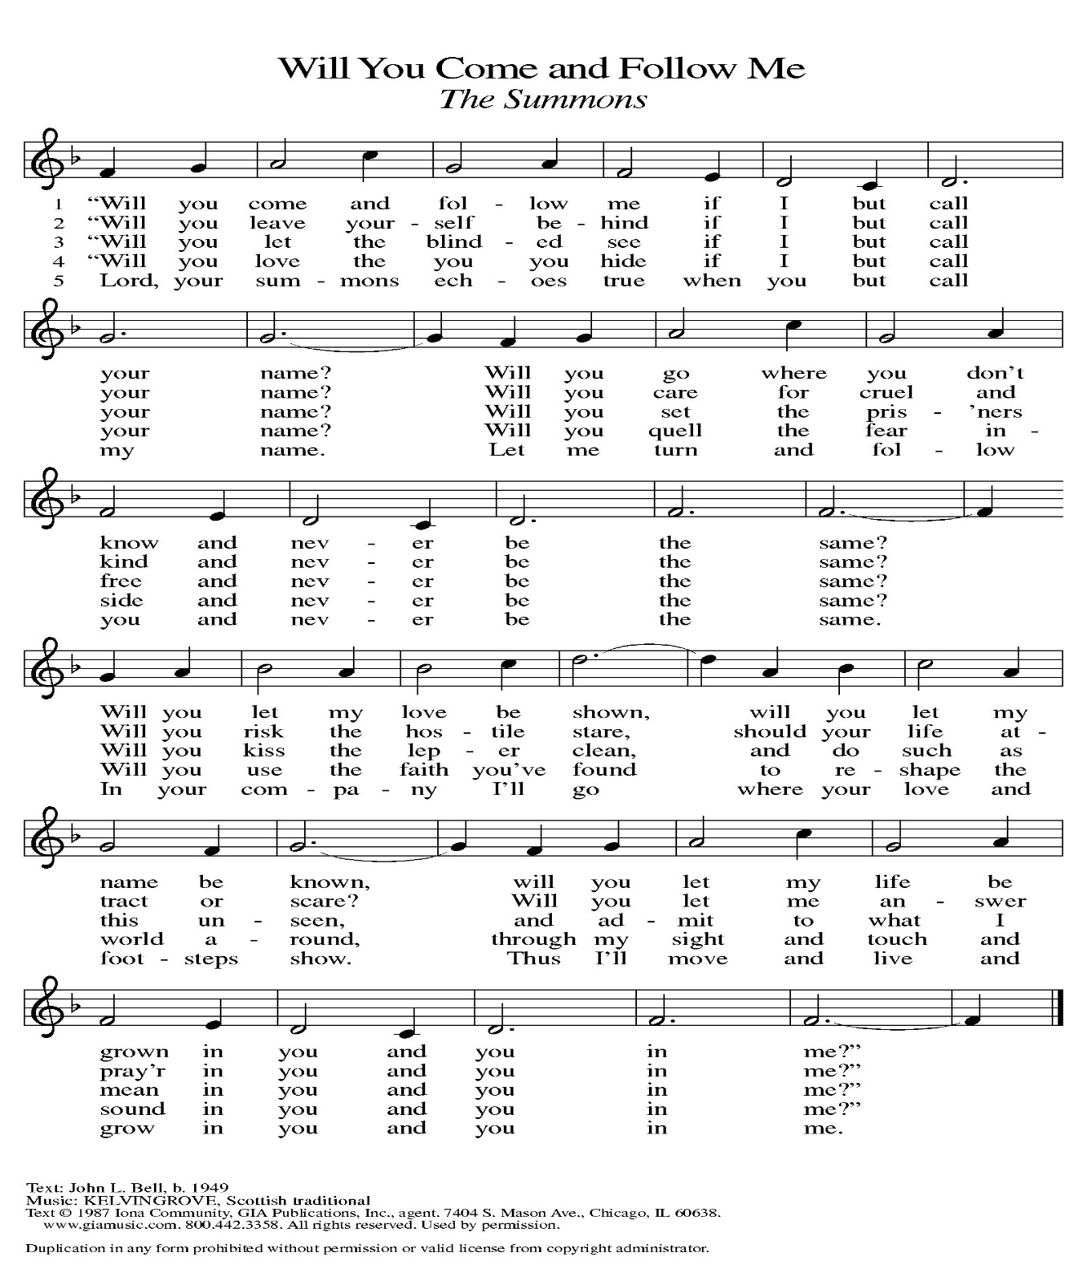

**APOSTLES’ CREED**

V. God has made us his people through our Baptism into Christ. Living together in

trust and hope let us confess our faith together using the Apostles’ Creed.

**C. I believe in God, the Father almighty,**

**creator of heaven and earth.**

**I believe in Jesus Christ, God’s only Son, our Lord,**

**who was conceived by the Holy Spirit,**

**born of the Virgin Mary,**

**suffered under Pontius Pilate,**

**was crucified, died, and was buried;**

**he descended to the dead.**

**On the third day he rose again;**

**he ascended into heaven,**

**he is seated at the right hand of the Father,**

**and he will come to judge the living and the dead.**

**I believe in the Holy Spirit,**

**the holy catholic church,**

**the communion of saints,**

**the forgiveness of sins,**

**the resurrection of the body,**

**and the life everlasting. Amen.**

**PRAYERS OF INTERCESSION**

(The prayers are prepared locally for each occasion.)

V. With the Spirit of Christ shining upon us, let us boldly pray for the church, the

world, and all of creation.

(A brief silence.)

A. Giver of gifts, you form each member of the church to serve. Inspire us to boldly

use gifts of welcome and healing, service and teaching, leading and preaching,

for the sake of your work in the world. God of grace,

C. hear our prayer.

A. Refuge of creatures, you place all the living under the shadow of your wings.

Lead us in ways that tend to the needs of wild and domestic animals, creatures

threatened by extinction, and the environment we share. God of grace,

**C. hear our prayer.**

A. Voice of the oppressed, you call prophets throughout time. We remember the

Reverend Doctor Martin Luther King, Junior, a voice for racial and economic

justice and for peace. Guide our nation in continuing to heed your prophetic call.

God of grace,

**C. hear our prayer.**

A. God of steadfast love, as Jesus celebrated at Cana, nurture marriages and

relationships in mutual care; in times of separation or divorce hold tenderly

broken hearts and broken dreams. Be present to all who are sick, grieving or in

any need; especially:

Betty Lang (Church Member)

BettyAnn Rich-White (Church Member)

Chip Hand (Church Member)

Lynn Bargstadt (Church Member)

Audrey Kinka (Church Member)

Sharon Ford (Church Member)

Carol Amundsen (Church Member)

Kim McGinley (Church Member)

Marie Hand (Church Member)

Frank Ford (Church Member)

Eric Dishman (Church Family)

Joan Sommerman (Church Family)

Megan Pratz (Betty Lang’s Friend)

Patty Cioce (Betty Lang’s Friend)

Carla Wagner (Betty Lang’s Family)

Tom McNamara (Audrey Kinka’s Family)

Beth & Bill Knapp (Betty Lang’s Family)

Bill Kanass (Betty Lang's Family)

Ed Borse (Betty Lang’s Friend)

James Kershaw (Audrey Kinka’s Friend)

Kali Poe (Betty Lang's Family)

Linda Dressic (Carol Detweiler's Family)

Suzie Clark (Rose Lang's Friend)

Evy (Betty Lang's Friend)

Amelia Skyrm (Audrey Kinka's Family)

Cindy Irana (Betty Lang’s Friend)

Ed Watson (Betty Lang's Friend)

Francis Clock (Dianna DeNote’s Family)

Andrew Hudak (Rose Lang’s Friend)

Fred Lang (Betty Lang’s Family)

Viena Murtha (Bob Fritsch’s Friend)

Christine Schneider (Audrey Kinka’s Family)

Jackie Churchman (Audrey Kinka’s Family)

Sharon Waicus (Skip & Bonnie Millard's Friend)

Karen O'Brien (Paul Bowker's Friend)

Dustin Irizzary (Mary Melnicoff's Family)

Linda Smith (Rose Lang's Friend)

Joan Brown (Betty Lang's Friend)

Donna Bradley (Betty Lang's Friend)

Theresa Marioti (Betty Lang's Friend)

The Bryan Family (Wanda Bryan's Family)

Ernie Kinzler (Marie Hand & Doreen Kinzler’s Family)

Craig Brearey (Judy Brannan & Mary Melnicoff's Friend)

Sarah Dutton (Frank & Sharon Ford's Family)

Christina McNasby (Fran Green’s Family)

The Kinkson Family (Judy Brannan's Friends)

Mark Stephen Dennis (Diana DeNote's Family)

Cathy Snyder (Audrey Kinka's Family)

Dellie Valcourt (Skip & Bonnie Millard's Family)

Joyce (Betty Lang's Family)

Hannah (Betty Lang's Family)

Donna Lee (Betty Lang's Friend)

Bill Lodge (Skip & Bonnie Millard's Friend)

Patrick & Denise Brannan (Judy Brannan's Family)

Ron Anderson (Bill Kelly's Friend)

Jerry P (Wanda Bryan's Friend)

Pat Labrae (Kathy Poehler's Friend)

Bud Brearey (Judy Brannan & Mary Melnicoff's Friend)

Mary Skain (Kathy Poehler's Friend)

Bill Rand (Wayne & Eleanor Rand's Family)

Kevin Naylor (Vicki Rinier's Friend)

Robert Chaplin (Mary Melnicoff's Friend)

Jack Wieckouski (Theresa & Kim McGinley's Family)

Rick (Carol Amundsen’s Friend)

Vera (Carol Amundsen's Friend)

Carolyn Santarpio (Bob Fritsch's Friend)

Cathy Hines (Rose Lang’s Friend)

Ken Mortensen (Del McKenna’s Family)

Harry (Judy Brannan's Friend)

Janet K (Philomena Noak's Friend)

Michael Hart (Diana DeNote's Friend)

Rocco Leonard DeNote (Diana DeNote's Family)

Spencer Oditt (Butch Poehler's Family)

Julie Schlereth (Diana DeNote's Friend)

Tina Crull (Vicki Rinier's Family)

Al Singer & Family (Frank & Sharon Ford's Friends)

Sherri Lynn (Bob Fritsch’s Friend)

John Bannco (Bob Fritsch’s Friend)

(Additional Names Added Prior to the Worship Service.)

A. God of grace,

**C. hear our prayer.**

A. Spirit of peace, celebrating this Week of Prayer for Christian Unity, we pray for

neighboring congregations and ministry sites. Nurture our shared commitment to

embody Jesus’ love, justice, and healing. God of grace,

**C. hear our prayer.**

A. Wellspring of life, in living and dying we trust in you. We give thanks for the saints.

Guide us in our living until, at last, we rest in you. God of grace,

**C. hear our prayer.**

(Here other intercessions may be offered.)

V. Watch over all of us who are worried and suffering, and especially those whose

names we now say aloud or within our hearts (extended pause). God of grace,

**C. hear our prayer.**

V. We entrust our prayers to you, O God, in the sure and certain hope that your

promise is revealed among the people.

**C. Amen.**

**SHARING OF THE PEACE**

V. May the peace of the Lord be with you always.

**C. And also with you.**

V. Let us share God’s Peace with one another.



(Please remain in your pews and offer the sign of peace with a peace sign or wave.)

V. We invite you to be seated.

**OFFERING**

V. We now worship God with our tithes and offerings, wine and bread for use in holy

communion, and monetary gifts to support our ministry for service in God’s name.

Our Ushers will be around to your pews to pass the Offering Plates.

(Ushers come forward to get the Offering Plates from the Assistant.)

(Vicar and Assistant prepare the Altar for Communion.)

**OFFERING SONG**

(We invite you to sing along with the music offered by our Organist.)

Evangelical Lutheran Worship—677

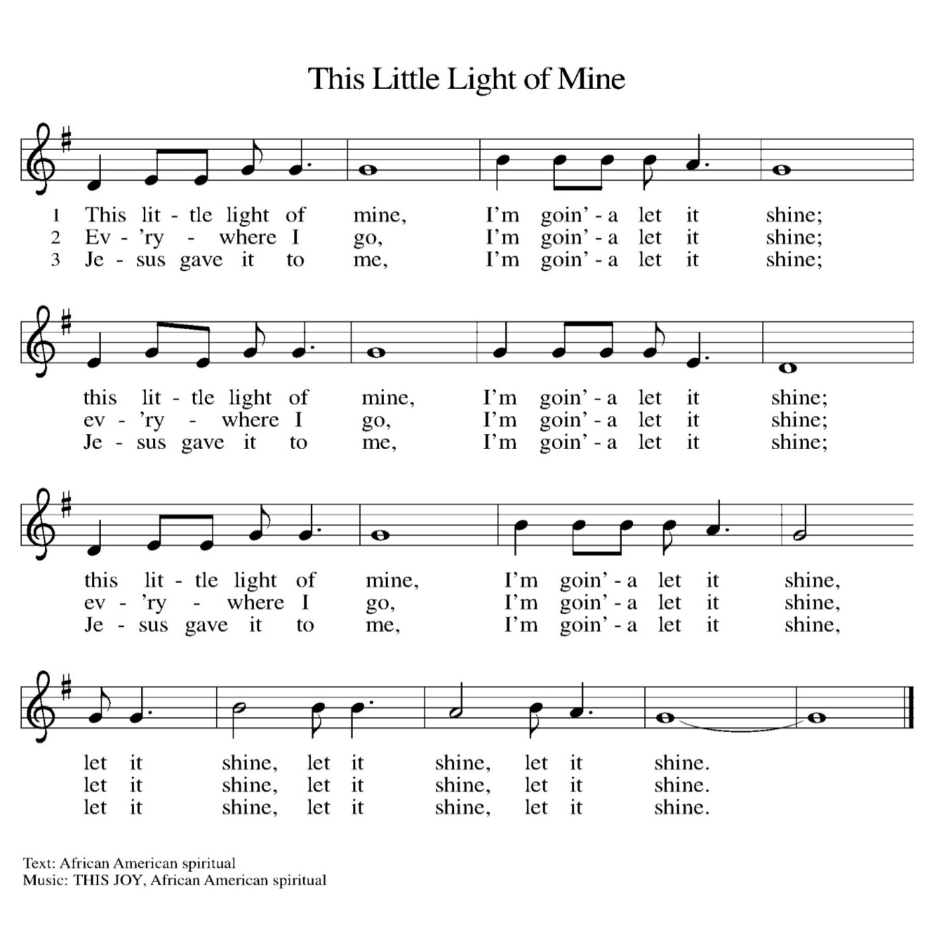

(Usher(s) brings the Tithes and Offerings up front to the Assistant.)

V. We invite you to stand if you are able.

**OFFERING PRAYER**

V. Let us pray,

God of grace, your love reaches to the heavens,

and your abundance to the depths of the seas.

Bless what we offer to your service:

our gifts, our abilities, and our hearts.

Let us overflow with gratitude and generosity,

now and always.

**C. Amen.**

**GREAT THANKSGIVING**

V. The Lord be with you.

**C. And also with you.**

V. Lift up your hearts.

**C. We lift them to the Lord.**

V. Let us give thanks to the Lord our God.

**C. It is right to give him thanks and praise.**

V. It is indeed right and salutary that we should at all times and in all places offer

thanks and praise to you, O Lord, holy Father, through Christ our Lord; who rose

beyond the bounds of death and, as he promised, poured out your Spirit of life

and power upon the chosen disciples. At this the whole earth exults in boundless

joy. And so, with the Church on earth and the hosts of heaven, we praise your

name and join their unending hymn:

**SANCTUS**

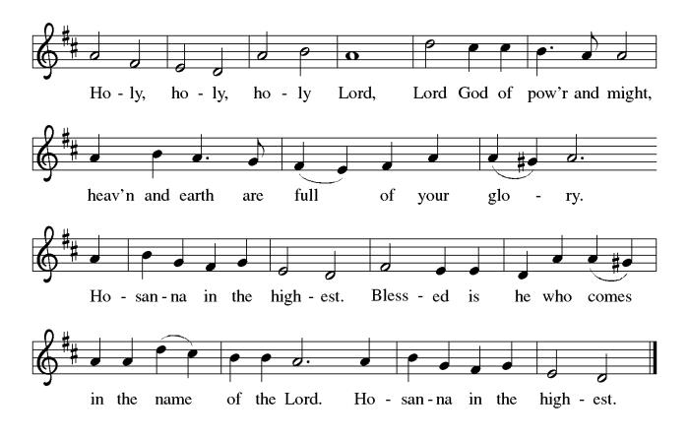

**THE EUCHARISTIC PRAYER**

V. Blessed are you, Lord of heaven and earth, in mercy for our fallen world you gave

your only Son, that all those who believe in Him should not perish, but have

eternal life. We give thanks to you for the salvation you have prepared for us

through Jesus Christ. Send now your Holy Spirit into our hearts that we may

receive our Lord with a living faith as He comes to us in His holy supper.

**C. Amen. Come, Lord Jesus.**

V. In the night in which he was betrayed our Lord Jesus took bread,

he gave thanks; broke it, and gave it to his disciples, saying:

*Take and eat; this is my body, given for you.*

*Do this for the remembrance of me.*



V. Again, after supper, He took the cup, he gave thanks,

and gave it for all to drink, saying:

*This cup is the new covenant in my blood,*

*shed for you and for all people for the forgiveness of sin.*

*Do this for the remembrance of me.*



**THE LORD’S PRAYER**

(We ring the bell throughout the Lord’s Prayer at all services to

invite those in the community to join in praying the Lord’s Prayer.)

V. May we now join with one another and pray together as Jesus has taught us.

**C. Our Father, who art in heaven, hallowed be thy name, thy kingdom come,**

**thy will be done, on earth as it is in heaven. Give us this day our daily**

**bread; and forgive us our trespasses, as we forgive those who trespass**

**against us; and lead us not into temptation, but deliver us from evil. For**

**thine is the kingdom, and the power, and the glory, forever and ever.**

**Amen.**

**LAMB OF GOD**

**C:\Users\Vince and Heather\Downloads\Lamb of God, ELW Setting Four (Melody).tif**

V. We invite you to be seated.

**HOLY COMMUNION**

V. Communion here is pretty simple, and all who believe in Jesus Christ are

welcome at this very table. We utilize bread (or wafers), and we also have the

option of individually wrapped gluten free wafers. We have pre-filled red wine or

white grape juice cups in the Communion Tray to choose from.

The Usher will offer the option to leave your pew, and you can proceed forward

on the right side of the aisle to the steps between the Communion Rail. Following

Communion, please process back on the left side of the aisle and place your

empty cups in the basket before returning to your pew. Children who have not

had their First Communion instruction, and adults who do not wish to receive

Communion, are welcome to come forward and give me a sign to obtain a

special blessing.

If you are unable to leave your pew for health or other related reasons, please

inform the Usher of your desire to remain in your pew and have us come to you.

**INVITATION TO COMMUNION**

V. The joy of the Lord is our strength.

Come, eat this meal of gladness.

**C. Amen.**

(Distribution of Holy Communion)

**COMMUNION HYMN**

(Please enjoy various music offered by our Organist during your

quiet time, prayer, and reflection following Holy Communion.)

(Vicar and Assistant remove Communion Vessels from the Altar.)

V. Let us stand as we are able.

**POST COMMUNION BLESSING**

V. May the body and blood of our Lord Jesus Christ strengthen us and keep us

always in His grace.

**C. Amen.**

**POST COMMUNION CANTICLE**





**PRAYER AFTER COMMUNION**

A. Let us pray,

Nourishing God,

at this table you have refreshed us

with holy gifts of food and drink.

Strengthen us for service,

and send us out to embody your good news

of liberation and healing for the sake of the world.

In the name of Christ we pray,

**C. Amen.**

**BLESSING**

V. The Spirit of the triune God

☩ bless you with joy,

anoint you with compassion,

and send you in love.

**C. Amen.**

(We invite you to remain standing if you are able.)



**SENDING HYMN**

(We invite you to sing along with the music offered by our Organist.)

With One Voice—Blue Book

**755—We All Are One in Mission**

(Assistant extinguishes the Altar Candles half way through the Sending Hymn.)

(Vicar processes out once the Altar Candles have been extinguished.)

(We invite you to be seated.)

**BIRTHDAYS, ANNIVERSARIES,**

**& ADDITIONAL ANNOUNCEMENTS**

(Offered by Assistant and Congregation.)

**BIRTHDAYS**

19th Pastor William Hodgetts

20th Kathy Poehler

**ANNIVERSARIES**

None

**DISMISSAL**

A. Go in peace. Live in hope.

**C. Thanks be to God.**

**POSTLUDE**

(Music offered by our Organist as we depart following our Worship Service.)

**God of Grace and God of Glory**



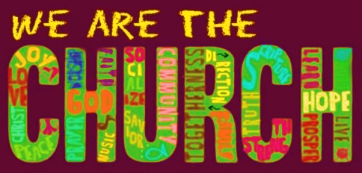

**LICENSES & EXPIRATION DATES**

Worship Service Content is used via permission through Augsburg Fortress Liturgies Annual License #SB144368. The next Subscription Renewal Date is 2/28/2025.

Our Hymns and Worship Music are used via permission through CCLI One License #11327166. The next Subscription Renewal Date is 1/31/2025.



**SOUND SYSTEM UPDATE**

Oliver Phillips at Not the DJ, LLC completed the upgrade to our Sound System on **Tuesday, January 14th**. Two Speakers, a Mixer, and Sound Board were donated from another church following their upgrades. The Fellowship Hall speakers were moved to the Narthex. We are currently waiting on a Power Supply for the Cordless Microphone. A good portion of the building was also rewired, with a lot of speaker cable being removed from the heating ducts. Other upgrades may need to be explored in the future. However, let’s see where we are right now with all the changes. Please provide feedback as adjustments can be made to the entire system. We are awaiting our final bill for full payment following our initial deposit.

**TAX STATEMENTS**

Heather is working on cleaning up the books and doing the last bit of entering for the 2024 giving year. Annual Statements will be coming out in the mail to you as per our privacy practice. We ask you to look over them closely and get back to Heather ASAP with any errors, missed giving, or adjustment you feel need made.



**SUNDAY SCHOOL & CONFIRMATION**

The Program went through a bit of a restructuring process. Most of the young folks that have been attending over the years have now made it to the age in which they will be preparing for Confirmation. As a result, Vicar Vince spoke with a few Pastors and reviewed various curriculum and programs for this. “Here We Stand” is a program that will allow our young folks to go through a 2-year process while focusing on the Bible and Luther’s Small Catechism. We will continue the program on **Sundays from 9-10AM**. Of course, there still will be snacks, games, arts & crafts, and other fun things. See Heather, Bonnie, & Vicar Vince for more information.

**WORSHIP MINISTRY**

The most important thing we do each week is gather together as God's people to worship. God is the center and focus of everything we do. Participating in worship is active. Liturgy means the work and actions of the people gathered. Everything we do during the week to prepare for worship, and everything we do as we assist in leading worship is important. We are thankful for all the wonderful work being done. If you are interested in any position let Vicar Vince know so a training can be set-up.

Sign-up sheets are located on the bulletin board between the church offices.



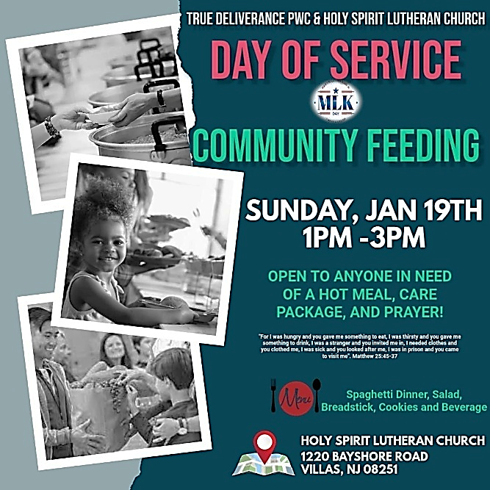

Join us **TODAY, Sunday, January 19th, from 1PM—3PM.** Various community agencies were informed of the event to promote those in need in the community to come out and join us for a Spaghetti Dinner, to receive Care Packages, and for Prayer. Please consider helping out in any way, or just by coming to welcome and sit with folks and talk as they eat. Let’s show our love and support to our neighbors!

**BIBLE STUDY & FAITH DISCUSSIONS**

​​​​​Bible Study & Faith Discussions was started in order to focus on various readings,

books, Bible verses, people of faith, and other general topics. Group Members offer

various points of view while reviewing the Bible and various aspects of faith while

being respectful and supportive of each other. **We will not meet this Tuesday due to our Church Council Meeting**. Join us on **Tuesday, January 28th, at 6PM**.

**CHURCH COUNCIL**

Share your comments, concerns, questions, or joys with one of our Church Council Members who can bring them back to our meetings. Visitors are always welcome to attend and listen to what is going on in and around the church. Join us In- Person or on our Conference Call at our next Meeting on **Tuesday, January 21st, at 6PM**.



**FOOD PANTRY & COMMUNITY DELIVERIES**

**Open every Thursday**, and the **last Saturday of every month**, from **10AM to 1PM**. 85 people were served in December. 1,095 people were served in 2024. Donations can be dropped in the basket in the Narthex, placed in the outdoor drop-box by the Church Office door, placed in the money jug in the back of the Church, mailed into the Church Office, or placed in the Offering Plate. Volunteers are needed each week. Sign-up sheets are located on the bulletin board between the church offices.

If you have questions or need training see Heather, Vicar Vince, or Bonnie.

|  |  |  |
| --- | --- | --- |
| **Thursday, 1/23** | **Saturday, 1/25** | **Thursday, 1/30** |
| Tori & Cathie | Skip & Bonnie | Cathie & Garnet |

Our local North Cape May Acme & Big Lots provide us with Expiring Soon, Recently Expired, and Slightly Damaged Foods & Items weekly. Kathy helps those in need by delivering items each Saturday in the community. Kathy then brings leftover items to the Church for church members in need, and those who visit the food pantry during the week. Additional items are then taken over to the Branches Outreach in Rio Grande. A special thanks to all who donate, pray, and help in any way!

**BULLETIN ENTRY DEADLINE**

The Bulletin is Printed on **Thursdays** during Church Office Hours. Changes need to be submitted to Vicar Vince or Heather no later than **Thursday by 4PM**. Thank you!

**CHURCH OFFICE**

Open **Thursdays from 6PM to 8PM** to serve the Congregation, the Community,

and to continue handling the business of the Church. Feel free to stop in to talk,

pick-up or drop off something, pray in the Sanctuary, or for whatever reason.



**S’MORES & SCRIPTURE TO SOUP & SCRIPTURE**

Did you ever look forward to sitting around a fire in the church yard hanging out with some folks, enjoying s’mores, and studying scripture? We will shift this Fellowship time to **Soup & Scripture** and be **indoors** following the holidays. **Join us on Saturday, January 25th, at 6PM**. Ask Heather or Vicar Vince for information.

**PREACHING AT BROOKDALE**

Vicar Vince will be Preaching at Brookdale Senior Living in Cape May Court House on **Sunday, January 26th, at 1PM**. Holy Communion will follow the service.

**DONATION STATION**

Get on the train and place all purchased items in the specified project donation bins located on the counter by the front doors. See Heather for more information.



**THEOLOGICAL EDUCATION FOR EMERGING MINISTRIES**

Vicar Vince is enrolled in 1 class at Seminary from **February 5th – 8th**. This class is only virtual. If you happen to see Vicar Vince’s car at church any of these days, please know he may be locked in his office focusing on class on the computer and may not be able to answer the door or attend to various needs as a result.



**ANNUAL CONGREGATIONAL MEETING**

2025 will bring about several new things and changes, but one thing is for certain, we will be meeting as a Congregation for our Annual Meeting. We will pray, discuss and review things, answer questions, and vote on a new budget on **Sunday, February 9th** following our Worship Service. Please make sure you attend.

**COFFEE HOUR**

The Women of the Church will host the next monthly Coffee Hour on

**Sunday, February 9th,** following our Annual Congregational Meeting.

Please see Judy or Kathy for more information.

**COMMUNITY RESOURCE DAY**

The 3rd Annual Community Resource Day will be hosted by Tabernacle United Methodist Church, at 702 Seashore Rd, Cape May, on **Saturday, February 15th, 2025, from 10AM—2PM**. There will be 75+ Social Service focused organizations available for you to get information from and get connected with. Please consider coming to check things out. For more information see Vicar Vince.

**CHURCH DIRECTORY**

The 2024 Church Directory is by the Church Office on the bookshelves. We continue to keep it updated throughout the year. Undoubtedly, we probably missed a few changes, and have made a few errors. The printed church directories have spaces for changes in information, new people’s information, notes, and your favorite Bible verses. If you have any changes or updates, please make it a point to inform the Church Office to keep us most up to date. **Our New 2025 Church Directory will be made available to everyone by the end of February**.

**ANNUAL SHORE MISSION DISTRICT MEETING**

In preparation for the upcoming NJ Synod Assembly, and the electing of a new Bishop, we will be meeting to answer questions, prepare, and prayer. We will be meeting at Zion Lutheran Church in Egg Harbor City on **Saturday, March 1st, from 10AM-12Noon.** Feel free to ask Vicar Vince more information about this.

**WOMEN OF THE CHURCH**

The Women of The Church will be taking time off during the Winter months and

their next monthly meeting will be held on **Monday, March 3rd, at 6PM**.

New members are always welcome to attend! Contact Judy for more information.

**NJ SYNOD ASSEMBLY**

Wayne, Mary, and Vicar Vince were able to attend Synod Assembly last year and meet with several people and handle the business of the church. This year the Assembly will transition from a one day to three-day event due to the election of a new Bishop, and other business to be handled. Vicar Vince is looking for two other church members to be able to attend the event with him. The event will be in East Brunswick at the Hilton from **Thursday, June 5th to Saturday, June 7th**. We will need to figure out hotel reservations and travel plans accordingly. Please reach out to Vicar Vince with any questions or your interest in attending.



Our 75th Anniversary will be occurring in 2025! How awesome is that?!?! The Synod has been contacted, and we have been placed on the Bishop’s Calendar for **Sunday, October 19th, 2025**. This congregation is a legacy that we have all lived in and through over all of these years, or maybe just for a short time. However, it is a legacy that we hope and desire to continue to carry on and move forward for those people that will be able to gather and worship with us and following us as well. We are the church carries a strong mentality with it, and it does not just mean within these very walls. We need to celebrate those 75 years of being part of this community, and all that has led up to the very start of this church body as well. I encourage you all to start thinking how we are going to celebrate this legacy as we begin preparations and **gather a committee together soon**.

**NEWSLETTER**

Information, stories, pictures, and committee reports for our seasonal publication can be submitted to Vicar Vince in-person or via email at vpie8282@gmail.com.

**TAKING FAITH HOME**

Vicar Vince was introduced to Milestones Ministries weekly guides for faith-filled studies and conversations through a Seminary class. A decision was made to pass these along to you. If you missed a week, or lost your insert, check our website for past issues. Feel free to ask questions and provide feedback to Vicar Vince.

**HOME COMMUNION MINISTRY**

A Minister is available if you have a loved one, or if you desire services. We look forward in sharing the Word and Holy Communion! Please inform Vicar Vince, Kathy, or the Church Office so plans can be made for visits.

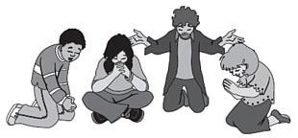

**PRAYER LIST**

Our Prayer List continues to lengthen and we realize the important need for prayers and healing. Sometimes the unfortunate result is that someone has passed away, and the words “The Family & Friends of” appear before someone’s name. However, sometimes we forget names are still on the list and their health has improved or the they are no longer struggling, and they can be removed. Please share the good and bad stories as we continue to pray for strength and healing. Names can be added or removed from the list on the clipboard in the Narthex prior to the Worship Service, by calling the church office, or addressing it on the Conference Call. Please let us know the relation to the person(s) you listed so we can be more mindful with our prayers. Names will stay on the list until removed by the person(s) who requested prayer.

**PRAYER SHAWL MINISTRY**

Prayer Shawls, Lap Quilts, Scarves, and other items have been made with love. Blessed items are located in the Narthex, and are free for anyone. Members of the group continue working at home on new stitches and patterns. We are blessed to be able to continue collecting new items. We have a donation station of yarn and other items located in the Narthex. You can find some new supplies for your next creation!

**FAVORITE HYMNS**

Carol is willing to play some of your favorite hymns for the Prelude & Postlude each Sunday during our Worship Service. Feel free to let her know of your suggestions.

**INTERESTED IN BECOMING A NEW MEMBER**

Have you been attending our church for a while? Have you just recently returned to church after being away for a bit? Maybe you transitioned from another church,

or just started to recently attend our church. We are glad to have you, and would love to have you as a member of our Congregation. See Vicar Vince for more info.

**BAPTISM**

We are a church whose unity is in Jesus Christ, who gathers us around word and water, wine and bread. Baptism is a significant part of our faith journey as we come from the baptismal waters to live a new life as children of God. Our baptism sets us out on a lifelong journey that is characterized by our relationship to God, our relationship to our faith community, our relationships in our community and the wider world. Living our baptismal covenant means living a life of growth in the faith practices of discipleship. Please see Vicar Vince for more information.

**FIRST COMMUNION**

Although no particular age for first communion is prescribed by The Use of the Means of Grace, one guideline is offered. Because admission to the Sacrament is by invitation of the Lord to the baptized, "baptized children begin to commune on a regular basis at a time determined through mutual conversation that includes the pastor/vicar, the child, and the parents or sponsors involved, within the accepted practices of the congregation.” Each congregation is encouraged to ask the question of readiness for first communion, establish their own policies regarding age and practice, and accompany that practice with catechesis appropriate to the age of the communicant. If anyone has questions, please see Vicar Vince.

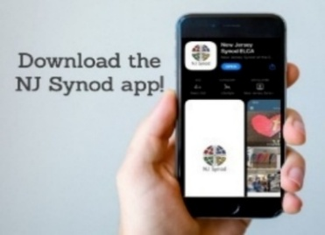

Jersey Jottings is a weekly e-newsletter that connects our synod together with weekly prayer, upcoming events, synod and churchwide activities, mission stories, congregational activities, and more. You can also sign up by going to https://www.njsynod.org/stay-connected and filling out the form! You can also get the app on your smartphone in the Apple App Store or on Google Play on your android.

**LIBRARY**

New books are added to our library from time to time. Several are borrowed and read and exchanged. Who knows, you might find one particularly interesting and share that with someone as well. Reading is a great way to pass spare time, learn, and explore. You may find some fresh ideas for prayer, ways to grow more spiritually, ways to grow closer to God, or some opportunities to understand our faith more. Visit the library between the church offices and see what books are there!

We also have a hidden extended library located in Vicar Vince’s office on the large green shelves. There are Bibles of various translations, books from his personal collection, books inherited from Pastor Leah, movies, past Bible Study Curriculums, and so much more. Feel free to ask Vicar Vince to be able to check things out!

**PROPERTY USE**

​​​​​Do you know anyone interested in utilizing our Fellowship Hall for a Party or Event?

It is a suggested $50 refundable security deposit, and $250 for facility use. There is no alcohol or games of chance permitted due to ELCA policy. Please contact Vicar Vince or the Church Office with questions, for info, or to reserve a date and time.

**TITHES, OFFERINGS, & ENVELOPES**

**2025 Offering Envelopes are available**. We do indeed worship God with our tithes and offerings. We hear this in scripture, “Each of you must give as you have made up your mind, not reluctantly or under compulsion, for God loves a cheerful giver.” (2 Corinthians 9:7) Feel free to drop your envelopes in the offering plate, mail them to the church, or drop them off in the locked mailbox. Thank you for your continued support in the mission of our church, its ministries, the NJ Synod, and other needs!

**ED GREEN CAPITAL IMPROVEMENT FUND**

We continue raising money for unforeseen costs or repairs.Kathy sells Wawa Tickets for $6, the donation bin is in the back of the church, and we have our Annual Church Rummage Sale. Thanks for your continued donations, prayers, and support!

**VICAR VINCE’S DAY OF REST**

A day of rest can have physical, mental, and spiritual benefits. “Mittwoch,” German for mid-week, or Wednesday, is the day that Vicar Vince will use to recharge and do some other things. Please do not hesitate to reach out if there is an emergency!

**VICE PASTOR UPDATE**

Pastor William Hodgetts continues to attend our monthly Church Council Meetings. Pastor William continues to provide Supervision and Direction for Vicar Vince.

**VICAR APPOINTMENT ON MARCH 19TH, 2023**

A Memorandum of Understanding on the Matter of Pastoral Appointment

In Theological Education for Emerging Ministries (TEEM) Candidacy

TO: Congregation Council, Holy Spirit Lutheran Church, Villas

FROM: The Rev. Tracie L. Bartholomew, Bishop, New Jersey Synod

Dear Brother and Sisters in Christ,

This memorandum is in support of your discussions with Vincent Piekarski as pastor of Holy Spirit, Villas. Because this is not the usual pattern for completing the educational and candidacy requirements for ordination, it is my hope that this memorandum will both provide guidelines and engage in conversation with those who are invested in this process.

I would say at the outset that because Vincent is an outstanding candidate for the Ministry of Word and Sacrament, we will all want to do whatever is necessary to assure that his placement serves the mission of the church in the best possible fashion.

The following notes reflect my own understanding of this matter:

(1) The appointment for Vincent will begin on April 1, 2023. At this time, Vincent

will assume all responsibilities of a regularly called pastor, including presiding at

the Sacrament of Holy Communion and Baptism at Holy Spirit, Villas.

(2) A pastoral appointment in the TEEM process is an option for completing

seminary educational requirements and the steps of the candidacy process.

Upon completion of the candidacy process and seminary education, the

candidate may receive and accept a call to ordained ministry from the

congregation where the appointment is being served.

(3) This appointment is jointly supervised by the Office of the Bishop and the TEEM

pastor’s seminary. A mentoring relationship with a local pastor is required for the

length of this appointment.

(4) The synod of candidacy origin will be responsible for the approval process.

(5) Upon approval for ordination, the congregation would be expected to extend a

call to the pastoral appointee.

(6) Compensation for the TEEM pastor will be according to the guidelines of the New

Jersey Synod. All normal forms of compensation should be in place for the term

of the appointment, including stipulation that base salary and housing shall be in

accord with synod guidelines for first call at time of ordination.

(7) The ELCA Portico benefit plan for lay persons in full-time church service should

be used for the pastoral appointee up to the time of ordination, whereupon the

benefit package is to be converted to the plan for ELCA clergy.

(8) A decision for Pastoral Appointment is made with the agreement of a synod and

its candidacy committee, and the ELCA, normally represented by the regional

staff person of each in consultation with the seminary and its Director for

Contextual Education.

(9) Pastoral Appointment in a TEEM Candidacy is an option that is to serve the

mission of the Church in a particular and vital way and is not to be viewed or

used as a means to circumvent the normal candidacy process and/or first call

placement process.

In the specific case of Vincent, the New Jersey Synod remains responsible for the candidacy and approval process, and has agreed to this proposal for Appointment at Holy Spirit, Villas.

Continued blessings to both Holy Spirit and Vincent Piekarski as you embark on this journey of mutual ministry. As partners in ministry, we walk with you and rejoice in this new relationship.

**TRUE DELIVERANCE PRAISE & WORSHIP CENTER**

Reverend Maria Brooks and True Deliverance Praise & Worship Center utilize our facilities from 1-4PM on Sundays. TDPWC helps with the Food Pantry and hosts or assists with other events throughout the year. TDPWC hosts a Prayer Line on Mondays, Thursdays, & Fridays at 5PM on their Conference Call # 1-657-390-7957.

**WHAT IS THE EVANGELICAL LUTHERAN**

**CHURCH IN AMERICA (ELCA)?**

The ELCA was formed in 1987 by the merger of three Lutheran Church bodies –

the ALC (American Lutheran Church), the LCA (Lutheran Church in America),

and the AELC (Association of Evangelical Lutheran Churches).

To learn more, go to the ELCA's website at www.elca.org.

**WHAT IS THE NEW JERSEY SYNOD?**

The New Jersey Synod is a geographical grouping of Evangelical Lutheran Church in America (ELCA) congregations that share the mission and ministry of the Church on the New Jersey territory. It is one of 65 synods in the ELCA. The NJ Synod is comprised of 146 congregations, which include over 45,000 baptized members.

|  |  |
| --- | --- |
| **2024 FINANCIAL STANDING** | |
| **DECEMBER INCOME** | $7,917.38 |
| **DECEMBER SPENDING** | $8,588.34 |
| **DECEMBER GAIN OR (LOSS)** | ($670.96) |
| **2024 INCOME** | $113,784.05 |
| **2024 SPENDING** | $124,179.72 |
| **2024 GAIN OR (LOSS)** | ($10,395.67) |
| **ED GREEN CAPITAL IMPROVEMENT FUND** | $17,838.88 |
| **FOOD PANTRY FUND (SOCIAL MINISTRY)** | $13,168.74 |
| **CD** | $25,393.98 |

**CHURCH STAFF & VOLUNTEERS**

**VICAR, BIBLE STUDY & FAITH DISCUSSIONS,**

**EVENTS, NEWSLETTER, & WEBSITE**

Vicar Vince Piekarski

**VICE PASTOR**

Pastor William Hodgetts

**ORGANIST & PIANIST**

Carol Amundsen

**CHURCH COUNCIL PRESIDENT**

Mary Melnicoff

**CHURCH COUNCIL VICE PRESIDENT**

Judy Brannan

**CHURCH COUNCIL TREASURER**

Bonnie Millard

**CHURCH COUNCIL SECRETARY**

Vicki Rinier

**CHURCH PROPERTY**

Frank Ford & Wayne Rand

**CHURCH OFFICE, SUNDAY SCHOOL, & FOOD PANTRY**

Heather Piekarski