One of the regional rockhounding places that I have never been to is the Wiley’s Wells area. I pitched the idea to the club and a number of folks said they were interested. Wiley’s Wells is near Blythe, CA and is about 3.5 hours away from San Diego. This is the furthest our club large scale field trip our club has done in a long time. We were there from 11/24/16 – 11/27/16. Richard Mueller and Dave Rosendahl had been in the area a number of times so they provided some essential guidance on where to go and what to look for.
The 11/24 was a travel day so most of us did not make it until lunch time. This is a large area so getting to the Hauser Beds meant spending some time driving on dirt roads. The first day we visited the original Hauser beds. The surface had been picked over but we did find some broken geodes.
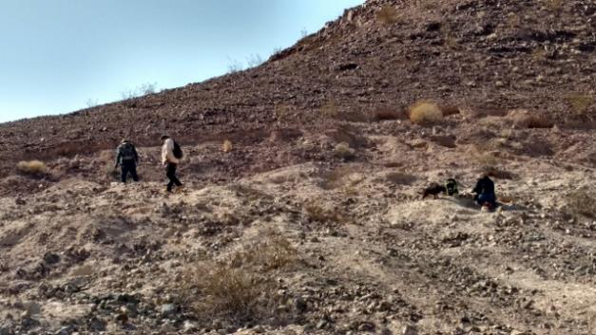
Richard Mueller, Dave Roendahl, Steve Burns and Tarley (the dog) digging at Hauser Geode Beds
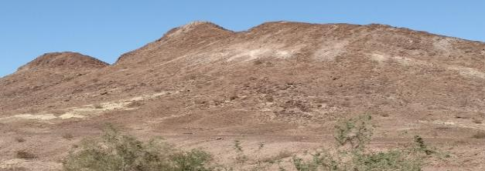
Other nearby diggings.

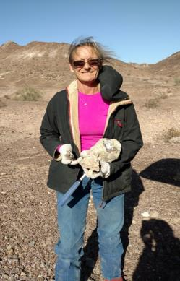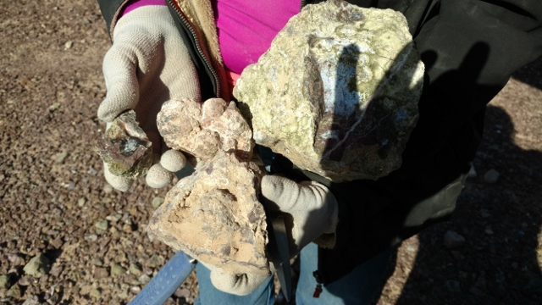
Yvonne Prudy and her finds from Hauser Geode Beds.
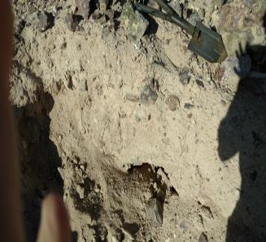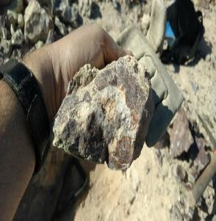
Digging in the volcanic ash for geodes at Hauser Geode Beds.

After a bit of digging it was back to the camp site for Thanksgiving in the field!
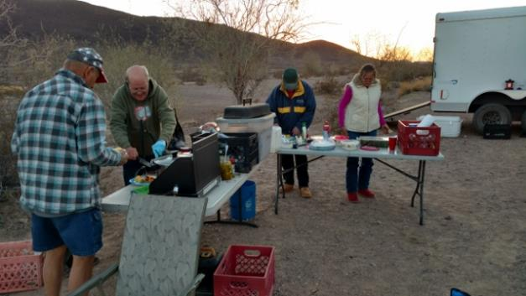

Day #2 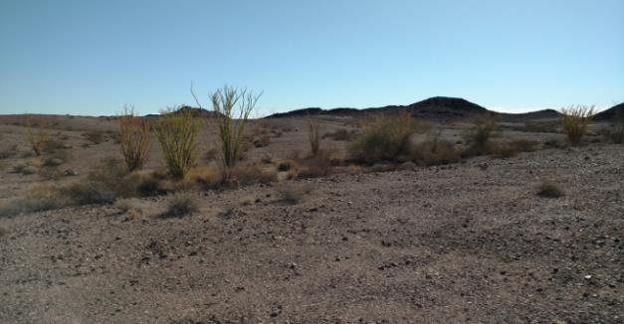
Ocotillo cactus
On the second day we started out digging for black agate nodules. The agate is actually clear to slightly milky, but the red rhyolite matrix blocks the light from illuminating the back of the stone giving it a black appearance. There were sandy washes between the road and the diggings so we had to walk about 5 whole minutes It was pretty easy.
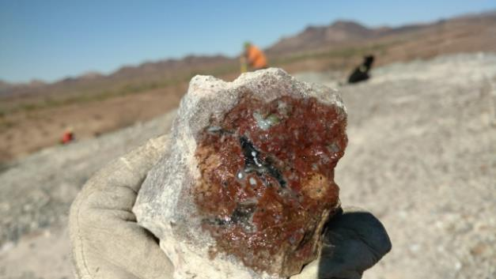
Black agate nodule
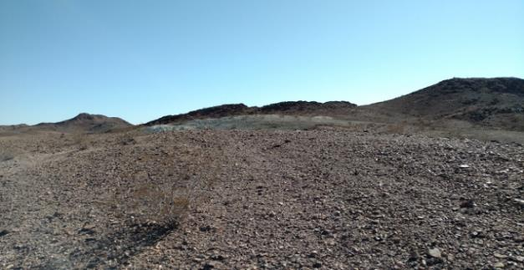
Black agate nodule diggings.
We also went hunting for chalcedony and paisley agate.
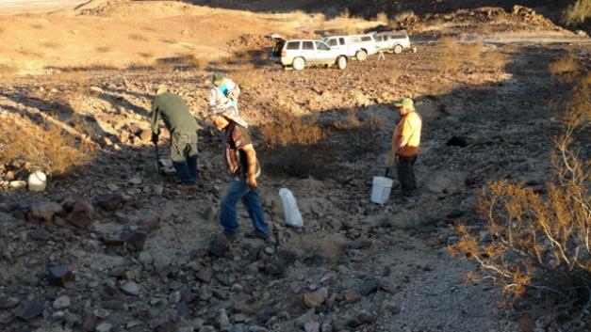
Richard Mueller, Dave Rosendahl, Steve Burns and a friend Digging for paisley agate.
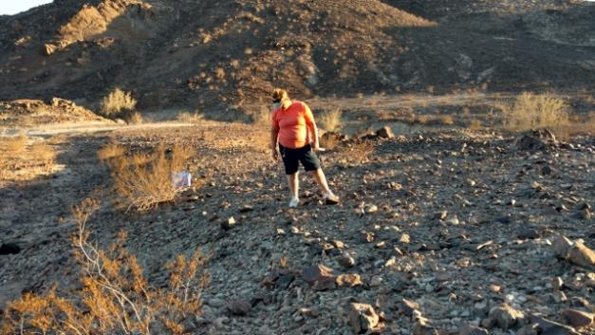
Donna DeGrande digging for paisley agate.
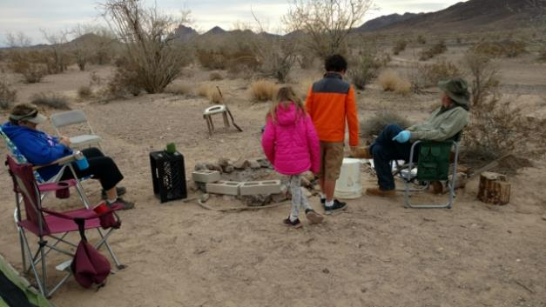
Hanging around the campsite after a hard day rock hounding.
Day #3
We started out day #3 at the Cinnamon beds. We drove up to the top of the hill and were digging on the side.
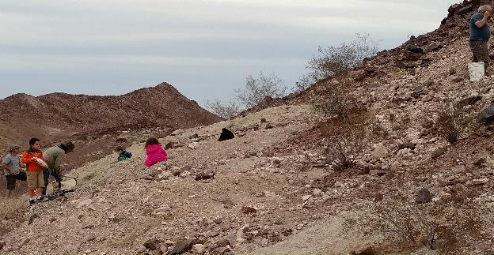
All of us digging at the Cinnamon Beds
Next we were off to the Potato Patch. After a little bit of fruitless digging we went across the road and found banded rhyolite. Some of it had alternating straight pink, white and grey pin stripe lines. Sometimes the lines got jumbled up. Donna called it “squirley” rhyolite and that sounds like a good name for it.
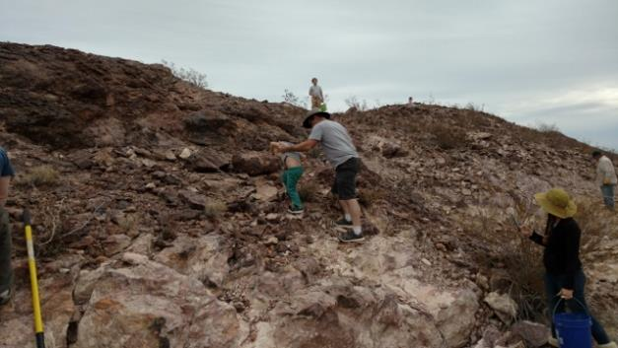
Gavin, Elisha, Daniel and Heather Cohen digging for rhyolite.
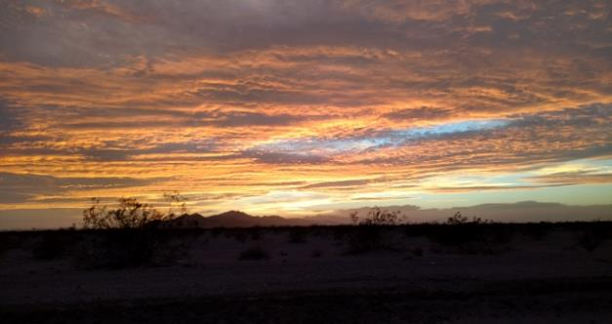
Beautiful sunset
Day #4
Most folks were worn out after Day #3, but the Cohens did some research of their own and had one more place they wanted to visit, the Palen Mountains for quartz points. The location was a long way from the highway so I decided to join them. I can honestly say this was the sketchiest off-roading I have ever done. At one point a small sand dune had grown up in the middle of the road. In other parts the raid had eroded a 2’ deep ditch down one side of the road.
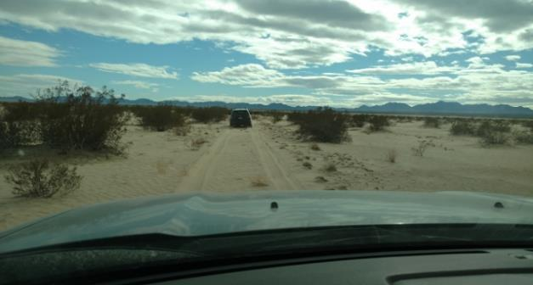 Is this really a road?
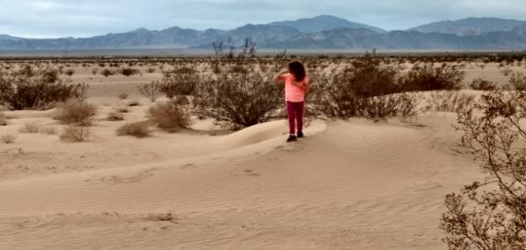
Fiona Cohen on the sand dune in the middle of the road

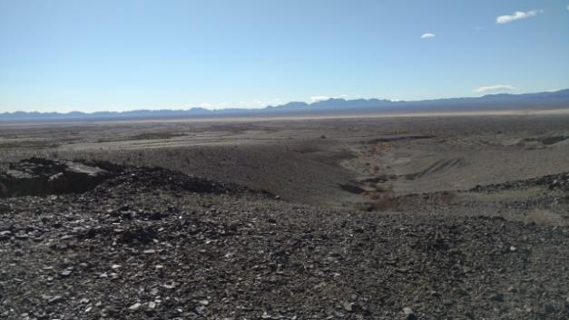
Can you see the highway from here? Me neither.
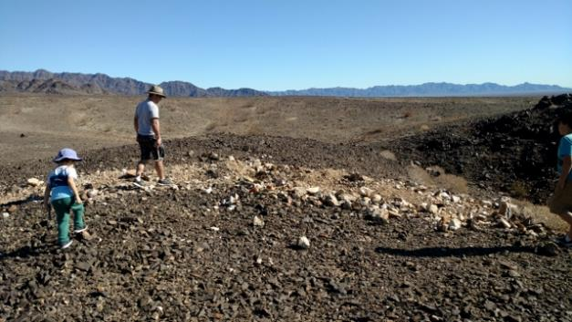
We must be in the right place, someone else dug here. Gavin and Daniel Cohen explore.
Saying that this location was off the beaten path is a bit of an understatement. On the other side of the road the Cohens found the “Mother Lode” trench and start pulling quartz points out. I am happy going through the debris pile. Next Daniel starts finding chrysocolla.

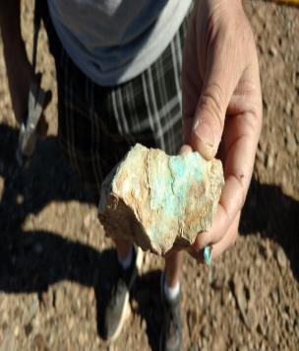
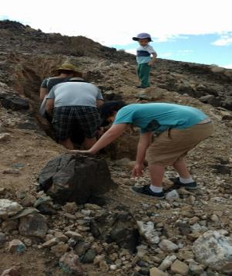
The Cohens explore the “Mother Lode” trench. Daniel finds chrysocolla.
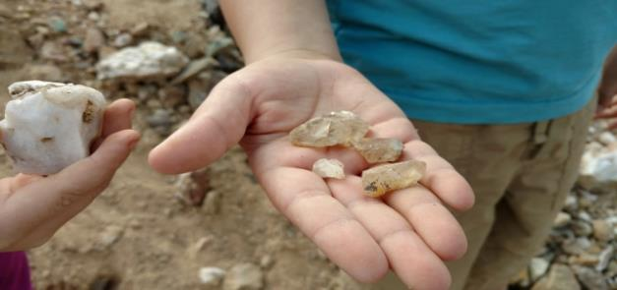
Elisha’s quartz points
Here is are the other rocks we found on this trip, yes there are a lot of them.
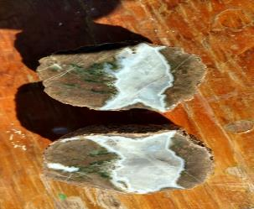 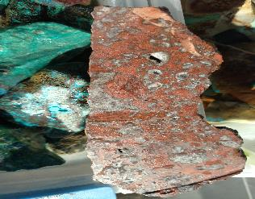Geodes Paisley jasper/agate
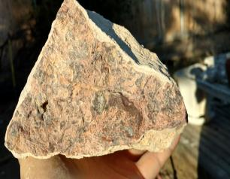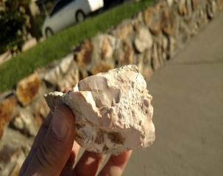
Squirley rhyolite Pink opal
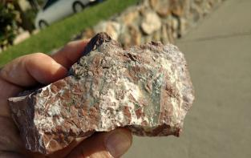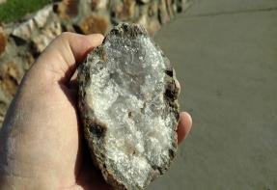
Brecciated jasper/agate Geode
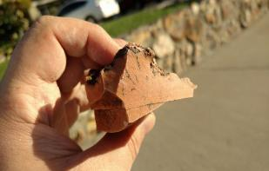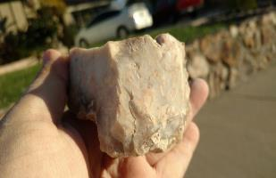
Orange jasper Chalcedony
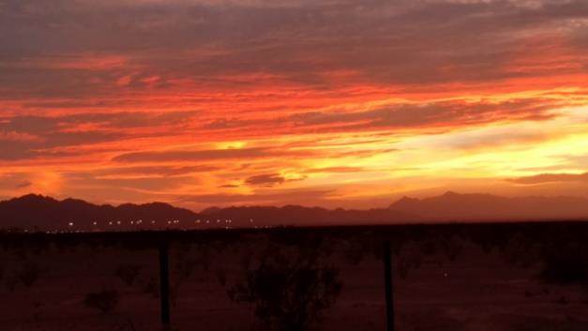

The End

