4/22/2017 Confirmation – The Sign of Asteroid 2014 JO25

Symbols of Divine Protection

Some personal experiences:

As I sat down this morning, 4/22/2017, and began to write this article, immediately there was a double sonic boom that gently shook the house. "Those boys aren't supposed to be doing that out there" I thought to myself. About a minute later there was another sonic boom, this one softer. About a half hour later boom numbers 3, 4, 5, and 6 were heard, softer yet. These were the first sonic booms we've heard since moving here last summer. We're located "out in the sticks", about 200 miles north of Detroit, so maybe the military can go supersonic nearby. Or maybe some angels were entering space-time, arriving from the end of the universe.

The sonic booms did fit in with the dream I had last night. A small group of us jumped (parachuted) into a foreign country at night. Our leader had a flare attached to his foot. Does that make any sense? We were bussed through the country side, on our way to board a flight to yet another country. Along the way I saw the largest ever high voltage power transmission tower with huge cables attached. It was a symbol of huge amounts of power, reminiscent of the baptism in YaHuWaH 's Set Apart Spirit mentioned in Acts chapter 2.

About a week before I was saved in 1978, I was made to understand that I had Divine protection. I wondered what that meant. On a 200 mile trip in snowy February, passing through Pennsylvania to visit a relative who was a Weslyan Methodist minister to find out about "God", we exited the highway to look at the map and see if there was a shortcut through the mountains to the minister's home. I began looking at the map and all of a sudden there was knock on the car's window. It was a Pennsylvania State Trooper. He said "You don't want to take any of these back mountain roads. They're too icy". That was my first experience with Divine protection. The thing is, I don't know where that State Trooper came from so quickly because there was no one at the exit when we stopped to look at the roadmap a few seconds earlier.

On another occasion, our family visited Zoar lake south of Canton, Ohio, in the early 80's on a Sunday outing. It was a calm day. I was standing by the waters edge and saw something flash out of the corner of my eye. It startled me and I flinched backward. It was a butterfly. The butterfly immediately stopped moving in mid air and fell straight down into the water. It had died. I wondered about that experience, and purposed to remember it.

On 11/8/2016, election day, I heard it coming and went outside. A few seconds later a USAF A-10 Thunderbolt II "Warthog" quite loudly passed about 150' above the treetops of our front yard. It was a symbol of YaHuWaH 's protection for us.



The A-10 can be used in combat to set up a zone of protection, called a bubble, around a fellow friendly on the ground until he can be rescued. The pilot of the circling A-10 stands watch and if any living thing enters the protective bubble, it's immediately destroyed.

An answer to prayer:

I worked in Christian television at a station in Canton, Ohio from 1978 to 1980. It was the only TV station owned by Jim Bakker of the PTL Television Network. Being on the inside of the PTL Television Network, I had, and still have, the highest regard for Evangelist Jim Bakker. Each morning the PTL TV station Manger would gather the crew for devotions and prayer. One morning we had news that an FCC Inspector would be visiting TV stations in the Youngstown and Canton, Ohio, area. This was troubling because it puts the technical crew on edge. We prayed during the morning devotions that the FCC Inspector wouldn't visit our station. We heard the next day that the Inspector had hit all 3 stations in Youngstown and the Public TV station in Alliance, Ohio, but he had a flat tire on the way to our transmitter location and was unable to visit us.

Our Awesome Creator Elohim

Our heavenly Father reveals Himself as the Creator of His universe in Genesis chapter 1. As such, He is in complete control of the motions of the Sun, Moon, Earth, Stars, Planets, Comets, Asteroids, etc. He set everything in motion at the time of creation and has revealed to us that the heavenly bodies are to be signs and a type of calendar.

Genesis 1:14 And Elohim said, Let there be lights in the firmament of the heaven to divide the day from the night; and let them be for signs, and for seasons, and for days, and years:

The word "signs" in Genesis 1:14 above is the Hebrew word "owth", which means "sign, distinguishing mark, omen, warning, miraculous sign". Our Creator, YaHuWaH Elohim, specifically put signs and omens in the sky at the time of creation of the heavens snd the earth for His people to notice for our own good.

The information I provide is not a spiritually perverted Miss Cleo fortune telling horoscope and astrology service. YaHuWaH Elohim is quite clear in that He wants us to ask of Him if we have questions concerning secret things. We're NOT to seek fortune tellers, mediums, or false spiritual beings for answers. YaHuWaH Elohim Himself will answer us, revealing secret and hidden things of which we have no prior knowledge.

The information in these articles is, to the best of my knowledge at the time, scientific, factual, and has biblical relevance. Daniel was the chief astrologer in ancient Babylon. He made no apology for his position, and was not considered a sinner by my Father YaHuWah Elohim. Centuries later, the descendants of Daniel's astrologers informed the spiritually callus Jerusalem priesthood of the birth of their great King, YAHUSHUA Messiah. Our heavenly Father has written messages in the heavens where no man can get to them to alter them. Someone needs to read them.

Take heed, as prophecy is cyclical and repetitive in nature. The heavenly signs of 2017 reveal the birth of a man child, just as the heavenly signs of 2,000 years ago led magi to Israel's King. The prophecied death of Rachel's children near Bethlehem followed the magi's announcement to King Herod that the great King had been born. It's very possible that death will again follow the heavenly signs of 2017 as the enemies of the man child seek to destroy Him. Two thousand years ago Messiah was whisked away to Egypt in the middle of the night for His protection. This time the man child will be whisked away to the throne of YaHuWaH Elohim for His protection. But, not to worry, he will return.

The Branch

The Branch Davidian congregation took their name from Israel's Messiah. Israel's Messiah is identified as "The Branch" in Zechariah 3:8-9. The term "Davidian" came from King David, from whom Israel's Messiah would come.

Zechariah 3:8 Hear now, O Yehoshua the high priest, thou, and thy fellows that sit before thee: for they are men who are signs: for, behold, I will bring forth My servant the BRANCH (Strong's 06780 - Tsemach).
9 For behold the stone that I have laid before Yehoshua; upon one stone shall be seven eyes: behold, I will engrave the graving thereof, saith YaHuWaH of hosts, and I will remove the iniquity of that land in one day.

Many people aren't aware that the constellation Virgo is depicted as holding a branch in one hand and a sheaf of wheat in the other hand.

Spica is the brightest of the 100 stars in the constellation Virgo, and one of the brightest stars in the sky. The Hebrew word for Spica is Tsemach "THE BRANCH".

Large Asteroid Passes Near Earth 4/19/2017

Below are radar images of Asteroid 2014 JO25. It was the largest Asteroid to pass near earth since 2004.

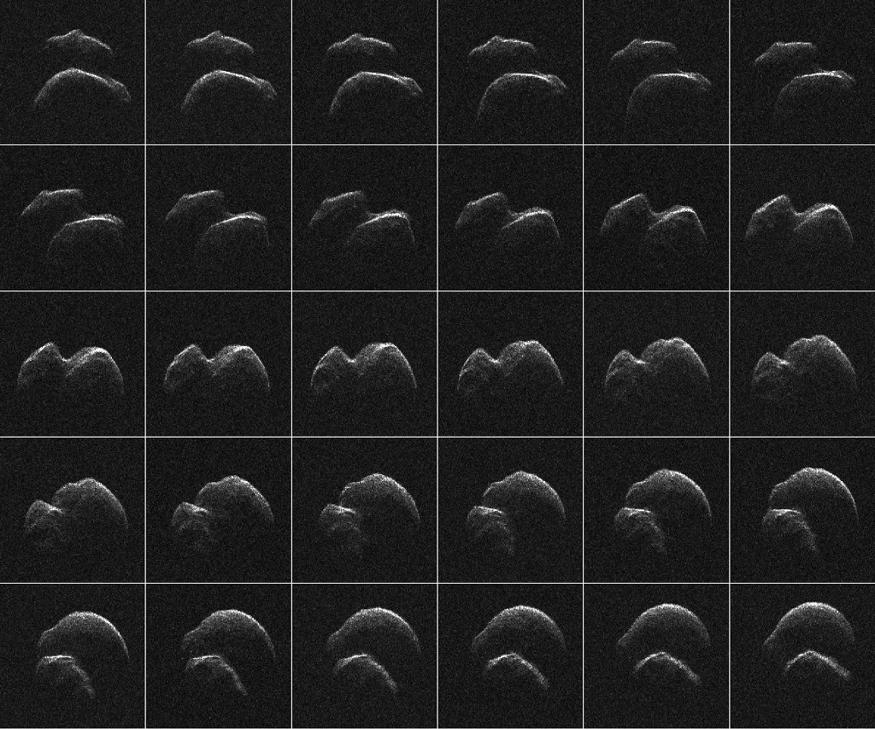

Below is a graphic showing the path of Asteroid 2014 JO25 on 4/18-20, with times corrected from the graphic in the previous article that had incorrect times on it.

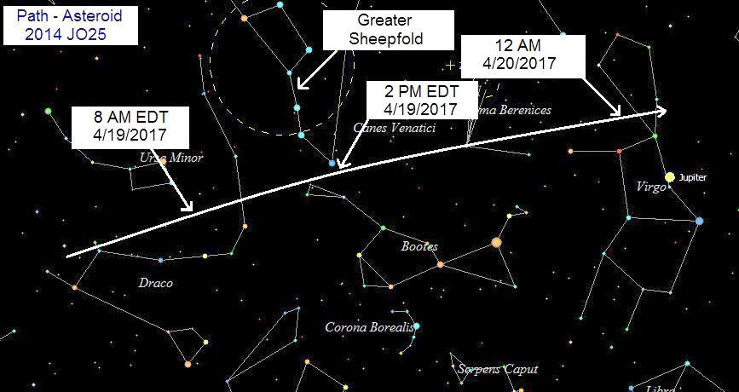

Note the position of the planet Jupiter in the graphic above, signifying the Man Child (Messiah), symbolically gestating in the womb of the woman on 4/19/2017 during the passing of Asteroid 2014 JO25.

YaHuWaH Elohim Confirms the Sign

Our Creator,YaHuWaH Elohim, sometimes reveals things to me when I wake up during the night. Last night the thought came to check the position of the planet Jupiter as it was on 4/19/1993 during the burning alive of the Branch Davidian Sabbath keeping group in Waco, Texas, by agents of Babylon the Great.

The Graphic below shows the position of the planet Jupiter on 4/19/1993 during the burning alive of the Branch Davidians in their church, and the path of Asteroid 2014 JO25 24 years later on 4/19/2017.

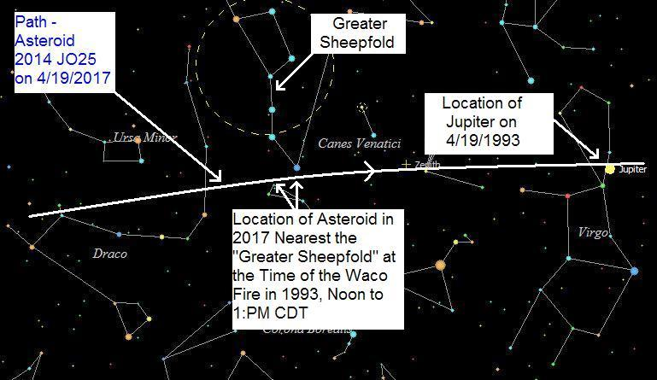

Note the location of Jupiter on 4/19/1993 in the graphic above. The Asteroid of 2017 nearly intersects Jupiter's position as it was in 1993, again confirming a relationship between the Asteroid in 2017, the Branch Davidians burning in their "sheepfold" in 1993, and the Messiah.

The path of Asteroid 2014 JO25 on 4/19/2017 passes closest by the "Greater Sheepfold" at the exact time, 12 noon to 1:00 PM, of the Branch Davidian holocaust 24 years earlier on 4/19/1993.

Getting Burned in Babylon

In the early 1980's I was working full time at a church in Canton, Ohio, as an engineer in a television ministry. Several times during the day I would enter the church sanctuary and kneel and pray. I had found that the work of the ministry would go better if accompanied with more frequent prayer. One week as I was praying, I would see myself walking alive in the midst of a nuclear explosion. I didn't know why I was seeing this image almost every time I prayed. That weekend in the Sunday evening praise service, the young Pastor leading the congregation in praise and worship declared "even if we were involved in an atomic explosion, we would walk through it alive". It was a confirmation of what I had been seeing that week during prayer.

There's an account of three men being cast into a furnace in ancient Babylon because they remained obedient to the instructions (Torah) of YaHuWaH Elohim. Daniel chapter 3 tells the account of the men who walked alive in the furnace of fire in Babylon, while the soldiers who cast them into the fire were themselves burned to death.

Daniel 3:22 Therefore because the king’s commandment was urgent, and the furnace exceeding hot, the flame of the fire slew those men that took up Shadrach, Meshach, and Abednego.
23 And these three men, Shadrach, Meshach, and Abednego, fell down bound into the midst of the burning fiery furnace.
24 Then Nebuchadnezzar the king was astonied, and rose up in haste, and spake, and said unto his counselors, Did not we cast three men bound into the midst of the fire? They answered and said unto the king, True, O king.
25 He answered and said, Lo, I see four men loose, walking in the midst of the fire, and they have no hurt; and the form of the fourth is like the Son of Elahh.

That account in Daniel chapter 3 is there for a purpose, because we're told that we all will go through the fire. Whether we survive the fire or not depends entirely on our personal relationship with our heavenly Father.

Isaiah 43:1 But now thus saith YaHuWaH that created thee, O Jacob, and he that formed thee, O Israel, Fear not: for I have redeemed thee, I have called thee by thy name; thou art Mine.
2 When thou passest through the waters, I will be with thee; and through the rivers, they shall not overflow thee: when thou walkest through the fire, thou shalt not be burned; neither shall the flame kindle upon thee.

Zechariah 13:8 And it shall come to pass, that in all the land, saith YaHuWaH , two parts therein shall be cut off and die; but the third shall be left therein.
9 And I will bring the third part through the fire, and will refine them as silver is refined, and will try them as gold is tried: they shall call on My Name, and I will hear them: I will say, It is My people: and they shall say, YaHuWaH is my Elohim.

Getting Burned in Babylon the Great

The people of Babylon the Great will experience the fires of destruction according to Revelation chapter 18.

Revelation 18:1 And after these things I saw another angel come down from heaven, having great power; and the earth was lightened with his glory.

Revelation 18:1 is the precise description of a nuclear warhead arriving by way of a missile (messenger, Greek - angelos) coming down from heaven, having great power (exploding), and the earth being lightened (by the blinding flash of intense light and radiation).

Revelation 18:2 And he cried mightily with a strong voice, saying, Babylon the great is fallen, is fallen, ....

Revelation 18:2 can be paraphrased this way "...the messenger made a mighty and loud noise, saying, Babylon the great is fallen, is fallen,...". The mighty noise (explosion) of the messenger (nuclear missile) announced that Babylon the great was fallen, was fallen.

Biblical Concept: First the Water, then the Fire

There's a general concept in the bible that tells of a water baptism and a later baptism of fire. Both events separate one type of people from another type.

The theme appears in Noah's flood, with a coming prophesied renovation of the earth by fire. It appears when Elijah baptizes a sacrifice and altar with water and then fire comes from heaven in answer to his prayer to consume the sacrifice. The concept again appears in the water baptism of John the Baptist and the Baptism in the Spirit by YAHUSHUA Messiah of Acts chapter 2.

The baptism in water came to the children of Israel when they left Egypt. Israel passed through the water alive, while Pharaoh and his army were drowned in the water. It follows that in the future, YaHuWaH 's righteous people will have to walk through the fire alive while others perish in the flames.

Getting Burned Alive and Living Through It Unharmed

Malachi 4:1 For, behold, the day cometh, that shall burn as an oven; and all the proud, yea, and all that do wickedly, shall be stubble: and the day that cometh shall burn them up, saith YaHuWaH of hosts, that it shall leave them neither root nor branch.
2 But unto you that fear My Name shall the Sun of righteousness arise with healing in His wings; and ye shall go forth, and grow up as calves of the stall.
3 And ye shall tread down the wicked; for they shall be ashes under the soles of your feet in the day that I shall do this, saith YaHuWaH of hosts.

Instructions and YaHuWaH 's Promises

Malachi 4:4 Remember ye the Torah of Moses My servant, which I commanded unto him in Horeb for all Israel, with the statutes and judgments.
5 Behold, I will send you Elijah the prophet before the coming of the great and dreadful day of YaHuWaH :
6 And he shall turn the heart of the fathers to the children, and the heart of the children to their fathers, lest I come and utterly destroy the earth.

