This is City of Light
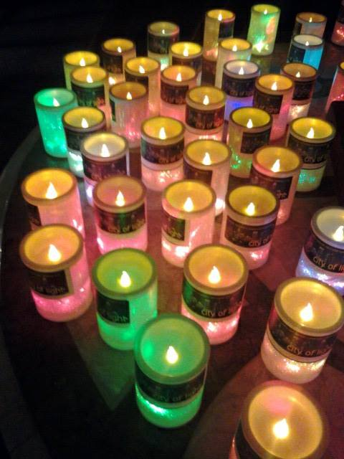
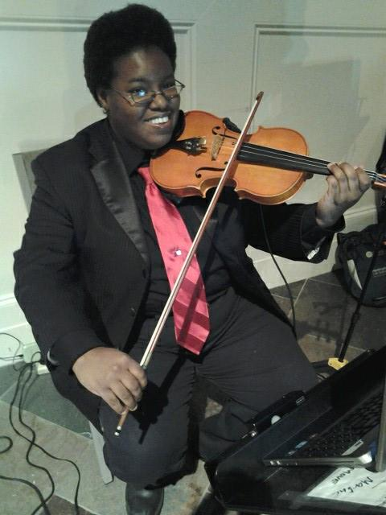
Welcome, we’re glad you’re here
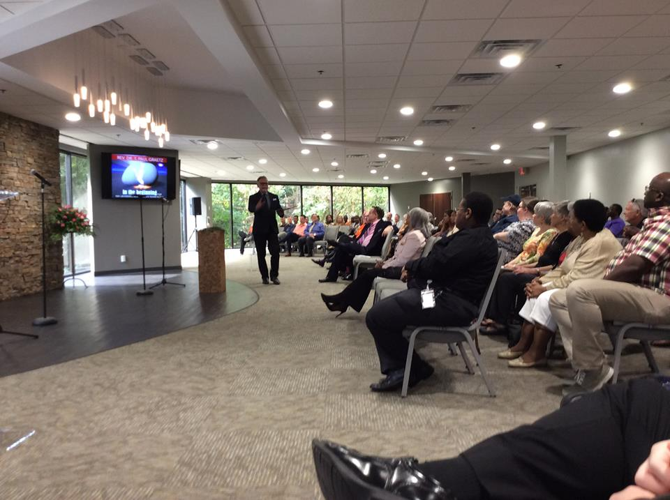
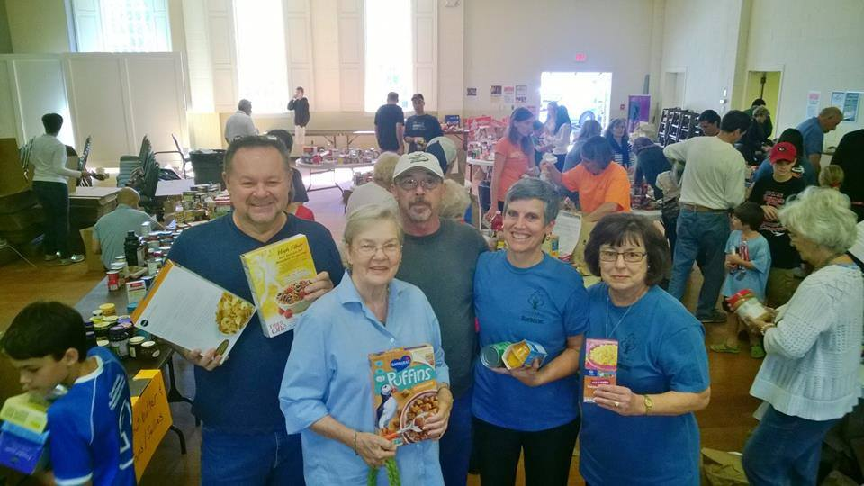
Caring,
Compassionate,
Inclusive,
Empowering,
Growing,
Loving,
We are the light of the world
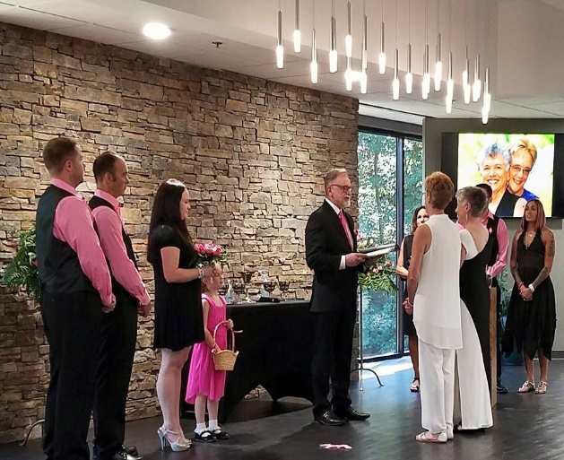
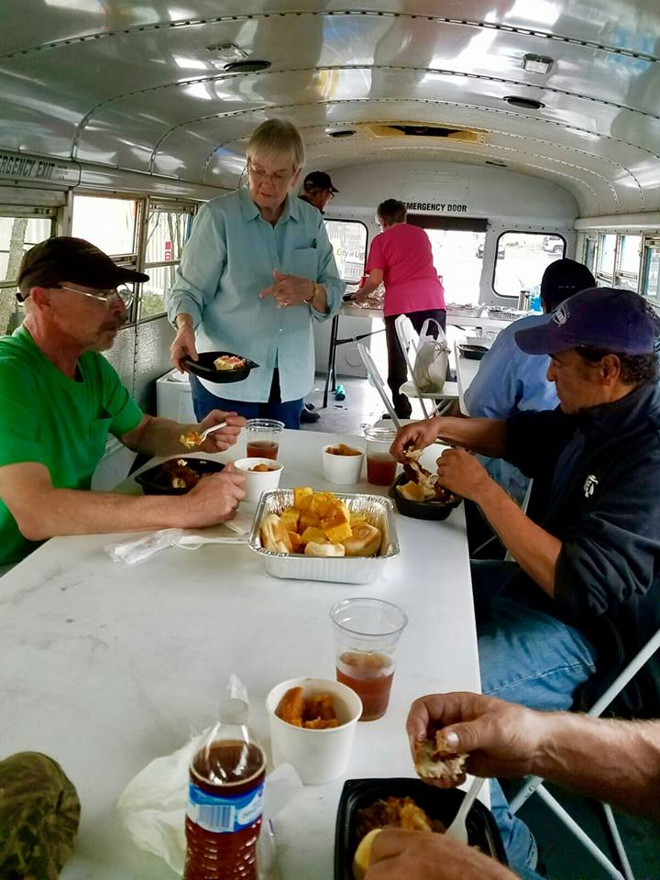
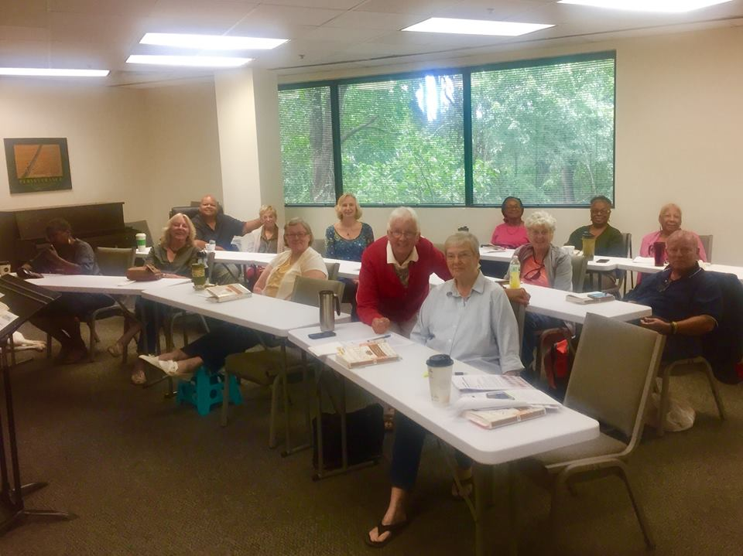City of Light
3125 Presidential Parkway, Atlanta, GA 30340 Phone: 470-545-2821
The collective congregations of the Affiliated New Thought Network, Unity and the Metropolitan Community Church

About Who We Are
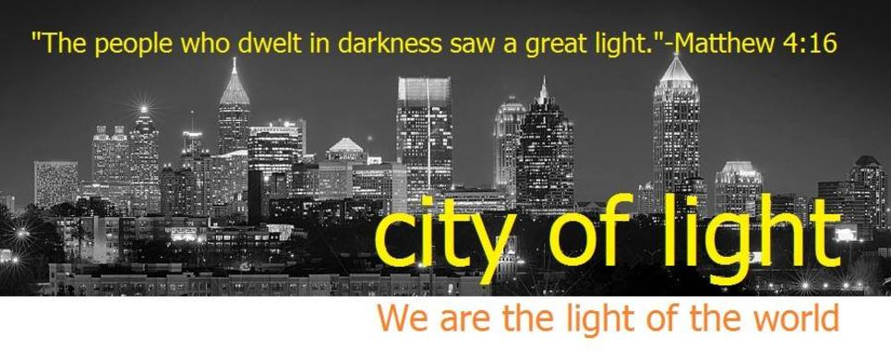
What Describes City of Light?
On November 2, 2014 this congregation embraced the vision and calling to be a community or city of light for the world. This concept is from the passage in Matthew 5: 14-16 where Jesus said, “A city
(a metropolitan Community) built on a hill (a place of higher understanding) cannot be hidden…So let your light shine so that others may see your good works and give glory to God the Source of all.”
With that calling we set out to be just what Jesus described: A community, a city that shines with the light of God’s love, that brings glory; attention to God who is the power, strength and source of all.

Our Mission is to be the light of the World
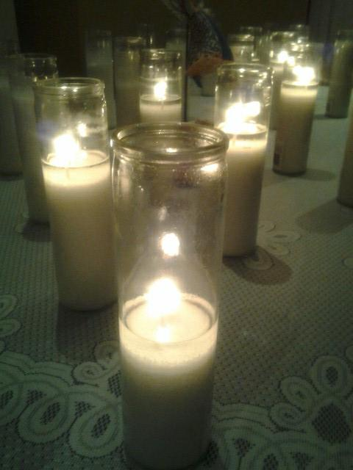
We are called to be a light for the world that brings glory to God, the source of our being.
We do this by:
- practicing compassion in action, (Jesus said, “when you do it unto the least of these you have done it unto me”)
- radical inclusion that really means ALL are welcome,(We embrace the passages: “Beloved, love one another”)
- and empowering one another not only to grow in knowledge and understanding of God but to put it into practice. (“Go ye into all the world making disciples.”)

We know that if we let the light of God within shine we will transform the world as we transform ourselves. So in simple words…Our mission is to be Christ for today, for this moment, for one another.

Our Message:
Is positive practical spirituality that transforms your life
Through our teaching and actions we are awakening our world to be Christ Centered; Christ Conscious; yes, to be the revelation of God for the world.

If you are looking for a church that practices practical day to day spiritual living and teaches you how to live a spiritual life that brings out your highest and best, then City of Light is for you.
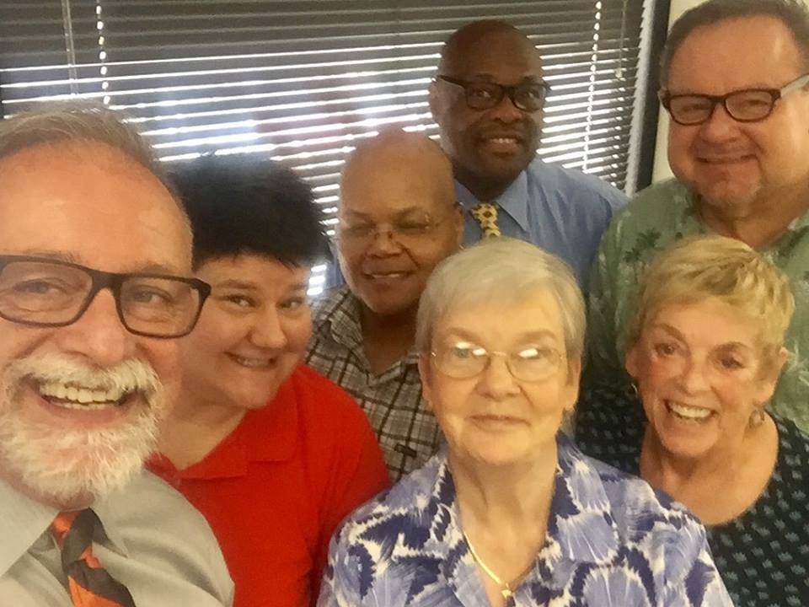
This is a Welcoming Place
“A judgment free zone”
You will find City of light to be very welcoming. In fact this church has been awarded the title of Atlanta’s most inclusive congregation. We take the words “all are welcome” seriously. We are proud of our diversity and share that no one is a “second class” person in their journey with God. We follow the scriptures that call us not to judge one another but to walk in love.

At City of Light it’s all about Love
This is a love based Teaching vs. a Fear based teaching
At City of Light we invite people to discover a spiritual journey by coming to know the love of God vs. being manipulated to come to God out of fear of judgment, punishment or being left behind. The gateway to your highest and best is never through fear but knowing the infinite love that transforms our lives.

At City of Light we are working together
A place of collaboration and building bridges
We are affiliated with Unity and the Metropolitan Community Churches
We are members of the Affiliated New Thought Network
And in collaboration with Centers for Spiritual Living

We are a church that is building bridges among different denominations. We are dedicated to working with others and constantly welcoming congregations to collaborate or to assist.
We are City of Light working with: Unity North, Midtown Center for Spiritual Living, Decatur United Church of Christ, Atlanta Spiritual Living Center, Oak Grove United Methodist, Atlanta Inclusive Catholic Ministries and many more. We love building bridges across denominational lines.

This is how we live Our Mission and Message:
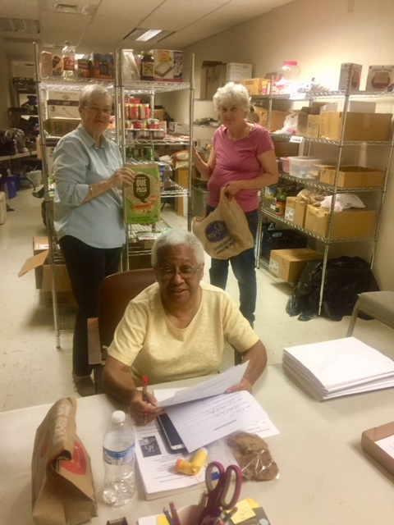
We live our mission and message as a transforming community of faith with a positive message of compassion, inclusion and empowerment.

How We Live Out Compassion:
- Weekly Food Bank (food distribution on Fridays)
- Clothing Closet ( providing clothing for those in need)
- A weekly Dinner for the Hungry and or Homeless
- Congregational Care and Hospital Visitation
- Administrative Assistance for Homeless
- Partners in support with the Montclair Elementary School providing educational supplies, school uniforms and teacher support.
- Coat, blanket and sleeping bag drive for the homeless
- Weekly “Do Unto Others” offering taken as our first act of worship, thinking of the needs of others. Through this we support many benevolent needs.
- Global compassion, caring for needs across the world.

How We Practice Inclusion:
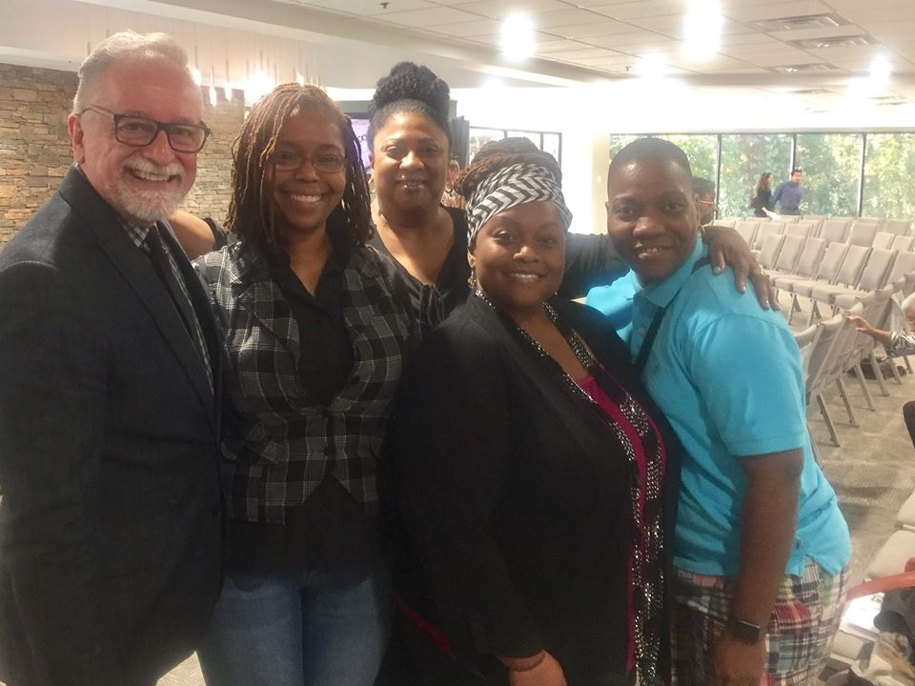
- This is a church for everyone, no matter who you are or where you are on life’s journey you are welcome here.
- We were founded on the principle that no one is a second class person in their walk with God and that all are equal and all are welcome.
- For 45 years we have been the leader in Atlanta as one of the City’s most welcoming and diverse congregations. Rev. Dr. Paul received the progressive kingdom award in 2012 for leading Atlanta’s most diverse congregation.
- We know that the way we behave toward one another and toward other people is the fullest expression of what we believe.
- We invite all people to participate without insisting that they become like us in order to be acceptable.
- We hold to the truth that the Christ in me sees the Christ in you and that we are all one.
How We Empower Others:
- Dynamic positive Worship
- Over 20 ministry opportunities for spiritual growth and service
- Weekly classes providing the best in spiritual education that enables you to live the abundant life.
- Prayer ministries and prayer opportunities abound.
- We are a Community Center. City of Light opens its doors to the community and welcomes over 600 people each week in non-church sponsored activities. We are a home for our community.

We Believe:
These are our Guiding Truths
1. God is the source and creator of all. There is no other enduring power….just one power. God is good and present everywhere.

2. We are all spiritual beings, created in God’s image. The spirit of God lives within each person we are the spark of the Divine… therefore, all people are inherently good. We are called to love each other by allowing the Christ within to see the Christ within others.

3. We create our life experiences through our way of thinking. We take the Scripture seriously that says, “We are renewed by the transforming of our mind…as you believe so shall you receive.”

4. There is power in affirmative prayer, which we believe increases our awareness of God. Affirming prayer is a faith filled prayer that claims vs. begs; it speaks from a heart of knowing vs. doubt.

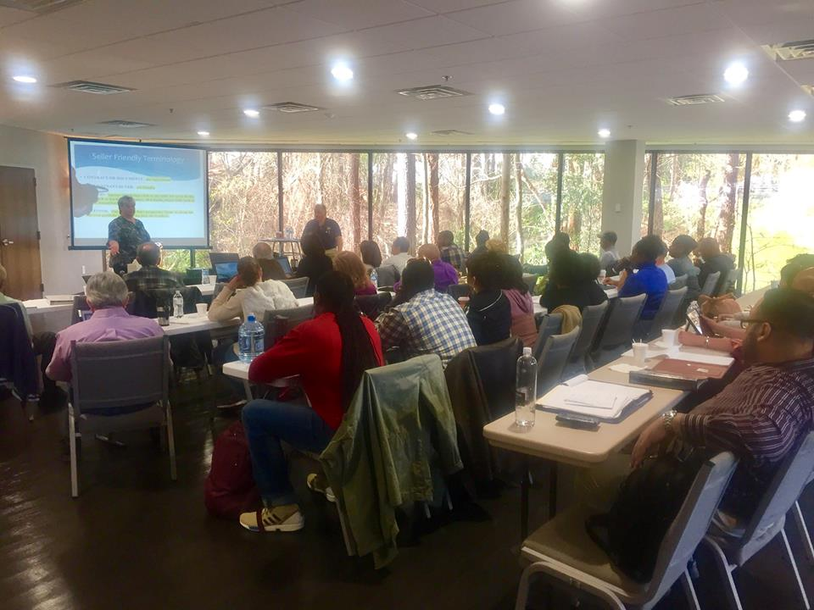
5. Knowledge of these spiritual principles is not enough. We must live them. We know that our spiritual life is only as strong as our daily practice of it. We are called to be like Jesus…we are called to let our light shine!
We are avid students of the Scriptures and passionate about the teachings of Jesus. After all he is showing us the way. We do not take the Bible literally, but we do take it seriously willing to study it and understand the true depth of teaching. We know that there is more depth in the spiritual search for understanding than just the words themselves…we look for the truth that is everlasting.

Typical Schedule of Events at City of Light

Mondays Church office closed
Tuesday-Friday
11:00 0 4:00 Church Office open
Tuesdays:
7:30 PM Emerson Theological Institute Classes, check for current schedule
Wednesdays:
5:00 Dinner for the Hungry and or Homeless, Clothing Distribution
7:00 PM Emerson Theological Institute Classes, check for current schedule
Thursdays:
10:00 AM Emerson Theological Institute Classes
Friday:
11:00- 1:00 Food distribution through our food bank
Sundays:
10:00 AM Coffee and continental breakfast
9:30 AM Spiritual Growth classes
11:00 AM Worship Service
12:15 PM Coffee social following the service

Ministries at City of Light
If you would like to get involved in one or more of these exciting programs, contact Rev. Dr. Paul Graetz, Senior Minister
- Wednesday Dinner for the Hungry and or Homeless (cooking and or serving)
- Clothing Closet (providing clothing for those in need)
- Food Bank (distribution of food every Friday)
- Prayer Ministry
- Multi-Media Ministry
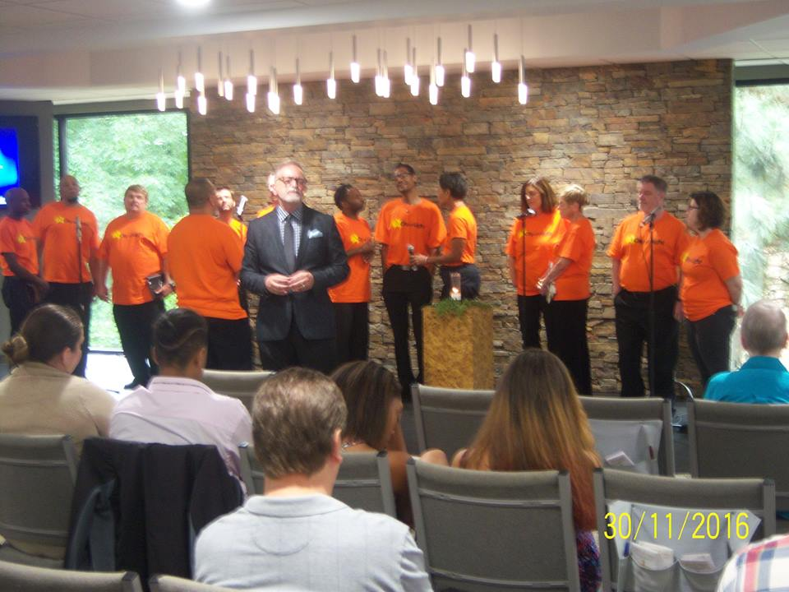
- Children and Youth Ministries
- Congregational Care
- Ushers and Greeters and Worship Participants
- Ministry in Motion Liturgical Dance Team
- Voices and Instruments of Celebration
- Institute for Spiritual Growth (weekly Spiritual Growth Classes)
- Pride
- Yoga
- Hospitality
- Social Ministry

Spiritual Growth Institute @ City of Light
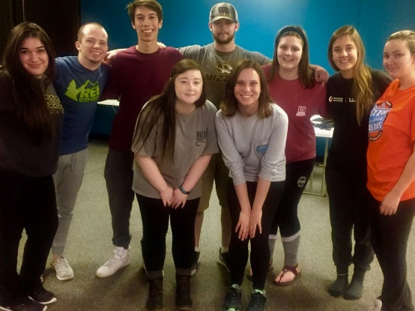
City of Light is committed to helping you grow spiritually. We offer weekly classes for your spiritual enrichment that help you understand who you are as a child of God and how God works in our daily lives. We have classes for all ages children through adults. Your faith is only as strong as your level of understanding and we are here to take you to another level. Each class is offered by a qualified member of our faculty in the Institute for Spiritual Growth.

Do You need someone to Pray with you?
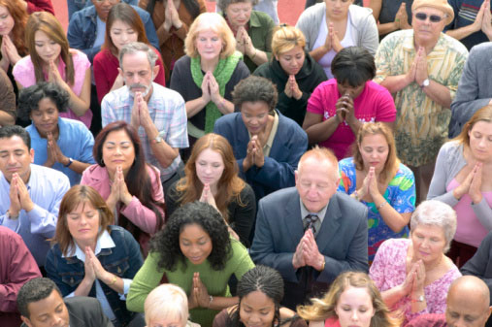
You are not alone…someone is waiting to pray with you right now.
Call “Silent Unity” our 24/7 prayer line at any time day or night and join in prayer with a prayer partner. Call: 1-800-669-7729

What are others saying about
City of Light?
These are actual comments from our guests attending City of Light
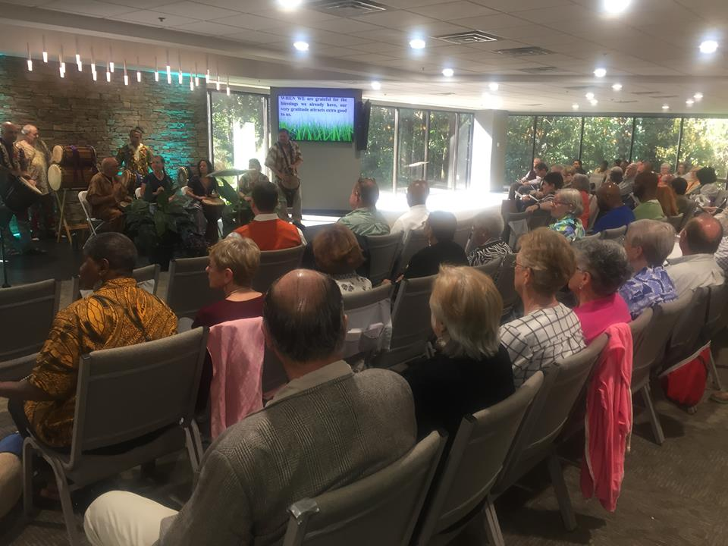
- “It’s a sanctuary a safe place,
- “Wow, everyone really is welcomed here, I feel right at home.”
- “This is a teaching church where we can all learn and I love that.”
- “A friendly church very welcoming. I felt right at home…lots of love”
- “I love the contemporary music and the energy of the place.”
- “A church for the entire family whether it’s a chosen family or biological and that means a lot to me…”
- “I’m not a church kind of person, but this place really surprised me.”
- “They really do let their light shine.”
- “I’ve grown a lot spiritually in a short time because the teaching is so practical.”

If you have questions or want more information simply stop by our “Welcome Center” in our Lobby referred to as “Friendship Commons” and you will find some friendly faces eager to help you.
Our team of greeters have a gift for you for choosing to worship with us. Please fill out the attached form and present it to our volunteers at the welcome center and receive your thank you gift.

About our Senior Pastor

Rev. Dr. Paul Graetz, D. Div. D. R. S.

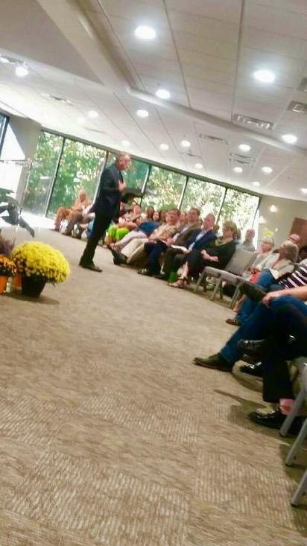
Rev. Dr. Paul Graetz, known as “Dr. Paul” accepted the call of God to become City of Light’s tenth Pastor in July of 2000. After conducting a nationwide search the pastoral search team, recommended him to the congregation and he was elected by overwhelming majority to serve as our shepherd.

Rev. Graetz previously served a growing congregation for 7 years as the Senior Pastor at All God’s Children Metropolitan Community Church, Minneapolis, MN.

He comes to Atlanta with a rich background in multicultural ministry having served over the years with congregations in Dar es Salaam, Tanzania; Kisumu, Kenya; Bombay, India, Bangkok, Thailand, Hong Kong, Nassau, Bahamas, Mexico City, Mexico and Brighton, England.
He was ordained in the Assemblies of God denomination in May of 1978 after completing his seminary work at Trinity Bible College and North Central University. In 1993 he transferred his credentials and ordination to the Metropolitan Community Churches.

An avid student, he has studied Ancient Wisdom a precursor to the times of Jesus with Kabbalah University for two years culminating with a study tour of Israel. Dr. Paul went on to receive a Doctor of Divinity in 2013 and in 2014 a second Doctorate this time, in Religious Studies both from Emerson Theological Institute. He is a member of the International New Thought (Ancient Wisdom/Truth) Alliance and the Affiliated New Thought Network and holds a dual ordination with this body.

Rev. Graetz, has been and educator of Pastors, a Bible teacher and field instructor, a director of global ministries and inspirational preacher. He was selected by the Assemblies of God to oversee 26 congregations as a district official and since coming to MCC he has served in various denominational committees, district and regional positions.

He serves as our “Dean” for the Emerson Theological Institute at City of Light, as a Bible teacher, spiritual coach and writer of curriculum for instructional programs.

He was one of the first trained Supervisors of MCC student clergy and today continues to help to shape the lives of those called to full time ministry.

He is the father of two children Jordan Graetz and Jillian Toppen, grandfather to five grandchildren and shares his life with his partner Robert Mixon, their horse “Don’t Doubt This” and cat “Teddy”

He is an open door Pastor with a heart for his congregation. His door is open to you for spiritual guidance and prayerful support. You will find that Dr. Paul shares his passion for living and loving God in uplifting and empowering sermons and day to day conversation.

For more information on our ministries, mission and or beliefs please contact one of our staff members. Please let us know if we can help you in any way…we are always here to serve you.

Here’s How to Reach Us:
Church Address: 3125 Presidential Parkway, Atlanta, GA 30340
Church office Hours Tuesday-Friday 11 AM to 4 PM
Church phone: 470-545-2821

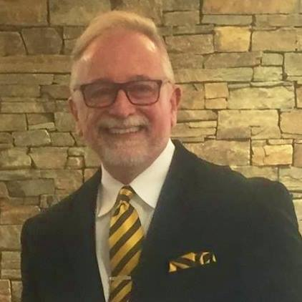
Rev. Dr. Paul Graetz, D. Div. D.R.S.
Senior Minister
Email: revtpaul@aol.com
Phone: 404-219-6075

“Coaching you to achieve your highest and best”

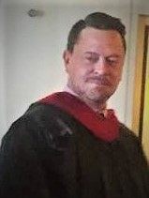
Rev. John Karn,
Faculty at Emerson Theological Institute at City of Light
Phone: 706-599-7260

Rev. Karn is a teacher and inspiration to all

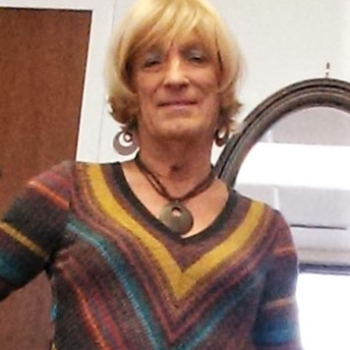

Sarah Lynn Elliotto
Facility Manager
Email: Sarah.cityoflight@gmail.com
Phone: 470-545-2821

Contact her for info on building use for any ministries.

