Kennedy High School
Advisor: Barry Wilson
Crew Chief: Jamie Voorhees (11th Grade)
Driver: Jamie Voorhees
Documentation Writer: Natalie McAllister and Molly Sullivan (11th grade)
4545 Wenig Rd. NE, Cedar Rapids, IA 52402
319-784-7697
BWilson@cr.k12.ia.us
4/1/17-4/30/17
30 Car, Class 2
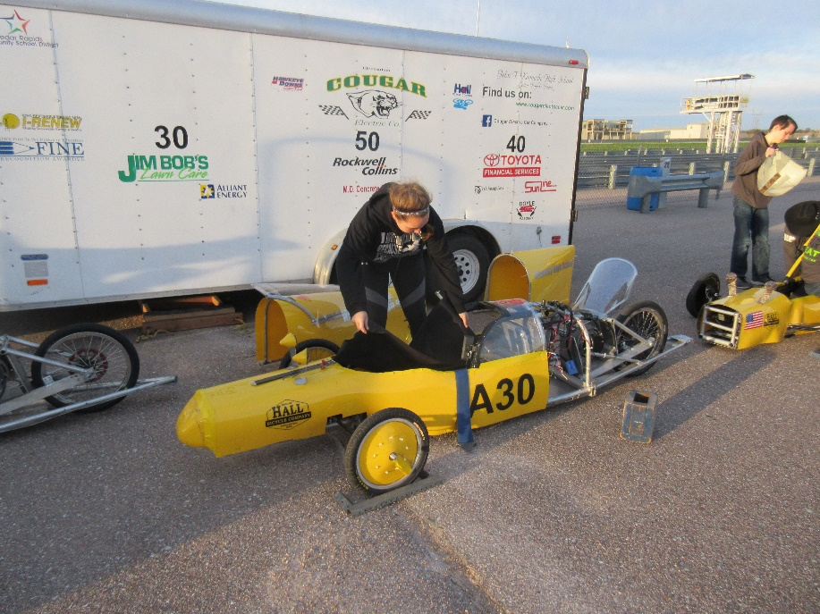
During the remainder of March and beginning of April, Jamie and Collin worked hard on getting the painted panels attached to the car, and designing and building a canopy for the car. Collin was working up until the race at Hastings on getting the canopy completed. On April 14th, we took all three cars out to the school parking lot and practiced braking and handling, along with generally testing the cars to see how they ran. The 30 performed the best of all three cars as everything was running fine before testing, and nothing broke during. We have also attended the first race of the season, where the 3o was the most successful of our cars, only pitting because it was required.
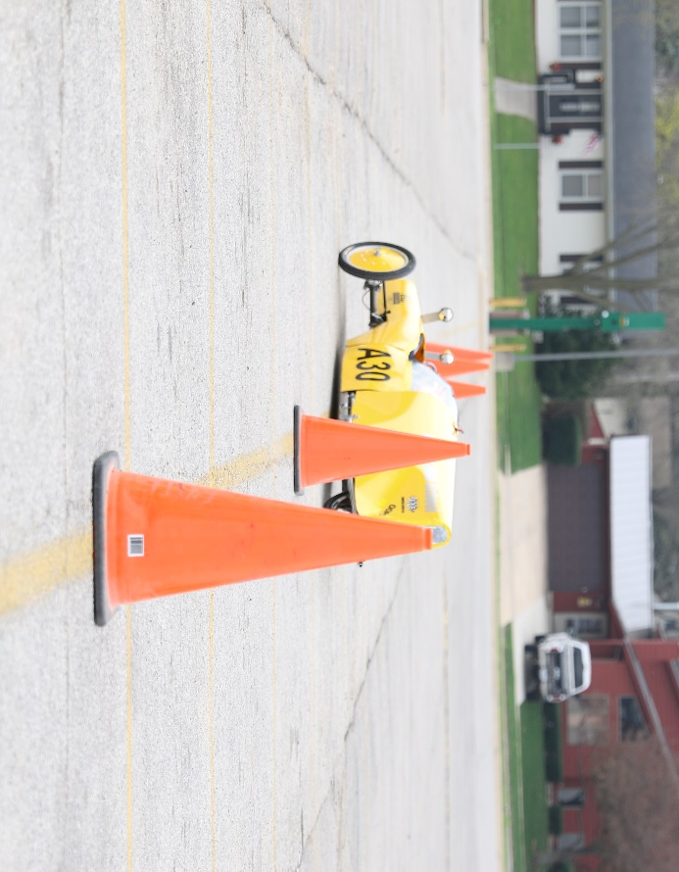
Kennedy High School
Advisor: Barry Wilson
Crew Chief: Derek Severson (10th Grade)
Driver: Molly Sullivan
Documentation Writer: Molly Sullivan (11th Grade)
4545 Wenig Rd. NE, Cedar Rapids, IA 52402
319-784-7697
BWilson@cr.k12.ia.us
4/1/17-4/30/17
40 Car, Class 1
During the end of March and start of April, the 40 team worked hard and fast to get the car ready to race. This included installing the painted body panels, installing seatbelts, wrapping the car in foam, and designing and building the canopy. We managed to get the car out to do some testing. By practicing braking and handling, we were able to see how well the car ran and how well the steering performed. We did find a few flaws, but nothing major was found. We attended the seasons first race and unfortunately, it wasn’t that successful. Our back tire came off, but was quickly fixed. Once a calm driver was available for the car, it went back out to finish the race.
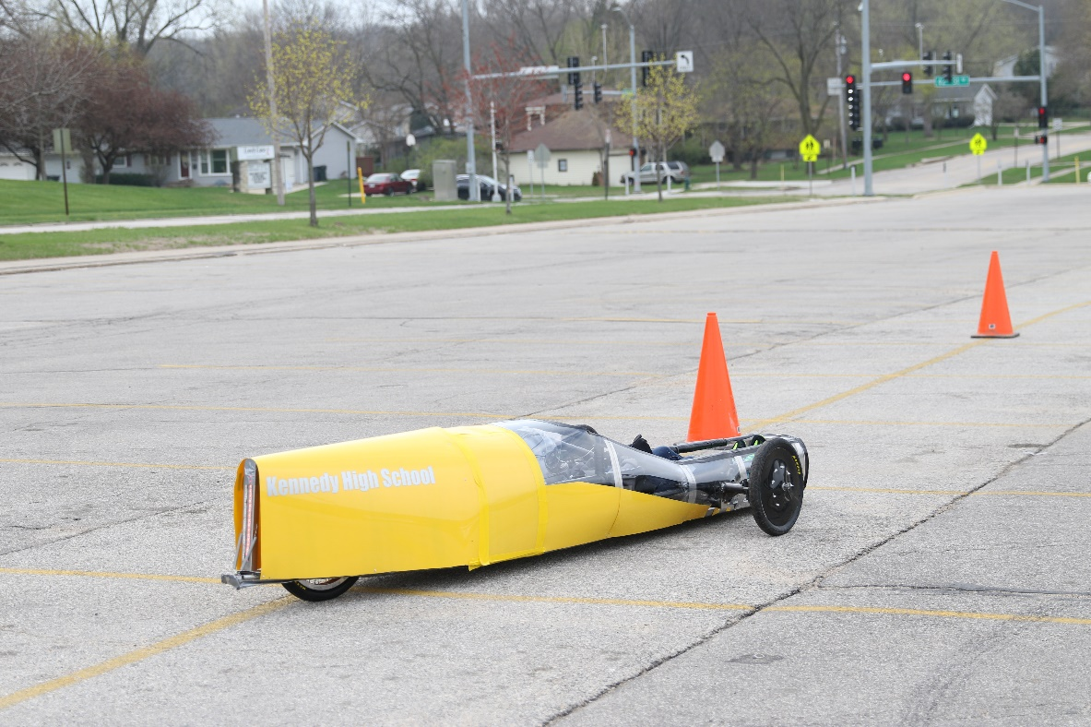
Kennedy High School
Advisor: Barry Wilson
Crew Chief: Ian Carlson and Hunter Torrey-McAdam(12th Grade)
Driver: Natalie McAllister (11th Grade) and Ian Carlson
Documentation Writer: Natalie McAllister (11th Grade)
4545 Wenig Rd. NE, Cedar Rapids, IA 52402
319-784-7697
BWilson@cr.k12.ia.us
4/1/17-4/30/17
50 Car, Class 1
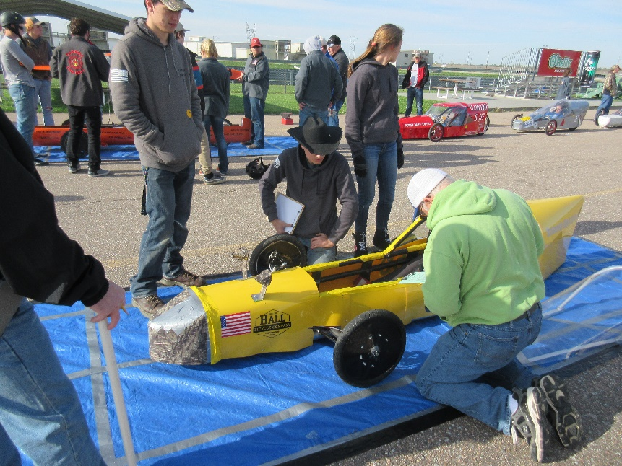
The remainder of March and start of April were spent getting the body panels for car ready to be painted and go on. The car was then ready to race. It went out with the cars to be tested with the rest but didn’t make it very far beyond the garage. The motor plate wasn’t sitting right and the chain kept rubbing on the belly pan, so getting the car didn’t get as much time to practice. At our first race, we found a few minor problems, such as having the chain come off, that caused the car to pit a few times. Regardless, the car was able to run and finish the race.
