

# 2020

# Liberation Petanque Club

**Club Doubles Cup**

Our 10th Annual Club Doubles Cup was held this year with 14 teams entered.

Current holders Andrew & Callum started off well in Round 1 with a 13 – 3 over Kat & Paul. There was a big shock as Laurent & Toby playing together for the first time lost 13 – 6 to Brandon & Tim who seem to be better against bigger teams.

A close match between Neil & Ross and Alex & Jean going to the wire 13 – 11 to the former and big wins for Mark & Matt over Daniel & James and Alice & David over Cassie & Chris.

Round 2 saw the first 13 – 0 as Brian & Paul suffered at the hands of Mark & Matt. This was nearly for the score for Geoffroy & Matt but they managed to get one point against Alice & David.

Holders Andrew & Callum lost heavily 13 – 5 to Graeme & Keith and Neil & Ross won another close match 13 – 12 over Brandon & Tim.

Round 3 saw Laurent & Toby lose again this time to Mark & Matt in a close match. Tournament leaders after round three were Alice & David on remarkable form with another 13 – 1 win this time over Neil & Ross.

Alex & Jean also won 13 – 1 over Cassie & Chris and Matt & Mo won their second match this time over Daniel & James.

Mark & Matt didn’t go the distance against Alice & David but still managed to win 10-9. Laurent & Toby got their second win with a 13 – 5 result over Graeme & Keith as did Alex & Jean over Branden & Tim 13 – 3.

Geoffroy & Matt found some form to hand Neil & Ross their second defeat with a comfortable 13 – 5 win and Brian & Paul moved into contention with a 13 -11 win over Kat & Paul.

In the final round Andrew & Callum handed Mark & Matt their first defeat but despite this Mark & Matt finished top with Andrew & Callum finishing third. A 13 – 10 win for Alice & David helped them finish second with their opponents Brian & Paul finishing fifth.

Geoffroy & Matt hand a big win over Matt H & Mo to finish forth and Toby & Laurent took sixth place with a big 13 – 1 win over Neil & Ross.

Alex & Jean won 13 – 5 over Kat & Paul to finish 7th and Graeme & Keith took the final spot in the knockout stages with a 13 – 6 win over Cassie & Chris.

FINAL RANKINGS

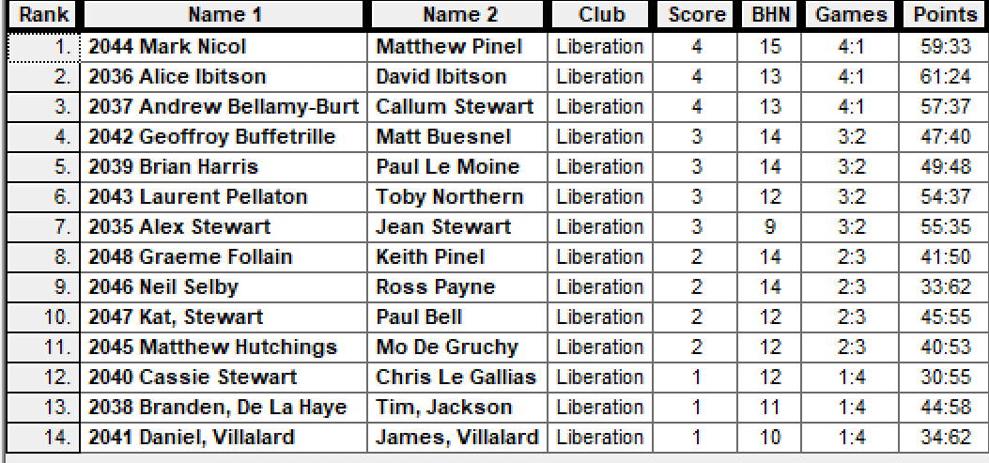

QUARTER FINALS

Ranked 1st Mark Nicol & Matt Pinel v Graeme Follain & Keith Pinel Ranked 8th

Ranked 2nd Alice & David Ibitson v Alex & Jean Stewart Ranked 7th

Ranked 3rd Andrew B-B & Callum Stewart v Laurent Pellaton & Toby Northern Ranked 6th

Ranked 4th Geoffroy Buffetrille & Matt Buesnel v Brian Harris & Paul Le Moine Ranked 5th

Andrew & Callum were well ahead 12 – 6 after some earlier exchanges in play against Laurent & Toby. On the next end Toby placed his boule on the coche which Callum hit not once but twice and the boule and coche stay very close together, this followed four placed boules not very close which Toby and then Laurent placing all 5 remaining boules on the coche for a 6 point end to make it 12 – 12. Callum then fired Toby boule out on the next end and Laurent couldn’t place in as Andrew & Callum survived into the semi finals.

Alice & David continued their fine form in the quarter-finals conceding just 5 points against Alex & Jean. Brian & Paul also had a big win over Geoffroy & Matt who just couldn’t get started with a 13 – 3 result. Mark & Matt also won 13 – 9 against Graeme & Keith.

SEMI FINALS

Ranked 1st Mark Nicol & Matt Pinel v Brian Harris & Paul Le Moine Ranked 5th

Ranked 3rd Andrew B-B & Callum Stewart v Alice & David Ibitson Ranked 2nd

The Semi-Finals saw Mark & Matt play Brian & Paul against after winning 13 – 0 in Round two, however Brian & Paul faired a little better getting 6 points with the match ending 12 – 6 with Brian and Paul seemingly unaware they needed 5 points on the last end just to tie the match. Andrew & Callum made their second successive final with a 13 – 8 win over Alice & David.

Brian & Paul achieved another top three finish, which is now a very regular occurrence beating Alice & David 13 – 7.

The final was finely poised at 8 – 8 but a great end from Mark & Matt gave them a five point end to win 13 - 8

Many thanks to everyone who took part on the day and thanks to all the committee and everyone else who helped set up and clear up, very much appreciated

**WEBSITE** [**www.liberationpetanque.co.uk**](http://www.liberationpetanque.co.uk)

**EMAIL** [**liberationpc@gmail.com**](mailto:liberationpc@gmail.com)

**Kind Regards**

**Toby Northern**

**Chairman**

**Liberation Petanque Club**

# SPONSORED BY

# http://nebula.wsimg.com/135a1bd6338e1b589a50cdec98bd84d1?AccessKeyId=C6E923731F1A482DD910&disposition=0&alloworigin=1