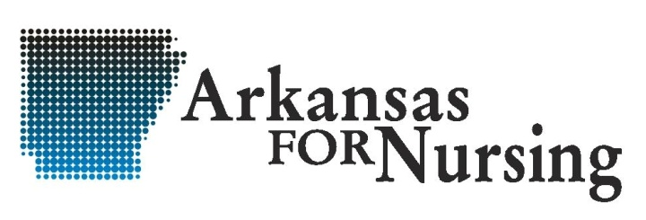
August, 2018

Thank you for your support of nursing in Arkansas!

ARKANSAS FOR NURSING
PO BOX 250610
LITTLE ROCK, AR 72225
www.arkansas4nursing.org

To:

ANNUAL DUES RENEWAL
DUE DATE | DESCRIPTION | AMOUNT
9/2018 | 2018 Annual Dues Renewal | $300.00

*Non payment results in disconnection of institution web link on www.arkansas4nursing.org.
Submit Payment To: Submit Website Corrections To:
Arkansas For Nursing Joni Stephenson
PO Box 250610 Joni.Stephenson@baptist-health.org
Little Rock, AR 72225

Fed. ID #: 71-0658290

AFN Chair
Joni Stephenson
Joni.Stephenson@baptist-health.org

