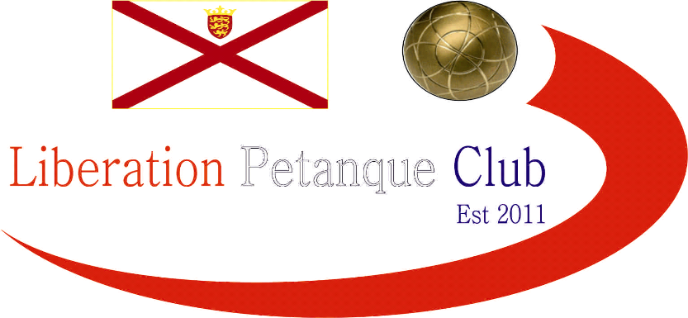

2017

Liberation Petanque Club

Mixed Doubles Open

This years competition was for the first time held at the clubs home ground at the weighbridge terrains.

5 rounds were played in glorious sunshine with many of the islands top players taking part and some players as partners who were new to competitions.

Round one saw a few really close matches with Ross & Brigitte getting the title defence off to a good start beating Callum & Kat 13 – 11. Andrew & Jean had the biggest win beating Chris & Natasha 13 – 2.

One match went into extra time, which was between Toby & Sam against Christine & Paul. On the final end Toby had 3 boules to win the match but failed to do so which mean’t it was tied at 9 – 9 so went to sudden death. Toby placed, his first boule on the coche but Paul fired it out first time. Sam knocked the coche right onto the string with their last boule to be holding, but Christine at 14 meters took the coche out to win the match.

Round 2

Andrew & Jean made in 2 wins in a row beating Dawn & Geoffroy as did Ross & Brigitte beating Christine & Paul. Penny & Ian and Chris & Natasha both got wins and Mark & Lydia made it 2 out of 2.

Round 3 saw Mark & Lydia and Ross & Brigitte continue to win. Callum & Kat won their first match 13 – 8 against Chris & Natasha.

Round 4 saw Mark & Lydia lose their first match to Andrew & Jean. Dawn & Geoffroy moved into contention beating Toby & Sam 13 – 11.

Christine & Paul moved in with a chance of making the semi finals with a win over Chris & Natasha and Ross & Brigitte made light work of Penny & Ian.

The final round saw a number of teams in with a chance of making the top 4.

Andrew & Jean lost though to Toby & Sam 13 – 10, and they thought this had lost them a top 4 place. Callum & Kat suffered a big defeat to Geoffroy & Dawn 13 – 2, this proved a crucial win for Dawn & Geoffroy as they went through on points difference in 4th place.

A 13 – 0 win for Chris & Natasha over Penny & Ian wasn’t enough to get them through, but it certainly ended Penny & Ians chances. Ross & Brigitte lost 13 – 2 to Mark & Lydia which mean’t the latter finished 1st and Ross & Brigitte 2nd.

Andrew & Jean did make it through in 3rd though.

Final 5 Round Placings

1st Mark Nicol & Lydia Beck 4 Wins +32
2nd Ross Payne & Brigitte Ibitson 4 Wins +18
3rd Andrew Bellamy-Burt & Jean Stewart 3 Wins +6
4th Dawn Buckley & Geoffroy Buffetrille 3 Wins +3
5th Christine Eccles & Paul Waters 3 Wins -2
6th Chris Romeril & Natasha 2 Wins +1
7th Toby & Sam Northern 2 Wins -3
8th Callum Stewart & Kat Migala 2 Wins -6
9th Penny & Ian Foster 2 Wins -19

Semi Finals

Mark Nicol & Lydia Beck v Dawn Buckley & Geoffroy Buffetrille

Ross Payne & Brigitte Ibitson v Andrew Bellamy-Burt & Jean Stewart

Both semi finals were close affairs. Dawn & Geoffroy who squeezed through to the Semi-Finals made it one step further as the pair continued their fine form from the previous 2 matches to take the match 13 – 9.

Ross & Brigitte were looking to make it back to back titles, had a close game against Andrew & Jean but just made it to the final 13 – 11.

So the final saw Dawn Buckley playing in every final since the competitions inception in 2015. Previously Dawn had lost both finals playing with partner James Gennoe. This time though Dawn & Geoffroy never looked like losing winning comfortably in the end 13 – 4.

3rd Place went to Mark Nicol & Lydia Beck winning 13 – 6 against Andrew & Jean.
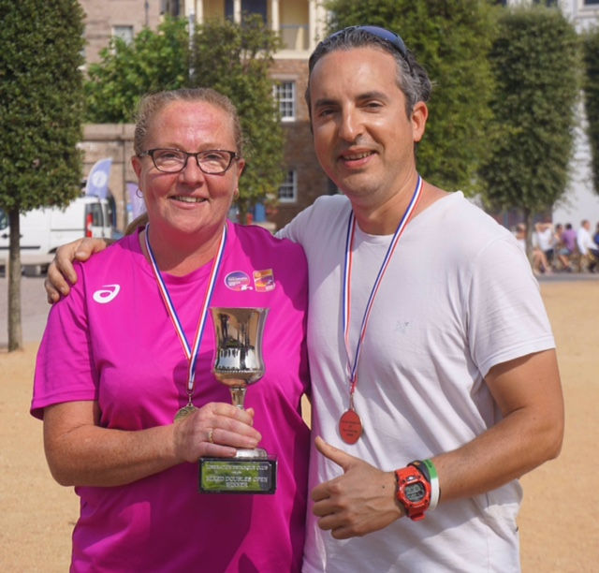
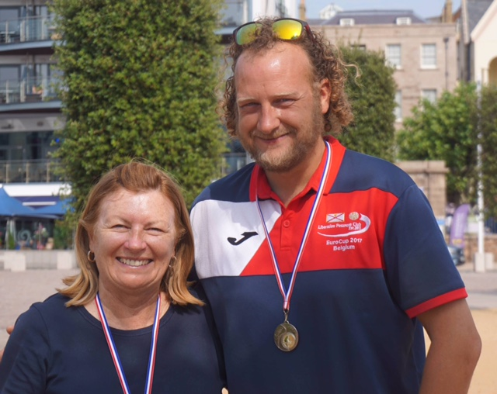
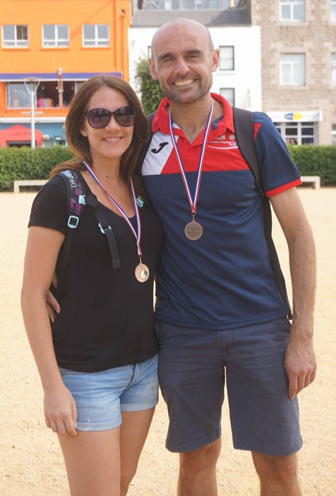

Congratulations to everyone who took part in another successful competition.

Thank you to everyone who helped prepare for this competition and the running of it on the day which takes a great deal of time and effort

Kind Regards

Toby Northern

Report Editor

Liberation Petanque Club

