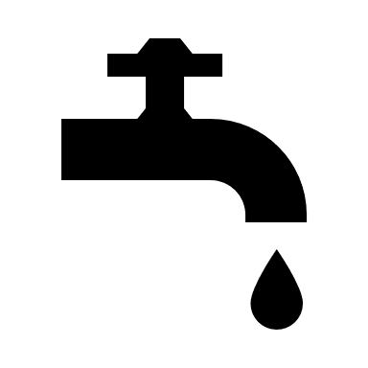

**Village of Tonica**

**Water/Sewer Billing**

**Direct Payment Authorization**

With your authorization, the village will arrange for the direct payment of your water bill each month. Your bank account will be automatically debited on the day your water bill is due. You are responsible for having the funds available on the due date.

*Questions? Call the Village Clerk: 815-442-3104*

*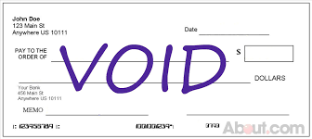Fill out the bottom of this form and return to Clerk’s office with a voided check. Mail (P.O. Box 268) or drop off at the Village Hall. (308 Uncas Street)*

|  |  |  |  |
| --- | --- | --- | --- |
| *Customer Name* | *Service Address* | | *Daytime Phone Number* |
| *Billing Account Number* | *Name of financial institution* | *Routing Number* | *Account Number* |
| *Checking*  *Savings* |
| *Signature* | | | *Date* |

*I AUTHORIZE THE VILLAGE OF TONICA TO WITHDRAW MY MONTHLY WATER BILL PAYMENT UNTIL I SEND WRITTEN AUTHORIZATION TO TERMINATE THIS AGREEMENT.*