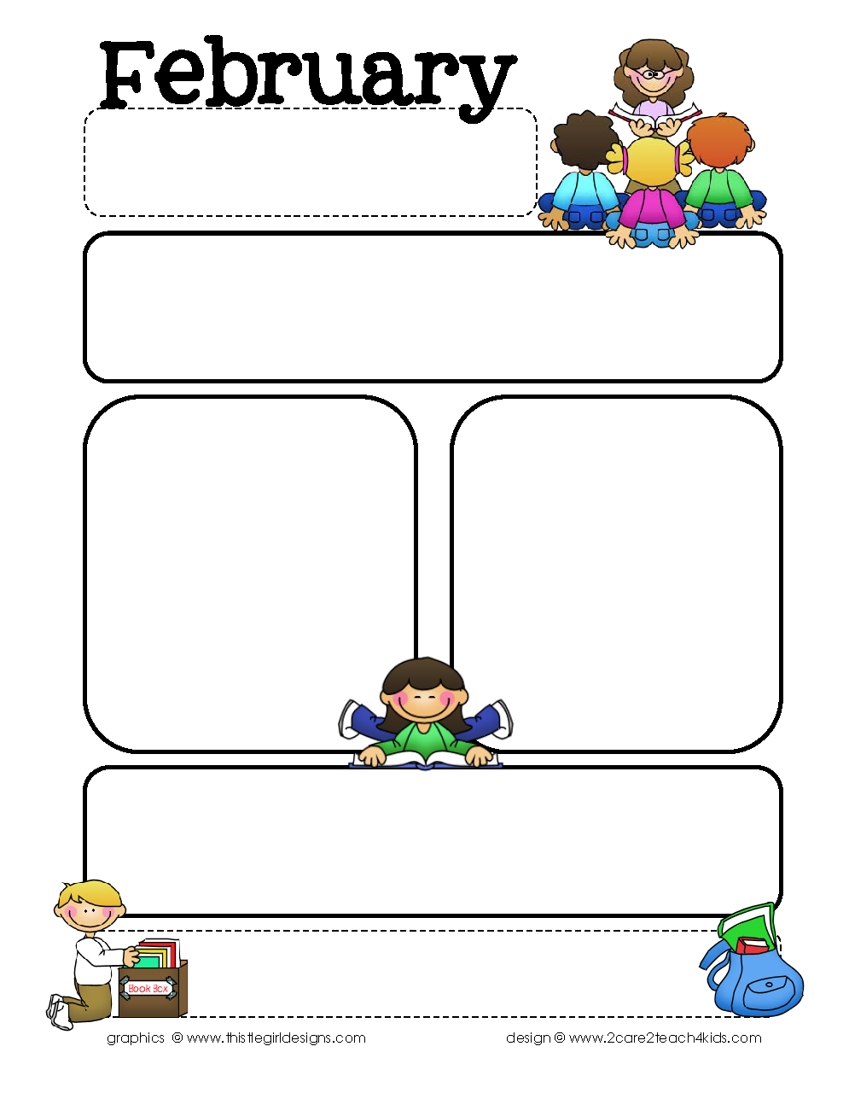

Providence Baptist Church Preschool

294 Seven Farms Drive, Daniel Island, SC 29492

843-971-5275, fax 843-971-6862

[www.pbcpreschool.com](http://www.pbcpreschool.com), [preschool@providencecharleston.org](mailto:preschool@providencecharleston.org)

It is hard to believe how quickly January flew by! February is such a fun month at preschool because all month long we talk about how much we love our family and friends and how much God loves us. Valentine’s Day will be celebrated before our long weekend Feb. 12-15 when we are closed for a BCSD workday and Presidents Day.

There are a few spots open in some classes for the 2016-17 school year. Registration materials can be found on our website, www.pbcpreschool.com.

Themes and Bible Stories

Feb. 1-5 Groundhog Day/Hibernating Animals

Jesus Calls the Fisherman- Matthew

4:18-22

Feb. 8-11 (No School Feb. 12) Valentine’s Day

Jesus Calls Levi-Luke 5:27-32

Feb. 16-19 (No School Feb. 15) Winter

Olympics/Presidents

Go Two by Two-Mark 6:7-13

Feb. 22-26 Teeth/ Dental Health

Women Follow Jesus-Luke 8:1-3

Focus Skills

Colors: Red/Pink

Shape: Heart

Opposite: Open/Closed

Letters: O P Q

Numbers: 1’s and 2’s-8 and 9

3’s and 4’s-14, 15, 16

Bible Verse: “Come, follow me.” Matthew 4:19

Important Upcoming Dates…

* There will be no school Feb. 12 and 15 for BCSD Teacher Workday and President’s Day.
* Pizza Days will be Feb. 18 and 19

Friendly reminder…

*Children with runny noses and coughs should stay home to snuggle. Even with no fever, congestion spreads germs.