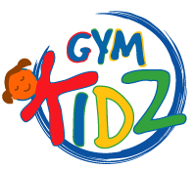

PARENTAL RELEASE WAIVER AND ASSUMPTION OF RISK

By allowing my child to attend and participated in a gymnastics birthday party with Gym Kidz. I acknowledge and agree to the following:

I am fully aware that a party, as a gymnastics activity represents the risk of injury. I am aware of the risk and damage that might occur as a result of my child’s participation in or attendance at the party.
Nonetheless, I on my own behalf and on behalf of my child and our heirs, administration and executor, do hereby release, Indemnify and agree to hold harmless Gym Kidz gymnastics, from any responsibility or liability for any and all claims, demands, damages, costs, causes of action and expenses (including, without limitation, reasonable Attorneys’ fees) arising out of or resulting from my child participation in or involvement with gymnastics training or a party, including, without limitation, any personal injury, disability or property damage incurred or sustained by me or my child during or as a result of the party.
I do hereby verify that I fully understand and accept the preceding conditions for permitting my child to participate in and attend this party.

THE PARTY IS FOR:

Date: ________________________

Time: ________________________

Place: Gym Kidz North Miami
405 University Drive
Coral Gables. FL 33134

Childs Name:___________________________________

Guardians Signature:_______________________________

