Government’s Role according to the Bible:
Research – Review scripture from previous session and watch Truth Project Lesson 9
Reason – Engage in the activities below
Relate – Present information with personal example from each group
Record – Document learning in spaces below

We understand that God has created a number of institutions and that each of these have specific areas of responsibility, influence and authority. Today, we’re going to look at this in a little more in-depth and we’re going to start with another video from the Truth Project.

Video Truth Project Lesson 9 “The State”

Paraphrase:
Romans 13:1-4
______________________________________________________________________
1 Peter 2:13-14 ______________________________________________________________________
1 Timothy 2:14 ______________________________________________________________________

Draw Biblical View of jurisdiction and authority
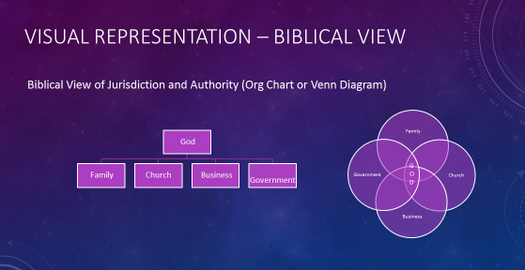

Draw non-Biblical View of jurisdiction and authority (Humanist, Socialist, Marxist, Big Government)

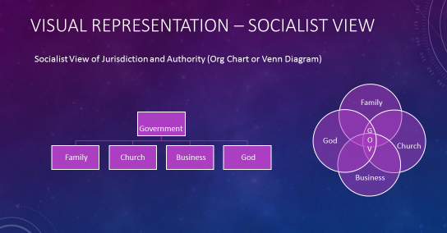

Activity: (Two groups of 3-5 participants with topic #1, Two groups of 3-5 participants with topic #2)
The groups each discuss their topics for 15 minutes and give the examples requested. Then each group will have a representative present their findings back to the whole group for three minutes each.

Possible answers, in red below, are not in the participants’ notebooks

- Two roles of government and five examples of each:
Punish evil: imprisonment, restitution requirements, loss of privileges, capital punishment, fines, military might, increased regulation/audits, take property

Praise good: recognition, certifications for business, laws promoting freedom, laws protecting life, liberty and property, encourage support of others, reward contracts (for support of law enforcement, security, justice)

Definitions of good and evil = Only 1 Truth - Laws and Regulations must have a basis

- Examples of situations where the government has taken the role of other spheres as designed by God:
- Education of children (Family – Proverbs 22:6)
- Welfare (Individuals/Church/Volunteer Organizations – John 3:17/I Timothy 5:3-10,16/II Thessalonians 3:6-12/ 2 Corinthians 9:7)
- Healthcare (Church/Volunteer Organizations – James 5:13-15/Matthew 10:8-11)
- Disaster relief (Individual/Volunteer Organizations – 2 Corinthians 8/Acts 11:27-30)
- Bank bailouts (Business – Proverbs 13:11, Proverbs 28:6) Leviticus 19:36 – Government should put in place regulations to reduce the potential need
- Retirement/elderly care (Family - Luke 14:28-30, 1 Tim 5:4&8, Mark 7:9-13)
- Hate crimes (Church – Matthew 5:21-22)

*Additional group question if time allows:
What types of taxes are proper? Taxes to fund - law enforcement, military, regulatory, public commons
Which of the examples are in direct violation of the Bible? Taxes to redistribution wealth or take responsibility from other spheres.
Worksheet: Label the columns below with the proper spheres of authority (Church, Family, Government, Individual/Voluntary Organization, Business) and complete the blank sections with the responsibility of the missing sphere. This is a high-level view only – it could be significantly expanded.
Portions in red are not in participants’ notebooks.

Spheres of Influence/Authority

Situation | Family | Indiv/VO | Business | Government | Church
People live in poverty | Teach children to care for others (Proverbs 22:6) | Relieve hunger by providing food (Acts 6:2) Opportunities to work for help (CARE Help) | Create opportunities for people to labor for their own food (Leviticus 19:10, 2 Thessalonians 3:10) | Ensure security for distribution of food, safe work and education environments (2 Corinthians 3:17) | Teach adults and hold them accountable to serving one another (Luke 3:10)
People steal from each other | Administer discipline early in life (Proverbs 13:24) | Neighborhood watch (Ecclesiastes 4:12) | Create opportunities for gain through labor (1Corinthians 9:9-10, Ephesians 4:8) | Administer justice (Romans 13:4) | Point people to Christ for forgiveness & teach biblical concept of work (Matthew 18:15-17)
Elderly need care | Children take care of parents (1 Tim 5:8) | Non-profit programs to support those who have no children | For-profit programs to meet elderly needs – nursing homes, Adult Daily Living | Regulatory | Take care of true widows and orphans (1 Timothy 5:1-25)
Children need education | Instruction of the father Proverbs 1:8-9 | Families support Christian Education | Hire good students, have internship programs, donate supplies, equipment | Recognize the best education, punish those who take advantage | Provide instruction, materials, support
Traffic problems | Provide good examples at home (Ephesians 6:4) | Lobby for new regulations, clean up right-of-ways, talk to media | Driving schools, Road maintenance | Driver’s License, tickets/fines, regulations | Teach people requirements to obey the law (1 Peter 2:13-17)
Declining populations | Procreation (Genesis 1:28) | Informational campaigns | Offer maternity leave, programs for summer work | Family tax credits | Family planning, marriage counseling
Potential Terrorist Attacks | Protection (Ephesians 5:25) | Bring attention to the problem | Create protection and preparation supplies for purchase | Provide for security (Obadiah 1:11) | Declare His Glory among the nations (Ps 96:3)

Two models of charitable giving – from Government Takes All by Dr. Max Lyons ₆:

(Information in red does not appear in participants’ notebooks)

Biblical | Un-Biblical
Personal aid – a knowledge of the individual you are assisting | Impersonal aid through bureaucrats
Character issues addressed | No consideration of lifestyle choices and character
Spiritual issues primary | Physical needs primary, spiritual needs ignored
Infirmed treated differently from able bodied | Blurred lines between need and want
Does not subsidize sinful behavior | Rewards sinful behavior
Requires family members to be the safety net | No obligation for family to be involved

